Practice Lab 04

ENTITY RELATIONSHIP DIAGRAM (ERD) And RELATIONAL SCHEMA

Q1. Business Case: Hotel Management System
A luxury hotel in Karachi wants to maintain its operations digitally. The hotel has several rooms, and each ROOM has a unique room number, type (Single, Double, Suite), floor number, and daily rent. Each room can be booked by one or more customers over time, but one booking can only be associated with one room. CUSTOMERS have a unique customer ID, name, CNIC, address, phone number, and email address. A customer can make multiple bookings, and each BOOKING includes check-in date, check-out date, payment method, and total amount. The hotel has several EMPLOYEES, including receptionists, housekeepers, and managers. Each employee has a unique employee ID, name, designation, salary, and contact number.
Each booking is handled by one receptionist, and one or more housekeepers are assigned to clean the booked rooms. The hotel also maintains a list of SERVICES such as laundry, food delivery, and spa, each with a unique service ID, name, and charges.
A customer may request one or more services during their stay, and each service request is linked to their booking.
Draw ERD and relational schema to show entities, attributes, and relationships between these entities.

Q2. Business Case: Online Food Delivery System
A food delivery platform called QuickBite operates in multiple cities. The system maintains data about restaurants, customers, orders, and delivery riders.
Each RESTURANT has a unique restaurant ID, name, address, cuisine type, and phone number. A restaurant offers multiple FOOD ITEMS, and each food item has a unique item ID, name, description, and price.
A CUSTOMER has a unique customer ID, name, phone number, address, and email. A customer can place multiple orders, and each order is identified by an ORDER ID, order date, delivery status, and total amount.
Each order may contain one or more food items from a single restaurant. A delivery rider delivers the order. Each RIDER has a unique rider ID, name, CNIC, phone number, and vehicle number.
PAYMENT INFORMATION is also stored for each order, including payment ID, method (Cash, Card, Wallet), and amount paid.
A restaurant can receive many orders, but each order belongs to one restaurant only. Each rider can deliver multiple orders but only one at a time.
Draw ERD and relational schema to show entities, attributes, and relationships between these entities.

Q3. Business Case: Library Management System
A public library in Islamabad maintains digital records for its members, books, and borrowing history.
Each BOOK has a unique book ID, title, author, publication year, ISBN number, and category (Fiction, Science, History, etc.). A book can have multiple COPIES, each identified by a unique copy number and shelf location.
LIBRARY MEMBERS have a unique member ID, name, address, phone number, and membership date. Members can borrow multiple books, but each book copy can be borrowed by only one member at a time.
Each BORROWING TRANSACTION is recorded with a unique transaction ID, issue date, due date, and return date (if applicable).
The library has STAFF MEMBERS, each with a unique staff ID, name, designation, salary, and contact number. A staff member issues and receives books for members.
The library also maintains information about FINES for late returns, including fine ID, amount, and reason. Each fine is linked to a specific borrowing transaction.
Draw ERD and relational schema to show entities, attributes, and relationships between these entities.

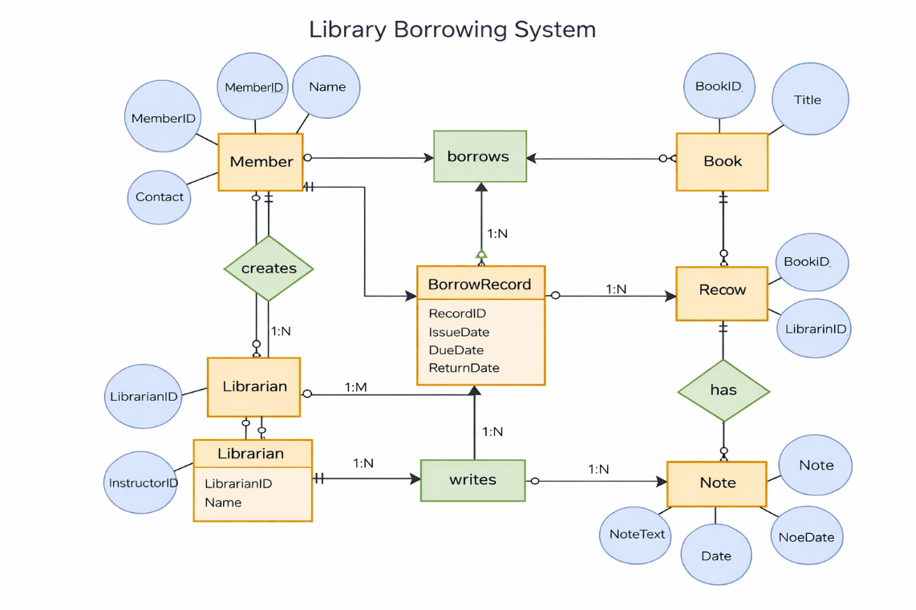
Q4.

Draw relational schema to show entities, attributes, and relationships between these entities.

Q5.
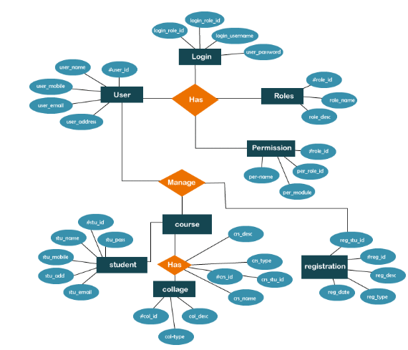
Draw relational schema to show entities, attributes, and relationships between these entities.
Q6:
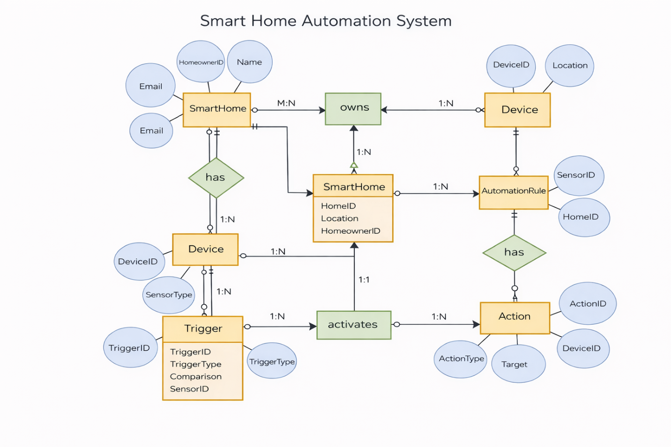
Draw relational schema to show entities, attributes, and relationships between these entities.
Tool: Use online ERD Plus tool

