University of Central Punjab
Operating Systems - Assignment 01
Name: Muhammad Hussain Raza Durrani | Roll No: L1F24BSCS0937

Question 1
Q:Write a program that creates 2 child processes to calculate grades of students of mathematics class. The parent process will send the array to one child processes to calculate the percentage of marks out of 250 total. The other child processes will assign the grade A+>=90, A>=80, B>=70, C>=60, D>=50, F< and send result to parent process for sorting in ascending order and display the final result of the students. Class strength of 50 students
- Declare and initialize the array
- Each child process should run on a separate CPU
- Binding process to a CPU called affinity

Solution
Approach: the parent declares and initializes an array of 50 marks and creates three pipes. Child 1 (bound to CPU 0) reads the marks and calculates each student's percentage out of 250. Child 2 (bound to CPU 1) reads the percentages and assigns grades. The parent collects the results, sorts them in ascending order of percentage with bubble sort, and displays the final table. CPU affinity is set with sched_setaffinity().
- Program (grades.c):
#define _GNU_SOURCE
#include <stdio.h>
#include <unistd.h>
#include <sys/wait.h>
#include <sched.h>

/* Bind the calling process to one CPU core (CPU affinity) */
void set_cpu_affinity(int cpu_id) {
cpu_set_t set;
CPU_ZERO(&set);
CPU_SET(cpu_id, &set);
sched_setaffinity(0, sizeof(cpu_set_t), &set);
printf("Child bound to CPU %d (running on CPU %d)\n", cpu_id, sched_getcpu());
fflush(stdout);
}
int main(void) {
int marks[50] = {
230, 210, 195, 180, 175, 160, 150, 140, 130, 120,
110, 100, 90, 80, 70, 60, 50, 40, 30, 20,
225, 205, 190, 185, 170, 165, 155, 145, 135, 125,
115, 105, 95, 85, 75, 65, 55, 45, 35, 25,
240, 200, 150, 100, 50, 10, 235, 175, 125, 75
};

/* pipe1: parent -> child1 (marks)
pipe2: child1 -> child2 (id, marks, percentages)
pipe3: child2 -> parent (id, marks, percentages, grades) */
int pipe1[2], pipe2[2], pipe3[2];
pipe(pipe1);
pipe(pipe2);
pipe(pipe3);

/* First child: Calculates percentage of marks out of 250 */
if (fork() == 0) {
set_cpu_affinity(0); /* run on CPU 0 */

close(pipe1[1]);
close(pipe2[0]);
close(pipe3[0]); close(pipe3[1]);

int id[50];
int m[50];
float p[50];

read(pipe1[0], m, sizeof(m));

for (int i = 0; i < 50; i++) {
id[i] = i + 1;
p[i] = (m[i] * 100.0) / 250; // Percentage Calculation
}
printf("Child 1: percentages calculated.\n");
fflush(stdout);

write(pipe2[1], id, sizeof(id));
write(pipe2[1], m, sizeof(m));
write(pipe2[1], p, sizeof(p));

close(pipe1[0]);
close(pipe2[1]);
_exit(0); // exit child process 1
}

/* Second child: Assigns grades */
if (fork() == 0) {
set_cpu_affinity(1); /* run on CPU 1 */

close(pipe1[0]); close(pipe1[1]);
close(pipe2[1]);
close(pipe3[0]);

int id[50];
int m[50];
float p[50];
char grade[50][3];

read(pipe2[0], id, sizeof(id));
read(pipe2[0], m, sizeof(m));
read(pipe2[0], p, sizeof(p));

// Grade Calculation:
for (int i = 0; i < 50; i++) {
if (p[i] >= 90) { grade[i][0] = 'A'; grade[i][1] = '+'; grade[i][2] = '\0'; }
else if (p[i] >= 80) { grade[i][0] = 'A'; grade[i][1] = '\0'; }
else if (p[i] >= 70) { grade[i][0] = 'B'; grade[i][1] = '\0'; }
else if (p[i] >= 60) { grade[i][0] = 'C'; grade[i][1] = '\0'; }
else if (p[i] >= 50) { grade[i][0] = 'D'; grade[i][1] = '\0'; }
else { grade[i][0] = 'F'; grade[i][1] = '\0'; }
}
printf("Child 2: grades assigned.\n");
fflush(stdout);

write(pipe3[1], id, sizeof(id));
write(pipe3[1], m, sizeof(m));
write(pipe3[1], p, sizeof(p));
write(pipe3[1], grade, sizeof(grade));

close(pipe2[0]);
close(pipe3[1]);
_exit(0); // exit child process 2
}

/* Parent: Sends array, receives results, sorts, displays */
close(pipe1[0]);
close(pipe2[0]); close(pipe2[1]);
close(pipe3[1]);

int id[50];
int m[50];
float p[50];
char grade[50][3];

write(pipe1[1], marks, sizeof(marks));
close(pipe1[1]);

read(pipe3[0], id, sizeof(id));
read(pipe3[0], m, sizeof(m));
read(pipe3[0], p, sizeof(p));
read(pipe3[0], grade, sizeof(grade));
close(pipe3[0]);

wait(0);
wait(0);

/* Sort in ascending order of percentage (bubble sort) */
for (int i = 0; i < 49; i++) {
for (int j = 0; j < 49 - i; j++) {
if (p[j] > p[j + 1]) {
float tf = p[j];
p[j] = p[j + 1];
p[j + 1] = tf;

int t = id[j];
id[j] = id[j + 1];
id[j + 1] = t;

t = m[j];
m[j] = m[j + 1];
m[j + 1] = t;

char c;
c = grade[j][0]; grade[j][0] = grade[j + 1][0]; grade[j + 1][0] = c;
c = grade[j][1]; grade[j][1] = grade[j + 1][1]; grade[j + 1][1] = c;
c = grade[j][2]; grade[j][2] = grade[j + 1][2]; grade[j + 1][2] = c;
}
}
}

/* Display the final result */
printf("\nID Marks Percentage Grade\n");
printf("----------------------------\n");
for (int i = 0; i < 50; i++) {
printf("%-3d %-6d %-10.2f %s\n", id[i], m[i], p[i], grade[i]);
}

return 0;
}

Output:
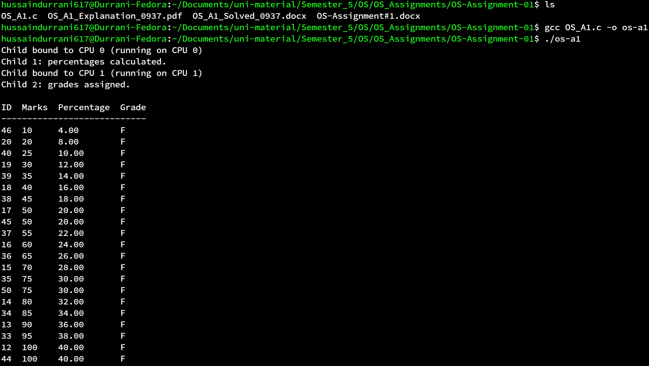
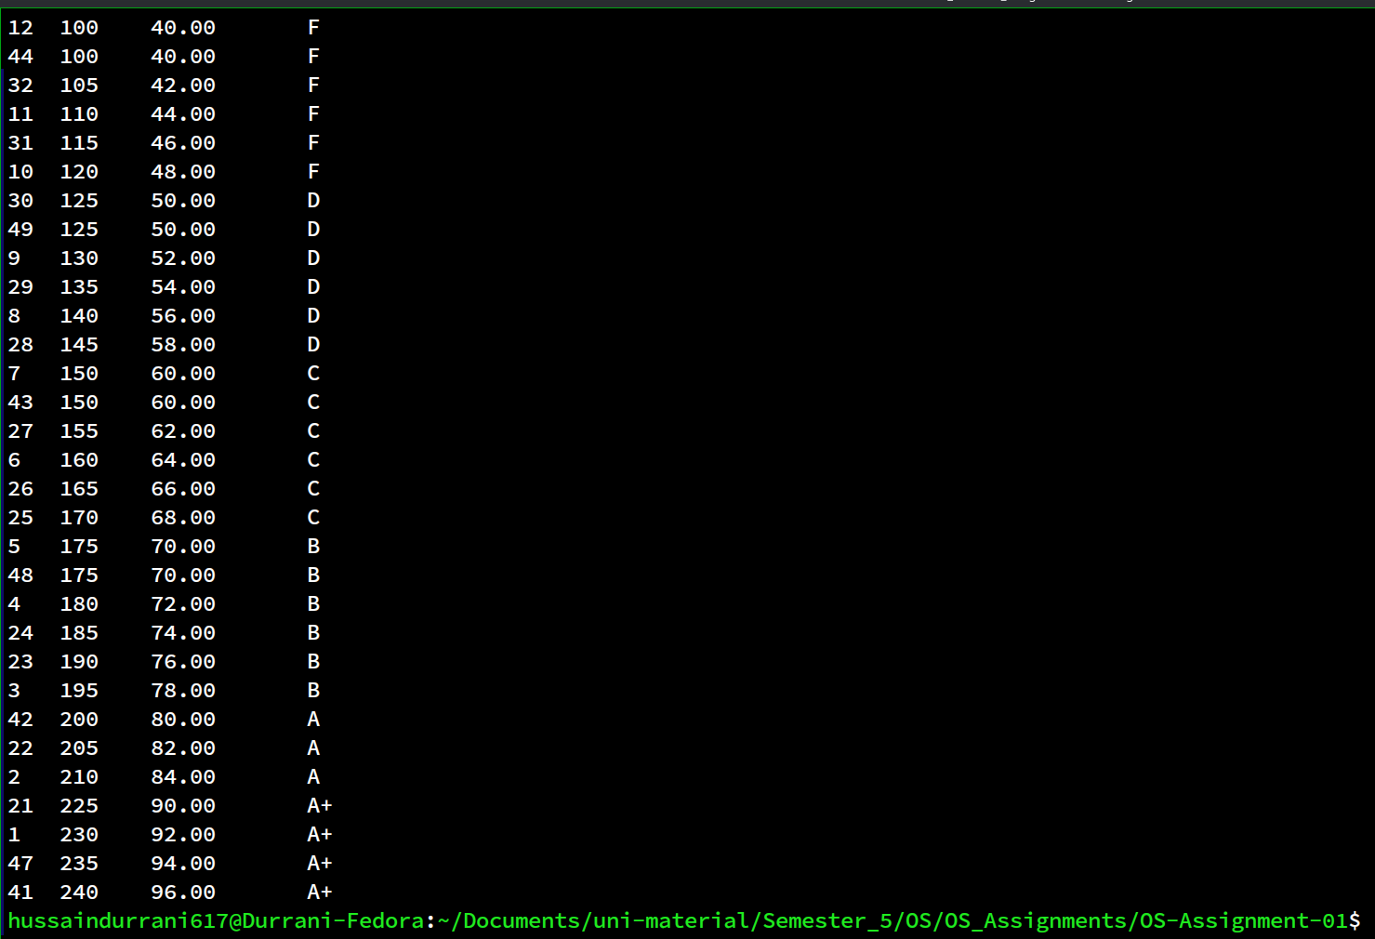

Question 2
What is an operating system and how does an operating system manage processes?

Answer
An operating system (OS) is the system software that sits between the computer hardware and all other software. It plays two roles: it hides the complexity of the raw hardware, letting programs work with simple abstractions like files and processes instead of disk sectors and CPU registers; and as a resource manager, it shares the CPU, memory, and I/O devices fairly and safely among competing programs.
The OS manages processes, where a process is a program in execution, through the following mechanisms:
- Process creation and termination: the OS creates processes (e.g. fork() duplicates a process, exec() loads a new program) and cleans them up on exit; a parent reaps a finished child with wait(), otherwise the child remains a zombie.
- Process tracking (PCB): for every process the OS keeps a Process Control Block holding its PID, CPU register values, program counter, memory information and current state.
- Process states and scheduling: a process moves between new, ready, running, waiting and terminated states, and the scheduler decides which ready process runs next on each CPU.
- Context switching: when a process's time slice ends or it blocks waiting for I/O, the OS saves its state into the PCB and loads another process's state so many processes can share a few CPUs.
- Inter-process communication (IPC): because processes have isolated memory, the OS provides shared memory and message queues so they can exchange data safely.
- CPU affinity: the scheduler normally migrates processes between CPU cores as it sees fit, but a process can also be pinned to specific cores so it always runs there, which improves cache performance and gives more predictable timing.
Together, these mechanisms let the OS run many programs safely and efficiently on shared hardware.

