INFORMATION SECURITY – LAB – Week 05
Lab Title: Kali Linux Setup: Configure & test a vulnerable Windows 7 target
Name: Hussain Durrani
Roll No: L1F24BSCS0937

Part A – VirtualBox Configuration:
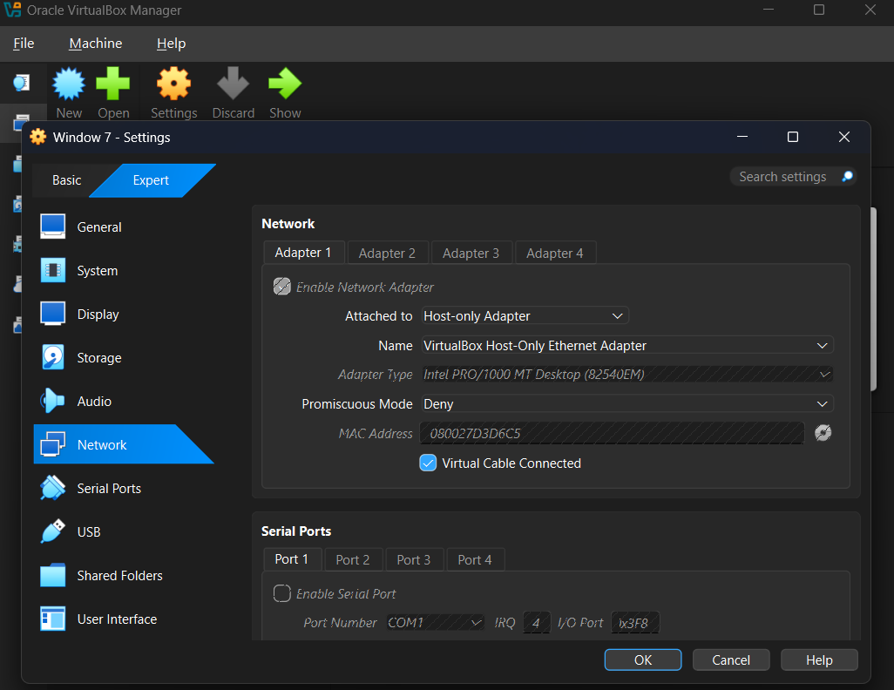Windows 7 is configured to use the VirtualBox Host-only Adapter, keeping the target machine isolated from the Internet
.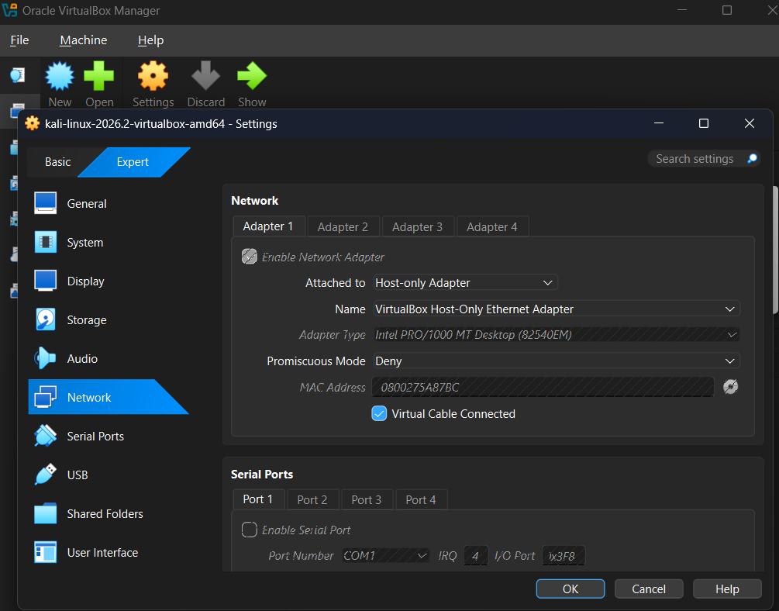
Kali Linux is configured to use the same Host-only Adapter as Windows 7, allowing both virtual machines to communicate securely within the lab network.

Part B – Kali Terminal Commands:
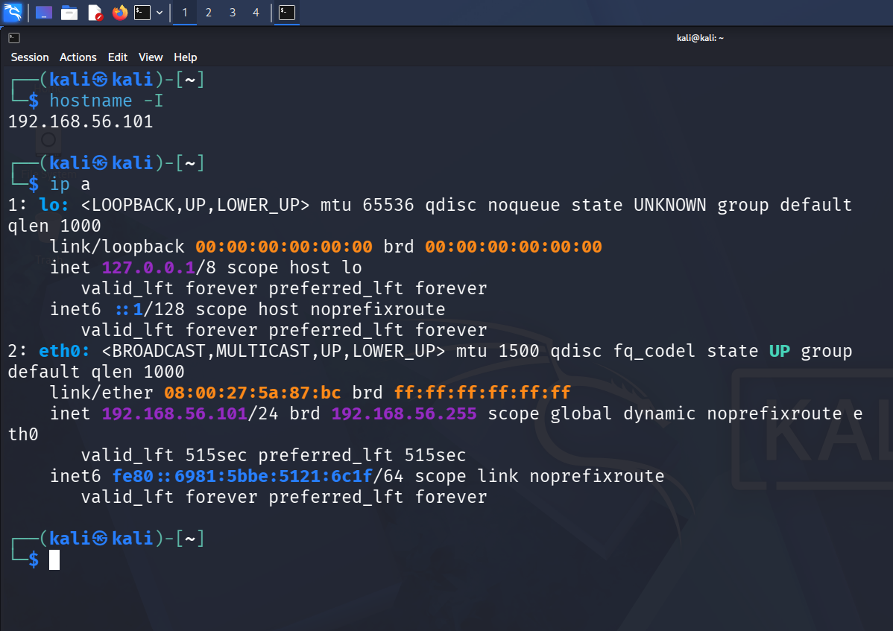
Verifies that the Kali machine interface eth0 has successfully obtained the private IP address 192.168.56.101 via DHCP.
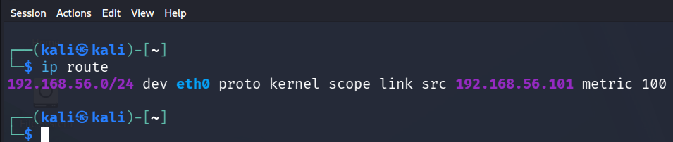
Shows the local routing table layout proving that network traffic targeting the local scope routes natively through interface eth0.
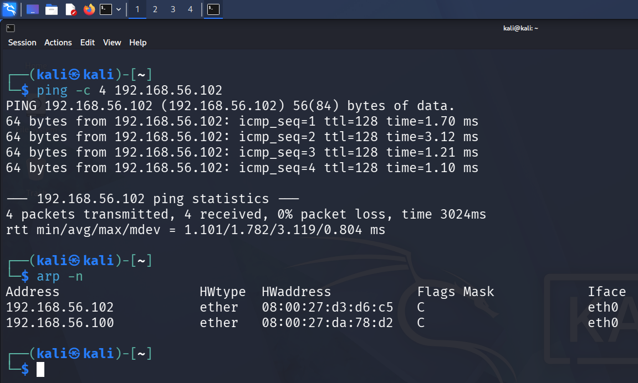
(ping -c 4 192.168.56.102): Documents a successful connectivity status check pointing to the target machine showing 0% packet loss.
(arp -n): Displays the learned kernel ARP table entries verifying that the IP address 192.168.56.102 correctly resolves to the target hardware MAC address.

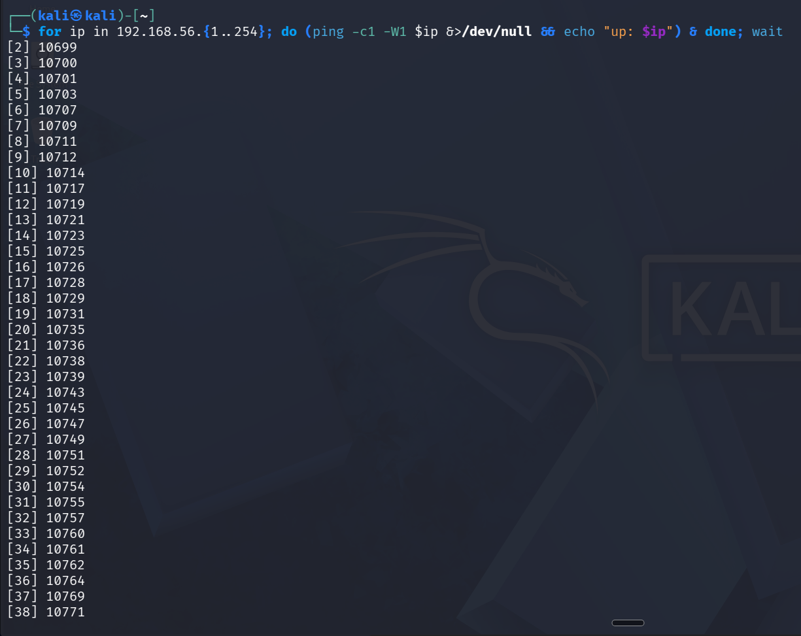
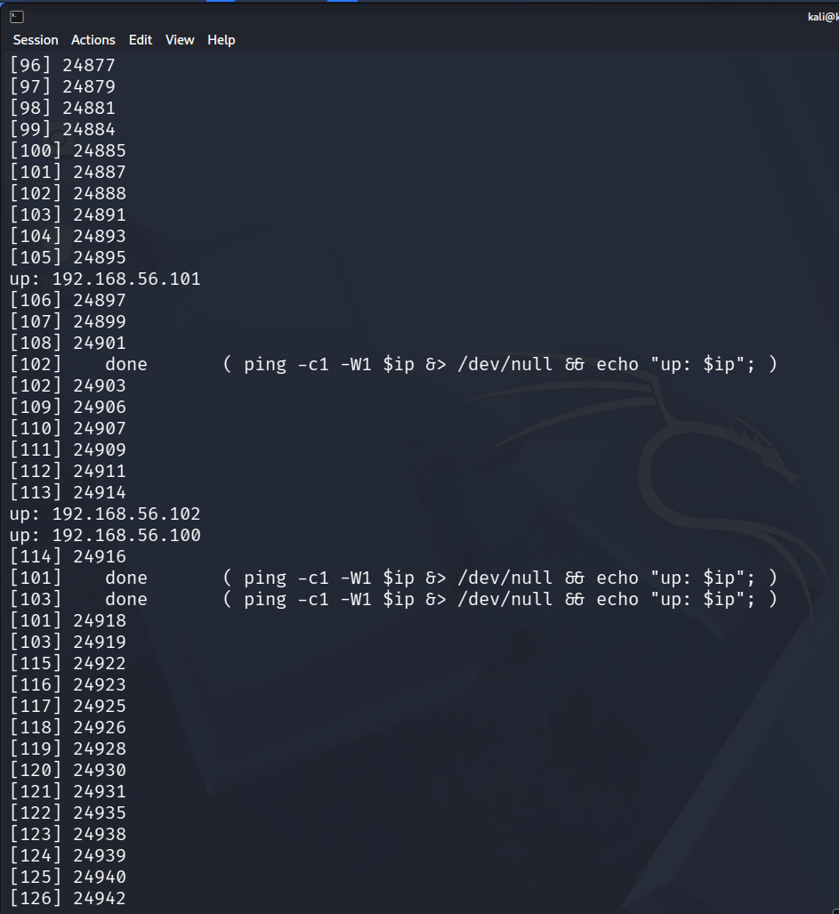
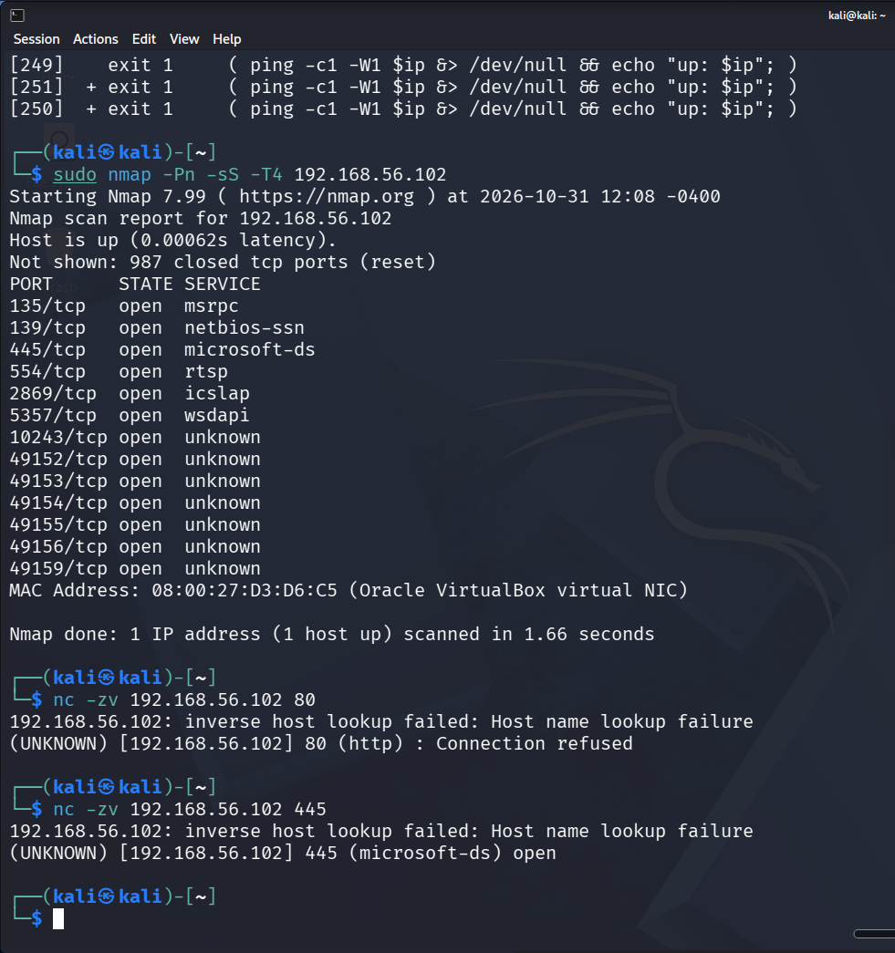
- (Ping Sweep Loop): Captures the executed background network discovery processes spawning clean status updates for active lab nodes.
- (nmap Scan): Summarizes non-destructive reconnaissance data tracking active common target ports like 135, 139, and 445.
- (nc Port Checks): Provides validation tests showing a refused connection error for closed services (Port 80) and a successful handle link verification message on open channels (Port 445).
Part C – Windows 7 Target Commands:
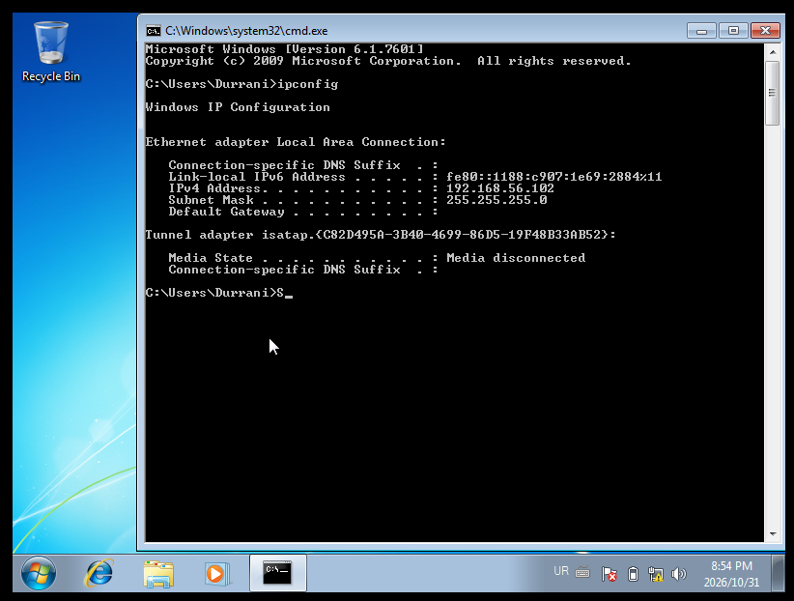
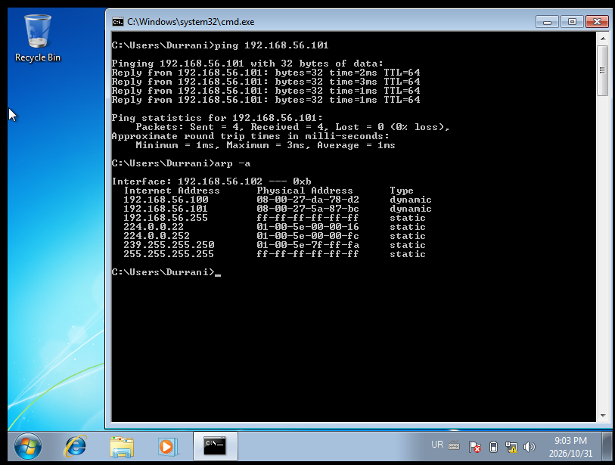
- (ipconfig): Shows the local area configuration dashboard confirming the assignment of target IP 192.168.56.102 on the virtual subnet.
- (ping 192.168.56.101): Captures full ICMP loop tracking replies back from Kali validating active bidirectional data routes.
- (arp -a): Documents the final network state containing the cached mapping pairing Kali's IP address with its virtual hardware adapter label.

In this lab, Kali Linux and Windows 7 were configured on an isolated Host-only network. Both machines successfully communicated using ping commands. IP addresses, ARP entries, and open ports were examined using networking tools. This lab helped in understanding basic network configuration and reconnaissance.

