Lab 4 Practice Tasks: Process Creation
Name: Hussain Durrani
Roll No: L1F24BSCS0937

Task 1: Declare a global integer array of 5 elements, filled with the values 1 to 5. Write a program in which the parent creates one child. The child replaces every element with its square and prints the array together with its own PID and its parent’s PID. The parent waits for the child, then prints its own copy of the array together with its PID and the PID of its child. Explain from the output why the two arrays differ.
Solution:
#include <stdio.h>
#include <unistd.h>
#include <sys/wait.h>

int arr[5] = { 1, 2, 3, 4, 5 };

int main() {
pid_t pid = fork();

if (pid == 0) {
// Child Process:
for (int i = 0; i < 5; i++) { arr[i] = arr[i] * arr[i]; }

printf("Child PID: %d, Parent PID: %d\n", getpid(), getppid());
printf("Child array: ");
for (int i = 0; i < 5; i++) { printf("%d ", arr[i]); }
printf("\n");
} else if (pid > 1) {
wait(NULL);

printf("Parent PID: %d, Child PID: %d\n", getpid(), pid);
printf("Parent array: ");
for (int i = 0; i < 5; i++) { printf("%d ", arr[i]); }
printf("\n");
} else {
printf("Error creating process.");
}

return 0;
}
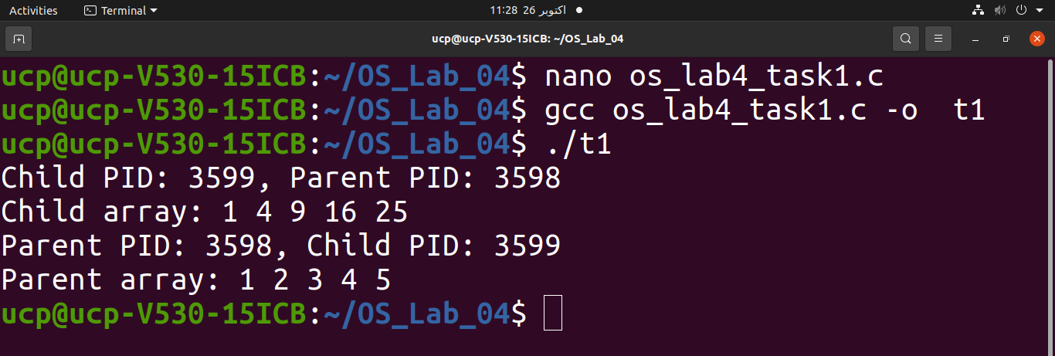
When fork() creates a child process, the child receives its own copy of the parent's memory, including the global array.
- Child: Squares each element in its own copy of the array.
- Parent: Waits for the child to finish using wait(NULL) and then prints its unchanged array.
Therefore, the arrays differ because the parent and child have separate memory spaces. Changes made by the child do not affect the parent's array.

Task 2: Write a program that calls fork() three times one after the other, with no conditions. After the calls, every process prints its PID and PPID. Run it and count the lines printed, then draw the process tree from your output and state how many processes exist in total and why. Finally, modify the program so that only the original parent creates the three children and the children create nothing further, and compare the number of lines printed.
Solution:
#include <stdio.h>
#include <unistd.h>

int main() {
fork();
fork();
fork();

printf("PID: %d, PPID: %d\n", getpid(), getppid());

return 0;
}

Original Parent (P)
├── Child 1
│ ├── Child 3
│ │ └── Child 7
│ └── Child 6
├── Child 2
│ └── Child 5
└── Child 4
Each fork() duplicates every process that reaches it.
- After the first fork(): 2 processes.
- After the second fork(): 4 processes.
- After the third fork(): 8 processes.
Total processes = 2³ = 8, including the original parent.
Each process executes the printf() statement once, so 8 lines are printed.

#include <stdio.h>
#include <unistd.h>
#include <sys/wait.h>

int main() {
for (int i = 0; i < 3; i++) {
if (fork() == 0) {
printf("Child PID: %d, PPID: %d\n", getpid(), getppid());
return 0;
}
}

for (int i = 0; i < 3; i++)
wait(NULL);

printf("Parent PID: %d, PPID: %d\n", getpid(), getppid());

return 0;
}

Original Parent (P)
├── Child 1
├── Child 2
└── Child 3
The if (fork() == 0) condition identifies each child. When a child is created, it prints its information and executes return 0, preventing it from creating additional children.
- Total processes: 4 (one parent and three children).
- Lines printed: 4 (one per process).
- Comparison: Three unconditional fork() calls create 8 processes and 8 lines, whereas the modified program creates 4 processes and 4 lines.

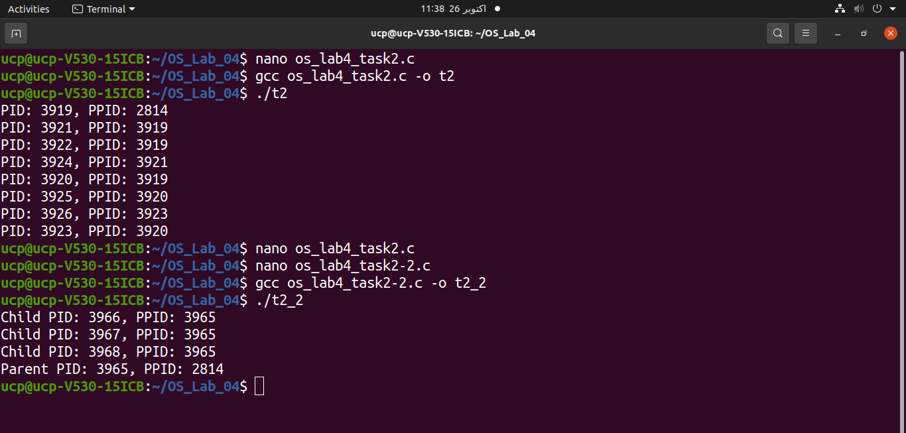
Task 3: Write a program that takes an integer n from the command line. The parent creates exactly n children using a loop. Child number i prints “Child i, PID = …, PPID = …” and exits. The parent waits for every child and then prints how many children it reaped. Test with n = 1, 4 and 0, and with a negative n.
Solution:
#include <stdio.h>
#include <stdlib.h>
#include <unistd.h>
#include <sys/wait.h>

int main(int argc, char *argv[]) {
if (argc != 2) {
printf("Usage: %s n\n", argv[0]);
return 1;
}

int n = atoi(argv[1]);

if (n < 0) {
printf("n must be non-negative.\n");
return 1;
}

for (int i = 1; i <= n; i++) {
if (fork() == 0) {
printf("Child %d, PID = %d, PPID = %d\n", i, getpid(), getppid());
exit(0);
}
}

int reaped = 0;
while (wait(NULL) > 0) { reaped++; }
printf("Parent: Reaped %d children.\n", reaped);

return 0;
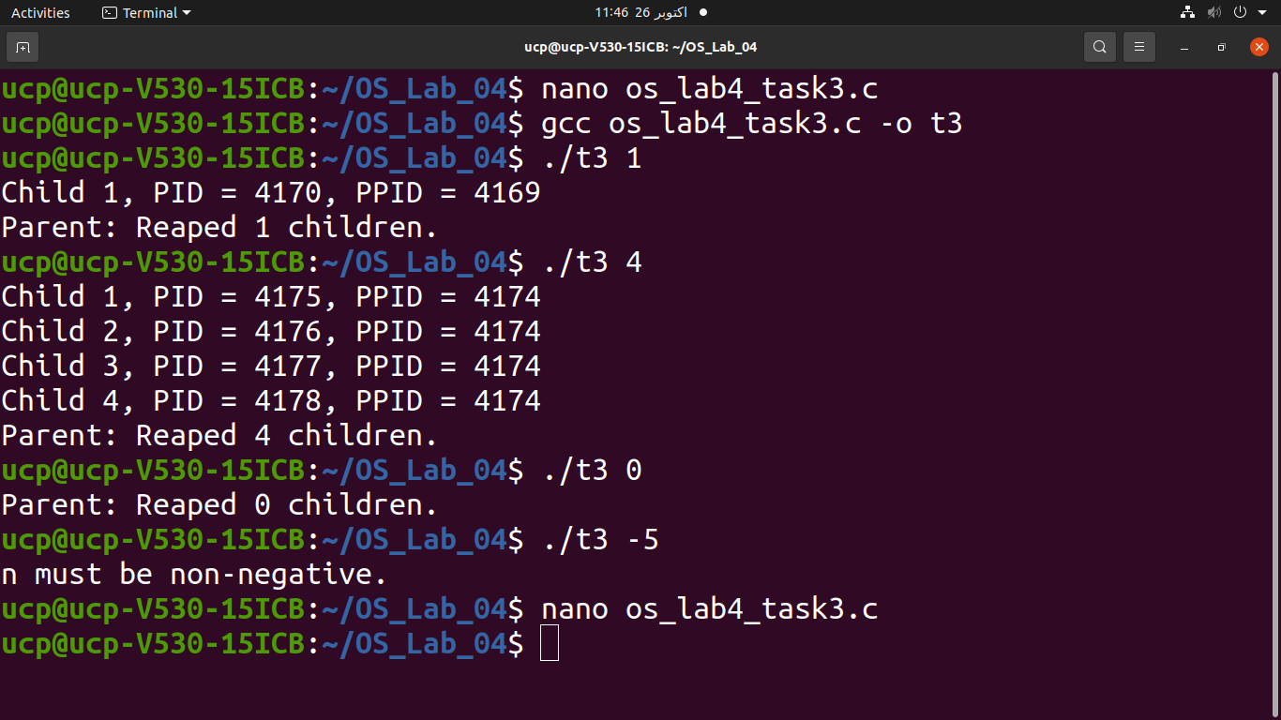
}
The loop creates exactly n children.
- Each child prints its number, PID, and PPID, then exits so it cannot create more children.
- The parent uses wait(NULL) to reap all terminated children and counts them.
- For n = 0, no children are created.
- For negative n, the program displays an error and exits without creating children.
Expected number of children reaped: n, for every non-negative input.
Task 4: Write a program that builds this tree: the original process (P) creates two children, C1 and C2, and C1 creates one child of its own, G1. Every process prints a line giving its role (P, C1, C2 or G1), its PID and its PPID. Arrange the waits so that G1 always finishes before C1, and both C1 and C2 finish before P.
Solution:
#include <stdio.h>
#include <unistd.h>
#include <sys/wait.h>

int main() {
printf("P: PID = %d, PPID = %d\n", getpid(), getppid());

pid_t c1 = fork();

if (c1 == 0) {
printf("C1: PID = %d, PPID = %d\n", getpid(), getppid());

pid_t g1 = fork();

if (g1 == 0) {
printf("G1: PID = %d, PPID = %d\n", getpid(), getppid());
return 0;
}

wait(NULL);
return 0;
}

pid_t c2 = fork();

if (c2 == 0) {
printf("C2: PID = %d, PPID = %d\n", getpid(), getppid());
return 0;
}

waitpid(c1, NULL, 0);
waitpid(c2, NULL, 0);

return 0;
}
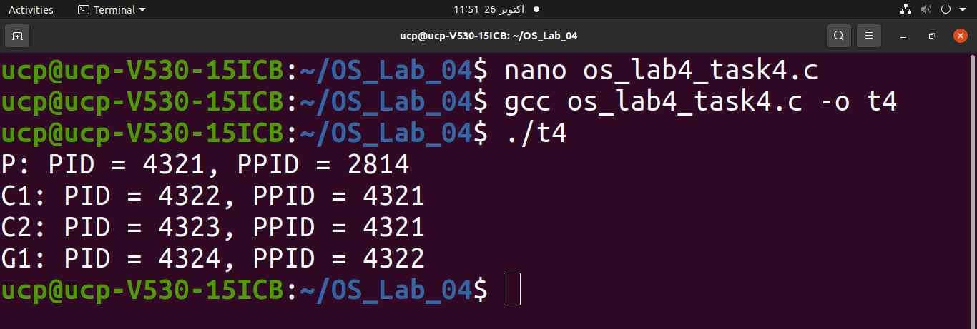
P
/ \
C1 C2
|
G1

P creates two children: C1 and C2.
- C1 creates G1 and calls wait(NULL) to ensure G1 finishes before C1 exits.
- P calls waitpid() for C1 and C2, ensuring both finish before P exits.
Thus, G1 finishes before C1, and both C1 and C2 finish before P, as required.

Task 5: Write a program that takes an integer n from the command line and creates three children. Child 1 tests whether n is a prime number and exits with 1 if it is prime and 0 if it is not. Child 2 calculates the sum of the numbers from 1 to n and returns the sum through its exit status. Child 3 terminates abnormally because of a runtime error that you cause on purpose. The parent waits for every child and, for each one, prints the PID and says whether it exited normally (with its exit code) or was killed by a signal. Test Child 2 with n = 5 and n = 30, and explain what happens to the sum when it is larger than 255.
Solution:
#include <stdio.h>
#include <stdlib.h>
#include <unistd.h>
#include <sys/wait.h>

int main(int argc, char *argv[]) {
if (argc != 2) {
printf("Usage: %s n\n", argv[0]);
return 1;
}

int n = atoi(argv[1]);

if (n < 0) {
printf("Enter a non-negative integer.\n");
return 1;
}

for (int i = 1; i <= 3; i++) {
pid_t pid = fork();

if (pid == 0) {
if (i == 1) {
int prime = n >= 2;
for (int j = 2; j <= n / j; j++) {
if (n % j == 0) {
prime = 0;
break;
}
}
exit(prime ? 1 : 0);
}

if (i == 2) {
int sum = n * (n + 1) / 2;
exit(sum);
}

if (i == 3) {
int *p = NULL;
*p = 10;
exit(0);
}
}
}

for (int i = 0; i < 3; i++) {
int status;
pid_t pid = wait(&status);

if (WIFEXITED(status))
printf("Child PID %d exited normally with code %d\n",
pid, WEXITSTATUS(status));
else if (WIFSIGNALED(status))
printf("Child PID %d was killed by signal %d\n",
pid, WTERMSIG(status));
}

return 0;
}
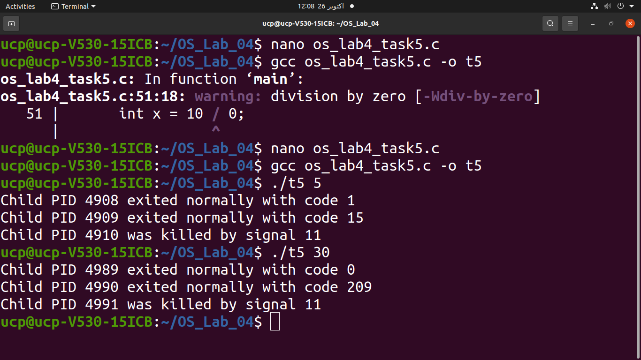
Child 1: Returns 1 because 5 is prime.
- Child 2: Calculates 1 + 2 + 3 + 4 + 5 = 15 and returns 15.
- Child 3: Attempts to write through a null pointer, typically causing a segmentation fault (signal 11 on Linux).

The sum of numbers 1 – 30: 465
On typical Unix/Linux systems, a process's exit status carries only 8 bits, so only values from 0 to 255 can be retrieved through WEXITSTATUS().
Therefore:
Child 2's reported exit code will be 209, not 465.

Explanation:
- fork() creates three children.
- Child 1 checks whether n is prime and returns 1 for prime or 0 otherwise.
- Child 2 calculates the sum and returns it through its exit status.
- Child 3 deliberately causes a runtime error.
- The parent uses wait() and checks WIFEXITED(), WEXITSTATUS(), and WIFSIGNALED() to determine how each child terminated.
Task 6: Write a program in which the parent creates four children and each one runs a different program using a different member of the exec family:
- Child 1 prints the message “Hello from exec” using execl().
- Child 2 counts the number of lines in the file /etc/passwd using execv().
- Child 3 lists the files of the current directory in long format using execvp() or execlp().
- Child 4 displays the environment using the env program, with a variable of your own choice added to the environment, using execle() or execve().
The parent waits for all four and prints the PID and exit status of each. Then change one of the program names to something that does not exist and show how your error handling reports it. In a comment, write which letters of the exec name (l, v, p, e) each of your four calls uses.
Solution:
#include <stdio.h>
#include <unistd.h>
#include <sys/wait.h>
#include <stdlib.h>

int main() {
pid_t pid[4];
int status, i;

for (i = 0; i < 4; i++) {
pid[i] = fork();

if (pid[i] == 0) {
switch (i) {
case 0:
// Uses l: execl()
execl("/bin/echo", "echo", "Hello from exec", NULL);
break;

case 1:
// Uses v: execv()
{
char *args[] = {"wc", "-l", "/etc/passwd", NULL};
execv("/usr/bin/wc", args);
}
break;

case 2:
// Uses p: execvp()
{
char *args[] = {"ls", "-l", NULL};
execvp("ls", args);
}
break;

case 3:
// Uses e: execle()
{
char *env[] = {"MY_VAR=Hello", NULL};
execle("/usr/bin/env", "env", NULL, env);
}
break;
}

perror("exec failed");
exit(1);
}
else if (pid[i] < 0) {
perror("fork failed");
exit(1);
}
}

for (i = 0; i < 4; i++) {
waitpid(pid[i], &status, 0);

printf("Child PID: %d, ", pid[i]);

if (WIFEXITED(status))
printf("Exit status: %d\n", WEXITSTATUS(status));
else
printf("Terminated abnormally\n");
}

return 0;
}

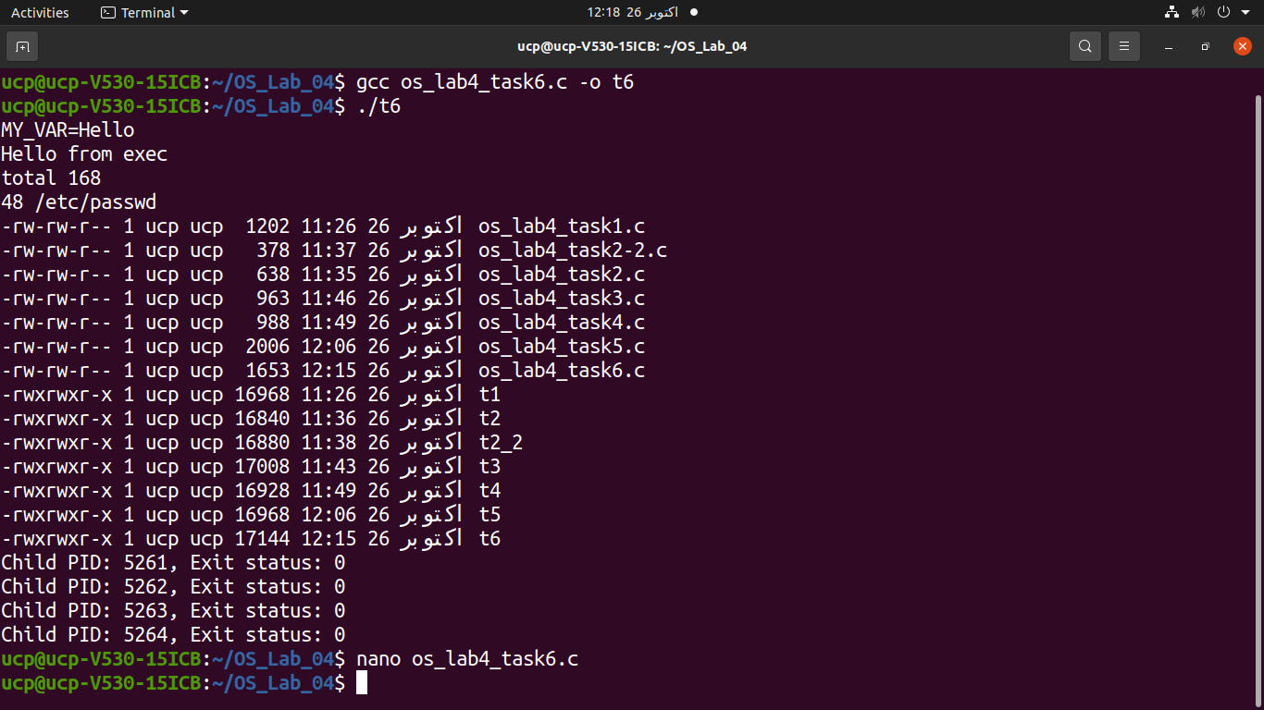

- Child 1 — execl(): Prints Hello from exec.
- Child 2 — execv(): Counts lines in /etc/passwd using wc -l.
- Child 3 — execvp(): Lists files in long format using ls -l.
- Child 4 — execle(): Displays environment variables, including MY_VAR=Hello.
- Parent: Waits for all four children and prints their PIDs and exit statuses.
The letters used by the four functions are:
- l — Argument list.
- v — Argument vector (array).
- p — Searches the PATH for the program.
- e — Accepts a custom environment.

Task 7: Write a program that takes a text file name as a command line argument. Each line of the file holds one command with its arguments (for example, ls -l /tmp). The program reads the file line by line and runs every command in its own child process, one after the other, using one of the exec functions. After each command finishes, the parent prints the command, its exit status, and a message “FAILED” if the status is not zero. A command that
Solution:
#include <stdio.h>
#include <stdlib.h>
#include <unistd.h>
#include <sys/wait.h>

int main(int argc, char *argv[]) {
char line[256], *args[32];
FILE *file;
int status, i;
pid_t pid;

if (argc != 2) {
printf("Usage: %s filename\n", argv[0]);
return 1;
}

file = fopen(argv[1], "r");
if (!file) {
perror("File error");
return 1;
}

while (fgets(line, sizeof(line), file)) {
printf("Command: %s", line);

i = 0;
args[i] = line;

for (char *p = line; *p; p++) {
if (*p == ' ' || *p == '\n' || *p == '\t') {
*p = '\0';

if (p[1] != '\0' && p[1] != ' ' &&
p[1] != '\n' && p[1] != '\t')
args[++i] = p + 1;
}
}

args[++i] = NULL;

if (!args[0][0])
continue;

pid = fork();

if (pid == 0) {
execvp(args[0], args);
perror("Command failed");
exit(127);
} else if (pid > 0) {
waitpid(pid, &status, 0);

if (WIFEXITED(status)) {
int result = WEXITSTATUS(status);
printf("Exit status: %d", result);
if (result != 0)
printf(" FAILED");
printf("\n");
} else {
printf("Terminated abnormally FAILED\n");
}
} else {
perror("fork failed");
}
}

fclose(file);
return 0;
}

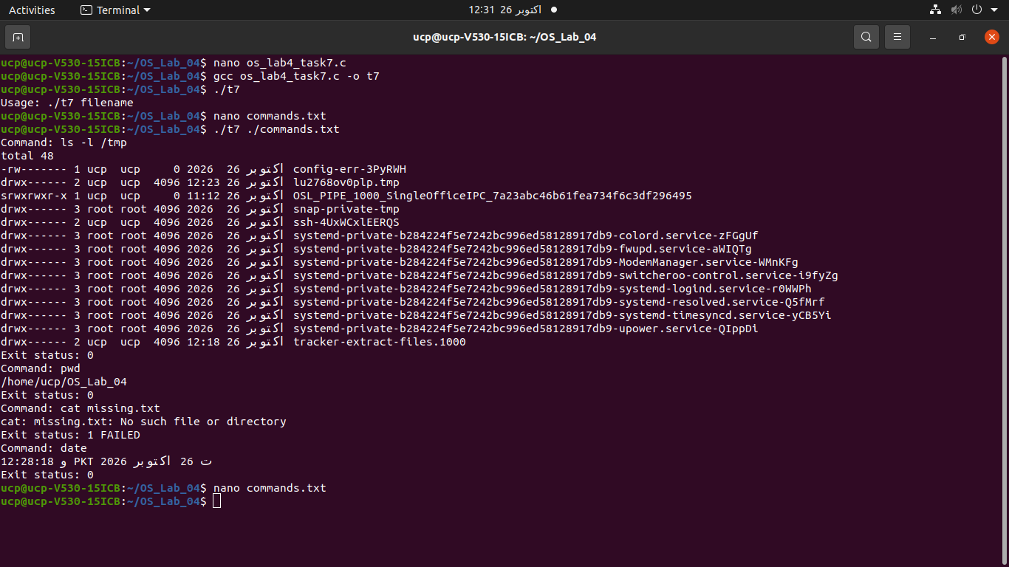

- fopen() opens the command file, and fgets() reads it line by line.
- strtok() separates each command into arguments.
- fork() creates a child process for each command.
- execvp() executes the command.
- waitpid() makes the parent wait until the current command finishes before starting the next one.
- The parent prints the exit status and displays FAILED if the command returns a nonzero status. If a command cannot be executed, the child reports the error and exits with status 127.
Task 8: Write a program in which the parent creates a child and exits after 2 seconds. The child prints its PPID once every second for 6 seconds. From the output, identify the second at which the PPID changes. Then find out the name of the process that became the new parent (use ps with the new PPID). The new parent may not be PID 1 on your system. Write, in a comment in your code, what you found and why this happens.
Solution:
#include <stdio.h>
#include <unistd.h>
#include <stdlib.h>

int main() {
pid_t pid = fork();

if (pid == 0) {
for (int i = 1; i <= 6; i++) {
sleep(1);
printf("Second %d: PPID = %d\n", i, getppid());
}

// PPID changes after the original parent exits.
// The child is adopted by init or a subreaper process,
// because its original parent terminated.
} else if (pid > 0) {
sleep(2);
printf("Parent exiting. PID = %d\n", getpid());
exit(0);
} else {
perror("fork");
return 1;
}

return 0;
}
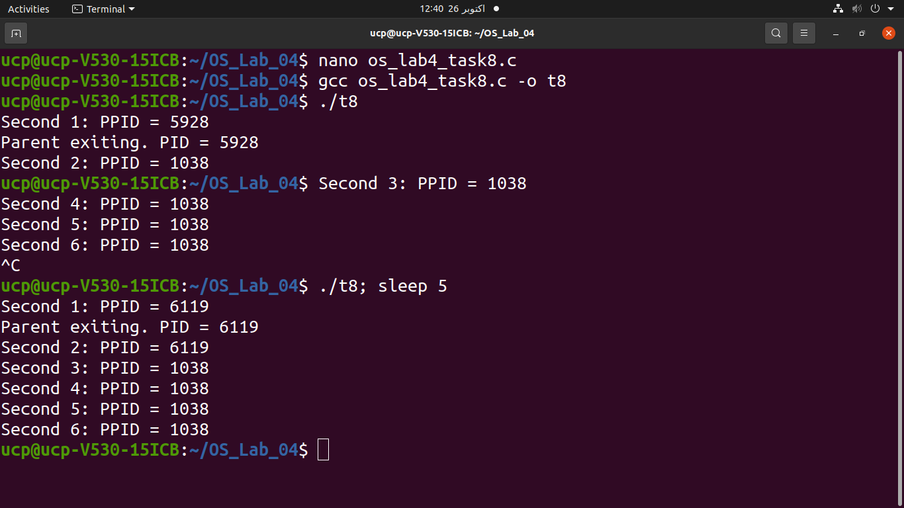
- The parent sleeps for 2 seconds and then exits.
- The child continues running and prints its PPID every second.
- The PPID changes when the original parent exits and the child is adopted by another process.
- The new parent is often PID 1 (init or systemd), but it may be a subreaper process in environments such as containers.

Task 9: Write a C program that uses the fork() system call to create a process tree in the shape of a binary tree with 7 processes, as shown in the given diagram.
Your program must satisfy the following requirements:
- The original process P0 must create two child processes, P1 and P2.
- Process P1 must create two child processes, P3and P4.
- Process P2 must create two child processes, P5 and P6.
- Each process must print its process ID (PID) and parent process ID (PPID).
- Use the fork() system call to establish the required parent-child relationships.
- Use wait() where appropriate to ensure parent processes wait for their children to finish.

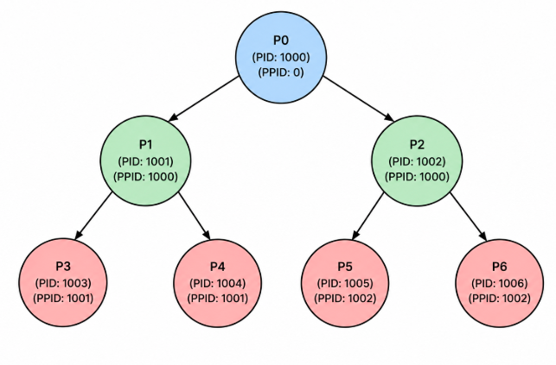
Solution:
#include <stdio.h>
#include <unistd.h>
#include <sys/wait.h>
#include <stdlib.h>

int main() {
pid_t p1, p2, p3, p4, p5, p6;

printf("P0: PID = %d, PPID = %d\n", getpid(), getppid());

p1 = fork();

if (p1 == 0) {
// P1 creates P3 and P4
printf("P1: PID = %d, PPID = %d\n", getpid(), getppid());

p3 = fork();

if (p3 == 0) {
printf("P3: PID = %d, PPID = %d\n", getpid(), getppid());
exit(0);
}

p4 = fork();

if (p4 == 0) {
printf("P4: PID = %d, PPID = %d\n", getpid(), getppid());
exit(0);
}

wait(NULL);
wait(NULL);
exit(0);
}

p2 = fork();

if (p2 == 0) {
// P2 creates P5 and P6
printf("P2: PID = %d, PPID = %d\n", getpid(), getppid());

p5 = fork();

if (p5 == 0) {
printf("P5: PID = %d, PPID = %d\n", getpid(), getppid());
exit(0);
}

p6 = fork();

if (p6 == 0) {
printf("P6: PID = %d, PPID = %d\n", getpid(), getppid());
exit(0);
}

wait(NULL);
wait(NULL);
exit(0);
}

// P0 waits for P1 and P2
wait(NULL);
wait(NULL);

return 0;
}
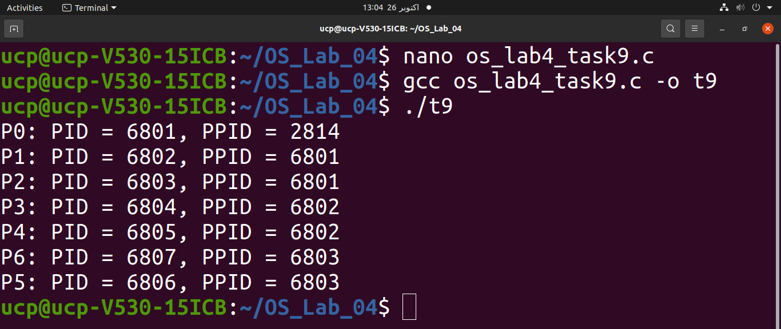
- P0 is the original parent process. It creates two children, P1 and P2, using fork().
- P1 creates two child processes, P3 and P4.
- P2 creates two child processes, P5 and P6.
- getpid() returns the process ID of the current process.
- getppid() returns the parent process ID.
- wait(NULL) makes each parent wait for its children to finish.
- exit(0) terminates child processes so they do not execute code intended for other processes.

