/;”Lab 5: COAL

NAME: Muhammad Salman
ROLL NO: L1F24BSCS0289
SECTION: C-9

Lab-5 Exercise

Task-1
Write a program that declares and initializes an array with 10 elements, then uses a loop to find the sum of those elements and stores the result in a variable named "SUM".
Solution:

.model small
.stack 64

.data
SUM dW ?
ARRAY dW 2, 4, 8, 10, 12, 14, 16, 18, 20, 22

.code

MAIN PROC FAR
MOV AX, @DATA
MOV DS, AX

MOV BX, offset ARRAY
MOV SI, 0

MOV DX, 0

MOV CX, 10

myCode:
ADD DX, [BX+SI]
ADD SI, 2

loop myCode

MOV SUM, DX

MOV AH, 4Ch
INT 21H

MAIN ENDP

.exit

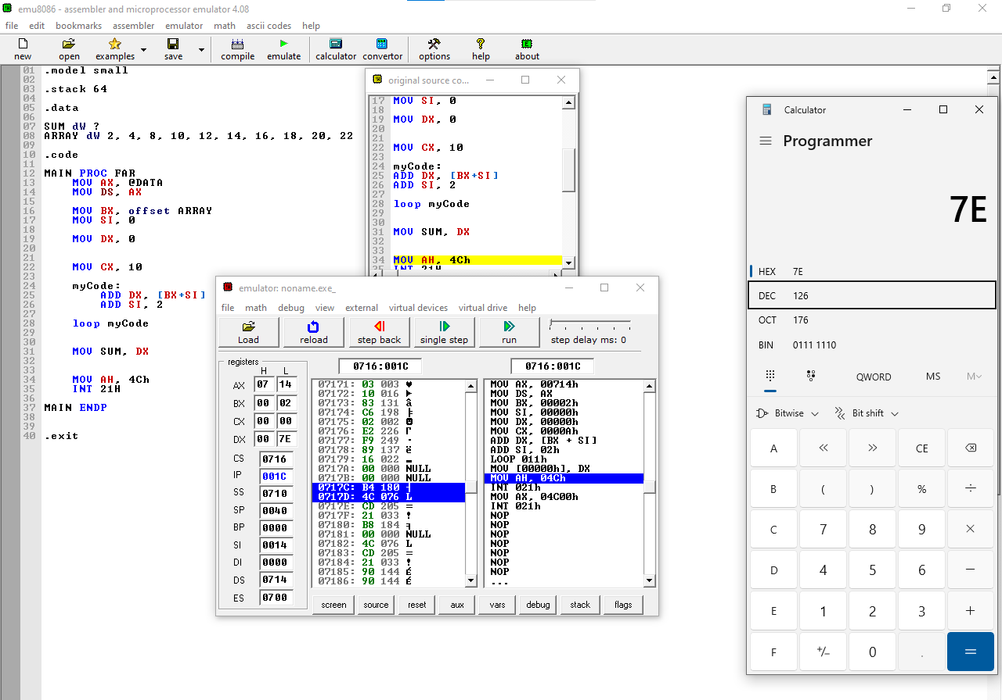

Task-2
Write a program that declares and initializes two word-type arrays: A and B, each of which has 20 elements. The program then adds the corresponding elements of these two arrays and stores the result in the third array: C.

Solution:

.model small
.stack 64

.data
ARRAY1 dW 1, 2, 3, 4, 5, 6, 7, 8, 9, 10, 11, 12, 13, 14, 15, 16, 17, 18, 19, 20
ARRAY2 dW 21, 22, 23, 24, 25, 26, 27, 28, 29, 30, 31, 32, 33, 34, 35, 36, 37, 38, 39, 40
SUM dW 20 DUP(0)

.code
MAIN PROC FAR
MOV AX, @DATA
MOV DS, AX

MOV CX, 20
MOV SI, OFFSET ARRAY1
MOV DI, OFFSET ARRAY2
MOV BX, OFFSET SUM

LOOP_START:
MOV AX, [SI]
ADD AX, [DI]
MOV [BX], AX

ADD SI, 2
ADD DI, 2
ADD BX, 2

LOOP LOOP_START

MOV AH, 4Ch
INT 21H

MAIN ENDP

END MAIN

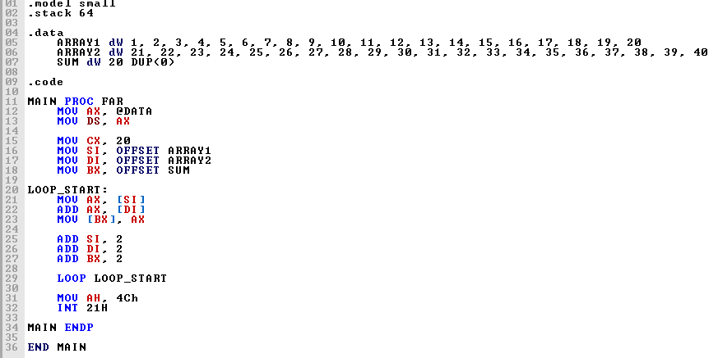

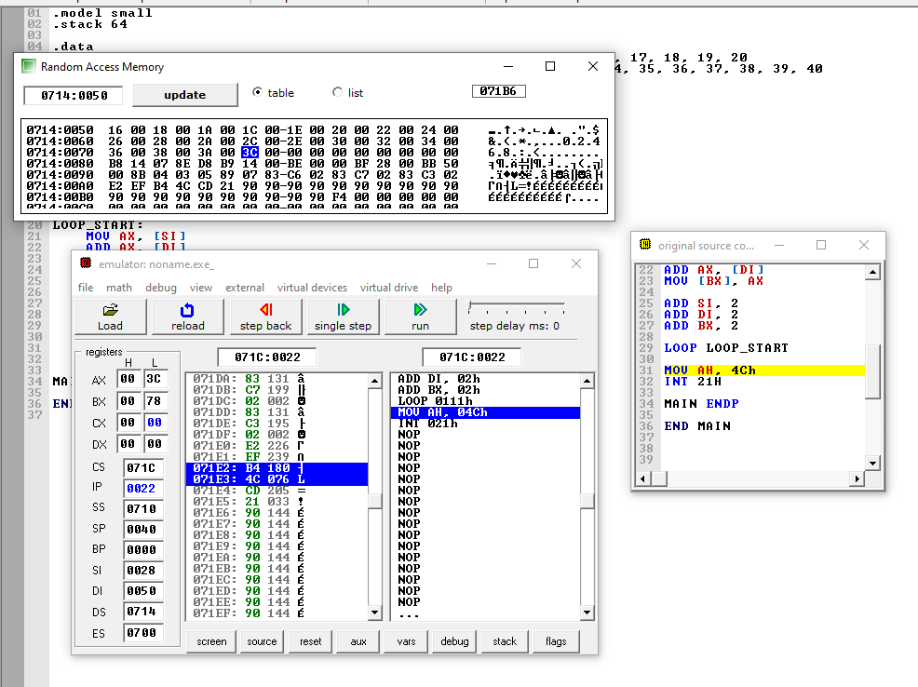
CP
Task 3
Write a program that declares an array of 8 elements and reverses the order of elements in the same array (first element becomes last, second becomes second-last, etc.).

.model small
.stack 64

.data
ARRAY DB 1, 2, 3, 4, 5, 6, 7, 8

.code
MAIN PROC FAR
MOV AX, @data
MOV DS, AX

MOV CX, 4

MOV BX, OFFSET ARRAY

MOV SI, 0
MOV DI, 7

LOOP_START:
MOV AL, [BX+SI]
MOV AH, [BX+DI]

MOV [BX+SI], AH
MOV [BX+DI], AL

INC SI
DEC DI

LOOP LOOP_START

MOV AH, 4Ch
INT 21h
MAIN ENDP
END MAIN

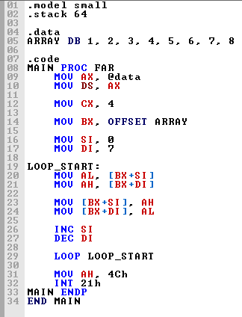

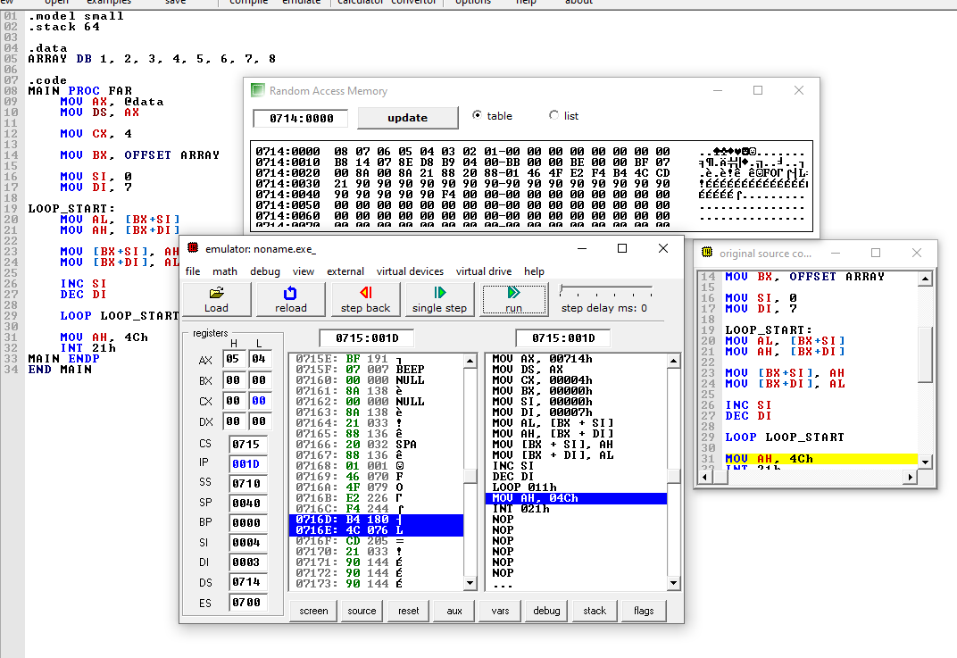

Task 4
Write a program that declares an array of 10 elements and finds the minimum value. Store the result in a variable named "MIN".

.model small
.stack 64

.data
ARRAY DB 5, 2, 3, 4, 1, 9
MIN DB ?
COUNT EQU 6

.code
MAIN PROC FAR
MOV AX, @data
MOV DS, AX

MOV CX, COUNT
MOV BX, OFFSET ARRAY
MOV SI, 0

MOV AL, [BX+SI]
MOV MIN, AL

INC SI
DEC CX

FIND_MIN:
CMP AL, [BX+SI]

JNA NEXT_ELEMENT

MOV AL, [BX+SI]
MOV MIN, AL

NEXT_ELEMENT:
INC SI
LOOP FIND_MIN

MOV AH, 4Ch
INT 21h
MAIN ENDP
END MAIN

