NAME: M. HUSSAIN DURRANI
ROLL NO: L1F24BSCS0937
COAL LAB MID

QUESTION NO 1
.model small
.stack 100h

.data
STRING dB "5 Quick Brown Fox Jumps Over The 3 Lazy Dogs :)$"
NUM_SUM dB 0

A dB 41h
Z dB 5Ah
one dB 31h
nine dB 39h
EMOJI DB 3Ah, 29h

.code
MAIN PROC FAR
MOV AX, @data
MOV DS, AX

MOV DI, offset EMOJI
MOV BX, offset STRING
mov cx, 47
MOV SI, 0

ITERATE:
MOV AL, [BX+SI]

CMP AL, A
JAE A_FORWARD

CMP AL, [DI]
JE EMOJI_CHECK

CMP AL, A
JB CHECK_NUM_SPACE
CMP AL, [DI]
JE EMOJI_CHECK
JMP NEXT

A_FORWARD:
CMP AL, Z
JBE CAPITAL
JMP NEXT

CAPITAL:
; FOR CAPITAL TO SMALL
ADD AL, 20h
JMP NEXT

CHECK_NUM_SPACE:
CMP AL, ONE
JGE ISNUM
JMP NEXT

ISNUM:
CMP AL, NINE
JBE REPLACE_NUM
JMP NEXT

REPLACE_NUM:
ADD NUM_SUM, AL
MOV AL, 20h
JMP NEXT

EMOJI_CHECK:
CMP AL, [DI+1]
JE R_EM_S
JMP NEXT

R_EM_S:
MOV AL, 20h
MOV BYTE PTR [BX+SI], 20h
MOV BYTE PTR [BX+SI+1], 20h
JMP EXIT

NEXT:
MOV BYTE PTR [BX+SI], AL
INC SI
LOOP ITERATE

EXIT:
MOV AH, 4Ch
INT 21h

MAIN ENDP
END MAIN
.exit

OUTPUT:
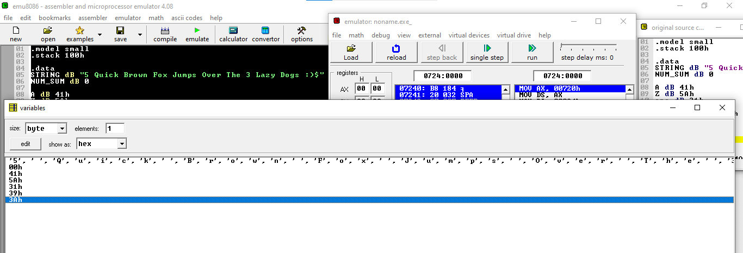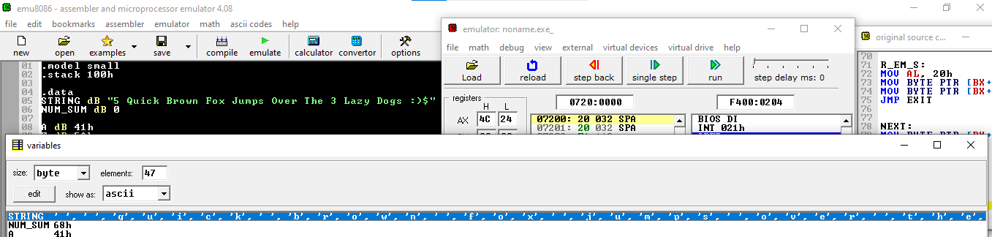

QUESTION NO 2
.model small
.stack 100h

.data
ROLL_NO dW 0, 9, 3, 7
dW 1, 0, 4, 8
dW 2, 1, 5, 9
dW 3, 2, 6, 0

MAIN_DIAG_SUM dW 0
SEC_DIAG_SUM dW 0
DIAG_DIFF dW 0

MAX_ROW dW 0
MAX_ROW_SUM dW 0
MIN_COL dW 0
MIN_COL_SUM dW 0
ROW_COL_DIFF dW 0

.code
MAIN PROC FAR
MOV AX, @data
MOV DS, AX

; PART A:
MOV BX, offset ROLL_NO
MOV SI, 0
; MAIN DIAGONAL
MOV CX, 4
MOV AX, 0
MAIN_DIAG:
ADD AX, [BX+SI]
MOV MAIN_DIAG_SUM, AX
ADD SI, 10
LOOP MAIN_DIAG

; SECODDARY DIAGONAL
MOV SI, 6
MOV CX, 4
MOV AX, 0
SEC_DIAG:
ADD AX, [BX+SI]
MOV SEC_DIAG_SUM, AX
ADD SI, 6
LOOP SEC_DIAG

; ABSOLUTE DIFFERENCE
MOV BX, MAIN_DIAG_SUM
MOV AX, SEC_DIAG_SUM
SUB AX, BX
MOV DIAG_DIFF, AX

; PART B:
; SUM OF MAX ROW
MOV SI, 0
MOV DX, 4
MOV BX, offset ROLL_NO
MOV AX, 0
OUTER:
MOV CX, 4

INNER_LOOP:
ADD AX, [BX+SI]
ADD SI, 2
LOOP INNER_LOOP

CMP AX, MAX_ROW_SUM
JA CHANGE_MAX
NEXT:
DEC DX
JNZ OUTER
JMP FORWARD

CHANGE_MAX:
MOV MAX_ROW_SUM, AX
MOV DI, 4
SUB DI, DX
MOV DX, DI
MOV MAX_ROW, DX
JMP NEXT

FORWARD:
; SUM OF MIN COL
MOV SI, 0
MOV DX, 4
MOV BX, offset ROLL_NO
MOV AX, 0

COL_LOOP:
ADD AX, [BX+SI]
ADD SI, 8
LOOP COL_LOOP

CMP AX, MIN_COL_SUM
JB CHANGE_MIN
NEXT:
DEC DX
JNZ FORWARD
JMP AGAY

CHANGE_MIM:
MOV MIN_COL_SUM, AX
JMP NEXT

AGAY:
; DIFFERENCE BETWEEN MAX_ROW_SUM AND MIN_COL_SUM
MOV AX, 0
MOV DX, 0
MOV AX, MAX_ROW_SUM
MOV DX, MIN_COL_SUM
SUB AX, DX
MOV AX, ROW_COL_DIFF

; PART C:
mov bx, offset ROLL_NO

mov cx, 4
row_loop:
mov row_count, cx

mov cx, 4
col_loop:
mov al, [BX]
mov [di], al

inc BX
add di, 3
loop col_loop

mov cx, row_count
add bx, 1
sub di, 11
loop row_loop

EXIT:
MOV AH, 4Ch
INT 21h

MAIN ENDP
END MAIN
.exit

