COAL – LAB 4
NAME: M. Hussain Durrani
ROLL NO: L1F24BSCS0937
SECTION: C-9

Lab-4 Exercise

Task-1
Write a program that stores the given two 32-bit numbers into the current data segment at offset: 0x1000 and 0x1008, respectively. The program then calculates the sum of these numbers and stores it at the offset: 0x1010.
Numbers: 0x1F540398, 0xC0A1F02E

CODE & OUTPUT:

.model small
.data
.code
MAIN PROC FAR
MOV AX, 1000h
MOV DS, AX
MOV SI, 0
MOV BX, 1000h
mov word ptr [BX + SI], 0398h ; low word
ADD SI, 2
mov word ptr [BX + SI], 1F54h ; high word
MOV BX, 1008h
MOV SI, 0
mov word ptr [BX + SI], 0F02Eh ; low word
ADD SI, 2
mov word ptr [BX + SI], 0C0A1h ; high word
mov AX, word ptr [1000h]
add AX, word ptr [1008h]
mov word ptr [1010h], AX ; result low
mov AX, word ptr [1002h]
adc AX, word ptr [100Ah]
mov word ptr [1012h], AX ; result high
mov AH, 4Ch
int 21h
MAIN ENDP
.exit

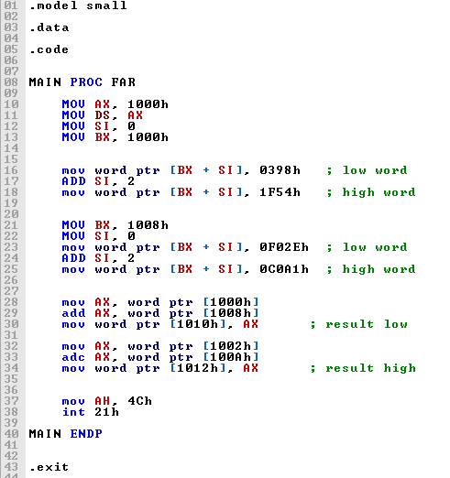

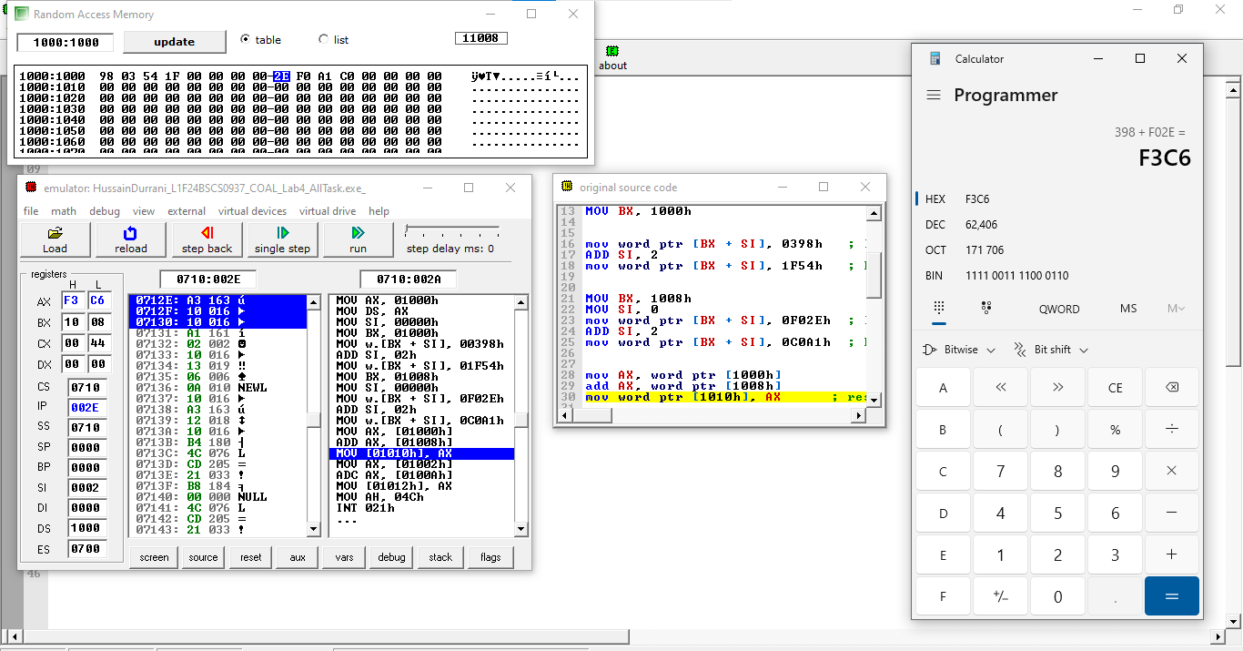

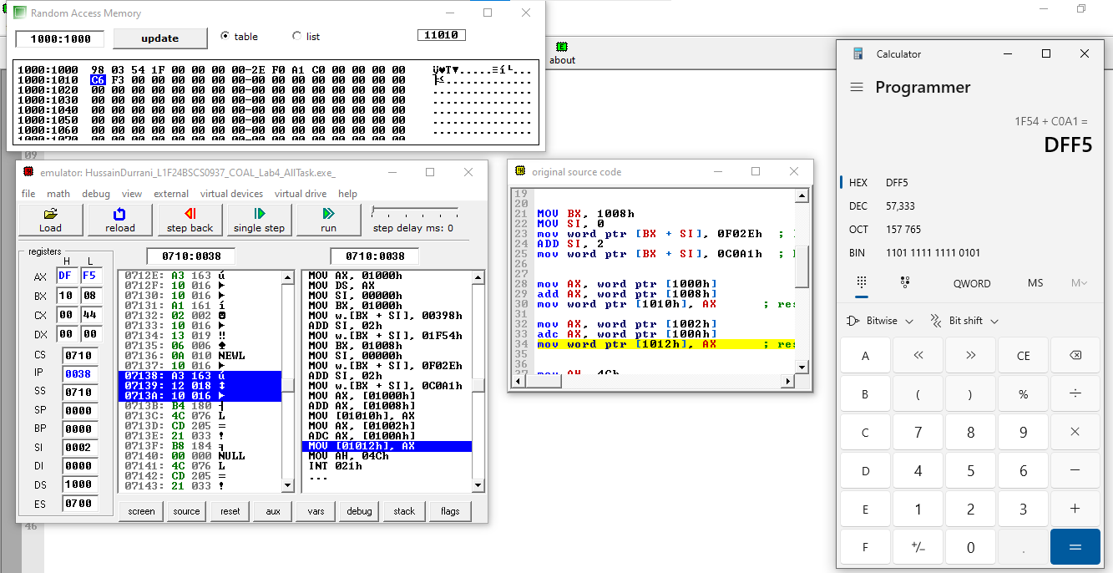

Task-2

Write a program to implement the following equation.

X = ~0xFF12 ^ {0xABFF & (0x2113 | 0x2340)}

~ | Invert all bits
^ | Bitwise XOR
& | Bitwise AND
| | Bitwise OR

CODE & OUTPUT:
; Task 2:
.model small
.data
RESULT dw 0
.code
MAIN PROC FAR
MOV AX, 0FF12h
NOT AX
MOV BX, AX
MOV AX, 02113h
OR AX, 02340h ; AX = 0x2113 | 0x2340
AND AX, 0ABFFh ; AX = 0xABFF & AX
XOR AX, BX ; X = (~0xFF12) ^ (0xABFF & (0x2113|0x2340))
MOV RESULT, AX
MOV AH, 4Ch
INT 21h
MAIN ENDP
END MAIN

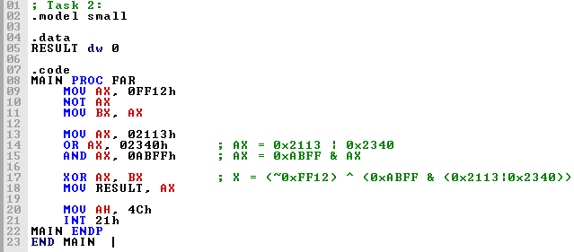

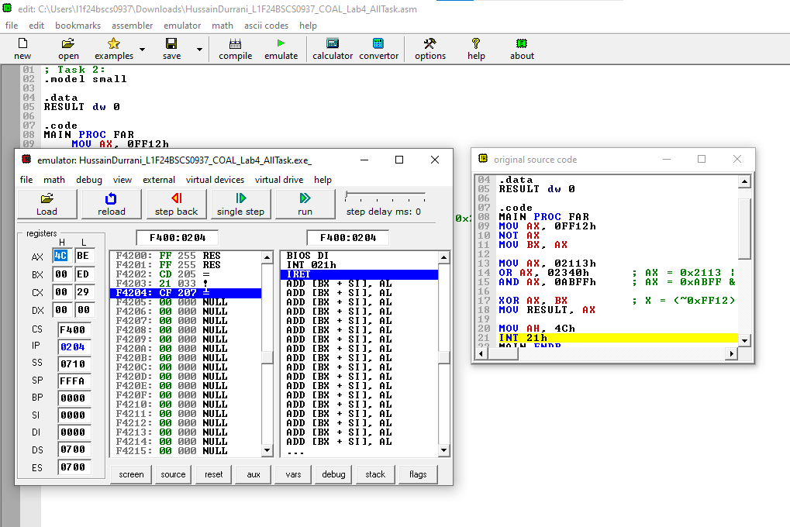

Task-3
Perform any ALU operation that sets CF and OF at the same time.

CODE & OUTPUT:

; Task 3:
.model small
.data
.code
MAIN PROC FAR

MOV AX, 8000h
ADD AX, 8000h ; CF and OF both will be set

MOV AH, 4Ch
INT 21h
MAIN ENDP
END MAIN

