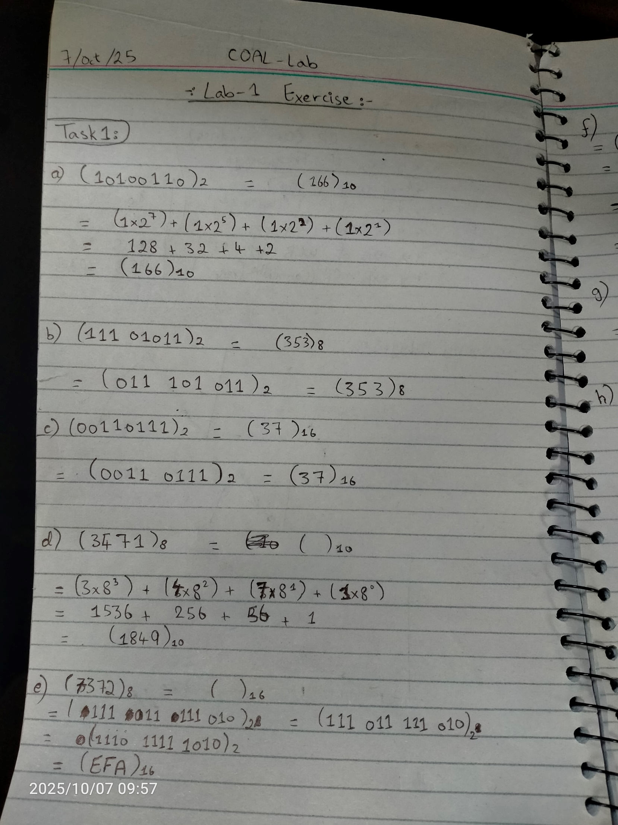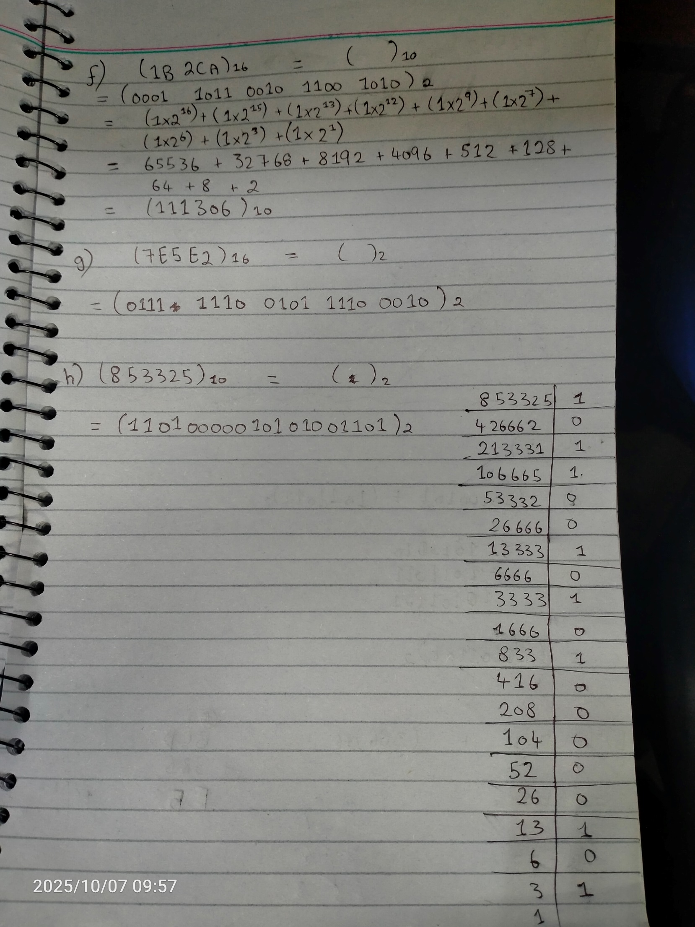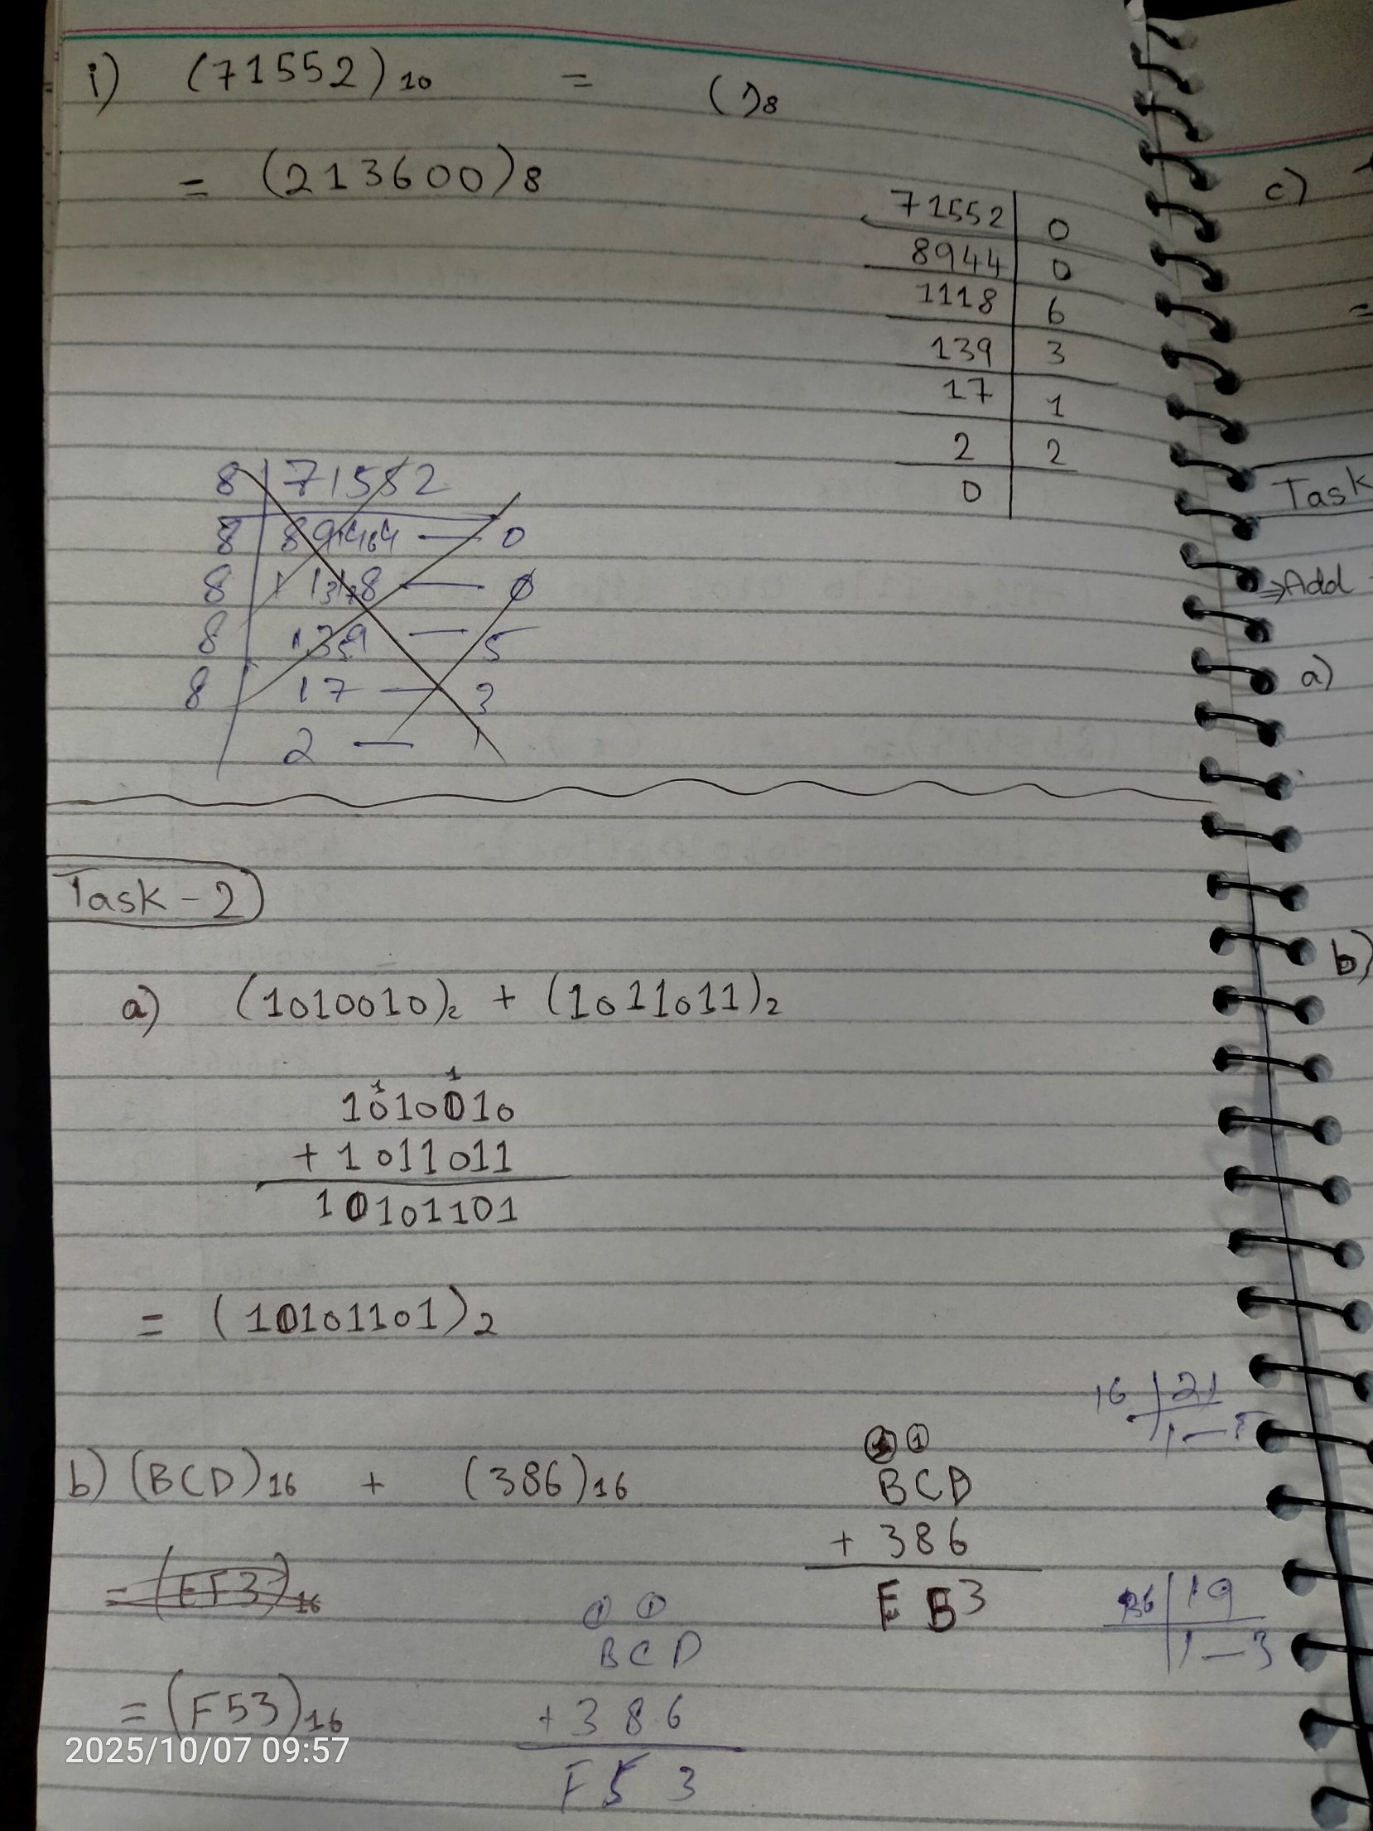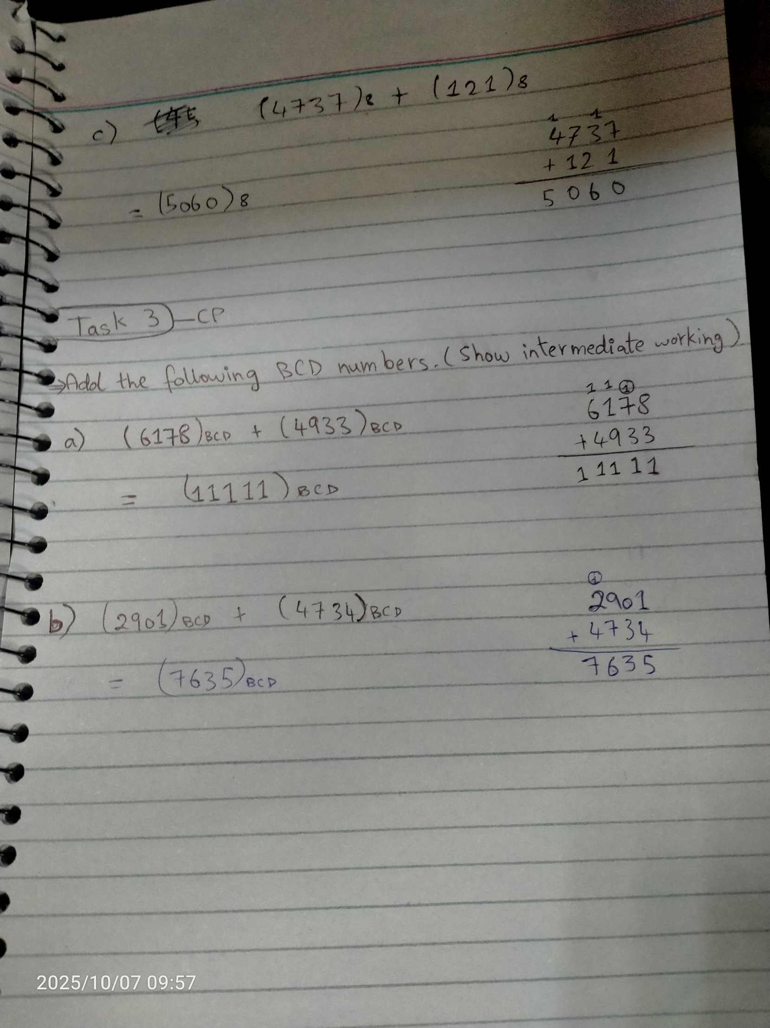

Lab-1 Exercise

Task-1
Convert the basis of the following numbers. Use direct method where applicable.

a) (10100110)2 | = (166 | )10
b) (11101011)2 | = (353 | )8
c) (00110111)2 | = (37 | )16
d) (3471)8 | = (1849 | )10
e) (7372)8 | = (EFA | )16
f) (1B2CA)16 | = (111306 | )10
g) (7E5E2)16 | = (0111 1110 0101 1110 0010 | )2
h) (853325)10 | = (11010000010101001101 | )2
i) (71552)10 | = (213600 | )8

Task-2
Perform the following arithmetic operations on numbers.
- (1010010)2 + (1011011)2 = (${10101101)}_{2}$
- (BCD)16 + (386)16 = (${F53)}_{16}$
- (4737)8 + (121)8 = ${(5060)}_{8}$

Task-3 CP
Add the following BCD numbers. (Show intermediate working.)
- (6178)BCD + (4933)BCD = (11111)BCD
- (2901)BCD + (4734)BCD = (7635)BCD

