Lab-3 Exercise

Name: M. Hussain Durrani

Roll No: L1F24BSCS0937

Section: C-9

Task-1
Write a program that stores the following numbers into the current data segment at offset: 0x1000 onwards. The program then calculates the sum of these numbers and stores it in the DX register, then stores the value of DX at the physical location: 0xCD1F3.
Numbers: 0x1F01, 0xA0EF, 0x7704, 0x34B0, 0x2250

SOLUTION:
; Task-1
.model small
.code
start:
mov di, 0x1000

mov word ptr [di], 0x1F01
add di, 2
mov word ptr [di], 0xA0EF
add di, 2
mov word ptr [di], 0x7704
add di, 2
mov word ptr [di], 0x34B0
add di, 2
mov word ptr [di], 0x2250

xor ax, ax
xor bx, bx
clc

mov dx, word ptr [0x1000]
add ax, dx
adc bx, 0

mov dx, word ptr [0x1002]
add ax, dx
adc bx, 0

mov dx, word ptr [0x1004]
add ax, dx
adc bx, 0

mov dx, word ptr [0x1006]
add ax, dx
adc bx, 0

mov dx, word ptr [0x1008]
add ax, dx
adc bx, 0

mov dx, ax

mov ax, 0xCD1F
mov es, ax
mov word ptr es:[0x0003], dx

hlt
end start

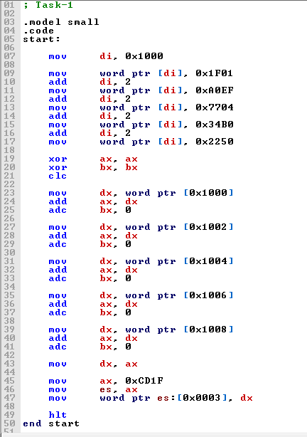

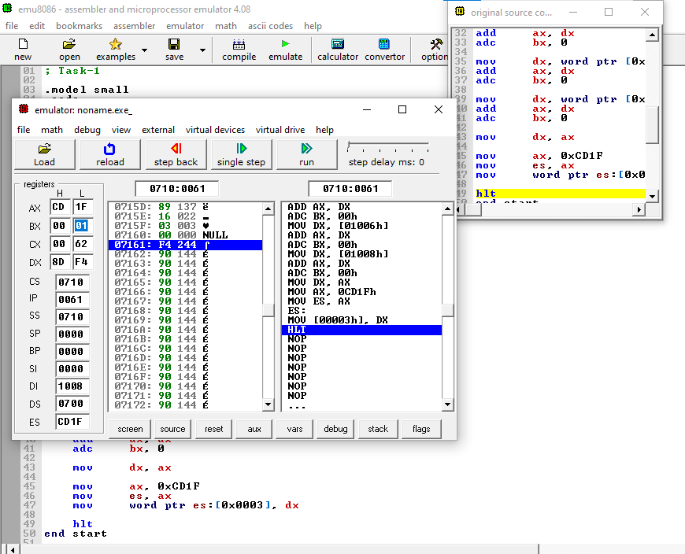

Task-2
The "HLT" has a machine code of "0xF4".
Insert this instruction before the first instruction of your program implemented in Task-1.
SOLUTION:
.model small
.stack 100h
.data
.code
main proc
hlt

mov ax, @data
mov ds, ax

mov word ptr [1000h], 1F01h
mov word ptr [1002h], A0EFh
mov word ptr [1004h], 7704h
mov word ptr [1006h], 34B0h
mov word ptr [1008h], 2250h

xor ax, ax
xor bx, bx

mov dx, [1000h]
add ax, dx
adc bx, 0

mov dx, [1002h]
add ax, dx
adc bx, 0

mov dx, [1004h]
add ax, dx
adc bx, 0

mov dx, [1006h]
add ax, dx
adc bx, 0

mov dx, [1008h]
add ax, dx
adc bx, 0

mov dx, ax

mov ax, 0CD1Fh
mov es, ax
mov word ptr es:[0003h], dx

hlt
main endp
end main

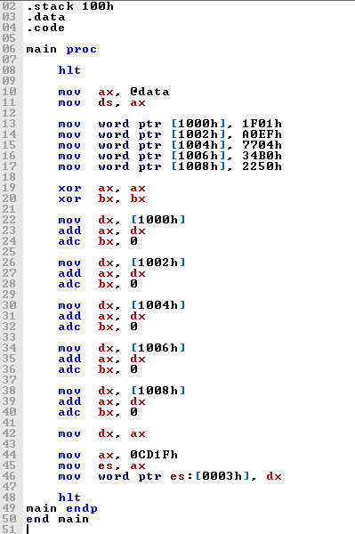
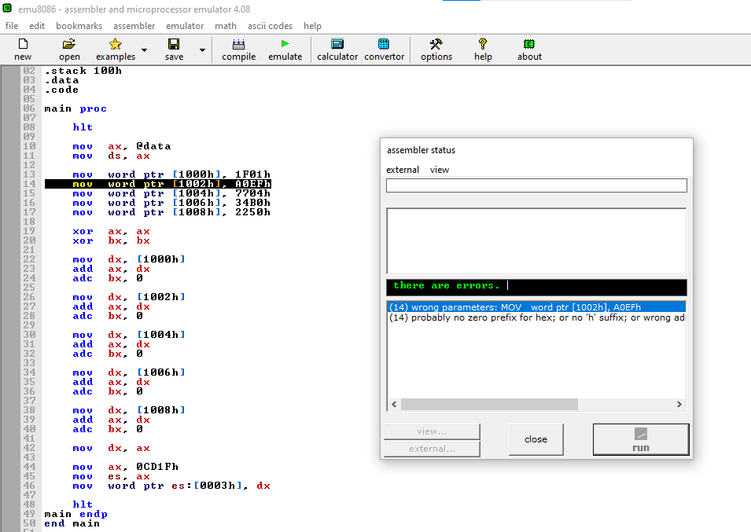

Task-3 CP
Assume that the registers have the following values (all in hex) and that CS = 1000, DS = 2000, SS = 3000, SI = 4000, DI = 5000, BX = 6080, BP = 7000, AX = 25FF, CX = 8791, and DX = 1299. Calculate the physical address of the memory.

- MOV [SI], AL | - MOV [BX] + 30, DX
- MOV [SI + BX + 8], AH | - MOV [BP] + 200, AX
- MOV [BX], AX | - MOV [BP + SI + 100], BX
- MOV [DI + 6], BX | - MOV [SI]+50, AH
- MOV [DI][BX] + 28, CX | - MOV [DI + BP + l00], AX

SOLVED IMAGES:

