
NAME: M. Hussain Durrani
ROLL NO: L1F24BSCS0937
SECTION: C-9
Submitted To: Ma’am Hina Tahir
COAL
ASSIGNMENT 2
Question#1:
Write a program that sums all the numbers between N and M and stores the sum in DX register. N and M are stored in BL and BH registers, respectively. (N and M will be included in the sum.)
CODE:
.model small
.stack 64

.data
N dB 1
M dB 9
SUM dW ?

.code
MAIN PROC FAR
MOV AX, @DATA
MOV DS, AX

MOV BL, N
MOV BH, M
MOV CX, 0
ADD CL, BL

MOV DX, 0

KEEP_ADDING:
ADD DX, CX
INC CX

CMP CL, BH
JBE KEEP_ADDING ;If BL <= 9

MOV SUM, DX

MAIN ENDP
.exit

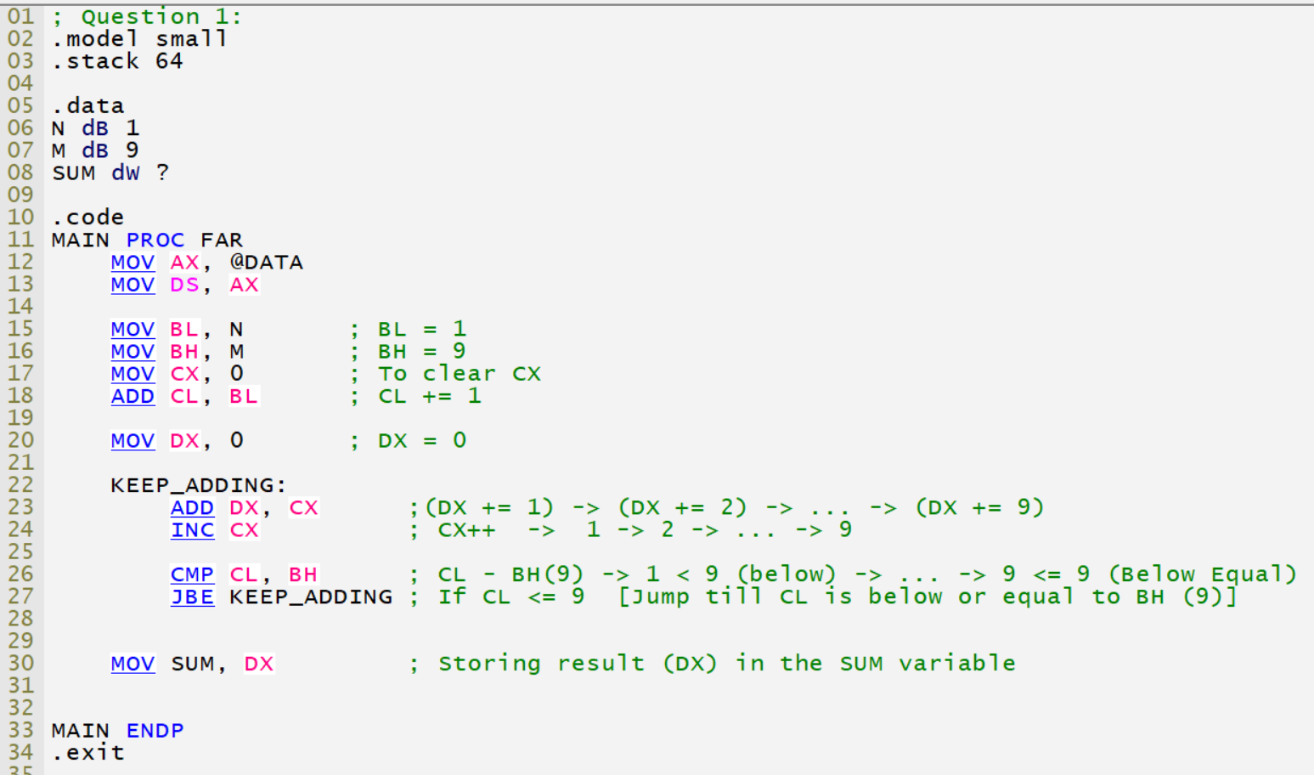

OUTPUT:
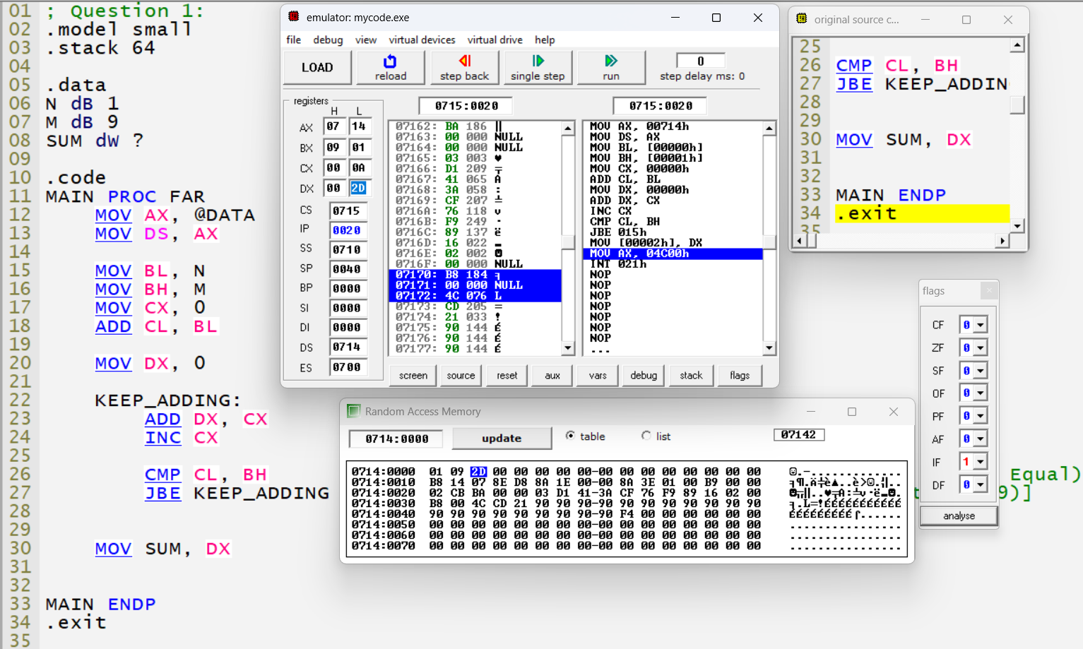

Question#2:
Write a program that copies all the numbers from address 0xA1AFF to address 0xA1B1F to a byte array. The array must be declared with the exact size of the data to be stored in it.
CODE:
.model small
.stack 0x100

.data
array db 33 dup(?) ; A1B1Fh - A1AFFh = 20h -> +1 = 21h = 33d -> 33 bytes total to store

.code
MAIN PROC FAR
mov ax, @data
mov ds, ax

mov ax, 0A1AFh
mov es, ax
mov si, 000Fh
mov di, si
mov cx, 33

FillMemory:
mov byte ptr es:[di], 3h
inc di
loop FillMemory

mov si, 000Fh
mov di, offset array
mov cx, 33

ReadMemory:
mov al, es:[si]
mov [di], al
inc si
inc di
loop ReadMemory

mov ah, 4Ch
int 21h
MAIN ENDP
END MAIN
.exit
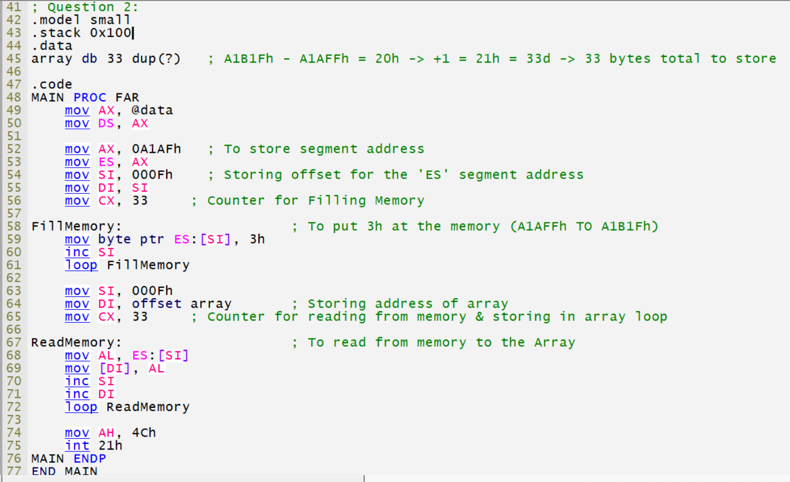
OUTPUT:
