COAL
NAME: MUHAMMAD HUSSAIN DURRANI
ROLL NO: L1F24BSCS0937
Assignment#3
Due date: 25-12-2025
Problem Statement #1
CODE:
; Problem Statement #1
; Calculator
.model small
.stack 100h
.data
SUM_NUM1 db ?
SUM_NUM2 db ?

DIFF_NUM1 db ?
DIFF_NUM2 db ?

PROD_NUM1 db ?
PROD_NUM2 db ?

DIV_NUM1 db ?
DIV_NUM2 db ?

;--- RESULT VARIABLES ---
SUM db ?
DIFF db ?
PROD db ?
QUOT db ?
REM db ?

;--- STRINGS ---
msgNum1 db 'Enter NUM1: $'
msgNum2 db 'Enter NUM2: $'
NEWLINE db 0Ah, 0Dh, '$'

msgSUM db '--- For Addition ---$'
msgDIFF db '--- For Subtraction ---$'
msgPROD db '--- For Multiplication ---$'
msgDIV db '--- For Division ---$'

msgResult db 0Ah, 0Dh, 'Result: $'
msgRemainder db ' Remainder: $'

.code
MAIN PROC FAR
MOV AX, @data
MOV DS, AX

;================================================
; 1. ADDITION
;================================================
MOV DX, OFFSET msgSUM
PUSH DX
LEA AX, SUM_NUM1
PUSH AX
LEA AX, SUM_NUM2
PUSH AX
CALL INPUT_PROC

XOR AX, AX
XOR DX, DX
MOV AL, SUM_NUM1
MOV DL, SUM_NUM2
PUSH AX
PUSH DX
CALL ADD_Proc

LEA DX, msgResult
MOV AH, 09h
INT 21h

XOR AX, AX
MOV AL, SUM
PUSH AX
CALL PRINT_PROC

;================================================
; 2. SUBTRACTION
;================================================
MOV DX, OFFSET msgDIFF
PUSH DX
LEA AX, DIFF_NUM1
PUSH AX
LEA AX, DIFF_NUM2
PUSH AX
CALL INPUT_PROC

XOR AX, AX
XOR DX, DX
MOV AL, DIFF_NUM1
MOV DL, DIFF_NUM2
PUSH AX
PUSH DX
CALL SUB_Proc

LEA DX, msgResult
MOV AH, 09h
INT 21h

XOR AX, AX
MOV AL, DIFF
PUSH AX
CALL PRINT_PROC

;================================================
; 3. MULTIPLICATION
;================================================
MOV DX, OFFSET msgPROD
PUSH DX
LEA AX, PROD_NUM1
PUSH AX
LEA AX, PROD_NUM2
PUSH AX
CALL INPUT_PROC

XOR AX, AX
XOR DX, DX
MOV AL, PROD_NUM1
MOV DL, PROD_NUM2
PUSH AX
PUSH DX
CALL MUL_Proc

LEA DX, msgResult
MOV AH, 09h
INT 21h

XOR AX, AX
MOV AL, PROD
PUSH AX
CALL PRINT_PROC

;================================================
; 4. DIVISION
;================================================
MOV DX, OFFSET msgDIV
PUSH DX
LEA AX, DIV_NUM1
PUSH AX
LEA AX, DIV_NUM2
PUSH AX
CALL INPUT_PROC

XOR AX, AX
XOR DX, DX
MOV AL, DIV_NUM1
MOV DL, DIV_NUM2
PUSH AX
PUSH DX
CALL DIV_Proc

LEA DX, msgResult
MOV AH, 09h
INT 21h

XOR AX, AX
MOV AL, QUOT
PUSH AX
CALL PRINT_PROC

LEA DX, msgRemainder
MOV AH, 09h
INT 21h

XOR AX, AX
MOV AL, REM
PUSH AX
CALL PRINT_PROC

LEA DX, NEWLINE
MOV AH, 09h
INT 21h

JMP endCode
MAIN ENDP

;====================================================
; INPUT PROCEDURE
;====================================================
INPUT_PROC PROC
PUSH BP
MOV BP, SP

LEA DX, NEWLINE
MOV AH, 09h
INT 21h

MOV DX, [BP+8]
MOV AH, 09h
INT 21h

LEA DX, NEWLINE
MOV AH, 09h
INT 21h

; --- INPUT 1 ---
LEA DX, msgNum1
MOV AH, 09h
INT 21h

CALL SCAN_NUM ; To take multiple digit Number as input

MOV BX, [BP+6] ; Load address of Var1
MOV [BX], AL ; Save result (AL) into Var1

LEA DX, NEWLINE
MOV AH, 09h
INT 21h

; --- INPUT 2 ---
LEA DX, msgNum2
MOV AH, 09h
INT 21h

CALL SCAN_NUM ; To take multiple digit Number as input

MOV BX, [BP+4] ; Load address of Var2
MOV [BX], AL ; Save result (AL) into Var2

LEA DX, NEWLINE
MOV AH, 09h
INT 21h

POP BP
RET 6
INPUT_PROC ENDP

;========================================================
; HELPER PROCEDURE TO TAKW MULTIPLE DIGIT NUMBER AS IMPUT
;========================================================
SCAN_NUM PROC
PUSH BX
PUSH CX
PUSH DX

XOR BX, BX ; BX holds the running total (Initialize to 0)

NEXT_DIGIT:
MOV AH, 01h ; To take 1 digit in Input
INT 21h

CMP AL, 0Dh ; Check if Enter key (Carriage Return) is pressed
JE END_SCAN ; If Enter, stop reading

SUB AL, 30h ; Convert ASCII to Integer
MOV AH, 0 ; Clear AH, so AX is just the digit
MOV CX, AX ; Save the digit in CX temporarily

MOV AX, 10 ; Prepare to multiply by 10
MUL BX ; AX = Total * 10
ADD AX, CX ; AX = (Total * 10) + New Digit
MOV BX, AX ; Update the Total in BX

JMP NEXT_DIGIT ; Go back for next char

END_SCAN:
MOV AX, BX ; Move final result to AX (Output is in AL)

POP DX
POP CX
POP BX
RET
SCAN_NUM ENDP

;====================================================
; PRINT PROCEDURE
;====================================================
PRINT_PROC PROC
PUSH BP
MOV BP, SP

MOV AX, [BP+4]
MOV CX, 0
MOV BX, 10

CMP AX, 0
JNE DIGIT_LOOP
MOV DL, '0'
MOV AH, 02h
INT 21h
JMP PRINT_EXIT

DIGIT_LOOP:
XOR DX, DX
DIV BX
PUSH DX
INC CX
CMP AX, 0
JNE DIGIT_LOOP

PRINT_LOOP:
POP DX
ADD DL, 30h
MOV AH, 02h
INT 21h
LOOP PRINT_LOOP

PRINT_EXIT:
POP BP
RET 2
PRINT_PROC ENDP

;====================================================
; MATH PROCEDURES
;====================================================
ADD_Proc PROC
PUSH BP
MOV BP, SP
MOV AX, [BP+6]
MOV DX, [BP+4]
XOR BX, BX
ADD BX, DX
ADD BX, AX
MOV SUM, BL
POP BP
RET 4
ADD_Proc ENDP

SUB_Proc PROC
PUSH BP
MOV BP, SP
MOV AX, [BP+6]
MOV DX, [BP+4]
XOR BX, BX
MOV BX, AX
SUB BX, DX
MOV DIFF, BL
POP BP
RET 4
SUB_Proc ENDP

MUL_Proc PROC
PUSH BP
MOV BP, SP
MOV AX, [BP+6]
MOV DX, [BP+4]
MOV CX, AX
MUL DX
MOV BX, AX
MOV AX, CX
MOV PROD, BL
POP BP
RET 4
MUL_Proc ENDP

DIV_Proc PROC
PUSH BP
MOV BP, SP
MOV AX, [BP+6]
MOV DX, [BP+4]
XOR AH, AH
DIV DL
MOV QUOT, AL
MOV REM, AH
POP BP
RET 4
DIV_Proc ENDP

endCode:
MOV AH, 4Ch
INT 21h
END MAIN

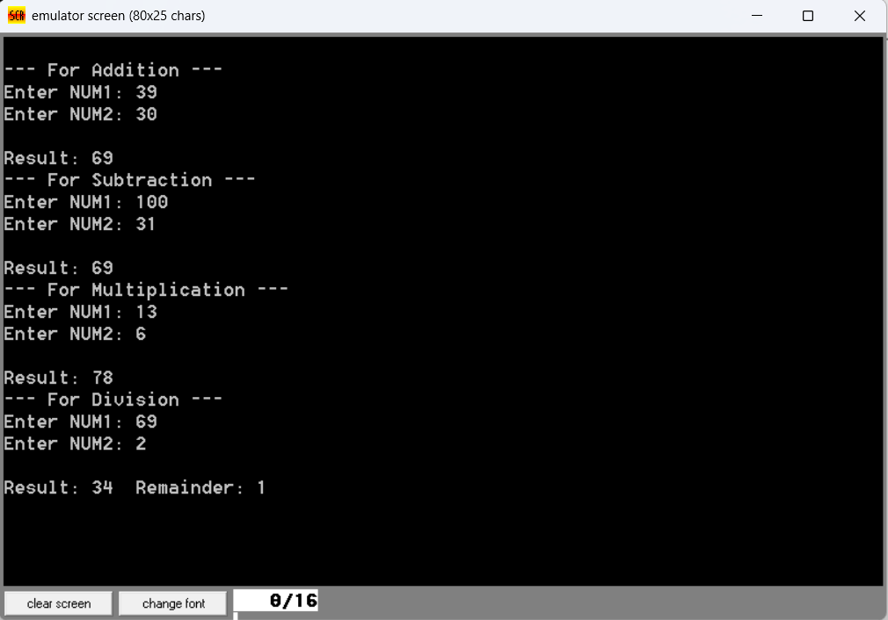
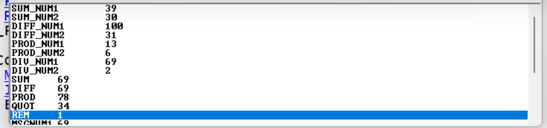
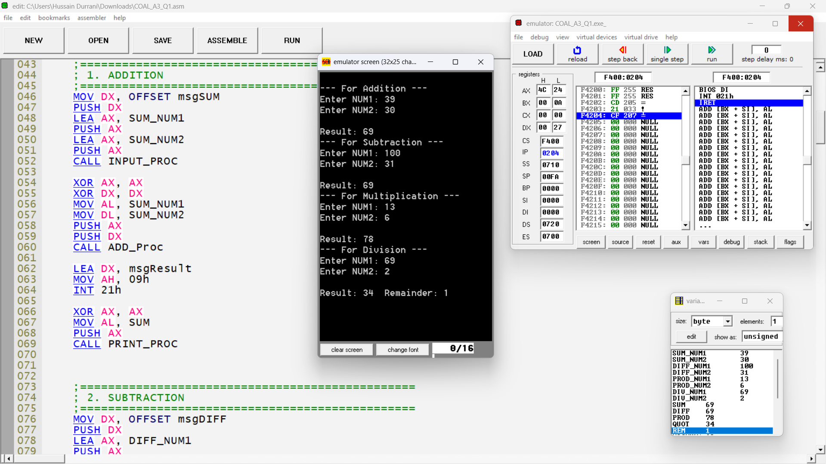

Problem Statement #2
CODE:
;================= PROBLEM STATEMENT #2 =================
; Hook INT 55h with services:
; 01h -> Take (x,y) from user, set cursor, print '*'
; 02h -> Beep until 'S' is pressed
; 06h -> Display Hello, scroll, display message
;=======================================================
.model small
.stack 100h

.data
msgX db 'Enter X-Coordinate (0-79): $'
msgY db 0Dh,0Ah,'Enter Y-Coordinate (0-24): $'
msgStop db "Press 'S' to stop beep: $"
msg1 db 'Hello$'
msg2 db 'Have a good day!$'

StarStr db '*', '$'

.code
MAIN PROC FAR
MOV AX, @data
MOV DS, AX

;---------- Hook INT 55h ---------------
MOV AX, 0
MOV ES, AX

MOV WORD PTR ES:[55h*4], OFFSET ISR55
MOV WORD PTR ES:[55h*4+2], CS
;---------------------------------------

; Service 01h: Set cursor and display '*'
MOV AH,01h
INT 55h

; Service 02h: Beep until 'S' is pressed
MOV AH,02h
INT 55h

; Service 06h: Display msg1, move cursor 2 lines, display msg2
MOV AH,06h
INT 55h

JMP EXIT
MAIN ENDP

;=======================================================
; INTERRUPT SERVICE ROUTINE FOR INT 55h
;=======================================================
ISR55 PROC FAR

CMP AH,01h
JE SERVICE_SetCursor

CMP AH,02h
JE SERVICE_BEEP

CMP AH,06h
JE SERVICE_DISPLAY

IRET

;---------------- SERVICE 01h ----------------
SERVICE_SetCursor:
; Print msgX (ask for X-coordinate):
MOV AH,09h
MOV DX,OFFSET msgX
INT 21h

; Take X-Coordinate in Input (more than 1 digit)
CALL SCAN_NUM
MOV SI, AX ; SI = X

; Print msgY (ask for Y-coordinate):
MOV AH,09h
LEA DX, msgY
INT 21h

; Take Y-Coordinate in Input (more than 1 digit)
CALL SCAN_NUM
MOV DI, AX ; DI = Y

; Clear Screen
MOV AX,0600h
MOV BH,07
MOV CX,0000
MOV DX,184Fh
INT 10h

; 4. Set Cursor Position (X,Y)
MOV AH,02h
MOV BH,00
MOV CX, SI
MOV DL, CL
MOV CX, DI
MOV DH, CL
INT 10h

; Print Star
MOV AH, 09h
LEA DX, StarStr
INT 21h

; DELAY LOOP
MOV CX, 01FFh
DELAY:
LOOP DELAY

; Clear screen again
MOV AX,0600h
MOV BH,07
MOV CX,0000
MOV DX,184Fh
INT 10h

; Reset Cursor to (0,0)
MOV AH,02h
MOV BH,00
MOV DH,0
MOV DL,0
INT 10h

IRET

;---------------- SERVICE 02h ----------------
SERVICE_BEEP:
; Display message to tell user to press 'S' to stop beep
MOV AH,09h
LEA DX, msgStop
INT 21h

BEEP_LOOP:
; Generate beep sound
MOV AH,02h
MOV DL,07
INT 21h

; Check if a key has been pressed
MOV AH,01h
INT 16h
JZ BEEP_LOOP ; repeat beep if no key

; Read pressed key
MOV AH,00h
INT 16h
CMP AL,'S' ; compare with 'S'
JE STOP_BEEP
JMP BEEP_LOOP ; continue beep until 'S' pressed

STOP_BEEP:
IRET

;---------------- SERVICE 06h ----------------
SERVICE_DISPLAY:
; Clear the screen
MOV AX,0600h
MOV BH,07
MOV CX,0000
MOV DX,184Fh
INT 10h

; Set cursor at start (0,0)
MOV AH,02h
MOV BH,00
MOV DH,0
MOV DL,0
INT 10h

; Display first message ("Hello")
MOV AH,09h
MOV DX,OFFSET msg1
INT 21h

; Move cursor two lines below (row 2, column 0)
MOV AH,02h
MOV BH,00
MOV DH,2
MOV DL,0
INT 10h

; Display second message ("Have a good day!")
MOV AH,09h
MOV DX,OFFSET msg2
INT 21h

IRET

ISR55 ENDP

;=======================================================
; HELPER PROCEDURE: SCAN_NUM
;=======================================================
SCAN_NUM PROC
PUSH BX
PUSH CX
PUSH DX

XOR BX, BX

NEXT_KEY:
MOV AH, 01h
INT 21h

CMP AL, 0Dh ; Check for Enter
JE FINISH_INPUT

SUB AL, 30h
MOV AH, 0
MOV CX, AX

MOV AX, 10
MUL BX
ADD AX, CX
MOV BX, AX

JMP NEXT_KEY

FINISH_INPUT:
MOV AX, BX
POP DX
POP CX
POP BX
RET
SCAN_NUM ENDP

EXIT:
MOV AH,4Ch
INT 21h
END MAIN

