University of Central Punjab
Faculty of Information Technology
Object Oriented Programming
Fall 2025

Lab 02
Topic
Functions
Pass-by-Value, Pass-by-Reference
Function Overloading, Default Arguments
* Dynamic Memory Allocation, Dangling Pointers, and Memory Leakage

Objective
The basic purpose of this lab is to revise some preliminary concepts of C++ that has been covered in the course of Introduction to Computing and Programming Fundamentals.
Its objective is to recall previously learned basic concepts like revision of arrays and functions
CLO
Apply object-oriented programming principles to implement real-world problems.

Instructions:
• Indent your code.
• Comment your code.
• Use meaningful variable names.
• Plan your code carefully on a piece of paper before you implement it.
• Name of the program should be same as the task name. i.e. the first program should be Task_1.cpp
• void main() is not allowed. Use int main()
• You are not allowed to use any built-in functions
• You are required to follow the naming conventions as follow:
• Variables: firstName; (no underscores allowed)
• Function: getName(); (no underscores allowed)
• ClassName: BankAccount (no underscores allowed)

Students are required to complete the following tasks in lab timings.

Task 1:
Write a C++ function to swap two integers. Implement this function in two ways:
• One using pass-by-value
• One using pass-by-reference

void swapByValue(int a, int b);
void swapByReference(int &a, int &b);

In main function, demonstrate each version of the ‘Swap function and print the results.

CODE:
// Task 1:
#include <iostream>
using namespace std;

void swapByValue(int a, int b) {
int temp = a;
a = b;
b = temp;
}

void swapByReference(int& a, int& b) {
int temp = a;
a = b;
b = temp;
}

int main() {

int a = 6, b = 9;

cout << "a = " << a << " , b = " << b << endl;
cout << "After Swap by Value..." << endl;
swapByValue(a, b);

cout << "a = " << a << " , b = " << b << endl;

cout << "After Swap by Reference..." << endl;
swapByReference(a, b);
cout << "a = " << a << " , b = " << b << endl;

return 0;
}

OUTPUT:
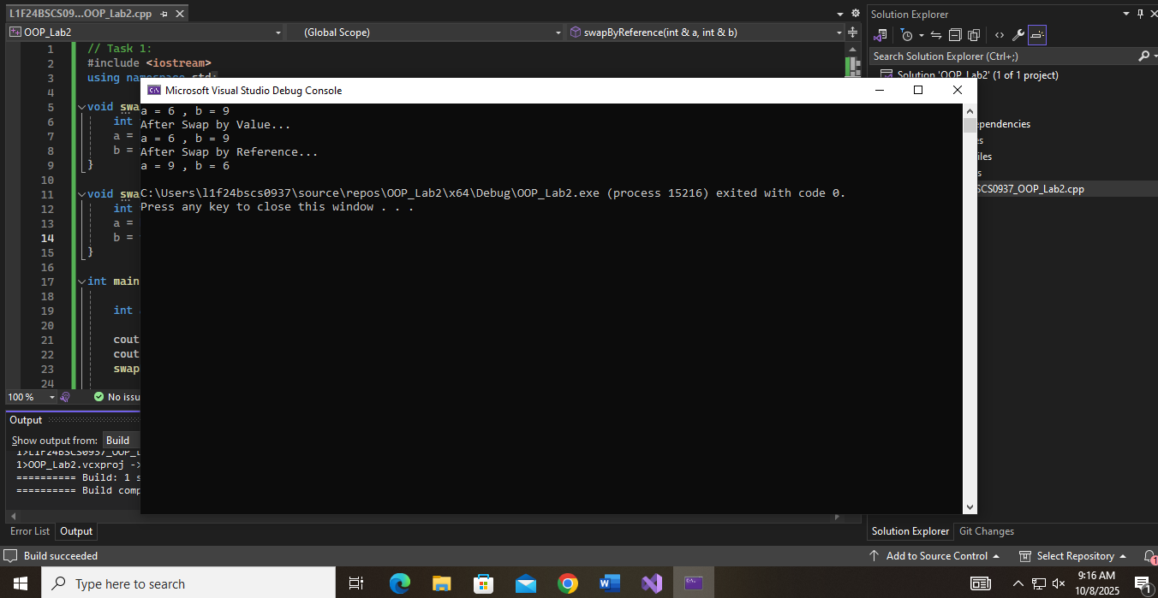

Task 2:
Write an overloaded function named ‘average’ that calculates:
• Average of two integers.
• Average of two doubles.
You can use return type for functions of your own choice (void, int, double).
void average(int a, int b);
void average(double a, double b);
In the main function, demonstrate each version of the ‘average’ function and print the results.

CODE:
// Task 2:
#include <iostream>
using namespace std;

int average(int a, int b) {
int sum = a + b;
return sum / 2;
}

double average(double a, double b) {
double sum = a + b;
double avg = sum / 2;
return avg;
}

int main() {

double a = 15.7, b = 19.2;

cout << "The average of a & b in double: " << average(a, b) << endl;

int c = 11, d = 42;
cout << "The average of a & b in integer: " << average(c, d) << endl;

return 0;
}

OUTPUT:
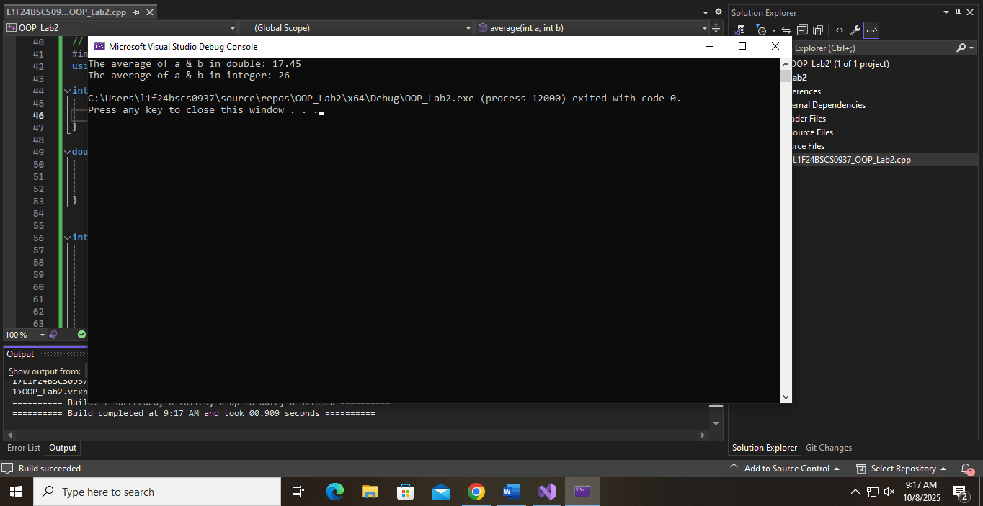

Task 3:
Write an overloaded function named ‘Area’ that will calculate:
• Area of a Square.
• Area of a Triangle.
• Area of a Circle.
You can use return type for functions, of your own choice (void, double, int).
void Area(int length);
void Area(int length, int width);
void Area(double radius);
In the main function, demonstrate each version of the ‘Area’ function and print the results.

CODE:
// Task 3:
#include <iostream>
using namespace std;

int Area(int length) {
return length * length;
}

int Area(int length, int width) {
return length * width;
}

double Area(double radius) {
return (3.14) * (radius * radius);
}

int main() {
int length = 8;
int width = 5;
double radius = 9.7;

cout << "The area of square = " << Area(length) << endl;
cout << "The area of rectangle = " << Area(length, width) << endl;
cout << "The area of circle = " << Area(radius) << endl;

return 0;
}

OUTPUT:
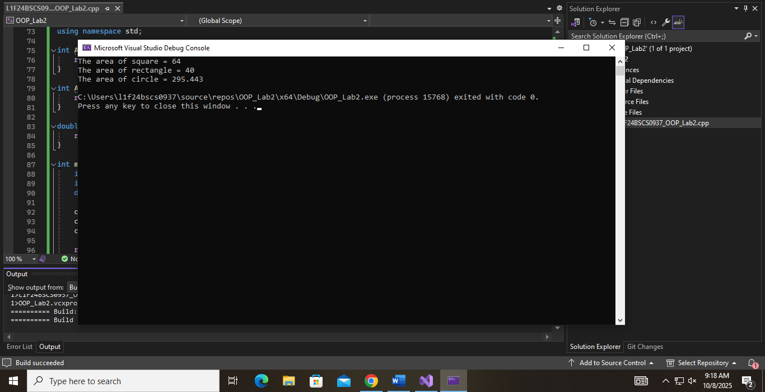

Task 4:
Write a C++ program that defines a function calculate that computes the area of a rectangle.
The function should accept two arguments:
• length
• width
The width argument should have a default value of 5.

int area1 = calculate(10); // Uses default width = 5
int area2 = calculate(10, 3); // Uses provided width = 3

Demonstrate how the function behaves when the width is provided and when it defaults to 5.

CODE:
// Task 4:
#include <iostream>
using namespace std;

int calculate(int length, int width = 5) {
return length * width;
}

int main() {
int length = 7, width = 9;

int area1 = calculate(length);
int area2 = calculate(length, width);

cout << "Area 1 = " << area1 << endl;
cout << "Area 2 = " << area2 << endl;

return 0;
}
OUTPUT:
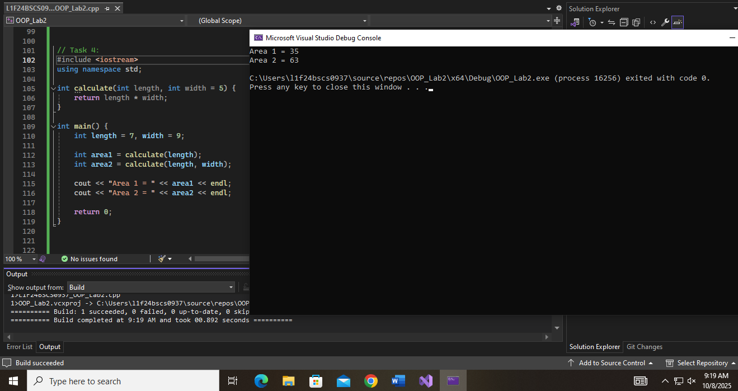

Task5:
Write a C++ program that:
• Dynamically allocates memory for an array of 5 integers.
• Assigns values to the array.
• Demonstrates the problem of dangling pointers by deleting the memory and trying to access the deleted pointer.
• Shows an example of memory leakage where memory is allocated but not properly deallocated before the program exits.

CODE:
// Task 5:
#include <iostream>
using namespace std;

int main() {
int size = 5;
int* arr = new int[size];

cout << "Enter " << size << " values for array: " << endl;
for (int i = 0; i < size; i++) {
cin >> arr[i];
}

//Deleting the array and then try to access it (dangling pointer)
delete[] arr; // Memory is deallocated
cout << "\nMemory deleted.\n";

// Dangling pointer access (unsafe, just for demonstration)
cout << "Trying to access deleted memory (dangling pointer):" << endl;
for (int i = 0; i < size; i++) {
cout << arr[i] << " "; // Undefined behavior!
}
cout << "\n";

//Creating a memory leak by allocating memory and not deleting it
int* leakedArray = new int[10]; // Memory is allocated
for (int i = 0; i < 10; i++) {
leakedArray[i] = i * 2; // Assign some values
}

// Intentionally NOT deleting leakedArray
// This memory will not be freed before the program exits (memory leak)

cout << "\nProgram ends. One block of memory was not deallocated (memory leak)." << endl;

return 0;
}

OUTPUT:
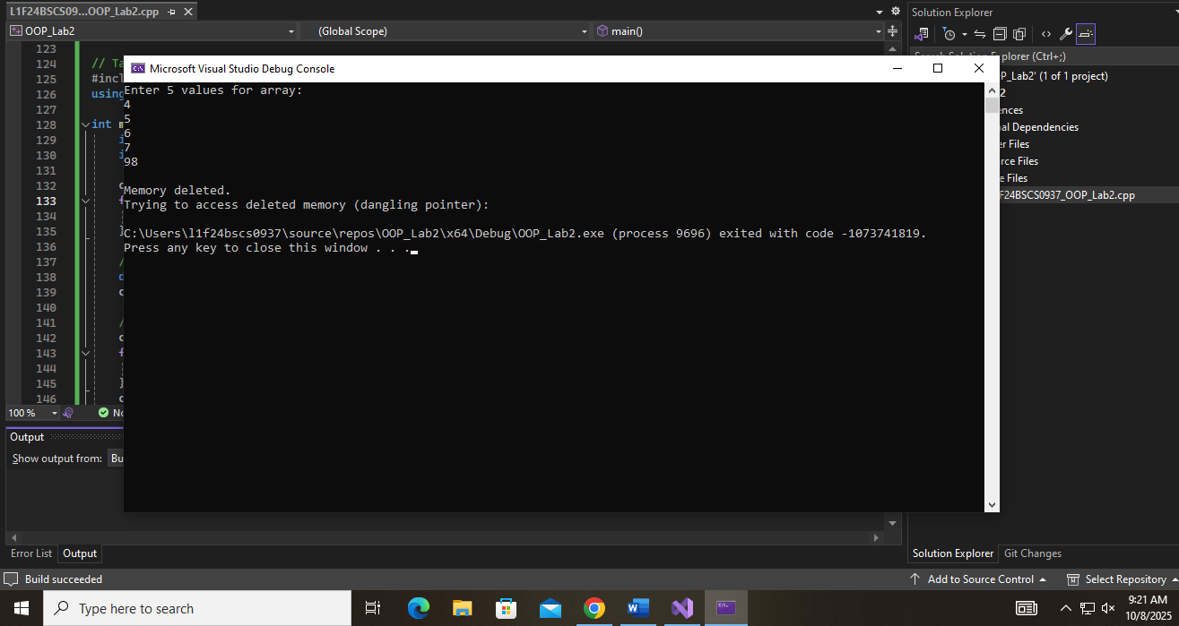

Task 6:
Now create a menu based program where user should select the function that needs to be tested from the above functions.
For example:
• Press 1 for PassByValue and PassByRef Function
• Press 2 for Overloaded Average Function
• Press 3 for Overloaded Area Function
• Press 4 for Default Argument Calculate Function.
• Press 5 for Testing Dynamic memory allocation, dangling pointers, and memory leak.
• Press 0 for exit.

CODE:
// Task 6:
#include <iostream>
using namespace std;

void swapByValue(int a, int b) {
int temp = a;
a = b;
b = temp;
}

void swapByReference(int& a, int& b) {
int temp = a;
a = b;
b = temp;
}

int average(int a, int b) {
int sum = a + b;
return sum / 2;
}

double average(double a, double b) {
double sum = a + b;
double avg = sum / 2;
return avg;
}

int Area(int length) {
return length * length;
}

int Area(int length, int width) {
return length * width;
}

double Area(double radius) {
return 3.14 * radius * radius;
}

int calculate(int length, int width = 5) {
return length * width;
}

void memoryTest() {
int size = 5;
int* arr = new int[size];

cout << "Enter " << size << " values for array: " << endl;
for (int i = 0; i < size; i++) {
cin >> arr[i];
}

delete[] arr; // Deallocate memory
cout << "\nMemory deleted.\n";

cout << "Trying to access deleted memory (dangling pointer):" << endl;
for (int i = 0; i < size; i++) {
cout << arr[i] << " "; // Undefined behavior
}
cout << "\n";

// Memory leak
int* leakedArray = new int[10];
for (int i = 0; i < 10; i++) {
leakedArray[i] = i * 2;
}

cout << "\nProgram ends. One block of memory was not deallocated (memory leak)." << endl;
}

int main() {
int choice;

do {
cout << "\n=== Main Menu ===" << endl;
cout << "1. PassByValue and PassByRef Function" << endl;
cout << "2. Overloaded Average Function" << endl;
cout << "3. Overloaded Area Function" << endl;
cout << "4. Default Argument Calculate Function" << endl;
cout << "5. Test Dynamic Memory, Dangling Pointers, Memory Leak" << endl;
cout << "0. Exit" << endl;
cout << "Enter your choice: ";
cin >> choice;

switch (choice) {
case 1: {
int a, b;
cout << "Enter two numbers: ";
cin >> a >> b;
swapByValue(a, b);
cout << "After Swapping by Value: a = " << a << ", b = " << b << endl;
swapByReference(a, b);
cout << "After Swapping by Reference: a = " << a << ", b = " << b << endl;
break;
}
case 2: {
double a, b;
cout << "Enter two floating point numbers: ";
cin >> a >> b;
cout << "Average (double): " << average(a, b) << endl;

int c, d;
cout << "Enter two integers: ";
cin >> c >> d;
cout << "Average (int): " << average(c, d) << endl;
break;
}
case 3: {
int length, width;
double radius;
cout << "Enter length for square: ";
cin >> length;
cout << "Area of square = " << Area(length) << endl;

cout << "Enter length and width for rectangle: ";
cin >> length >> width;
cout << "Area of rectangle = " << Area(length, width) << endl;

cout << "Enter radius for circle: ";
cin >> radius;
cout << "Area of circle = " << Area(radius) << endl;
break;
}
case 4: {
int length, width;
cout << "Enter length (and optionally width): ";
cin >> length;

cout << "Area using default width (5): " << calculate(length) << endl;

cout << "Now enter width: ";
cin >> width;
cout << "Area with user width: " << calculate(length, width) << endl;
break;
}
case 5:
memoryTest();
break;
case 0:
cout << "Exiting program." << endl;
break;
default:
cout << "Invalid choice. Please try again." << endl;
}

} while (choice != 0);

return 0;
}

OUTPUT:
