University of Central Punjab
Faculty of Information Technology
Object Oriented Programming
Fall 2025

Lab 03
Topic | Classes in C++, access specifiers, objects and methods.
Objective | The basic purpose of this lab is to revise some preliminary concepts of C++ that has been covered in the course of Introduction to Computing and Programming Fundamentals.  Its objective is to recall previously learned basic concepts like revision of arrays and functions
CLO | Apply object-oriented programming principles to implement real-world problems.

Instructions:
• Indent your code.
• Comment your code.
• Use meaningful variable names.
• Plan your code carefully on a piece of paper before you implement it.
• Name of the program should be same as the task name. i.e. the first program should be Task_1.cpp
• void main() is not allowed. Use int main()
• You are not allowed to use any built-in functions
• You are required to follow the naming conventions as follow:
• Variables: firstName; (no underscores allowed)
• Function: getName(); (no underscores allowed)
• ClassName: BankAccount (no underscores allowed)

Students are required to complete the following tasks in lab timings.

Task 1:

Create a class named as Rectangle having following private attributes:
• length (double)
• width(double)

Now write the following for the above-mentioned class:

• The program should include functions to assign user defined values to the above-mentioned variables of the Rectangle class.
void setValue()

• Write a display function to print the attributes of the class.
void display()
• Write a function calculateArea which calculates the area of the Rectangle and returns it.
double calculateArea (double length, double width)

Introduction:
This case study will be helpful in exploring the concepts of object-oriented programming (OOP) by developing a Rectangle class. Through this exercise, students will identify the class's features, attributes, and behaviors, to understand how to model real-world objects in code.
Objective:
The primary objective is to create a Rectangle class with specific attributes and methods. To perform calculations related to the Rectangle’s properties and data assigned to the attributes.
• Identify Attributes:
• What other attributes could be added to the Rectangle class (e.g., color, type, height)?
• How would you modify the class to include these attributes?
• Define Behaviors:
• Can you think of other methods that could enhance the functionality of the Rectangle class (e.g., perimeter calculation)?
• How would you implement those methods?
• Implementation:
• Implement the Rectangle class based on the identified attributes and behaviors.

CODE:
#include <iostream>
using namespace std;

class Rectangle {

private:
double length;
double width;

public:

void setValue(double l, double w) {
length = l;
width = w;
}

void display() {
cout << "The length of rectangle is: " << length << endl;
cout << "The width of rectangle is: " << width << endl;
}

double calculateArea(double length, double width) {
return length * width;
}

};

int main() {

Rectangle r1;
double length, width;
cout << "Enter the length of rectangle (in double): ";
cin >> length;
cout << "Enter the width of rectangle (in double): ";
cin >> width;

r1.setValue(length, width);
r1.display();
double l, w;
cout << "Enter length & width of rectangle to find its Area: ";
cin >> l >> w;
cout << "The area of rectangle is = " << r1.calculateArea(l, w) << endl;

return 0;
}
OUTPUT:
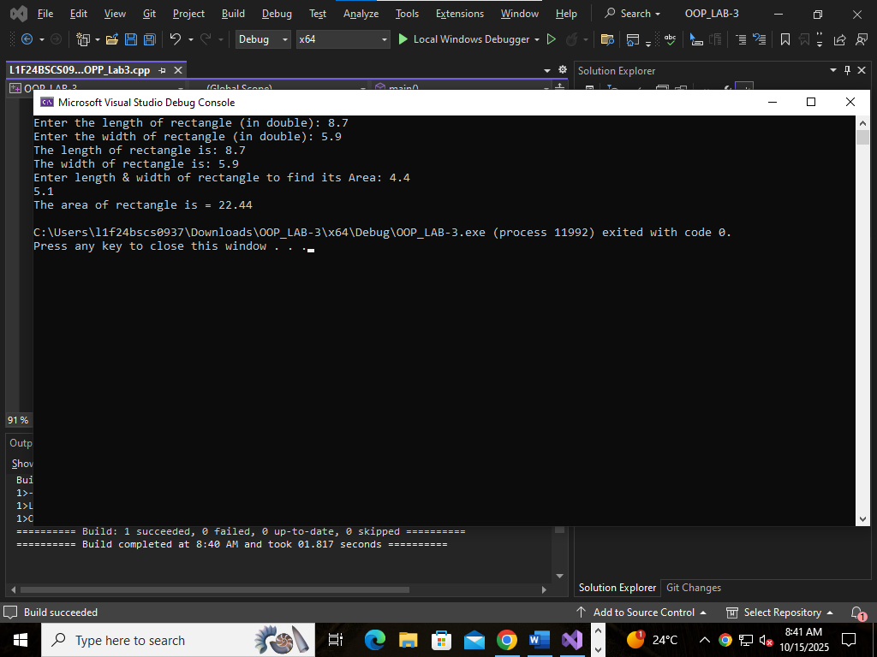

Task 2:
Create a class named as Student having following private attributes:
• studentName (char *)
• studentID(int)
• GPA(double)
• degreeName(char*) (e.g, BSCS, BSDS, BSAI)

• The program should include setter function(s) to assign user defined values to the above-mentioned variable.
void setValue()

• Write a non-returning display function to print all the attributes of the class.
void display()

• Write a function ‘calculatePercentage’ which calculates the student’s percentage for a specific course. The function will take 2 parameters for obtained marks and total marks as input

double calculatePercentage (int total, int obtained)

• Write a function ‘AssignGrade’ which will assign the grade to that specific course for the student according to the percentage. The function will take the calculated percentage as parameter and then returns or displays the assigned grade.
void AssignGrade (double percentage)
OR
char AssignGrade (double percentage)

• Create multiple objects of ‘Student’ class with different data. And then display all of the object’s data.

Use the table given below to assign the grade accordingly.

GRADE
Percentage
A+
86-100%
A
82-85%
B+
78-81%
B
74-77%
B-
70-73%
C+
66-69%
C
62-65%
C-
58-61%
D+
54-57%
D
50-53%
F
Below 50%

CODE:
// Task 2:
#include <iostream>
using namespace std;

class Student {
private:
char* studentName;
int studentID;
double GPA;
char* degreeName;

void copyString(const char* source, char*& dest) {
int length = 0;
while (source[length] != '\0') length++;
dest = new char[length + 1];
for (int i = 0; i < length; i++) {
dest[i] = source[i];
}
dest[length] = '\0';
}

public:
Student() {
studentName = nullptr;
degreeName = nullptr;
studentID = 0;
GPA = 0.0;
}

~Student() {
delete[] studentName;
delete[] degreeName;
}

void setValue(const char* name, int id, double gpa, const char* degree) {
delete[] studentName;
delete[] degreeName;

copyString(name, studentName);
studentID = id;
GPA = gpa;
copyString(degree, degreeName);
}

void display() {
cout << "Student Name: " << studentName << endl;
cout << "Student ID: " << studentID << endl;
cout << "GPA: " << GPA << endl;
cout << "Degree Name: " << degreeName << endl;
}

double calculatePercentage(int obtained, int total) {
if (total <= 0) return 0.0;
return (double(obtained) / total) * 100.0;
}

void displayGrade(double percentage) {
cout << "Grade: ";
if (percentage >= 86 && percentage <= 100)
cout << "A+";
else if (percentage >= 82)
cout << "A";
else if (percentage >= 78)
cout << "B+";
else if (percentage >= 74)
cout << "B";
else if (percentage >= 70)
cout << "B-";
else if (percentage >= 66)
cout << "C+";
else if (percentage >= 62)
cout << "C";
else if (percentage >= 58)
cout << "C-";
else if (percentage >= 54)
cout << "D+";
else if (percentage >= 50)
cout << "D";
else
cout << "F";
cout << endl;
}
};

int main() {
int temp;
cout << "Enter number of students you want to input: ";
cin >> temp;

for (int i = 0; i < temp; i++) {
cout << "\n--- Entering details for Student #" << i + 1 << " ---\n";

char name[100], degree[100];
int id, obtained, total;
double gpa;

cout << "Enter student name: ";
cin >> name;

cout << "Enter student ID: ";
cin >> id;

cout << "Enter GPA: ";
cin >> gpa;

cout << "Enter degree name: ";
cin >> degree;

cout << "Enter obtained marks: ";
cin >> obtained;

cout << "Enter total marks: ";
cin >> total;

Student s;
s.setValue(name, id, gpa, degree);

double percentage = s.calculatePercentage(obtained, total);

cout << "\nStudent #" << i + 1 << " Info:\n";
s.display();
cout << "Percentage: " << percentage << "%" << endl;
s.displayGrade(percentage);
}

return 0;
}

OUTPUT:
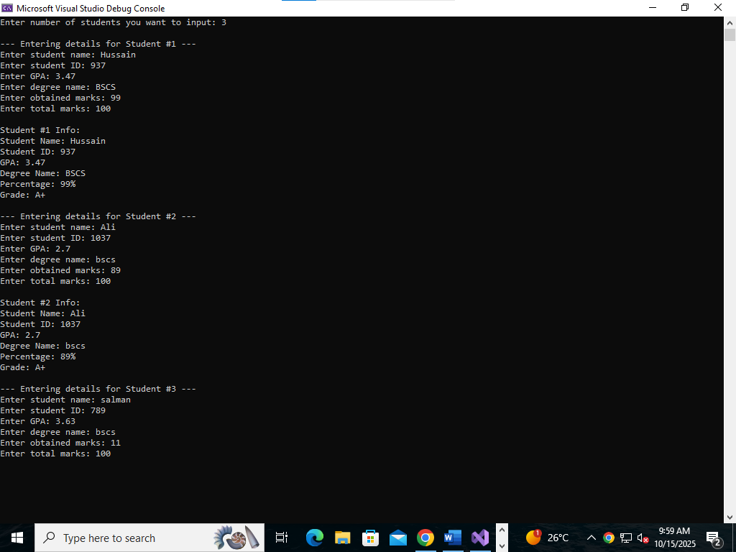
Task 3:
Create a class named as Calculator having following private attributes
• num1 (int)
• num2 (int)
• num3 (int)

• The program should include setter function(s) to assign user defined values to the above-mentioned variable.
⁃ void setValue()
• Write a non-returning display function to print all the attributes of the class.
⁃ void display()
Implemnet below methods as a member function of the Calculator class
Methods:
• add(): Adds all three numbers.
• average(): Calculates the average of the three numbers.
• multiply(): Multiplies all three numbers.
• maximum(): Finds the largest value among the three numbers.
• minimum(): Finds the smallest value among the three numbers.

Main Function:
• Creates an object calc of the Calculator class
• Demonstrates the use of these methods by displaying the results.

CODE:

// Task 3:
#include <iostream>
using namespace std;

class Calculator {
private:
int num1, num2, num3;

public:
Calculator(int n1, int n2, int n3) {
num1 = n1;
num2 = n2;
num3 = n3;
}

void display() {
cout << "Num1 = " << num1 << endl;
cout << "Num2 = " << num2 << endl;
cout << "Num3 = " << num3 << endl;
}

int add() {
return (num1 + num2 + num3);
}

int multiply() {
return (num1 * num2 * num3);
}

double average() {
double sum = num1 + num2 + num3;
double average = sum / 3;
return average;
}

int maximum() {
int max;
if (num1 > num2 && num1 > num3) {
max = num1;
}
else if (num2 > num1 && num2 > num3) {
max = num2;
}
else {
max = num3;
}
return max;
}

int minimum() {
int min;
if (num1 < num2 && num1 < num3) {
min = num1;
}
else if (num2 < num1 && num2 < num3) {
min = num2;
}
else {
min = num3;
}
return min;
}
};

int main() {
int n1, n2, n3;
cout << "Enter three numbers: " << endl;
cin >> n1 >> n2 >> n3;

Calculator obj1(n1, n2, n3);

obj1.display();

cout << "The addition of these 3 numbers is: " << obj1.add() << endl;
cout << "The product of these 3 number is: " << obj1.multiply() << endl;
cout << "The average of these 3 number is: " << obj1.average() << endl;
cout << "The maximum in these 3 number is: " << obj1.maximum() << endl;
cout << "The minimum in these 3 number is: " << obj1.minimum() << endl;

return 0;
}

OUTPUT:
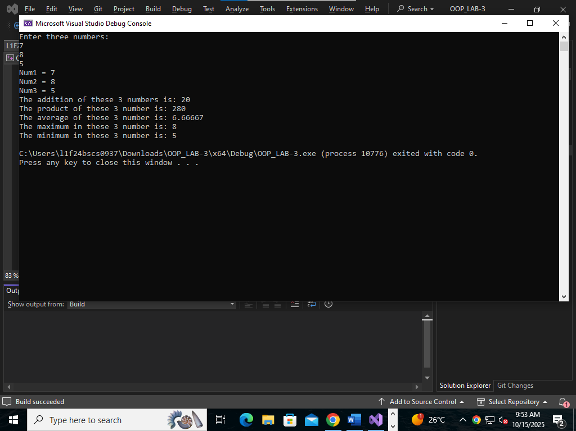

Task 4:
Create a class named as Car having following private attributes

• make (char*): The brand or manufacturer of the car (e.g., "Toyota").
• model (char*): The specific model of the car (e.g., "Corolla").
• year (int): The year the car was manufactured (e.g., 2000).
• The program should include setter function(s) to assign user defined values to the above-mentioned variable.
⁃ void setValue()
• Write a non-returning display function to print all the attributes of the class.
⁃ void display()
Implement below methods as a member function of the Car class
Methods:
• calculateCarAge(int currentYear): This method calculates the age of the car based on the current year passed as a parameter.
• isVintage(int currentYear): This method checks if the car is vintage. A car is considered vintage if it is older than 20 years.
• displayCarDetails(): Displays the car's make, model, year, calculated age, and whether the car is vintage.

Main Function:
• Creates two Car objects (car1 and car2).
• Calls the displayCarDetails() method to show the details for each car, including their age and vintage status.

CODE:
// Task 4:
#include <iostream>
using namespace std;

class Car {
private:
char* make;
char* model;
int year;

void copyString(const char* source, char*& dest) {
int length = 0;
while (source[length] != '\0') length++;
dest = new char[length + 1];
for (int i = 0; i < length; i++) {
dest[i] = source[i];
}
dest[length] = '\0';
}

public:
Car() {
make = nullptr;
model = nullptr;
year = 0;
}

~Car() {
delete[] make;
delete[] model;
}

void setValue(const char* mk, const char* mdl, int yr) {
delete[] make;
delete[] model;

copyString(mk, make);
copyString(mdl, model);
year = yr;
}

void display() {
cout << "Make: " << (make ? make : "N/A") << endl;
cout << "Model: " << (model ? model : "N/A") << endl;
cout << "Year: " << year << endl;
}

int calculateCarAge(int currentYear) {
return currentYear - year;
}

bool isVintage(int currentYear) {
return calculateCarAge(currentYear) > 20;
}

void displayCarDetails(int currentYear) {
display();
int age = calculateCarAge(currentYear);
cout << "Car Age: " << age << " years" << endl;
cout << "Vintage Status: " << (isVintage(currentYear) ? "Yes" : "No") << endl;
}
};

int main() {
Car car1, car2;
char make[100], model[100];
int year, currentYear;

cout << "Enter details for Car 1:" << endl;
cout << "Make: ";
cin >> make;
cout << "Model: ";
cin >> model;
cout << "Year: ";
cin >> year;
car1.setValue(make, model, year);

cout << "\nEnter details for Car 2:" << endl;
cout << "Make: ";
cin >> make;
cout << "Model: ";
cin >> model;
cout << "Year: ";
cin >> year;
car2.setValue(make, model, year);

cout << "\nEnter the current year: ";
cin >> currentYear;

cout << "\nCar 1 details:\n";
car1.displayCarDetails(currentYear);

cout << "\nCar 2 details:\n";
car2.displayCarDetails(currentYear);

return 0;
}

OUTPUT:
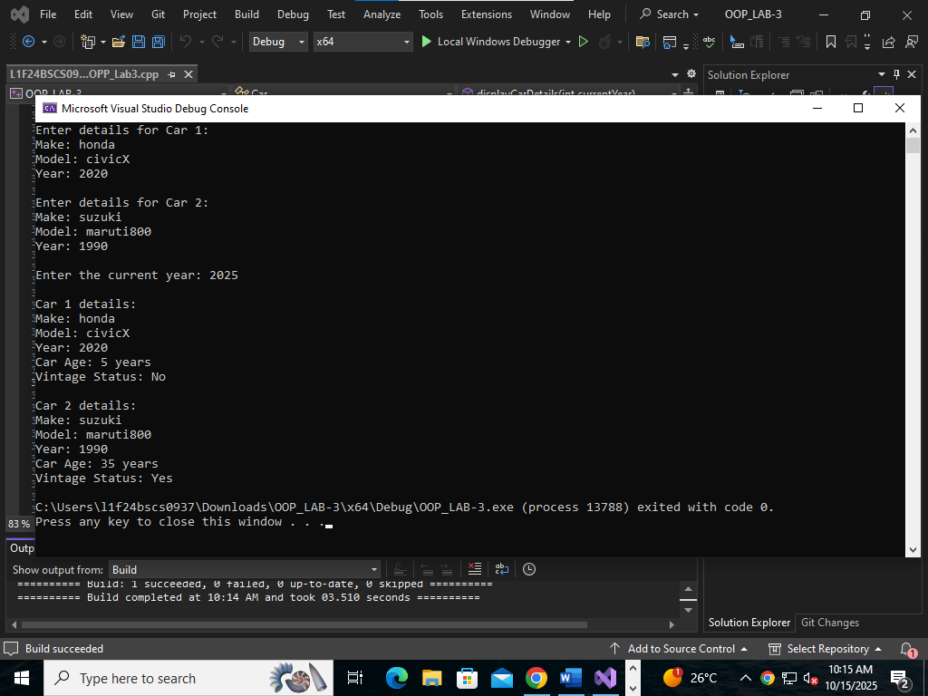

Task 5:
Now create a menu based program where user should select the function that needs to be tested from the above functions.
For example:
• Press 1 for Testing ‘Rectangle’ class.
• Press 2 for Testing ‘Student’ class.
• Press 3 for Testing ‘Calculator’ class.
• Press 4 for Testing ‘Car’ class.
• Press 0 for exit.

CODE:
//Task 5:
#include <iostream>
using namespace std;

class Rectangle {
private:
double length;
double width;
public:
void setValue(double l, double w) {
length = l;
width = w;
}
void display() {
cout << "The length of rectangle is: " << length << endl;
cout << "The width of rectangle is: " << width << endl;
}
double calculateArea(double length, double width) {
return length * width;
}
};

void testRectangle() {
Rectangle r1;
double length, width;
cout << "Enter the length of rectangle (in double): ";
cin >> length;
cout << "Enter the width of rectangle (in double): ";
cin >> width;
r1.setValue(length, width);
r1.display();

double l, w;
cout << "Enter length & width of rectangle to find its Area: ";
cin >> l >> w;
cout << "The area of rectangle is = " << r1.calculateArea(l, w) << endl;
}

class Student {
private:
char* studentName;
int studentID;
double GPA;
char* degreeName;

void copyString(const char* source, char*& dest) {
int length = 0;
while (source[length] != '\0') length++;
dest = new char[length + 1];
for (int i = 0; i < length; i++) {
dest[i] = source[i];
}
dest[length] = '\0';
}

public:
Student() {
studentName = nullptr;
degreeName = nullptr;
studentID = 0;
GPA = 0.0;
}
~Student() {
delete[] studentName;
delete[] degreeName;
}
void setValue(const char* name, int id, double gpa, const char* degree) {
delete[] studentName;
delete[] degreeName;
copyString(name, studentName);
studentID = id;
GPA = gpa;
copyString(degree, degreeName);
}
void display() {
cout << "Student Name: " << studentName << endl;
cout << "Student ID: " << studentID << endl;
cout << "GPA: " << GPA << endl;
cout << "Degree Name: " << degreeName << endl;
}
double calculatePercentage(int obtained, int total) {
if (total <= 0) return 0.0;
return (double(obtained) / total) * 100.0;
}
void displayGrade(double percentage) {
cout << "Grade: ";
if (percentage >= 86 && percentage <= 100)
cout << "A+";
else if (percentage >= 82)
cout << "A";
else if (percentage >= 78)
cout << "B+";
else if (percentage >= 74)
cout << "B";
else if (percentage >= 70)
cout << "B-";
else if (percentage >= 66)
cout << "C+";
else if (percentage >= 62)
cout << "C";
else if (percentage >= 58)
cout << "C-";
else if (percentage >= 54)
cout << "D+";
else if (percentage >= 50)
cout << "D";
else
cout << "F";
cout << endl;
}
};
void testStudent() {
int temp;
cout << "Enter number of students you want to input: ";
cin >> temp;

for (int i = 0; i < temp; i++) {
cout << "\n--- Entering details for Student #" << i + 1 << " ---\n";

char name[100], degree[100];
int id, obtained, total;
double gpa;

cout << "Enter student name: ";
cin >> name;

cout << "Enter student ID: ";
cin >> id;

cout << "Enter GPA: ";
cin >> gpa;

cout << "Enter degree name: ";
cin >> degree;

cout << "Enter obtained marks: ";
cin >> obtained;

cout << "Enter total marks: ";
cin >> total;

Student s;
s.setValue(name, id, gpa, degree);

double percentage = s.calculatePercentage(obtained, total);

cout << "\nStudent #" << i + 1 << " Info:\n";
s.display();
cout << "Percentage: " << percentage << "%" << endl;
s.displayGrade(percentage);
}
}

class Calculator {
private:
int num1, num2, num3;

public:
Calculator(int n1, int n2, int n3) {
num1 = n1;
num2 = n2;
num3 = n3;
}
void display() {
cout << "Num1 = " << num1 << endl;
cout << "Num2 = " << num2 << endl;
cout << "Num3 = " << num3 << endl;
}
int add() {
return (num1 + num2 + num3);
}
int multiply() {
return (num1 * num2 * num3);
}
double average() {
double sum = num1 + num2 + num3;
return sum / 3;
}
int maximum() {
int max = num1;
if (num2 > max) max = num2;
if (num3 > max) max = num3;
return max;
}
int minimum() {
int min = num1;
if (num2 < min) min = num2;
if (num3 < min) min = num3;
return min;
}
};
void testCalculator() {
int n1, n2, n3;
cout << "Enter three numbers: " << endl;
cin >> n1 >> n2 >> n3;

Calculator obj1(n1, n2, n3);

obj1.display();
cout << "The addition of these 3 numbers is: " << obj1.add() << endl;
cout << "The product of these 3 numbers is: " << obj1.multiply() << endl;
cout << "The average of these 3 numbers is: " << obj1.average() << endl;
cout << "The maximum of these 3 numbers is: " << obj1.maximum() << endl;
cout << "The minimum of these 3 numbers is: " << obj1.minimum() << endl;
}

class Car {
private:
char* make;
char* model;
int year;

void copyString(const char* source, char*& dest) {
int length = 0;
while (source[length] != '\0') length++;
dest = new char[length + 1];
for (int i = 0; i < length; i++) {
dest[i] = source[i];
}
dest[length] = '\0';
}

public:
Car() {
make = nullptr;
model = nullptr;
year = 0;
}
~Car() {
delete[] make;
delete[] model;
}
void setValue(const char* mk, const char* mdl, int yr) {
delete[] make;
delete[] model;
copyString(mk, make);
copyString(mdl, model);
year = yr;
}
void display() {
cout << "Make: " << (make ? make : "N/A") << endl;
cout << "Model: " << (model ? model : "N/A") << endl;
cout << "Year: " << year << endl;
}
int calculateCarAge(int currentYear) {
return currentYear - year;
}
bool isVintage(int currentYear) {
return calculateCarAge(currentYear) > 20;
}
void displayCarDetails(int currentYear) {
display();
int age = calculateCarAge(currentYear);
cout << "Car Age: " << age << " years" << endl;
cout << "Vintage Status: " << (isVintage(currentYear) ? "Yes" : "No") << endl;
}
};
void testCar() {
Car car1, car2;
char make[100], model[100];
int year, currentYear;

cout << "Enter details for Car 1:" << endl;
cout << "Make: ";
cin >> make;
cout << "Model: ";
cin >> model;
cout << "Year: ";
cin >> year;
car1.setValue(make, model, year);

cout << "\nEnter details for Car 2:" << endl;
cout << "Make: ";
cin >> make;
cout << "Model: ";
cin >> model;
cout << "Year: ";
cin >> year;
car2.setValue(make, model, year);

cout << "\nEnter the current year: ";
cin >> currentYear;

cout << "\nCar 1 details:\n";
car1.displayCarDetails(currentYear);

cout << "\nCar 2 details:\n";
car2.displayCarDetails(currentYear);
}

int main() {
int choice;

do {
cout << "\nMenu:\n";
cout << "1. Test Rectangle class\n";
cout << "2. Test Student class\n";
cout << "3. Test Calculator class\n";
cout << "4. Test Car class\n";
cout << "0. Exit\n";
cout << "Enter your choice: ";
cin >> choice;

switch (choice) {
case 1:
testRectangle();
break;
case 2:
testStudent();
break;
case 3:
testCalculator();
break;
case 4:
testCar();
break;
case 0:
cout << "Exiting program.\n";
break;
default:
cout << "Invalid choice, please try again.\n";
}
} while (choice != 0);

return 0;
}

OUTPUT:
