
University of Central Punjab
Faculty of Information Technology

Object Oriented Programming - Lab 01
Topic
Revision of Functions, Default Arguments, and Dynamic Memory (Dangling Pointers & Memory Leakage).
Objective
- Revise function creation and parameter passing (Value & Reference).
- Understand the use of default arguments in functions.
- Review dynamic memory allocation concepts.
- Identify issues of dangling pointers and memory leaks.
Outcomes
- Revise and apply functions with parameter passing (Value & Reference) in C++.
- Utilize default arguments in functions to simplify code implementation.
- Strengthen understanding of dynamic memory allocation in C++.
- Identify and prevent issues related to dangling pointers.
- Recognize and handle memory leaks in C++ programs.

Content
The following sections will be covered during this lab session.

- Functions and Parameter Passing will focus on revising function creation, understanding the difference between pass-by-value and pass-by-reference, and testing how parameter passing affects program output.
- Default Arguments will cover simplifying function calls by providing default values, reducing redundancy, and ensuring code flexibility through practical coding exercises.
- Dynamic Memory Allocation will involve revisiting the use of new and delete operators, reinforcing the importance of efficient memory management in C++.
- Dangling Pointers will guide students in identifying scenarios where dangling pointers occur, understanding their risks, and applying safe programming practices to avoid them.
- Memory Leaks will emphasize detecting memory leaks, explore common causes, and apply proper deallocation techniques to ensure reliable program execution.

Instructions
  - Indent your code properly.
  - Use meaningful variable and function names. Use the camelCase notation.
  - Use meaningful prompt lines/labels for all input/output.
  - In each file of your task either it is .cpp file or .h file Your name and roll no must be mentioned in the start of your file as comment. For example, //L1F20BSCS0000 – Ahmad
  - You are not allowed to use any built-in function.
  - You are required to complete the following tasks in lab timings

Task 01 – Debugging and Correction in Code
You are provided with a buggy C++ program that contains multiple types of errors, including syntax errors, logical errors, runtime issues (dangling pointers, memory leaks), and incorrect use of functions.
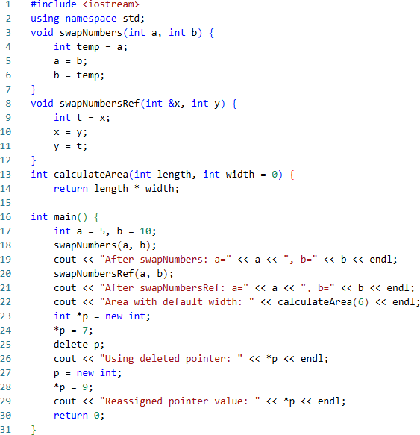

Your task is to carefully analyse and correct this program by following the steps below:

Dry Run & Identify Errors
  - Perform a manual dry run of the given program.
  - Identify all syntax, logical, and runtime errors.
  - Write them down clearly in a list.

Code Correction
  - Fix the identified errors in the code.
  - Ensure that the program compiles successfully.

Compilation & Debugging
  - Run the corrected code on the compiler.
  - Use sample inputs to test all parts of the program.
  - Debug any remaining issues until the program produces correct results.

Analysis Report
Prepare a short report covering the following points:
  - List of Errors: What errors did you find? (Syntax, Logical, Runtime)
  - Reason for Errors: Why did these errors occur? (Explain briefly)
  - Fix Applied: How did you fix them? (Write before-and-after code snippets if necessary)
  - Comparison of Results: Show outputs before fixing (expected vs actual) and after fixing.
  - Conclusion: Explain what you learned from this debugging process.

Analysis Report:
delete p;

cout << "After deleting " << *p << endl;

This line gives error because after deleting the pointer we are trying to use it which is an example of “Dangling Pointers”, so this line will not run.

void swapNumbersRef(int& x, int y)

In this function, we are trying to swap the numbers by reference, but we are not using ‘&’ operator with ‘y’, so after functions body their will be no change in ‘y’ as we are swaping with the copy of ‘y’. Correct version:
void swapNumbersRef(int& x, int& y)

int calculateArea(int length, int width = 0)

In this function, we are intended to find the area, but by setting width’s value to 0 will always give us 0 as area, which is not a valid area, so we will set width to 1, and we can also explicitly give value of width in the function call.

int calculateArea(int length, int width = 1)
cout << "Area = " << calculateArea(6, 2) << endl;
cout << "Area = " << calculateArea(6) << endl;

Correct Version of code:

#include <iostream>
using namespace std;

void swapNumbers(int a, int b) {
int temp = a;
a = b;
b = temp;
}

void swapNumbersRef(int& x, int& y) {
int temp = x;
x = y;
y = temp;
}

int calculateArea(int length, int width = 1) {
return length * width;
}

int main() {
int a = 9, b = 11;

cout << "Before swap---> a = " << a << " & b = " << b << endl;
swapNumbers(a, b);
cout << "After swap---> a = " << a << " & b = " << b << endl;

cout << "Before swap by Refernce---> a = " << a << " & b = " << b << endl;
swapNumbersRef(a, b);
cout << "After swap by Refernce---> a = " << a << " & b = " << b << endl;

cout << "Area = " << calculateArea(6, 2) << endl;

int* p = new int;
*p = 9;
cout << "Before deleting pointer = " << *p << endl;
delete p;
//cout << "After deleting " << *p << endl; // This will give a dangling error
p = new int;
*p = 10;
cout << "After reassigning pointer = " << *p << endl;

return 0;
}
OUTPUT:
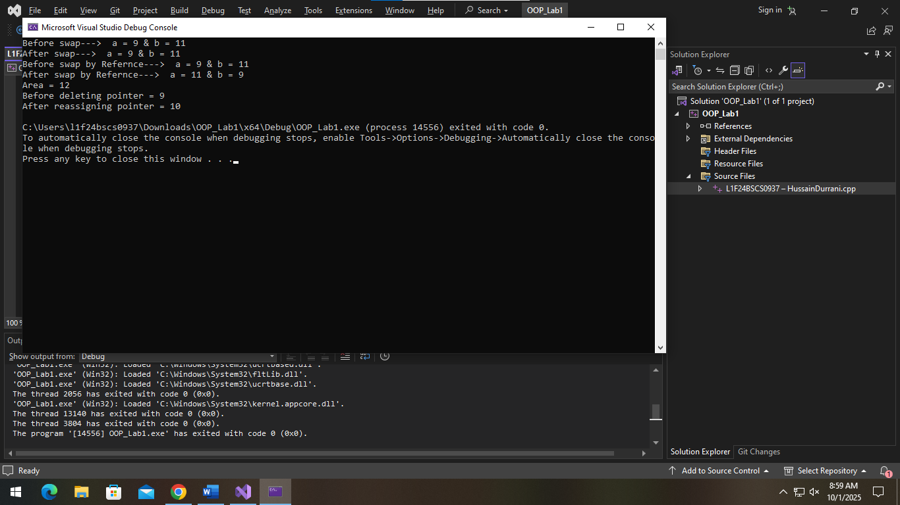

Task 02 – Function (Pass by value)
Write a C++ program that performs the following tasks:
- Ask user to enter two integers.
- Implement a function swapNumbers(int a, int b) that attempts to swap the two numbers using pass- by-value.
- Call the function and pass the user-provided values as arguments.
- Display the numbers before and after calling the function.
CODE:
// Task 2:
#include <iostream>
using namespace std;

void swapNumbers(int a, int b) {
int temp = a;
a = b;
b = temp;
}

int main() {
int a, b;
cout << "Enter value of a: ";
cin >> a;
cout << "Enter value of b: ";
cin >> b;
cout << "Before swapping by value:\na = " << a << ", b = " << b << endl;
swapNumbers(a, b); // There will be no change because it swaps the copy of a & b which is only in the function
cout << "After swapping by value:\na = " << a << ", b = " << b << endl;
return 0;
}
OUTPUT:
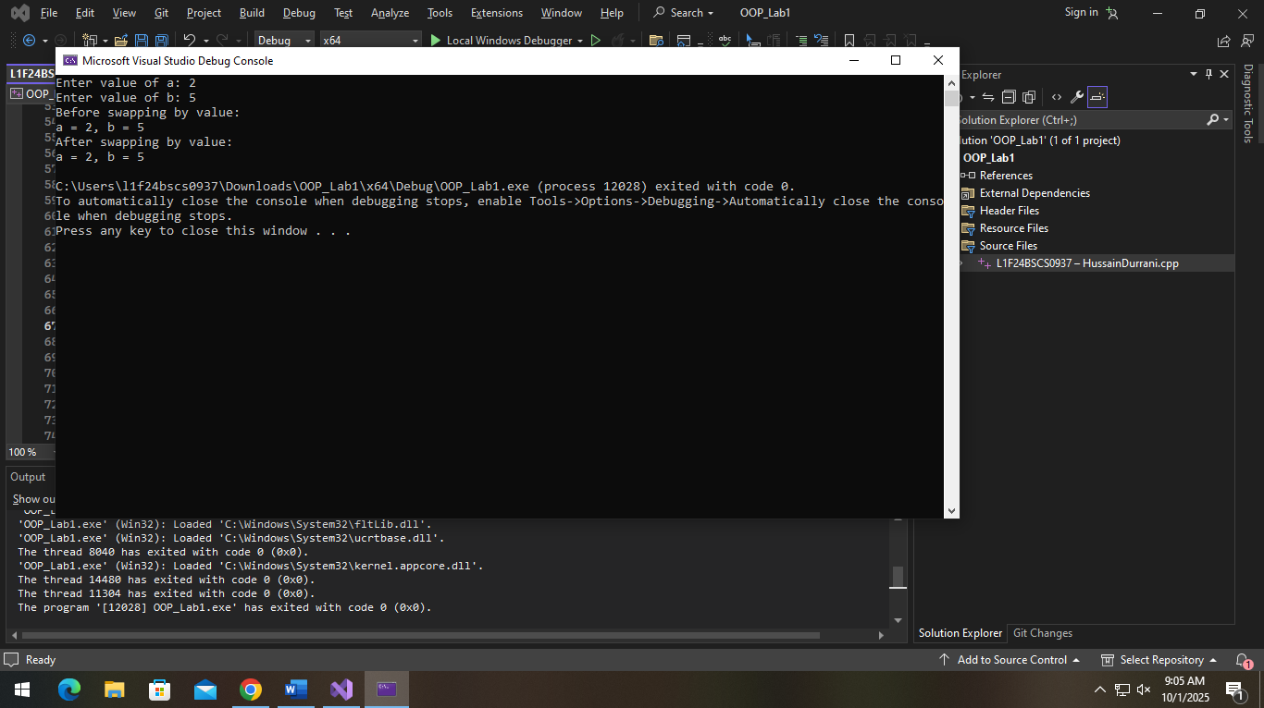

Task 03 – Function (Pass by reference)
Using the program implemented in Question 1, perform the following tasks:
- Modify the function swapNumbers(int a, int b) to use pass-by-reference instead of pass-by-value.
- Call the function and pass the user-provided values as arguments.
- Display the numbers before and after calling the function.
- Prepare a short comparison highlighting the difference between pass-by-value and pass-by-reference, and submit your code along with the explanation in a Word file.

CODE:
// Task 3:
#include <iostream>
using namespace std;

void swapNumbersRef(int& x, int& y) {
int temp = x;
x = y;
y = temp;
}

int main() {
int a = 9, b = 5;

cout << "Before swap by Refernce---> a = " << a << " & b = " << b << endl;
swapNumbersRef(a, b);
cout << "After swap by Refernce---> a = " << a << " & b = " << b << endl;

return 0;
}

Explanation:
In pass by value, the function makes a copy of the original variables and makes changes in them, and their scope is only till inside the function, so outside function in main() the values remain un changed.

In Pass by Reference, the function makes changes in the original variables, so they are actually changed because function goes to the address of the variable and make changes their.
OUTPUT:
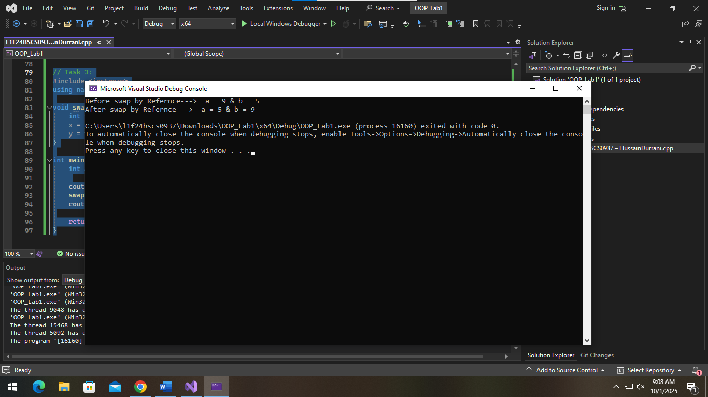

Task 04 – Function (default arguments)
Write a C++ program that performs the following tasks:
- Implement a function calculateArea(int length, int width = 5) that calculates the area of a rectangle, where the parameter width has a default value of 5.
- Call the function by passing only one argument (length) to use the default width value.
- Call the function again by passing both length and width as arguments.
- Display the calculated area in both cases to demonstrate the effect of using a default argument.
Explanation:
If we don’t provide the 2nd argument, the function takes the default argument (5). And if we provide the value of width then it will use the provided value.
Code:
// Task 4:
#include <iostream>
using namespace std;

int calculateArea(int length, int width = 5) {
return length * width;
}

int main() {
int a = 9, b = 5;

cout << "Area calculateArea(6, 2) = " << calculateArea(6, 2) << endl;
cout << "Area calculateArea(6) = " << calculateArea(6) << endl;

return 0;
}

OUTPUT:
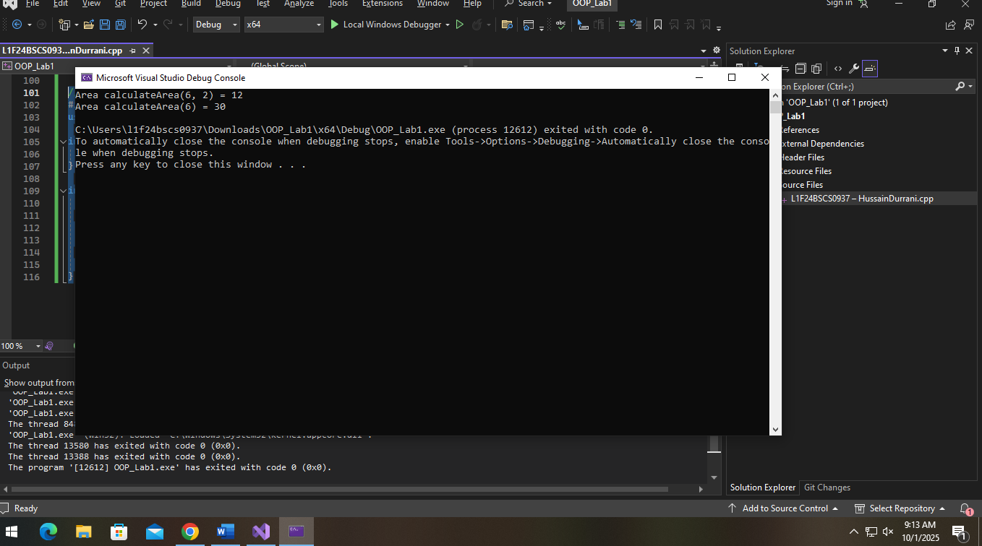

Task 05 – Dynamic Memory Allocation
Write a C++ program that performs the following tasks:

- Dynamically allocate memory for an integer array of size N, where N is entered by the user.
- Take input N integers from the user and store them in the dynamically allocated array.
- Define a function int calculateSum(int arr[], int size) that takes the array as a parameter and returns the sum of its elements.
- Define a function double calculateAverage(int arr[], int size) that takes the array as a parameter and returns the average of its elements.
- In the main() function, call both functions using the array, store their return values, and display the array elements along with the calculated sum and average.
CODE:
// Task 5:
#include <iostream>
using namespace std;

int calculateSum(int arr[], int size){
int sum = 0;
for (int i = 0; i < size; i++) {
sum += arr[i];
}
return sum;
}

double calculateAverage(int arr[], int size) {
double average = 0;
double sum = 0;
for (int i = 0; i < size; i++) {
sum += arr[i];
}
average = sum / size;
return average;
}

int main() {
int N;
cout << "Enter the size of array: ";
cin >> N;

int* arr = new int[N];
cout << "Enter the values in the array: " << endl;
for (int i = 0; i < N; i++) {
cout << i + 1 << ") ";
cin >> arr[i];
}

cout << "Values in the array: " << endl;
for (int i = 0; i < N; i++) {
cout << arr[i] << " ";
}cout << endl;

cout << "The sum of the elements in the array: " << calculateSum(arr, N) << endl;
cout << "The sum of the elements in the array: " << calculateAverage(arr, N) << endl;

return 0;
}

OUTPUT:
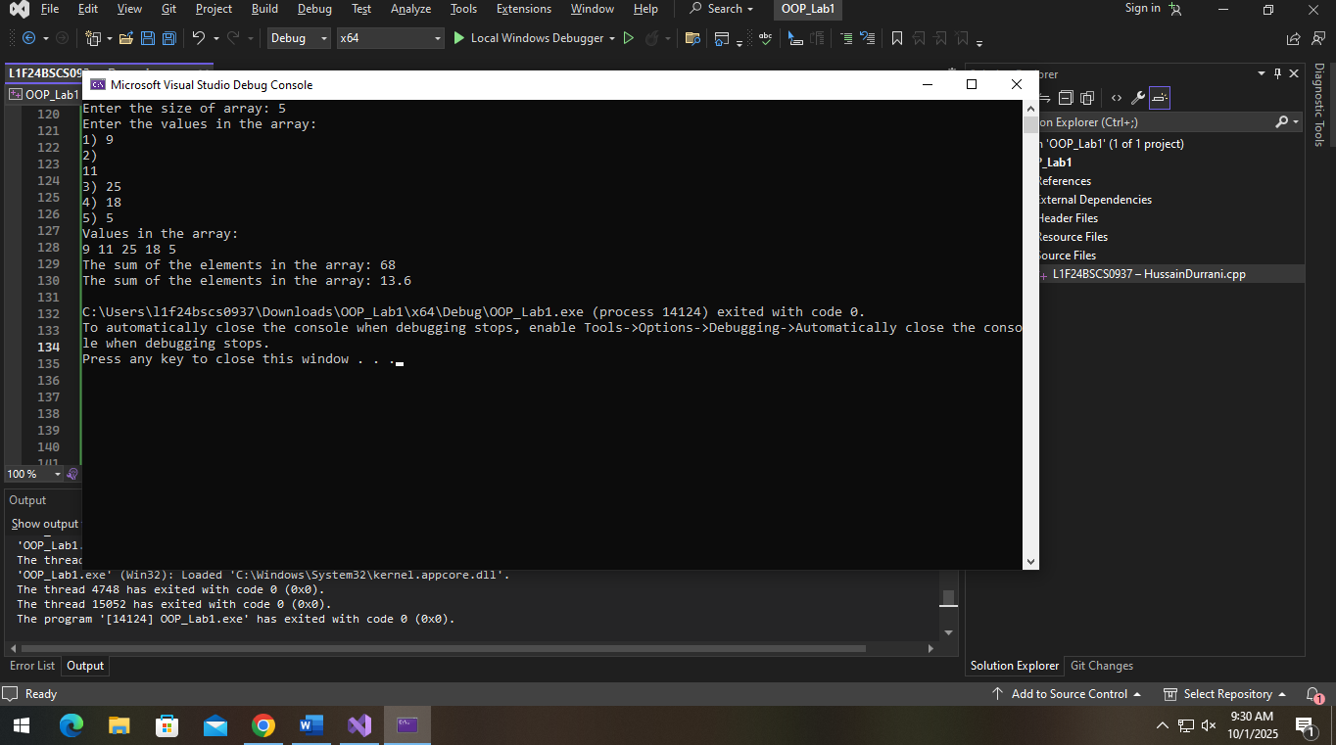

Task 06 – Dynamic Memory Allocation + Dangling Pointers
Write a C++ program that performs the following tasks:

- Dynamically allocate memory for an integer variable.
- Take a user-input value, store it in the allocated memory, and display it.
- Create a function int squareValue(int* ptr) that accepts a pointer to the integer and returns the square of the stored value.
- Display the squared result returned by the function.
- Deallocate the memory using the delete operator.
- Demonstrate the issue of a dangling pointer by attempting to access the deleted memory (after deletion, but before resetting the pointer).
- Correct the problem by assigning the pointer to NULL (or nullptr) after deletion.
- Show that reusing the same pointer after assigning it new memory works correctly (e.g., store a new value and display it).
CODE:

// Task 6:
#include <iostream>
using namespace std;

int squareValue(int* ptr) {
return (*ptr) * (*ptr);
}
int main() {
int* ptr = new int;

cout << "Enter an integer value: ";
cin >> *ptr;
cout << "You entered: " << *ptr << endl;

int squared = squareValue(ptr);
cout << "Square of the value: " << squared << endl;

delete ptr;

//cout << "After deletion, accessing ptr (dangling pointer): " << *ptr << " (undefined behavior!)" << endl;
// This is giving errors

ptr = nullptr;

ptr = new int;
cout << "Enter a new integer value: ";
cin >> *ptr;
cout << "You entered (new value): " << *ptr << endl;

delete ptr;
ptr = nullptr;

return 0;
}
OUTPUT:

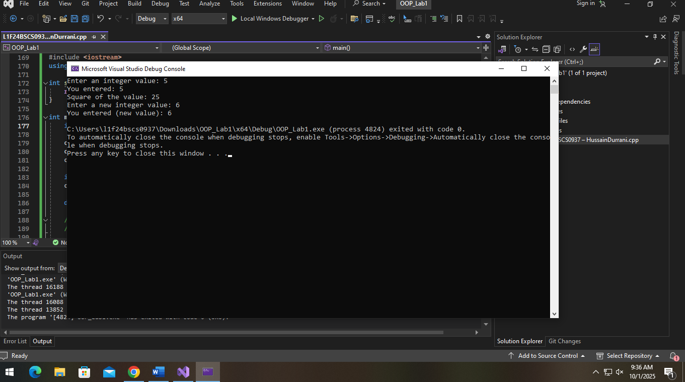

Task 07 – Dynamic Memory + Dangling Pointers+ Memory Leakage
Write a C++ program that extends the previous question with the following additional tasks:
- Reuse the same program from Question 6 (dynamic allocation, user input, squaring function, deallocation, dangling pointer, and fixing it with nullptr).
- Before deallocating the first allocated memory, assign the pointer to a new dynamically allocated memory location without calling delete.
- Show that the old memory block is now inaccessible (i.e., leaked).
- Explain (through comments) why this causes a memory leak.
- Finally, correct the issue by properly deleting the memory before reassigning the pointer.

CODE:

// Task 7:
#include <iostream>
using namespace std;

int squareValue(int* ptr) {
return (*ptr) * (*ptr);
}

int main() {
int* ptr = new int;

cout << "Enter an integer value: ";
cin >> *ptr;
cout << "You entered: " << *ptr << endl;

int squared = squareValue(ptr);
cout << "Square of the value: " << squared << endl;

// Step 2: Reassign pointer to new memory without deleting old memory first
ptr = new int;

// Step 3: Old memory block is now inaccessible (memory leak)
cout << "Pointer reassigned to new memory without deleting old memory." << endl;

cout << "Enter a new integer value: ";
cin >> *ptr;
cout << "You entered (new value): " << *ptr << endl;

// Step 5: Properly delete memory before reassigning pointer to avoid leak
// (For demonstration, delete current memory and then allocate new memory again)
delete ptr;

ptr = new int;
cout << "Enter another new integer value: ";
cin >> *ptr;
cout << "You entered (another new value): " << *ptr << endl;

delete ptr;
ptr = nullptr;

return 0;
}

/*
Explanation (Step 4):

When we assign 'ptr' to a new dynamically allocated memory location without deleting the old memory,
the original memory block becomes inaccessible. This means we lose the pointer/reference to that block,
and thus cannot free it later. This situation causes a memory leak because the allocated memory remains
reserved but cannot be reclaimed or used anymore.
*/

OUTPUT:
