University of Central Punjab
Faculty of Information Technology

Object Oriented Programming
Fall 2025

 | Lab 10
Topic | Classes in C++, access specifiers, objects, methods, constructors, association, aggregation, composition
Objective | Making students familiarize with the concepts of constructors, association, aggregation, composition
CLO | Apply object-oriented programming principles to implement real-world problems.

NAME: M. HUSSAIN DURRANI
ROLL NO: L1F24BSCS0937

Task 1: Association (One-to-One, One-to-Many, Many-to-Many)
CODE:
Passport.h
#pragma once
#include <iostream>
using namespace std;

class Passport
{
private:
int passportNumber;
string nationality;

public:
Passport(int pNum, string n) : passportNumber(pNum) {
nationality = n;
}

void setPassportNumber(int pNum) { passportNumber = pNum; }
int getPassportNumber() const { return passportNumber; }

void setNationality(string n) {
nationality = n;
}
string getNationality() const { return nationality; }

void display() const {
cout << "Nationality: " << getNationality() << ", Passport Number: " << getPassportNumber() << ".\n";
}
};

Person.h
#pragma once
#include <iostream>
#include "Passport.h"
using namespace std;

class Person
{
private:
Passport* passport;
string name;

public:
Person(string nom, Passport* pass) {
name = nom;
passport = pass;
}

void setName(string nom) {
name = nom;
}
string getName() const { return name; }

void setPassport(Passport* pass) {
passport = pass;
}

Passport* getPassport() const { return passport; }

void display() const {
cout << "Name: " << getName() << "\n";
passport->display();
}
};

Task1.cpp
#include <iostream>
#include "Passport.h"
#include "Person.h"
using namespace std;

int main() {
string name, nationality;
int passportNumber = 0;

cout << "Enter your Nationality: ";
cin >> nationality;
cout << "Enter Passport Number: ";
cin >> passportNumber;
Passport pass1(passportNumber, nationality);
cout << "\n------------------------------------------------\n";
cout << "Passport Object: \n";
pass1.display();
cout << "------------------------------------------------\n\n";

cout << "Enter your Name: ";
cin >> name;
Person per1(name, &pass1);
cout << "\n------------------------------------------------\n";
cout << "Person Object: \n";
per1.display();
cout << "-----------------------------------------------\n\n";

cout << "Enter New Passport Number: ";
cin >> passportNumber;
pass1.setPassportNumber(passportNumber);

cout << "\n------------------------------------------------\n";
cout << "Updated1 Passport Object: \n";
pass1.display();
cout << "Updated1 Person Object: \n";
per1.display();
cout << "------------------------------------------------\n\n";

cout << "Enter your New Nationality: ";
cin >> nationality;
pass1.setNationality(nationality);
cout << "\n-------------------------------------------------\n";
cout << "Updated2 Passport Object: \n";
pass1.display();
cout << "Updated2 Person Object: \n";
per1.display();
cout << "------------------------------------------------\n\n";

cout << "Enter your New Name: ";
cin >> name;
per1.setName(name);
cout << "\n------------------------------------------------\n";
cout << "Updated3 Passport Object: \n";
pass1.display();
cout << "Updated3 Person Object: \n";
per1.display();
cout << "------------------------------------------------\n\n";

return 0;
}

OUTPUT:
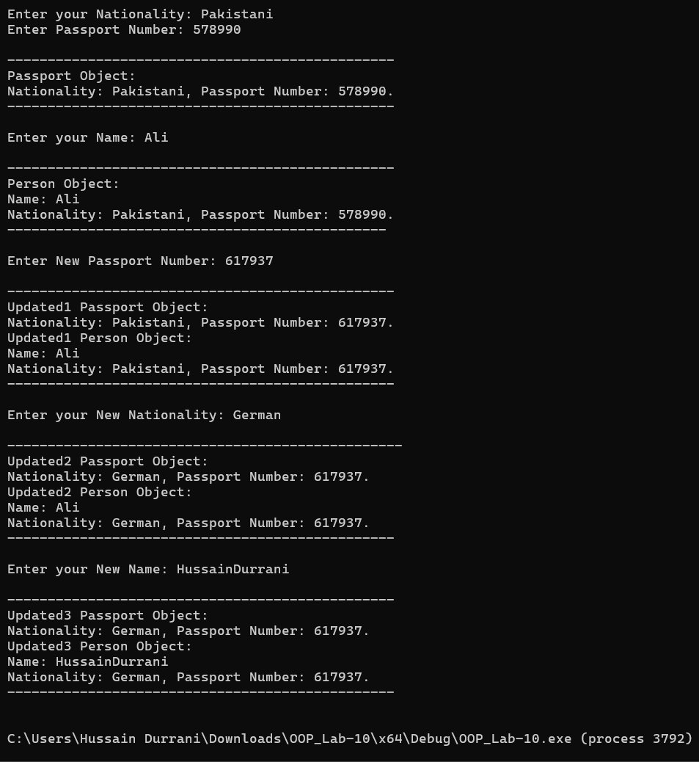

Task 2: One-to-Many Association
CODE:
Course.h
#pragma once
#include <iostream>
using namespace std;

class Course {
private:
string courseCode;
string title;

public:
Course(string code, string t) {
courseCode = code;
title = t;
}

void setCourseCode(string code) { courseCode = code; }
void setTitle(string t) { title = t; }

string getCourseCode() const { return courseCode; }
string getTitle() const { return title; }

void display() const {
cout << " [Course] " << title << " (" << courseCode << ")" << endl;
}
};

Teacher.h
#pragma once
#include <iostream>
#include "Course.h"
using namespace std;

class Teacher {
private:
string name;
Course* courses[5];
int courseCount;

public:
Teacher(string n) {
name = n;
courseCount = 0;
for (int i = 0; i < 5; i++) courses[i] = nullptr;
}

void setName(string n) { name = n; }
string getName() const { return name; }

void addCourse(Course* c) {
if (courseCount < 5) {
courses[courseCount] = c;
courseCount++;
}
else {
cout << "Error: Limit reached.\n";
}
}

int getCourseCount() const { return courseCount; }

Course* getCourse(int index) const {
if (index >= 0 && index < courseCount) {
return courses[index];
}
return nullptr;
}

void display() const {
cout << "Teacher Name: " << name << endl;
for (int i = 0; i < courseCount; i++) {
courses[i]->display();
}
}
};

Task2.cpp
#include <iostream>
#include "Course.h"
#include "Teacher.h"
using namespace std;

int main() {
string tName, cTitle, cCode;
int numCourses;

cout << "Enter Teacher's Name: ";
cin >> tName;
Teacher teacher1(tName);

cout << "How many courses does " << tName << " teach? (Max 5): ";
cin >> numCourses;

cin.ignore();

if (numCourses > 5) {
cout << "Limit is 5. Setting to 5.\n";
numCourses = 5;
}

for (int i = 0; i < numCourses; i++) {
cout << "\n--- Enter Details for Course " << i + 1 << " ---\n";

cout << "Enter Course Code: ";
cin >> cCode;

cout << "Enter Course Title: ";
cin >> cTitle;

Course* newCourse = new Course(cCode, cTitle);
teacher1.addCourse(newCourse);
}

cout << "\n------------------------------------------------\n";
cout << "FINAL TEACHER RECORD\n";
teacher1.display();
cout << "------------------------------------------------\n";

cout << "\nRetrieving Course Codes manually:\n";
for (int i = 0; i < teacher1.getCourseCount(); i++) {
cout << "Course " << i + 1 << " Code: " << teacher1.getCourse(i)->getCourseCode() << endl;
}

return 0;
}

OUTPUT:
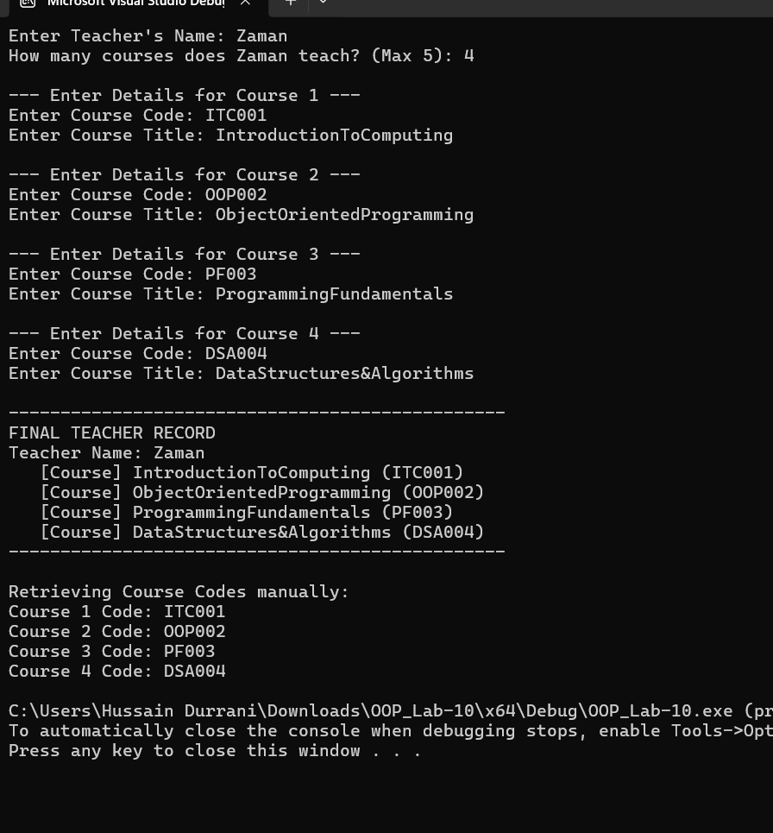

Task 3: Many-to-Many Association
CODE:
Student.h
#pragma once
#include <iostream>
using namespace std;

class Student {
private:
int studentID;
string name;

public:
Student(int id, string n) {
studentID = id;
name = n;
}
void setID(int id) { studentID = id; }
void setName(string n) { name = n; }

int getID() const { return studentID; }
string getName() const { return name; }

void display() const {
cout << "Student: " << name << " (ID: " << studentID << ")";
}
};

Club.h
#pragma once
#include <iostream>
using namespace std;

class Club {
private:
string clubName;

public:
Club(string n) {
clubName = n;
}
void setClubName(string n) { clubName = n; }
string getClubName() const { return clubName; }

void display() const {
cout << "Club: " << clubName;
}
};

Membership.h
#pragma once
#include <iostream>
#include "Student.h"
#include "Club.h"
using namespace std;

class Membership {
private:
Student* student;
Club* club;

public:
Membership(Student* s, Club* c) {
student = s;
club = c;
}
void display() const {
cout << "Membership Record:\n";
cout << " "; student->display(); cout << "\n";
cout << " Joined -> "; club->display(); cout << "\n";
}
};

Task3.cpp
#include <iostream>
#include "Student.h"
#include "Club.h"
#include "Membership.h"
using namespace std;

int main() {
int id;
string sName, cName;

cout << "--- Create Student ---\n";
cout << "Enter Student ID: ";
cin >> id;
cin.ignore();

cout << "Enter Student Name: ";
cin >> sName;
Student s1(id, sName);

cout << "\n--- Create Club ---\n";
cout << "Enter Club Name: ";
cin >> cName;
Club c1(cName);
Membership member1(&s1, &c1);
cout << "\n------------------------------------------------\n";
cout << "FINAL MEMBERSHIP RECORD\n";
member1.display();
cout << "------------------------------------------------\n";

return 0;
}

OUTPUT:
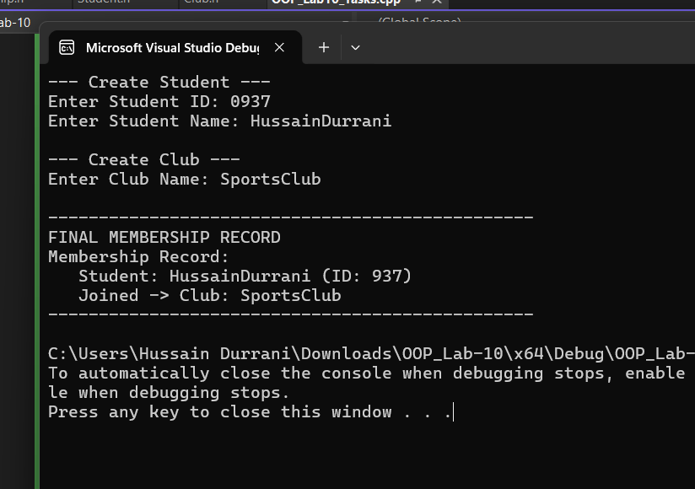

Task 4: Aggregation
CODE:
Book.h
#pragma once
#include <iostream>
using namespace std;

class Book {
private:
string title;
string author;

public:
Book(string t, string a) {
title = t;
author = a;
}

void setTitle(string t) { title = t; }
void setAuthor(string a) { author = a; }

string getTitle() const { return title; }
string getAuthor() const { return author; }

void display() const {
cout << " - '" << title << "' by " << author << endl;
}
};

Library.h
#pragma once
#include <iostream>
#include "Book.h"
using namespace std;

class Library {
private:
Book* books[10];
int bookCount;

public:
Library() {
bookCount = 0;
for (int i = 0; i < 10; i++) {
books[i] = nullptr;
}
}

void addBook(Book* b) {
if (bookCount < 10) {
books[bookCount] = b;
bookCount++;
}
else {
cout << "Library is full (Max 10 books).\n";
}
}

int getBookCount() const { return bookCount; }

void display() const {
cout << "Library Collection (" << bookCount << " books):\n";
for (int i = 0; i < bookCount; i++) {
books[i]->display();
}
}
};

Task4.cpp
#include <iostream>
#include "Book.h"
#include "Library.h"
using namespace std;

int main() {
int count;
string title, author;

Library myLibrary;
cout << "--- Create Your Library ---\n";

cout << "How many books to add? (Max 10): ";
cin >> count;
cin.ignore();

if (count > 10) count = 10;

for (int i = 0; i < count; i++) {
cout << "\nEnter details for Book " << i + 1 << ":\n";
cout << "Title: ";
cin >> title;
cout << "Author: ";
cin >> author;

Book* newBook = new Book(title, author);

myLibrary.addBook(newBook);
}

cout << "\n----------------------------------------\n";
cout << "FINAL LIBRARY CATALOG\n";
cout << "----------------------------------------\n";
myLibrary.display();

return 0;
}

OUTPUT:

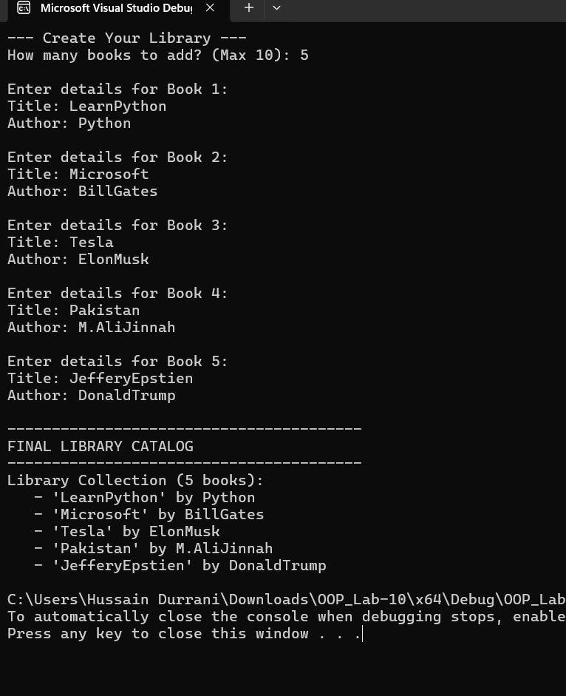

Task 5: Composition
CODE:
Engine.h
#pragma once
#include <iostream>
using namespace std;

class Engine {
private:
string type;
int horsepower;

public:
Engine() {
type = "Standard";
horsepower = 100;
}

Engine(string t, int hp) {
type = t;
horsepower = hp;
}

void setType(string t) { type = t; }
void setHP(int hp) { horsepower = hp; }

string getType() const { return type; }
int getHP() const { return horsepower; }

void display() const {
cout << "Engine Type: " << type << " | Horsepower: " << horsepower << "HP\n";
}
};

Car.h
#pragma once
#include <iostream>
#include "Engine.h"
using namespace std;

class Car {
private:
Engine* engine;

public:
Car() {
engine = new Engine();
}

Car(string type, int hp) {
engine = new Engine(type, hp);
}

~Car() {
delete engine;
cout << "(Car object destroyed, Engine deleted)\n";
}

void setEngineDetails(string type, int hp) {
engine->setType(type);
engine->setHP(hp);
}

Engine* getEngine() const { return engine; }

void display() const {
cout << "Car Details:\n";
cout << " Status: Functional\n";
cout << " ";
engine->display();
}
};

Task5.cpp
#include <iostream>
#include "Engine.h"
#include "Car.h"
using namespace std;

int main() {
string type;
int hp;

cout << "--- Car Manufacturing Plant ---\n";
cout << "Enter Engine Type (e.g., V8, Electric): ";
cin >> type;

cout << "Enter Horsepower: ";
cin >> hp;
cin.ignore();

cout << "\nBuilding Car...\n";
Car myCar(type, hp);

cout << "\n----------------------------------------\n";
cout << "FINAL CAR SPECS\n";
cout << "----------------------------------------\n";
myCar.display();

cout << "\nExiting program...\n";
return 0;
}

OUTPUT:
