University of Central Punjab
Faculty of Information Technology

Object Oriented Programming
Spring 2025

 | Lab 06
Topic | Classes in C++, access specifiers, objects, methods, constructors, destructors, Constructor Initializer List, Static Objects , array of objects, pointer to objects, array of pointers to objects, Friend functions and friend classes
Objective | Making students familiarize with the concepts of constructors, destructors, array of objects, pointer to objects, array of pointers to objects, Friend  functions and friend classes
CLO | Apply object-oriented programming principles to implement real-world problems.

Instructions:
- Indent your code.
- Comment your code.
- Use meaningful variable names.
- Plan your code carefully on a piece of paper before you implement it. • Name of the program should be same as the task name. i.e. the first program should be Task_1.cpp
- void main() is not allowed. Use int main()
- You are not allowed to use any built-in functions
- You are required to follow the naming conventions as follow:
- Variables: firstName; (no underscores allowed)
- Function: getName(); (no underscores allowed)
- ClassName: BankAccount (no underscores allowed)

Students are required to complete the following tasks in lab timings.

Task 1: Static Object
CODE:
Task1.cpp
#include "Counter.h"
#include <iostream>
using namespace std;

void performTask() {
static Counter c;

c.increment();
c.displayCount();
}

int main() {
cout << "First call to performTask():" << endl;
performTask();

cout << "\nSecond call to performTask():" << endl;
performTask();

cout << "\nThird call to performTask():" << endl;
performTask();

cout << "\nProgram ending..." << endl;

return 0;
}

Counter.h
#pragma once
#include <iostream>
using namespace std;
class Counter {
private:
int count;

public:
Counter() : count(0) {
cout << "Counter initialized." << endl;
}

void increment() { count++; }

void displayCount() const {
cout << "Current count: " << count << endl;
}

~Counter() {
cout << "Counter destroyed." << endl;
}
};

OUTPUT:
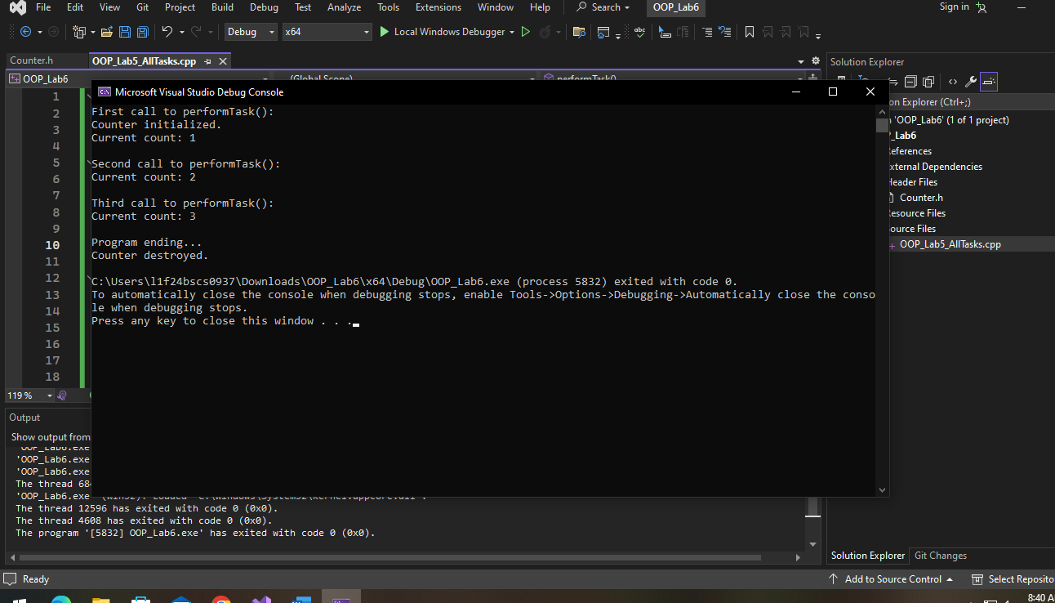

Task 2: Arrays of Objects
CODE:
Task2.cpp
#include "Student.h"
#include <iostream>
using namespace std;

int main() {
int count = 5;
Student* students[5];

for (int i = 0; i < count; i++) {
char name[100];
cout << "Enter the name of the Student " << i+1 << ": ";
cin.getline(name, 100);

int marks = 0;
cout << "Enter marks of Student " << i+1 << ": ";
cin >> marks;
cin.ignore();
students[i] = new Student(name, marks);
}

cout << "Student Details: \n";
for (int i = 0; i < count; i++) {
students[i]->display();
}

return 0;
}

Student.h
#pragma once
#include <iostream>
using namespace std;
class Student {
private:
char* name;
int marks;

int getLength(const char* src) {
int len = 0;
while (src[len] != '\0') { len++; }
return len;
}

char* copyString(const char* src) {
int length = getLength(src);
char* dest = new char[length + 1];
for (int i = 0; i < length; i++) {
dest[i] = src[i];
}
dest[length] = '\0';
return dest;
}

public:
Student() : marks(0) {
name = copyString("Unknown");
}

Student(char* n, int m) : marks(m) {
name = copyString(n);
}

~Student() {
delete[] name;
name = nullptr;
}

int getMarks() { return marks; }
void setMarks(int m) { marks = m; }

char* getName() { return name; }
void setName(char* n) {
name = copyString(n);
}

void display() {
cout << "Student's Name: " << name << ", Marks = " << marks << " \n";
}

};

OUTPUT:
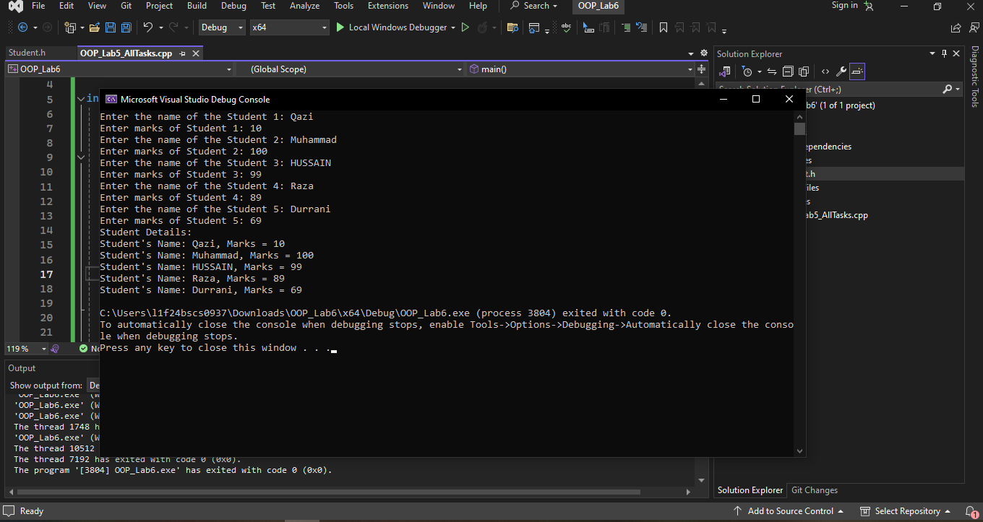
Task3: Pointers to Objects
CODE:
Task3.cpp
#include "Book.h"
#include <iostream>
using namespace std;

int main() {
Book* myBookPtr = nullptr;

char title[100];
float price;

cout << "Enter title of book: ";
cin.getline(title, 100);

cout << "Enter price of book: ";
cin >> price;

myBookPtr = new Book(title, price);

myBookPtr->display();

cout << "\nDeallocating the Book object..." << endl;
delete myBookPtr;
myBookPtr = nullptr;

return 0;
}

Book.h
#pragma once
#include <iostream>
using namespace std;
class Book {
private:
char* title;
float price;

int getLength(const char* src) {
int len = 0;
while (src[len] != '\0') { len++; }
return len;
}

char* copyString(const char* src) {
int length = getLength(src);
char* dest = new char[length + 1];
for (int i = 0; i < length; i++) {
dest[i] = src[i];
}
dest[length] = '\0';
return dest;
}

public:
Book() : price(0.0f) {
title = copyString("Unknown");
cout << "Default Book object created." << endl;
}

Book(const char* t, float p) : price(p) {
if (t != nullptr) {
title = copyString(t);
}
else {
title = new char[1];
title[0] = '\0';
}
}

~Book() {
delete[] title;
}

void setTitle(const char* t) {
delete[] title;

if (t != nullptr) {
title = copyString(t);
}
else {
title = new char[1];
title[0] = '\0';
}
}

void setPrice(float p) {
price = p;
}

void display() const {
cout << "\nBook Details:" << endl;
cout << "Title: " << title << endl;
cout << "Price: " << price << endl;
}

};

OUTPUT:
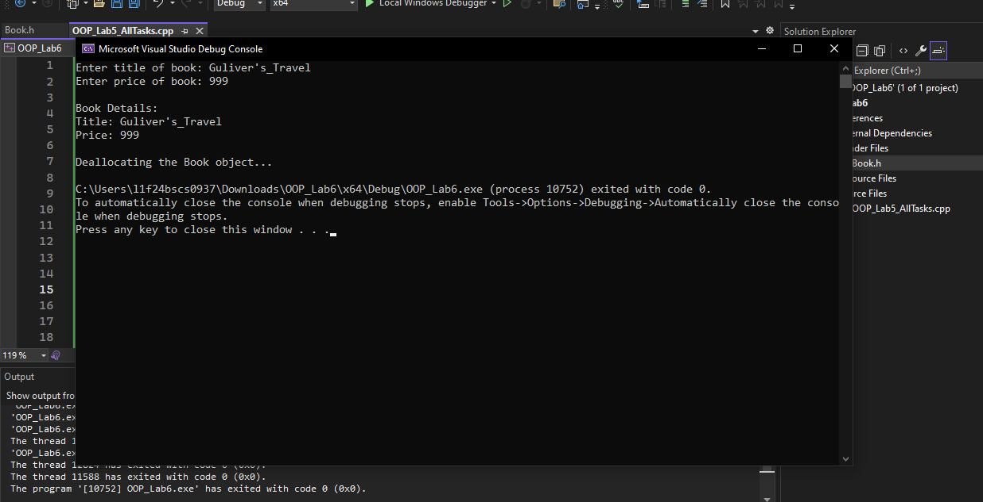
Task 4: Array of Pointers to Objects
CODE:
Task4.cpp
#include "Employee.h"
#include <iostream>
using namespace std;

int main() {
const int NUM_EMPLOYEES = 3;

Employee* employees[NUM_EMPLOYEES];

for (int i = 0; i < NUM_EMPLOYEES; ++i) {
int inputId;
double inputSalary;

cout << "Enter details for Employee " << i + 1 << ":" << endl;
cout << "Enter ID: ";
cin >> inputId;
cout << "Enter Salary: ";
cin >> inputSalary;

employees[i] = new Employee(inputId, inputSalary);
}

cout << "--- Employee Details ---" << endl;
for (int i = 0; i < NUM_EMPLOYEES; ++i) {
if (employees[i] != nullptr) {
employees[i]->display();
}
}

cout << "--- Deallocating Memory ---" << endl;
for (int i = 0; i < NUM_EMPLOYEES; ++i) {
delete employees[i];
employees[i] = nullptr;
cout << "Deleted employee object at index " << i << endl;
}

return 0;
}

Employee.h
#pragma once
#include <iostream>
using namespace std;
class Employee {
private:
int id;
double salary;

public:
Employee() : id(1), salary(1000.10) {}

Employee(int i, double s) : id(i), salary(s) {}

void setId(int i) { id = i; }
int getId() const { return id; }

void setSalary(double s) { salary = s; }
double getSalary() const { return salary; }

void display() const {
cout << "Employee ID: " << id << ", Salary: " << salary << endl;
}

~Employee() {
}
};

OUTPUT:
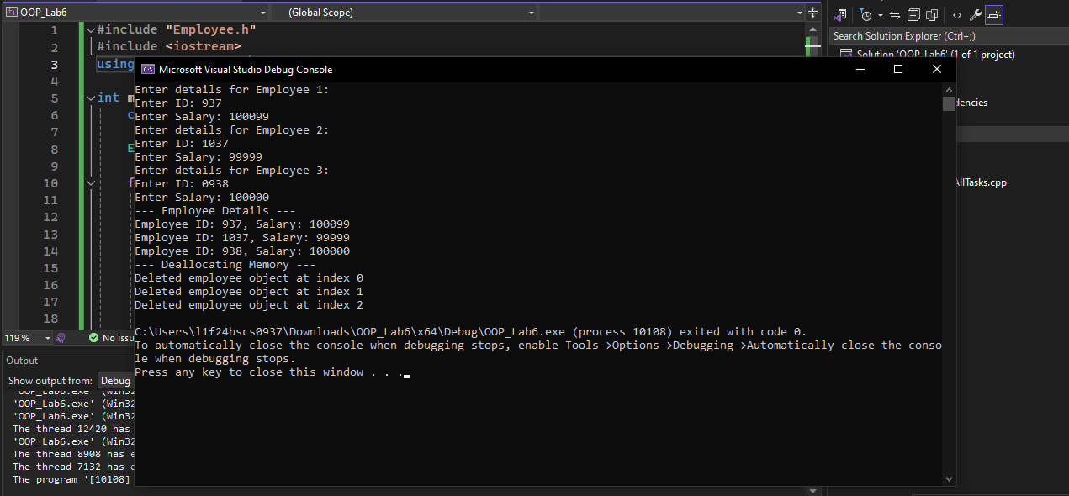
Task 5: Friend Functions and Friend Classes
CODE:
Task5.cpp
#include <iostream>
#include "Rectangle.h"
#include "Calculator.h"

using namespace std;

Rectangle::Rectangle(int l, int w) : length(l), width(w) {}

int calculateArea(const Rectangle& r) {
return r.length * r.width;
}

int Calculator::area(const Rectangle& r) {
return r.length * r.width;
}

int main() {
int inputLength, inputWidth;

cout << "Enter the length of the rectangle: ";
cin >> inputLength;

cout << "Enter the width of the rectangle: ";
cin >> inputWidth;

Rectangle rect(inputLength, inputWidth);

cout << "--- Friend Function Demo ---" << endl;
int area1 = calculateArea(rect);
cout << "Area calculated by standalone friend function: " << area1 << endl;

cout << "--- Friend Class Demo ---" << endl;
Calculator calc;
int area2 = calc.area(rect);
cout << "Area calculated by Calculator's member function: " << area2 << endl;

return 0;
}

Rectangle.h
#pragma once
#include <iostream>
using namespace std;

class Calculator;

class Rectangle {
private:
int length;
int width;

public:
Rectangle(int l, int w);

friend int calculateArea(const Rectangle& r);

friend class Calculator;

~Rectangle() {}
};

Calculator.h
#pragma once
#include "Rectangle.h"

class Calculator {
public:
int area(const Rectangle& r);
};

OUTPUT:
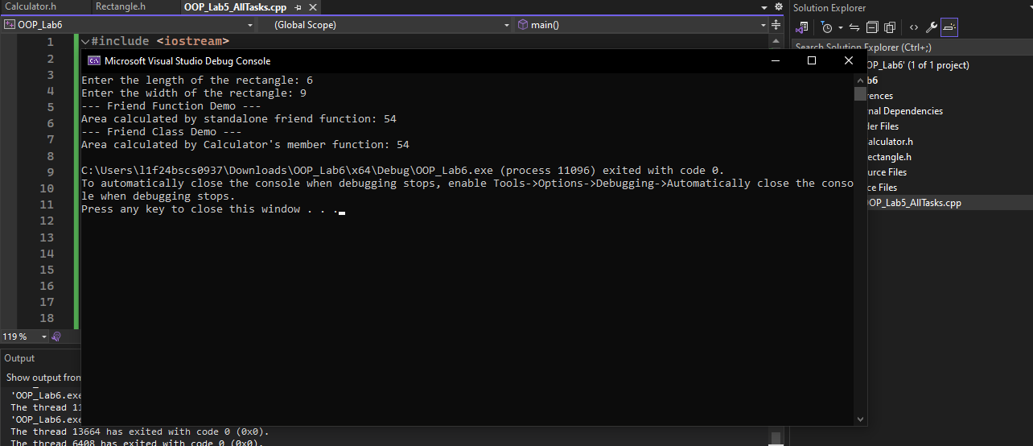

Task 6: Menu Based
CODE:
Task6.cpp
#include "Rectangle.h"
#include "Calculator.h"
#include "Book.h"
#include "Counter.h"
#include "Employee.h"
#include "Student.h"
#include <iostream>
using namespace std;

Rectangle::Rectangle(int l, int w) : length(l), width(w) {}

int calculateArea(const Rectangle& r) {
return r.length * r.width;
}

int Calculator::area(const Rectangle& r) {
return r.length * r.width;
}

void performTask() {
static Counter c;

c.increment();
c.displayCount();
}

int main() {
int choice;
cout << "---------------------------------------------------------\n";
cout << "Press 1 Testing Pointer to Objects & (Static Object)\n";
cout << "Press 2 for testing Array of Pointers to Objects\n";
cout << "Press 3 for testing Friend functions and friend classes\n";
cout << "Press 4 for exit.\n";
cout << "Enter your choice: ";
cin >> choice;
cout << "---------------------------------------------------------\n";
cin.ignore();

while (choice != 4) {
if (choice == 1) {

Book* myBookPtr = nullptr;

char title[100];
float price;

cout << "Enter title of book: ";
cin.getline(title, 100);

cout << "Enter price of book: ";
cin >> price;

myBookPtr = new Book(title, price);

myBookPtr->display();

cout << "\nDeallocating the Book object..." << endl;
delete myBookPtr;
myBookPtr = nullptr;

// ------------------------------------

cout << "First call to performTask():" << endl;
performTask();

cout << "\nSecond call to performTask():" << endl;
performTask();

cout << "\nThird call to performTask():" << endl;
performTask();

cout << "\nProgram ending..." << endl;

// ------------------------------------
}
else if (choice == 2) {
int count = 5;
Student* students[5];

for (int i = 0; i < count; i++) {
char name[100];
cout << "Enter the name of the Student " << i + 1 << ": ";
cin.getline(name, 100);

int marks = 0;
cout << "Enter marks of Student " << i + 1 << ": ";
cin >> marks;
cin.ignore();
students[i] = new Student(name, marks);
}

cout << "Student Details: \n";
for (int i = 0; i < count; i++) {
students[i]->display();
}

// ------------------------------------

const int NUM_EMPLOYEES = 3;

Employee* employees[NUM_EMPLOYEES];

for (int i = 0; i < NUM_EMPLOYEES; ++i) {
int inputId;
double inputSalary;

cout << "Enter details for Employee " << i + 1 << ":" << endl;
cout << "Enter ID: ";
cin >> inputId;
cout << "Enter Salary: ";
cin >> inputSalary;

employees[i] = new Employee(inputId, inputSalary);
}

cout << "--- Employee Details ---" << endl;
for (int i = 0; i < NUM_EMPLOYEES; ++i) {
if (employees[i] != nullptr) {
employees[i]->display();
}
}

cout << "--- Deallocating Memory ---" << endl;
for (int i = 0; i < NUM_EMPLOYEES; ++i) {
delete employees[i];
employees[i] = nullptr;
cout << "Deleted employee object at index " << i << endl;
}

// ------------------------------------
}
else if (choice == 3) {
int inputLength, inputWidth;

cout << "Enter the length of the rectangle: ";
cin >> inputLength;

cout << "Enter the width of the rectangle: ";
cin >> inputWidth;

Rectangle rect(inputLength, inputWidth);

cout << "--- Friend Function Demo ---" << endl;
int area1 = calculateArea(rect);
cout << "Area calculated by standalone friend function: " << area1 << endl;

cout << "--- Friend Class Demo ---" << endl;
Calculator calc;
int area2 = calc.area(rect);
cout << "Area calculated by Calculator's member function: " << area2 << endl;
}
else {
cout << "Invalid...\n";
}
cout << "\n---------------------------------------------------------\n";
cout << "Press 1 Testing Pointer to Objects & (Static Object)\n";
cout << "Press 2 for testing Array of Pointers to Objects\n";
cout << "Press 3 for testing Friend functions and friend classes\n";
cout << "Press 4 for exit.\n";
cout << "Enter your choice: ";
cin >> choice;
cin.ignore();
cout << "---------------------------------------------------------\n";

}

return 0;
}

OUTPUT:
