

Subject: Object Oriented Programming - Lab | Course Code: CP221 | Exam: Mid Term
Duration: 1h 30 Mins | Marks: 45 | Semester: Fall 2025

CLO | Apply object-oriented programming principles to implement real-world problems

NAME: M. HUSSAIN DURRANI
ROLL NO: L1F24BSCS0937

Q1. Library Bookstore System
Book.h
#pragma once
#include <iostream>
using namespace std;

int getLength(const char* str) {
int length = 0;
while (str[length] != '\0') { length++; }
return length;
}

char* copyString(const char* src) {
int len = getLength(src);
char* dest = new char[len + 1];
for (int i = 0; i < len; i++) {
dest[i] = src[i];
}
dest[len] = '\0';
return dest;
}

class Book
{

private:
char* title;
float price;
int uniqueBookID;
static int totalBooks;

public:
Book(): price(0.0){
title = copyString("Untitled");
++totalBooks;
uniqueBookID = ((totalBooks + 1) * 10);
}

Book(char* t, float p) : price(p) {
title = copyString(t);
++totalBooks;
uniqueBookID = ((totalBooks + 1) * 10);
}

Book(const Book& obj) : price(obj.price) {
title = copyString(obj.title);
++totalBooks;
uniqueBookID = ((totalBooks + 1) * 10);
}

~Book() {
delete[] title;
title = nullptr;
--totalBooks;
}

char* getTitle() { return title; }
void setTitle() {
char t[100];
cin.getline(t, 100);

delete[] title;
title = copyString(t);
}

float getPrice() { return price; }
void setPrice(float p) {
if (p > 0) {
price = p;
}
else {
cout << "This is not a valid price. \n";
}
}

int getUniqueBookID() { return uniqueBookID; }

static int getTotalBooks() { return totalBooks; }

void display() {
cout << "\n-----------------------------------------------------------\n";
cout << "Title: \"" << getTitle() << "\", Price: " << getPrice() << ". \n";
cout << "Book's Unique ID: " << getUniqueBookID() << ". \n";
cout << "-------------------------------------------------------------\n\n";
}

void operator +(const Book& obj){
if (obj.price > price) {
cout << obj.title << " ($" << obj.price << ") \n";
}
else {
cout << title << " ($" << price << ") \n";
}
}

};
OOP-Lab_MID_Q1.cpp
#include "Book.h"
#include <iostream>
using namespace std;

int Book::totalBooks = 0;

int main() {
char title[100];
float price;

Book book1;
cout << "Default Constructor: \n";
book1.display();
cout << "Enter the Title of the Book 1: ";
book1.setTitle();
cout << "Enter Price of the Book 1: ";
cin >> price;
book1.setPrice(price);
cout << "Values Set using Setters: \n";
book1.display();

cout << "Enter Title of Book 2: ";
cin.ignore();
cin.getline(title, 100);
cout << "Enter Price of the Book 2: ";
cin >> price;
Book book2(title, price);
cout << "\nParameterized Constructor: \n";
book2.display();

cout << "\nCopy Constructor: \n";
Book book3 = book1;
book3.display();

cout << "Total Books so far are: " << Book::getTotalBooks() << ". \n";

cout << "Comparing Books using Operator Overloading: \n";
book1 + book2;

return 0;
}

OUTPUT:
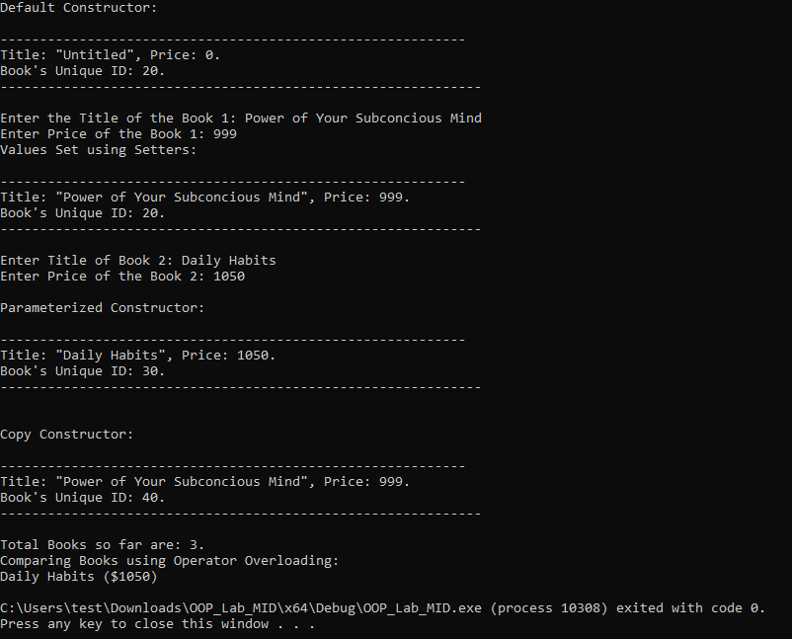

Q2. Library Bookstore Extension
Book.h
// Q2 -> Extended Version of Q1
// Advanced Bookstore Management
#pragma once
#include <iostream>
using namespace std;

int getLength(const char* str) {
int length = 0;
while (str[length] != '\0') { length++; }
return length;
}

char* copyString(const char* src) {
int len = getLength(src);
char* dest = new char[len + 1];
for (int i = 0; i < len; i++) {
dest[i] = src[i];
}
dest[len] = '\0';
return dest;
}

char* concatenateString(const char* str1, const char* str2) {
int len1 = getLength(str1);
int len2 = getLength(str2);
char* combined = new char[len1 + len2 + 2];
int index = 0;
while (index < len1) { combined[index] = str1[index++]; }
combined[index++] = ' ';
while (index < len2) { combined[index] = str2[index++]; }
combined[index] = '\0';
return combined;
}

class Book
{

private:
char* title;
char* author;
float price;
int uniqueBookID;
static int totalBooks;

public:
Book(): price(0.0){
title = copyString("Untitled");
++totalBooks;
uniqueBookID = ((totalBooks + 1) * 10);
}

Book(char* t, float p) : price(p) {
title = copyString(t);
++totalBooks;
uniqueBookID = ((totalBooks + 1) * 10);
}

void setDetails(char* title, char* author, float price) {
if (price >= 0){ this->price = price; }
else { cout << "Invalid Price. \n"; this->price = 0.0; }
this->title = copyString(title);
uniqueBookID = ((totalBooks + 1) * 10);
}

Book(const Book& obj) : price(obj.price) {
title = copyString(obj.title);
++totalBooks;
uniqueBookID = ((totalBooks + 1) * 10);
}

~Book() {
delete[] title;
title = nullptr;
--totalBooks;
}

friend void findCostliestBook(Book* arr[]);

friend void sortBooksByPrice(Book* arr[]);

char* getTitle() { return title; }
void setTitle() {
char t[100];
cin.getline(t, 100);

delete[] title;
title = copyString(t);
}

float getPrice() { return price; }
void setPrice(float p) {
if (p > 0) {
price = p;
}
else {
cout << "This is not a valid price. \n";
}
}

char* getAuthor() { return author; }
void setAuthor() {
char a[100];
cin.getline(a, 100);

delete[] author;
author = copyString(a);
}

int getUniqueBookID() { return uniqueBookID; }

static int getTotalBooks() { return totalBooks; }

void display() {
cout << "\n-------------------------------------------------------------------------------------\n";
cout << "Book ID: " << getUniqueBookID() << "\n";
cout << "Title: " << getTitle() << ", Author: " << getAuthor() << ", Price: "<< getPrice() << " \n";
cout << "----------------------------------------------------------------------------------------\n\n";
}

void operator +(const Book& obj){
if (obj.price > price) {
cout << obj.title << " ($" << obj.price << ") \n";
}
else {
cout << title << " ($" << price << ") \n";
}
}

};
OOP-Lab_MID_Q2.cpp
#include "Book.h"
#include <iostream>
using namespace std;

int Book::totalBooks = 0;

// Sort Books array by price
void sortBooksByPrice(Book* arr[]) {
Book* tempbook = nullptr;
float maxBookPrice = arr[0]->price;
for (int i = 0; arr[i] != nullptr; i++) {
if (arr[i+1]->price > arr[i]->price) {
tempbook = arr[i + 1];
arr[i] = arr[i + 1];
arr[i] = tempbook;
}
}

cout << "(Sorted Successfully)\n";
}

// Finding Costliest Book (friend Func)
void findCostliestBook(Book* arr[]) {
int MaxPriceIndex;
float maxPrice = arr[0]->price;
for (int i = 1; arr[i] != nullptr; i++) {
if (arr[i]->price > maxPrice) { maxPrice = arr[i]->price; }
MaxPriceIndex = i;
}
cout << "Book ID: " << arr[MaxPriceIndex]->uniqueBookID << ", Title: " << arr[MaxPriceIndex]->title << ", Price: $" << arr[MaxPriceIndex]->price <<". \n";
}

int main() {
char title[100];
char author[100];
float price;
const int MAX_BOOKS = 10;
Book* books[MAX_BOOKS] = { nullptr };

int n = 0;
cout << "How many Books do you want to add? ";
cin >> n;
cin.ignore();
int index;

for (int i = 0; i < n; i++) {
cout << "Enter Title of Book " << i + 1 << ": ";
cin.getline(title, 100);
cout << "Enter Author: ";
cin.getline(author, 100);
cout << "Enter Price: ";
cin >> price;
index = Book::getTotalBooks();
books[index]->setDetails(title, author, price);
cin.ignore();
}

cout << "BookStore Inventory: \n";
for (int i = 0; i < n; i++) {
books[i]->display();
}

cout << "Costliest Book (Using Friend Function): \n";
findCostliestBook(books);

cout << "Sorting books by price using friend function\n";
sortBooksByPrice(books);
for (int i = 0; i < n; i++) {
books[i]->display();
}

cout << "Total Books in System: " << Book::getTotalBooks() << ". \n";

for (int i = 0; i < n; i++) {
delete books[i];
}

return 0;
}

OUTPUT:

