
Object Oriented Programming
Assignment 1
NAME: M. HUSSIAN DURRANI
ROLL NO: L1F24BSCS0937
SECTION: C-9

Question #1: You are designing a class Book for a library system. Each book has a title, author, price, Available Quantity, and Category of the book. You also need a function that calculates a discounted price, and Order a Book for purchase based on a given discount percentage. Make sure all data members should not be accessible for outer programing world. 1 constructor set all data member default values, and another should initialize it to fixed values.

CODE:
Book.h
#pragma once
#include <iostream>
using namespace std;

class Book {

private:
char* title;
char* author;
double price;
int availableQuantity;
char* category;

int findLength(const char* src) const {
int len = 0;
for (int i = 0; src[i]; i++) len++;
return len;
}

char* copyString(const char* src) {
if (src == nullptr) {
return nullptr;
}
int length = findLength(src);
char* dest = new char[length + 1];
for (int i = 0; i < length; i++) {
dest[i] = src[i];
}
dest[length] = '\0';
return dest;
}

public:
Book() {
title = copyString("Unknown");
author = copyString("Unknown");
price = 0.0;
availableQuantity = 0;
category = copyString("None");
}

Book(const char* bookTitle, const char* bookAuthor, double bookPrice, int bookAQ, const char* bookCategory) {
title = copyString(bookTitle);
author = copyString(bookAuthor);
price = bookPrice;
availableQuantity = bookAQ;
category = copyString(bookCategory);
}

~Book() {
delete[] title;
delete[] author;
delete[] category;
title = nullptr;
author = nullptr;
category = nullptr;
}

Book(const Book& other) {
title = copyString(other.title);
author = copyString(other.author);
price = other.price;
availableQuantity = other.availableQuantity;
category = copyString(other.category);
}

Book& operator=(const Book& other) {
if (this == &other) {
return *this;
}

delete[] title;
delete[] author;
delete[] category;

title = copyString(other.title);
author = copyString(other.author);
price = other.price;
availableQuantity = other.availableQuantity;
category = copyString(other.category);

return *this;
}

double calculateDiscountedPrice(double discountPercentage) const {
if (discountPercentage < 0.0 || discountPercentage > 100.0) {
return price;
}
return price * (1.0 - (discountPercentage / 100.0));
}

bool orderBook(int quantity) {
if (quantity <= 0) {
cout << "Order quantity must be positive.\n";
return false;
}
if (quantity <= availableQuantity) {
availableQuantity -= quantity;
cout << "Order successful. " << quantity << " copies purchased.\n";
return true;
}
else {
cout << "Order failed. Only " << availableQuantity << " copies available.\n";
return false;
}
}

char* getTitle() { return title; }

void display() const {
cout << "---------------------------------\n";
cout << "Title: " << (title ? title : "N/A") << "\n";
cout << "Author: " << (author ? author : "N/A") << "\n";
cout << "Category: " << (category ? category : "N/A") << "\n";
cout << "Price: $" << price << "\n";
cout << "Available: " << availableQuantity << " copies\n";
cout << "---------------------------------\n";
}
};

Q1_Solved.cpp
#include "Book.h"
#include <iostream>
using namespace std;

int main() {
Book b1;
cout << "--- Default Book ---\n";
b1.display();

char title[100];
cout << "Enter the Title of the Book: ";
cin.getline(title, 100);
char author[100];
cout << "Enter the name of Author of the Book: ";
cin.getline(author, 100);
double price;
cout << "Enter the price of the book: ";
cin >> price;
cout << "Enter the available quantity of the book: ";
int quantity;
cin >> quantity;
char category[100];
cout << "Enter the category of the book: ";
cin.ignore();
cin.getline(category, 100);

Book b2(title, author, price, quantity, category);
cout << "\n--- Parameterized Book ---\n";
b2.display();

double discount = 15.0;
cout << "Price of '" << b2.getTitle() << "' after " << discount << "% discount: $";
cout << b2.calculateDiscountedPrice(discount) << "\n\n";

int temp;
cout << "Enter how many books you want: ";
cin >> temp;
b2.orderBook(temp);
cout << "After ordering " << temp << " copies:\n";
b2.display();

cout << "Enter how many more books you want: ";
cin >> temp;
b2.orderBook(temp);
b2.display();

return 0;
}

OUTPUT:
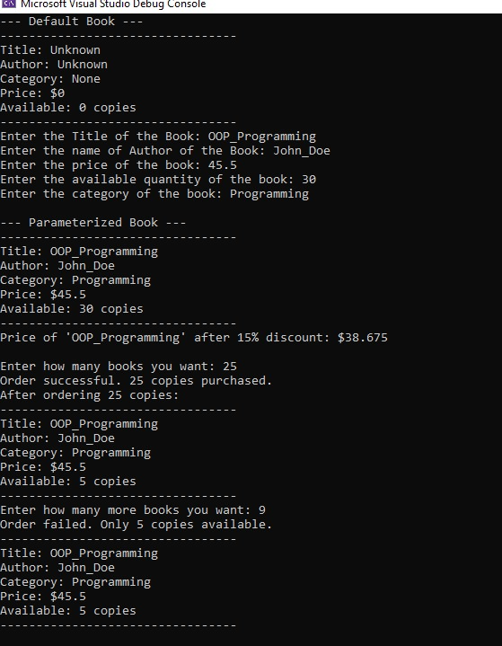

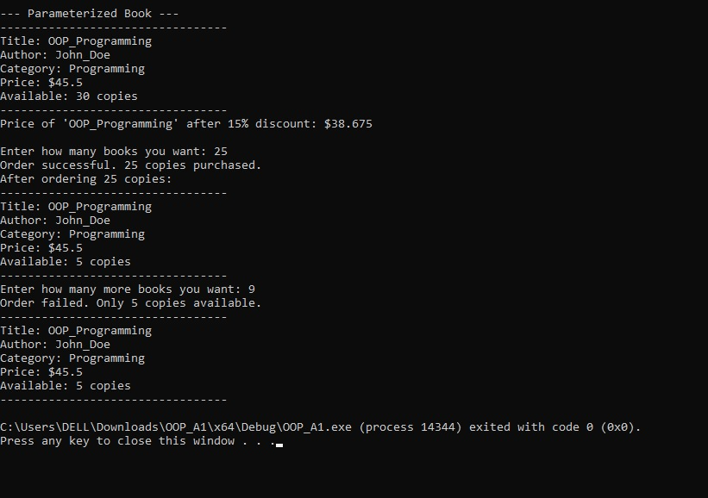
Question #2: Write a class Car that has:
• Data members: brand, model, and price.
• A default constructor that sets default values ("Unknown", "N/A", 0).
• Constructor Overloads take all values
• A function display() that shows all details.
Task:
1. Create two objects: one using the default constructor and another using a parameterized constructor.
2. Display both cars’ details.
3. Use getter and setter function to set and get the car attributes values

CODE:
Car.h
#pragma once
#include <iostream>
using namespace std;

class Car {
private:
char* brand;
char* model;
double price;

int findLength(const char* src) const {
int len = 0;
for (int i = 0; src[i]; i++) len++;
return len;
}

char* copyString(const char* src) {
if (src == nullptr) {
return nullptr;
}
int length = findLength(src);
char* dest = new char[length + 1];
for (int i = 0; i < length; i++) {
dest[i] = src[i];
}
dest[length] = '\0';
return dest;
}

public:
Car() {
brand = copyString("Unknown");
model = copyString("N/A");
price = 0.0;
}

Car(const char* carBrand, const char* carModel, double carPrice) {
brand = copyString(carBrand);
model = copyString(carModel);
price = carPrice;
}

~Car() {
delete[] brand;
delete[] model;
brand = nullptr;
model = nullptr;
}

Car(const Car& other) {
brand = copyString(other.brand);
model = copyString(other.model);
price = other.price;
}

void setBrand(const char* b) {
if (brand != nullptr) {
delete[] brand;
}
brand = copyString(b);
}

void setModel(const char* m) {
if (model != nullptr) {
delete[] model;
}
model = copyString(m);
}

void setPrice(double p) { price = p; }

char* getBrand() const { return brand; }
char* getModel() const { return model; }
double getPrice() const { return price; }

void display() const {
cout << "----------------------------------------------------------------------\n";
cout << "Car Details: " << "Brand: "
<< (brand ? brand : "N/A") << ", Model: "
<< (model ? model : "N/A") << ", Price: $"
<< price << "\n";
cout << "----------------------------------------------------------------------\n";
}
};

Q2_Solved.cpp
#include "Car.h"
#include <iostream>
using namespace std;

int main() {
Car car1;

char brand[100], model[100];
double price;
cout << "Enter the BRAND of the car: ";
cin.getline(brand, 100);
cout << "Enter the MODEL of the car: ";
cin.getline(model, 100);
cout << "Enter the price of the car: ";
cin >> price;
Car car2(brand, model, price);

cout << "\n--- Initial Car Details ---\n";
car1.display();
car2.display();

cin.ignore();
cout << "Enter the BRAND of the car: ";
cin.getline(brand, 100);
cout << "Enter the MODEL of the car: ";
cin.getline(model, 100);
cout << "Enter the price of the car: ";
cin >> price;
cout << "\n--- Updating Car 1 ---\n";
car1.setModel(brand);
car1.setBrand(model);
car1.setPrice(price);

cout << "Car 1's new brand (via getter): " << car1.getBrand() << "\n";
cout << "Car 1's new model (via getter): " << car1.getModel() << "\n";
cout << "Car 1's new price (via getter): " << car1.getPrice() << "\n";

cout << "\n--- Final Car Details ---\n";
car1.display();
car2.display();

return 0;
}

OUTPUT:
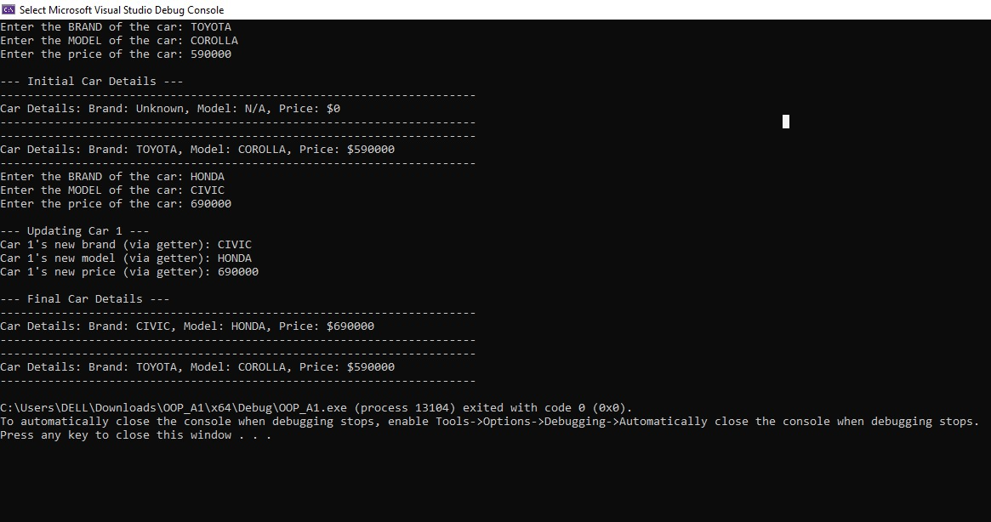

Question #3: Create a class BankAccount with:
• Private data members: accountNumber, balance, branch number.
• Setter functions for Account number and balance (that also prevents negative values).
• Getter functions to get account no or balance values
• A function deposit() to add money.
• A function withdraw() that subtracts money only if enough balance exists.
• A function display() to show account info.
• A function Bank_Transfer() deposit an account and withdraw from other account
• A function Bill_Pyment() will take bill number and type of bill and paid that from the account.
All functions should be in working conditions.

CODE:
BankAccount.h
#pragma once
#include <iostream>
using namespace std;

class BankAccount {
private:
int accountNumber;
double balance;
int branchNumber;

public:
BankAccount() {
accountNumber = 0;
balance = 0.0;
branchNumber = 0;
}

BankAccount(int acc, double bal, int br) {
accountNumber = acc;
if (bal < 0.0) {
balance = 0.0;
}
else {
balance = bal;
}
branchNumber = br;
}

void setAccountNumber(int acc) {
accountNumber = acc;
}

void setBalance(double bal) {
if (bal >= 0.0) {
balance = bal;
}
else {
cout << "Error: Cannot set a negative balance.\n";
}
}

int getAccountNumber() const { return accountNumber; }
double getBalance() const { return balance; }
int getBranchNumber() const { return branchNumber; }

void deposit(double amount) {
if (amount > 0.0) {
balance += amount;
cout << "Deposited $" << amount << ". New balance: $" << balance << "\n";
}
else {
cout << "Error: Deposit amount must be positive.\n";
}
}

bool withdraw(double amount) {
if (amount <= 0.0) {
cout << "Error: Withdrawal amount must be positive.\n";
return false;
}
if (amount <= balance) {
balance -= amount;
cout << "Withdrew $" << amount << ". New balance: $" << balance << "\n";
return true;
}
else {
cout << "Error: Insufficient funds for withdrawal of $" << amount << ".\n";
return false;
}
}

void bankTransfer(BankAccount& recipient, double amount) {
cout << "--- Transferring $" << amount << " from " << accountNumber << " to " << recipient.accountNumber << " ---\n";
if (this->withdraw(amount)) {
recipient.deposit(amount);
cout << "--- Transfer Successful ---\n";
}
else {
cout << "--- Transfer Failed --- \n";
}
}

void billPayment(int billNumber, const char* billType, double amount) {
cout << "--- Paying Bill #" << billNumber << " (" << billType << ") of $" << amount << " ---\n";
if (withdraw(amount)) {
cout << "--- Bill Payment Successful ---\n";
}
else {
cout << "--- Bill Payment Failed --- \n";
}
}

void display() const {
cout << "--------------------------------------\n";
cout << "Account #: " << accountNumber << "\n";
cout << "Branch #: " << branchNumber << "\n";
cout << "Balance: $" << balance << "\n";
cout << "--------------------------------------\n";
}
};

Q3_Solved.cpp
#include "BankAccount.h"
#include <iostream>
using namespace std;

int main() {
int accNum, branchNum;
double balance;
cout << "Enter ACCOUNT NUMBER: ";
cin >> accNum;
cout << "Enter BALANCE: ";
cin >> balance;
cout << "Enter BRANCH NUMBER: ";
cin >> branchNum;
BankAccount acc1(accNum, balance, branchNum);

cout << "\nEnter ACCOUNT NUMBER: ";
cin >> accNum;
cout << "Enter BALANCE: ";
cin >> balance;
cout << "Enter BRANCH NUMBER: ";
cin >> branchNum;
BankAccount acc2(accNum, balance, branchNum);

cout << "--- Initial Account Status ---\n";
acc1.display();
acc2.display();

cout << "\n--- Depositing to Account 1 ---\n";
double amount;
cout << "Enter the amount you want to deposit: ";
cin >> amount;
acc1.deposit(amount);
acc1.display();

cout << "\n--- Withdrawing from Account 1 ---\n";
cout << "Enter amount you want to withdraw: ";
cin >> amount;
acc1.withdraw(amount);
acc1.display();

cout << "\n--- Withdrawing from Account 2 ---\n";
cout << "Enter amount you want to withdraw: ";
cin >> amount;
acc2.withdraw(amount);
acc2.display();

cout << "\n--- Bank Transfer from 1 to 2 ---\n";
cout << "Enter amount you want to Transfer: ";
cin >> amount;
acc1.bankTransfer(acc2, amount);
acc1.display();
acc2.display();

cout << "\n--- Bill Payment from Account 2 ---\n";
cout << "Enter Bill Number: ";
int billNo;
cin >> billNo;
cin.ignore();
char billType[100];
cout << "Enter the Bill Type: ";
cin.getline(billType, 100);
cout << "Enter the amount: ";
cin >> amount;
acc2.billPayment(billNo, billType, amount);
acc2.display();

cout << "\n--- Testing Setters ---\n";
cout << "Enter new ACCOUNT NUMBER: ";
cin >> accNum;
acc1.setAccountNumber(accNum);
cout << "Enter new BALANCE: ";
cin >> amount;
acc1.setBalance(amount);
acc1.display();

return 0;
}
OUTPUT:


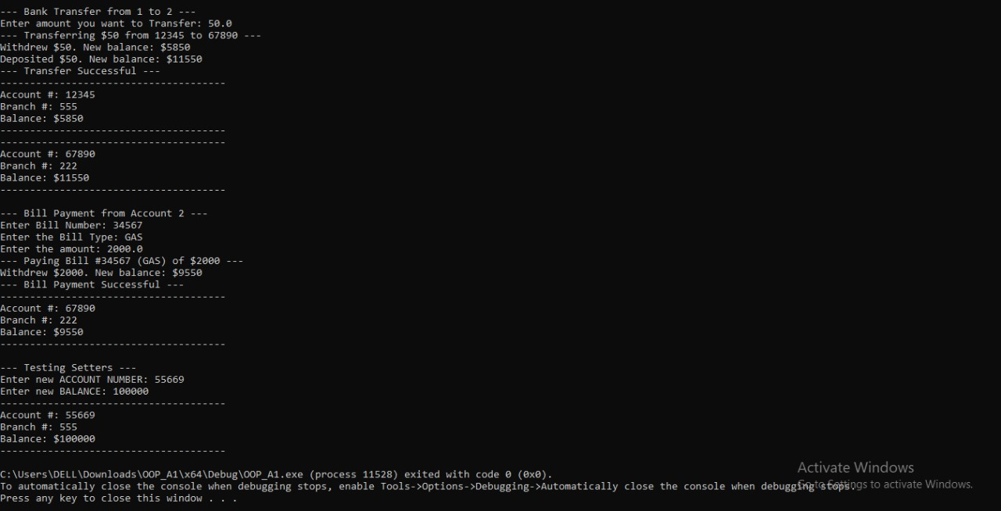

Question #4: You have a class Student with some basic private data members name, marks, roll number, and subjects names that (s)he is studying. The roll number is integer pointer type variable. You need controlled access to these values by getter and setter. The Class can perform multiple operations like:
1. Make student Grade (86>= A, 80 >= B+, 75 >=, B 70>= B and D. but below 60 is F).
2. Told student is (s)he is eligible for scholarship. (requirement is marks >80 merit, >70 is Punjab).
3. Make both Default and parametrize constructor.
4. Make Destructor.
5. Make print function which show all data of the object, grade and scholarship for the student as well

CODE:
Student.h
#pragma once
#include <iostream>
using namespace std;

class Student {

private:
char* name;
double marks;
int* rollNumber;
char** subjects;
int numSubjects;

int findLength(const char* src) const {
int len = 0;
for (int i = 0; src[i]; i++) len++;
return len;
}

char* copyString(const char* src) {
if (src == nullptr) {
return nullptr;
}
int length = findLength(src);
char* dest = new char[length + 1];
for (int i = 0; i < length; i++) {
dest[i] = src[i];
}
dest[length] = '\0';
return dest;
}

public:
Student() {
name = copyString("Unknown");
marks = 0.0;
rollNumber = new int(0);
subjects = nullptr;
numSubjects = 0;
}

Student(const char* studentName, double studentMarks, int studentRollNo, const char** subject_list, int subject_count) {
name = copyString(studentName);
marks = studentMarks;
rollNumber = new int(studentRollNo);

numSubjects = subject_count;
subjects = new char* [numSubjects];
for (int i = 0; i < numSubjects; i++) {
subjects[i] = copyString(subject_list[i]);
}
}

~Student() {
delete[] name;
delete rollNumber;

for (int i = 0; i < numSubjects; i++) {
delete[] subjects[i];
}
delete[] subjects;

name = nullptr;
rollNumber = nullptr;
subjects = nullptr;
}

Student(const Student& student) {
name = copyString(student.name);
marks = student.marks;
rollNumber = new int(*(student.rollNumber));

numSubjects = student.numSubjects;
subjects = new char* [numSubjects];
for (int i = 0; i < numSubjects; i++) {
subjects[i] = copyString(student.subjects[i]);
}
}
//---------------------------------------------------------------
Student& operator=(const Student& other) {
if (this == &other) {
return *this;
}

delete[] name;
delete rollNumber;
for (int i = 0; i < numSubjects; i++) {
delete[] subjects[i];
}
delete[] subjects;

name = copyString(other.name);
marks = other.marks;
rollNumber = new int(*(other.rollNumber));

numSubjects = other.numSubjects;
subjects = new char* [numSubjects];
for (int i = 0; i < numSubjects; i++) {
subjects[i] = copyString(other.subjects[i]);
}

return *this;
}
//--------------------------------------------------------------------------
void setName(const char* studentName) {
if (name != nullptr) { delete[] name; }
name = copyString(studentName);
}

void setMarks(double studentMarks) { marks = studentMarks; }

void setRollNumber(int studentRollNo) {
if (rollNumber != nullptr) { *(this->rollNumber) = studentRollNo; }
else { rollNumber = new int(studentRollNo); }
}

void setSubjects(const char** subject_list, int subject_count) {
for (int i = 0; i < numSubjects; i++) {
delete[] subjects[i];
}
delete[] subjects;

numSubjects = subject_count;
subjects = new char* [numSubjects];
for (int i = 0; i < numSubjects; i++) {
subjects[i] = copyString(subject_list[i]);
}
}

char* getName() const { return name; }
double getMarks() const { return marks; }
int getRollNumber() const {
return (rollNumber != nullptr) ? *rollNumber : 0;
}
char** getSubjects() const { return subjects; }
int getNumSubjects() const { return numSubjects; }

const char* calculateGrade() const {
if (marks >= 86) return "A";
if (marks >= 80) return "B+";
if (marks >= 75) return "B";
if (marks >= 70) return "B-";
if (marks >= 60) return "D";
return "F";
}

const char* checkScholarship() const {
if (marks > 80) return "Merit Scholarship";
if (marks > 70) return "Punjab Scholarship";
return "Not Eligible";
}

void print() const {
cout << "======================================\n";
cout << "Student: " << (name ? name : "N/A") << "\n";
cout << "Roll #: " << getRollNumber() << "\n";
cout << "Marks: " << marks << "%\n";

cout << "Subjects (" << numSubjects << "):\n";
if (numSubjects > 0 && subjects != nullptr) {
for (int i = 0; i < numSubjects; i++) {
cout << " - " << (subjects[i] ? subjects[i] : "N/A") << "\n";
}
}
else {
cout << " - None\n";
}

cout << "Grade: " << calculateGrade() << "\n";
cout << "Scholarship: " << checkScholarship() << "\n";
cout << "======================================\n";
}
};

Q4_Solved.cpp
#include "Student.h"
#include <iostream>
using namespace std;

int main() {
Student s1;
cout << "--- Default Student ---\n";
s1.print();

char name[100];
double marks;
int roll;
int numSubjects;

cout << "\n--- Enter Details for New Student ---\n";
cout << "Enter Name: ";
cin.getline(name, 100);

cout << "Enter Marks: ";
cin >> marks;

cout << "Enter Roll Number: ";
cin >> roll;

cout << "Enter Number of Subjects: ";
cin >> numSubjects;
cin.ignore();

char** s2_subjects = new char* [numSubjects];
char temp_subject[100];

for (int i = 0; i < numSubjects; i++) {
cout << "Enter Subject " << (i + 1) << ": ";
cin.getline(temp_subject, 100);

int len = 0;
for (int j = 0; temp_subject[j]; j++) len++;
s2_subjects[i] = new char[len + 1];
for (int j = 0; j < len; j++) s2_subjects[i][j] = temp_subject[j];
s2_subjects[i][len] = '\0';
}

Student s2(name, marks, roll, (const char**)s2_subjects, numSubjects);

for (int i = 0; i < numSubjects; i++) {
delete[] s2_subjects[i];
}
delete[] s2_subjects;

cout << "\n--- New Student Details ---\n";
s2.print();

cout << "\n--- Updating Default Student ---\n";
cout << "Enter new Name for Student 1: ";
cin.getline(name, 100);
s1.setName(name);

cout << "Enter new Roll Number: ";
cin >> roll;
s1.setRollNumber(roll);

cout << "Enter new Marks: ";
cin >> marks;
s1.setMarks(marks);

cout << "Enter new Number of Subjects: ";
cin >> numSubjects;
cin.ignore();

char** s1_subjects = new char* [numSubjects];
for (int i = 0; i < numSubjects; i++) {
cout << "Enter Subject " << (i + 1) << ": ";
cin.getline(temp_subject, 100);

int len = 0;
for (int j = 0; temp_subject[j]; j++) len++;
s1_subjects[i] = new char[len + 1];
for (int j = 0; j < len; j++) s1_subjects[i][j] = temp_subject[j];
s1_subjects[i][len] = '\0';
}

s1.setSubjects((const char**)s1_subjects, numSubjects);

for (int i = 0; i < numSubjects; i++) {
delete[] s1_subjects[i];
}
delete[] s1_subjects;

cout << "\nUpdated Details for " << s1.getName() << ":\n";
s1.print();

cout << "\n--- Testing Copy Constructor ---\n";
Student s3 = s2;
cout << "This is a copy of the new student created above:\n";
s3.print();

cout << "\n--- Testing Copy Assignment ---\n";
s3 = s1;
cout << "The copy object now holds a copy of the updated Student 1:\n";
s3.print();

return 0;
}

OUTPUT:

