
University of Central Punjab
FOIT & CS
Assignment 03

Course: | Object Oriented Programming | Date: 28/12/2025
Course Code: | CSCP 2023 | Max Marks: 30
Faculty’s Name: | M Umar Hameed | Deadline: 2 jan 2026

Instructions:

CLO | CLO STATEMENT | Bloom’s Taxonomy Level | PLO
2 | Interpret real world problems in terms of object-oriented design | C3 (Apply) | 3

NAME: MUHAMMAD HUSSAIN DURRANI
ROLL NO: L1F24BSCS0937
Question 1
Design a class hierarchy for a game that involves different types of characters. Create a base class called Character with common attributes like name and health. Derive two classes, Player and Enemy, from the Character class. Now, create a class called Boss which is derived from both Player and Enemy using virtual inheritance. Implement necessary methods to display the details of a boss character.
CODE:
Q1.cpp
#include <iostream>
#include "Boss.h"
using namespace std;

int main() {
string name, ability;
int health, level, damage;

cout << "--- Create Boss Character ---\n";
cout << "Enter Name: ";
cin >> name;

cout << "Enter Health: ";
cin >> health;

cout << "Enter Level (Player Attribute): ";
cin >> level;

cout << "Enter Damage (Enemy Attribute): ";
cin >> damage;
cin.ignore();

cout << "Enter Special Ability: ";
cin >> ability;

Boss finalBoss(name, health, level, damage, ability);

finalBoss.displayDetails();

return 0;
}

Boss.h
#pragma once
#include "Player.h"
#include "Enemy.h"
#include <iostream>
using namespace std;

class Boss : public Player, public Enemy {
private:
string specialAbility;

public:
Boss() : specialAbility("Flying"), Character("Player", 0), Player("Player", 0, 0), Enemy("Player", 0, 0) {}

Boss(string n, int h, int l, int d, string ability)
: Character(n, h), Player(n, h, l), Enemy(n, h, d) {
specialAbility = ability;
}

void displayDetails() const {
cout << "\n--- BOSS DETAILS ---\n";
displayCharacter();
displayPlayer();
displayEnemy();
cout << "Special Ability: " << specialAbility << endl;
}
};

Player.h
#pragma once
#include "Character.h"
#include <iostream>
using namespace std;

class Player : virtual public Character {
protected:
int level;

public:
Player(): level(0), Character("Player", 0) {}

Player(string n, int h, int l) : Character(n, h) {
level = l;
}

void displayPlayer() const {
cout << "Player Level: " << level << endl;
}
};

Enemy.h
#pragma once
#include "Character.h"
#include <iostream>
using namespace std;

class Enemy : virtual public Character {
protected:
int damage;

public:
Enemy(): damage(0), Character("Player", 0){}

Enemy(string n, int h, int d) : Character(n, h) {
damage = d;
}

void displayEnemy() const {
cout << "Enemy Damage: " << damage << endl;
}
};

Character.h
#pragma once
#include <iostream>
using namespace std;

class Character {
protected:
string name;
int health;

public:
Character(): health(0), name("Player") {}

Character(string n, int h) {
name = n;
health = h;
}

void displayCharacter() const {
cout << "Name: " << name << " | Health: " << health << endl;
}
};

OUTPUT:
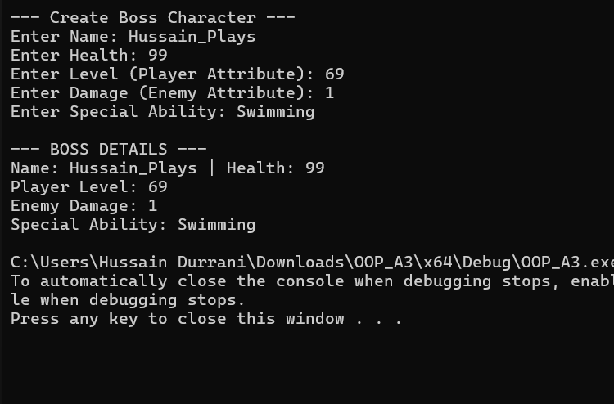
Question 2:
Define an abstract class called Vehicle with data members type, model, year, name, engine number and with pure virtual functions startEngine() and stopEngine() along with constructors and setters/getters. Create two classes Car and Motorcycle that inherit from Vehicle and implement their own versions of the startEngine() and stopEngine() functions. Create objects of Car and Motorcycle and call their startEngine() and stopEngine() functions.
Also, define an owner class and associate it with vehicle in terms of aggregation or composition. Think of the proper attributes and functions for the mentioned class.
CODE:
Q2.cpp
#include <iostream>
#include "Car.h"
#include "Motorcycle.h"
#include "Owner.h"
using namespace std;

int main() {
string oName, vName, model;
int year, choice, engNum;

cout << "Enter Owner Name: ";
cin >> oName;
Owner owner(oName);

cout << "Select Vehicle to buy:\n1. Car\n2. Motorcycle\nEnter choice: ";
cin >> choice;
cin.ignore();

cout << "Enter Make (Name): ";
cin >> vName;
cout << "Enter Model: ";
cin >> model;
cout << "Enter Year: ";
cin >> year;
cin.ignore();
cout << "Enter Engine Number: ";
cin >> engNum;

Vehicle* myVehicle = nullptr;

if (choice == 1) {
myVehicle = new Car(model, year, vName, engNum);
}
else {
myVehicle = new Motorcycle(model, year, vName, engNum);
}
owner.setVehicle(myVehicle);

cout << "\n--- Ownership Details ---\n";
owner.showOwnership();

Delete myVehicle;
myVehicle = nullptr;
return 0;
}

Vehicle.h
#pragma once
#include <iostream>
using namespace std;

class Vehicle {
protected:
string type;
string model;
string name;
int year;
int engineNumber;

public:
Vehicle(): year(2000), type("Any"), model("S"), name("Unknown"), engineNumber(0){}

Vehicle(string t, string m, int y, string n, int eng) {
type = t;
model = m;
year = y;
name = n;
engineNumber = eng;
}

virtual void startEngine() = 0;
virtual void stopEngine() = 0;

string getName() const { return name; }
string getModel() const { return model; }

virtual void displayInfo() const {
cout << year << " " << name << " " << model << " (" << type << ")";
}
};

Owner.h
#pragma once
#include <iostream>
#include "Vehicle.h"
using namespace std;

class Owner {
private:
string ownerName;
Vehicle* vehicle;

public:
Owner(string n) {
ownerName = n;
vehicle = nullptr;
}

void setVehicle(Vehicle* v) {
vehicle = v;
}

void showOwnership() const {
cout << ownerName << " owns a: ";
if (vehicle != nullptr) {
vehicle->displayInfo();
cout << endl;
vehicle->startEngine();
vehicle->stopEngine();
}
else {
cout << "No vehicle assigned.\n";
}
}
};

Car.h
#pragma once
#include "Vehicle.h"
#include <iostream>
using namespace std;

class Car : public Vehicle {
public:
Car() : Vehicle("Car", "S", 2000, "Unknown", 0) {}

Car(string m, int y, string n, int eng): Vehicle("Car", m, y, n, eng) {}

void startEngine() override {
cout << "Car Engine (" << engineNumber << ") started with a key turn.\n";
}

void stopEngine() override {
cout << "Car Engine stopped.\n";
}
};

Motorcycle.h
#pragma once
#include "Vehicle.h"
#include <iostream>
using namespace std;

class Motorcycle : public Vehicle {
public:
Motorcycle() : Vehicle("Motorcycle", "cc", 2025, "Unknown", 0) {}

Motorcycle(string m, int y, string n, int eng): Vehicle("Motorcycle", m, y, n, eng) {}

void startEngine() override {
cout << "Motorcycle Engine (" << engineNumber << ") started with a kick.\n";
}

void stopEngine() override {
cout << "Motorcycle Engine stopped.\n";
}
};

OUTPUT:
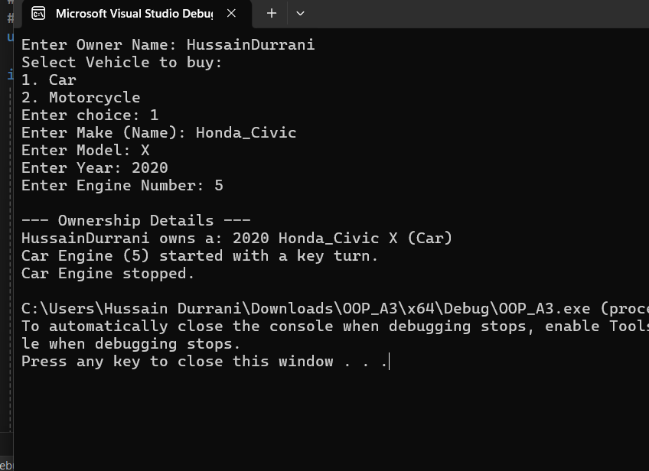

Question 3:
Define a class Shape with pure virtual functions area() and perimeter(). Create two classes Rectangle and Circle, both derived from Shape, with their own implementations of area() and perimeter(). Now, define a class Cylinder derived from both Rectangle and Circle. Implement its area() and perimeter() functions. Create an object of Cylinder and call its area() and perimeter() functions.
CODE:
Q3.cpp
#include <iostream>
#include "Cylinder.h"
using namespace std;

int main() {
float radius, height;

cout << "--- Cylinder Calculator ---\n";
cout << "Enter Radius of Cylinder base: ";
cin >> radius;
cout << "Enter Height of Cylinder: ";
cin >> height;

Cylinder myCylinder(radius, height);

cout << "\n----------------------------\n";
myCylinder.display();
cout << "----------------------------\n";

cout << "Debug Access:\n";
cout << "Area() call: " << myCylinder.area() << endl;
cout << "Perimeter() call: " << myCylinder.perimeter() << endl;

return 0;
}

Shape.h
#pragma once
#include <iostream>
using namespace std;

class Shape {
public:
virtual float area() = 0;
virtual float perimeter() = 0;
};

Rectangle.h
#pragma once
#include "Shape.h"
using namespace std;

class Rectangle : virtual public Shape {
protected:
float length;
float width;

public:
Rectangle(float l, float w) {
length = l;
width = w;
}

float area() override {
return length * width;
}

float perimeter() override {
return 2 * (length + width);
}
};

Circle.h
#pragma once
#include "Shape.h"
using namespace std;

class Circle : virtual public Shape {
protected:
float radius;

public:
Circle(float r) {
radius = r;
}

float area() override {
return 3.14159f * radius * radius;
}

float perimeter() override {
return 2 * 3.14159f * radius;
}
};

Cylinder.h
#pragma once
#include "Rectangle.h"
#include "Circle.h"
#include <iostream>
using namespace std;

class Cylinder : public Rectangle, public Circle {
public:
Cylinder(float r, float h)
: Rectangle(2 * 3.14159f * r, h), Circle(r) {
}

float area() override {
return (2 * Circle::area()) + Rectangle::area();
}

float perimeter() override {
return Circle::perimeter();
}

void display() {
cout << "Cylinder Properties:\n";
cout << " Base Radius: " << radius << endl;
cout << " Height: " << width << endl;
cout << " Total Surface Area: " << area() << endl;
}
};

OUTPUT:
