
University of Central Punjab
FOIT & CS
Assignment 04
(Fall 2025)

Course: | Object Oriented Programming | Date: _______________
Course Code: | CSCP 2023 | Max Marks: 40
Faculty’s Name: | M Umar Hameed | Deadline: 15 jan 2026

CLO | CLO STATEMENT | Bloom’s Taxonomy Level | PLO
2 | Interpret real world problems in terms of object-oriented design | C3 (Apply) | 3

Task 1:
Write a template function that returns the average of all the elements of an array. The arguments to the function should be the array name and the size of the array (type int). In main(), exercise the function with arrays of type int, long, double, and char.
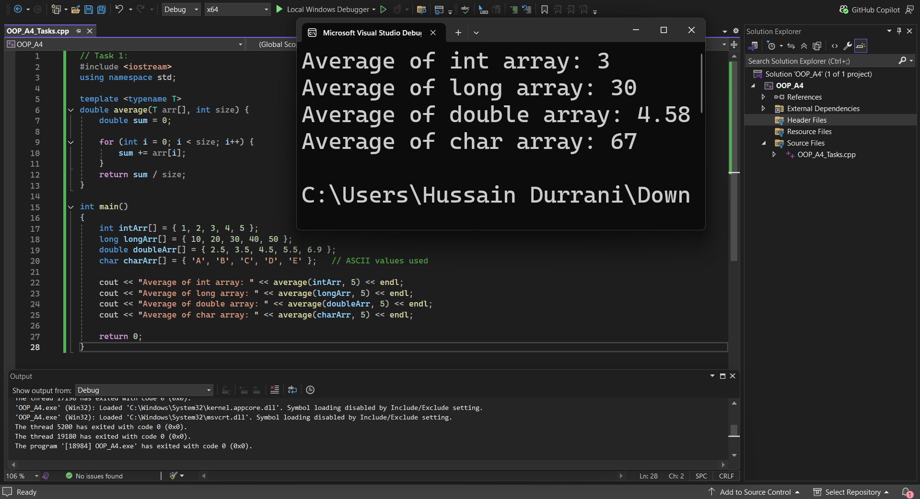
Task 2:
Create a Class Template Rectangle with data members length, breath and height. Members functions of class should be Cal_Volume and Compare, to calculate volume of the box and compare two objects’ volume to check which object have greater volume. (Implementation: use this pointer).
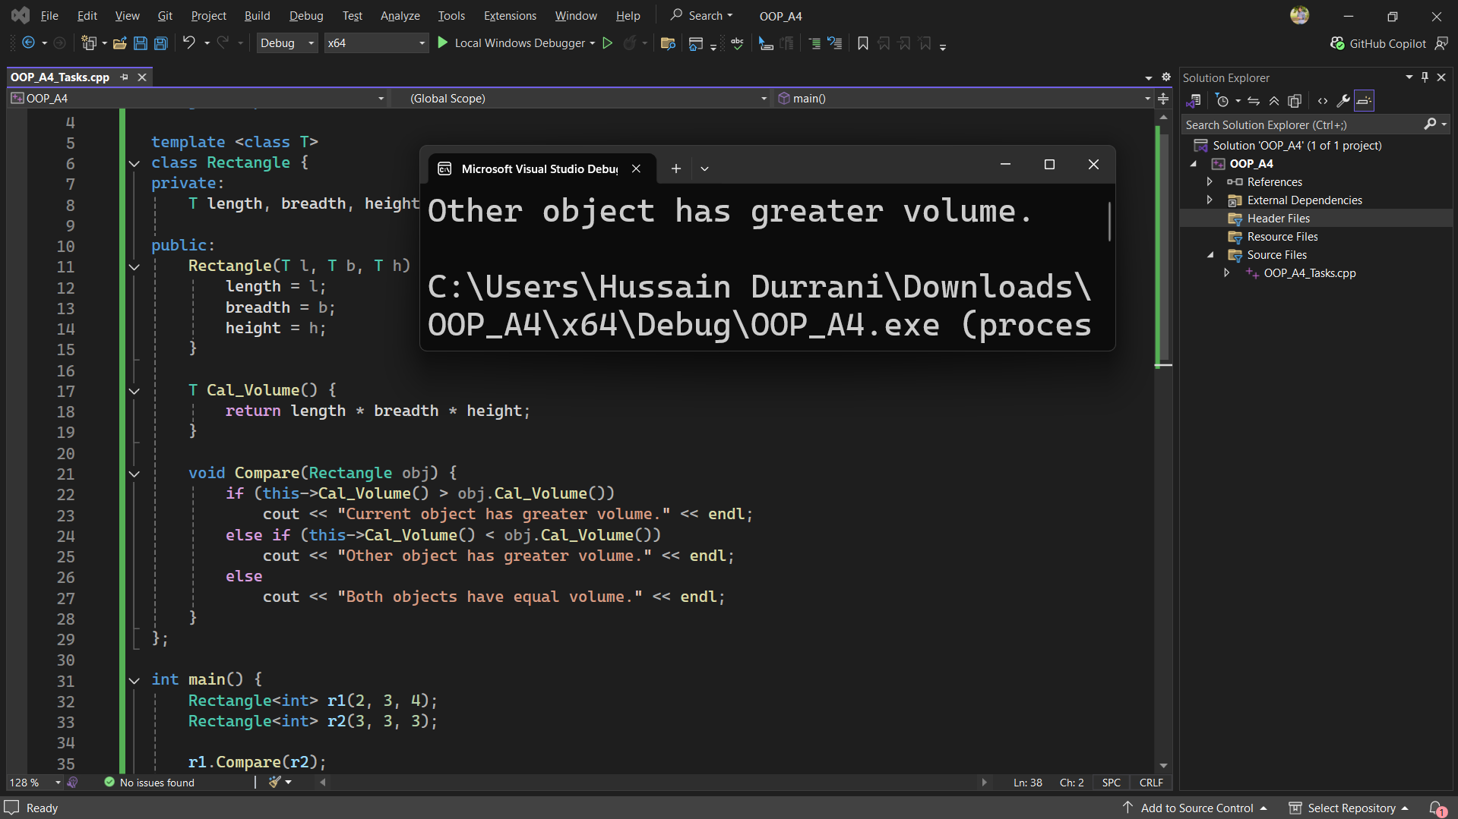

Task 3:
Create a program that models a university student's enrollment in courses. The program should have two classes: Student and Course.
The Student class should have the following properties:
- name (string): representing the student's name.
- id (int): representing the student's ID.
- courses (array): representing the courses in which the student is enrolled.
The Course class should have the following properties:
- name (string): representing the course name.
- code (string): representing the course code.
- credits (int): representing the number of credits for the course.
The Student class should have the following methods:
- addCourse: takes a Course object as a parameter and adds it to the student's list of courses.
- totalCredits: returns the total number of credits the student is enrolled in.
- displayCourses: displays the details of all the courses in which the student is enrolled.
Write the necessary C++ code to implement the Student and Course classes, along with a sample main function to demonstrate their usage. Solve the problem using Class Template.
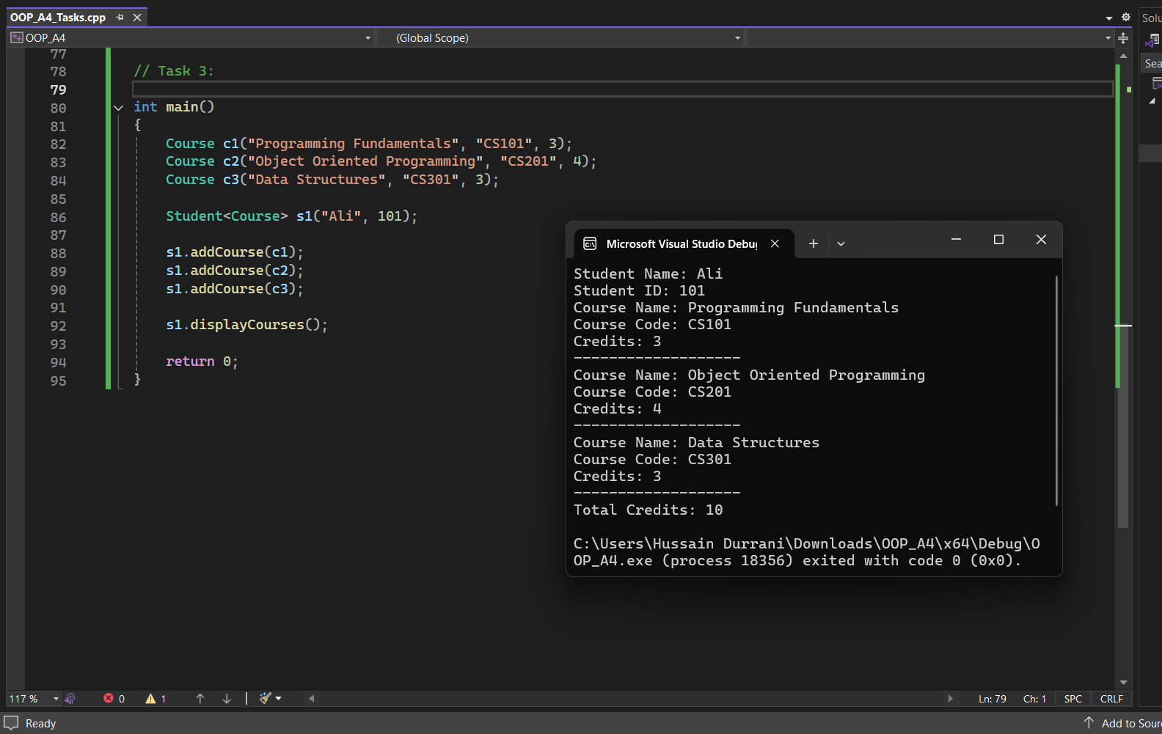

Task 4:
Design a class hierarchy for a game that involves different types of characters. Create a base class called Character with common attributes like name and health. Derive two classes, Player and Enemy, from the Character class. Now, create a class called Boss which is derived from both Player and Enemy using virtual inheritance. Implement necessary methods to display the details of a boss character. Solve this problem using Class Templates.
