

Introduction to Database System BSCS (D7)
Graded Lab 3

Name: Hussain Durrani | Program: BS(CS) | Time Allowed: 40 Minutes
Registration No: L1F24BSCS0937 | Semester: 4th | Total Marks:

Instructions:
- This is a closed Book/closed Notes Exam; no cheat sheet is allowed.
- Understanding of question is part of paper. Therefore, no queries will be entertained during examination.
- Required Schema and SQL files are uploaded to LMS.
- You can use any method or approach to solve a query unless you are explicitly instructed to use a specific approach.
- Use proper indentation/formatting while writing queries.
- SOME ONE is always with You, so be Relaxed. SOME ONE is always watching You, so be Honest. Keep Calm & stay Blessed.
- Type query in text form against each question in MS word and add screen shot of that query along with execution time.
- One absolute mark is given if you follow the above-mentioned instructions.

Q1. List the full name of every student along with the name of their department. Include students even if they have not yet been assigned to any department.

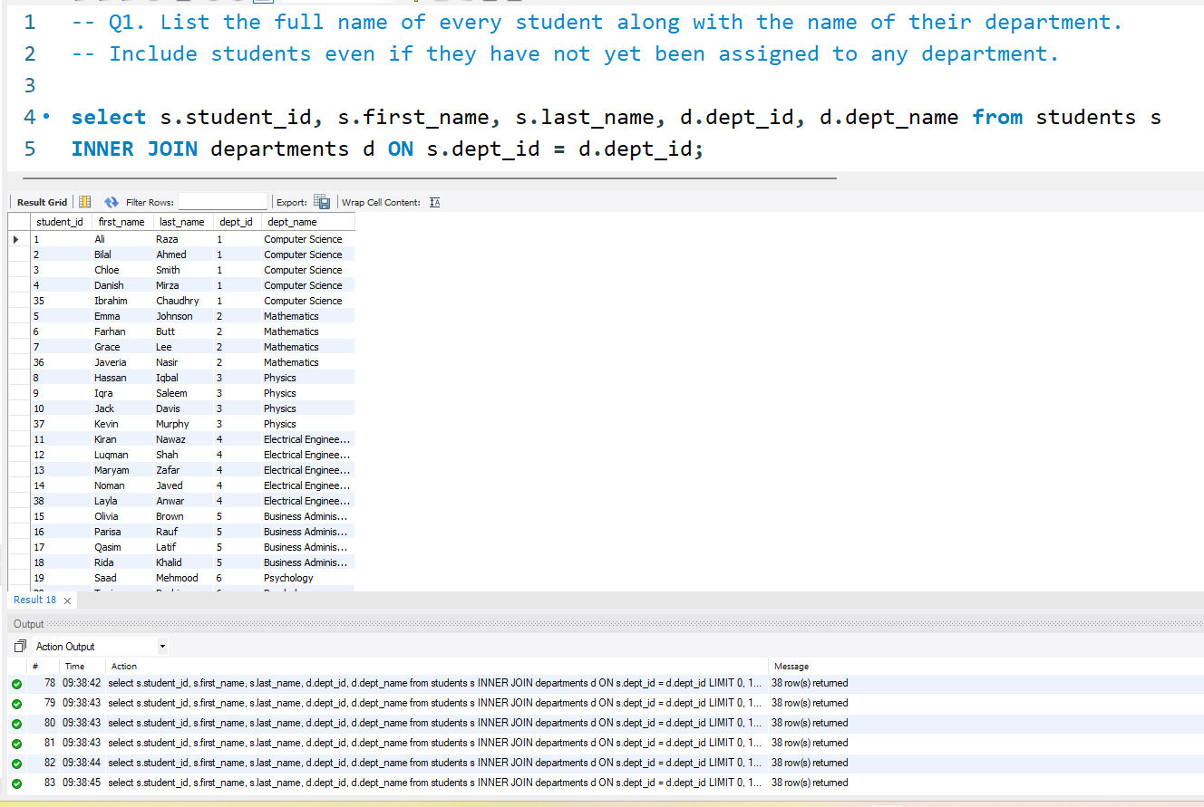

Q2. Display each department name along with the total number of professors employed in it. Also include departments that currently have no professors assigned to them.

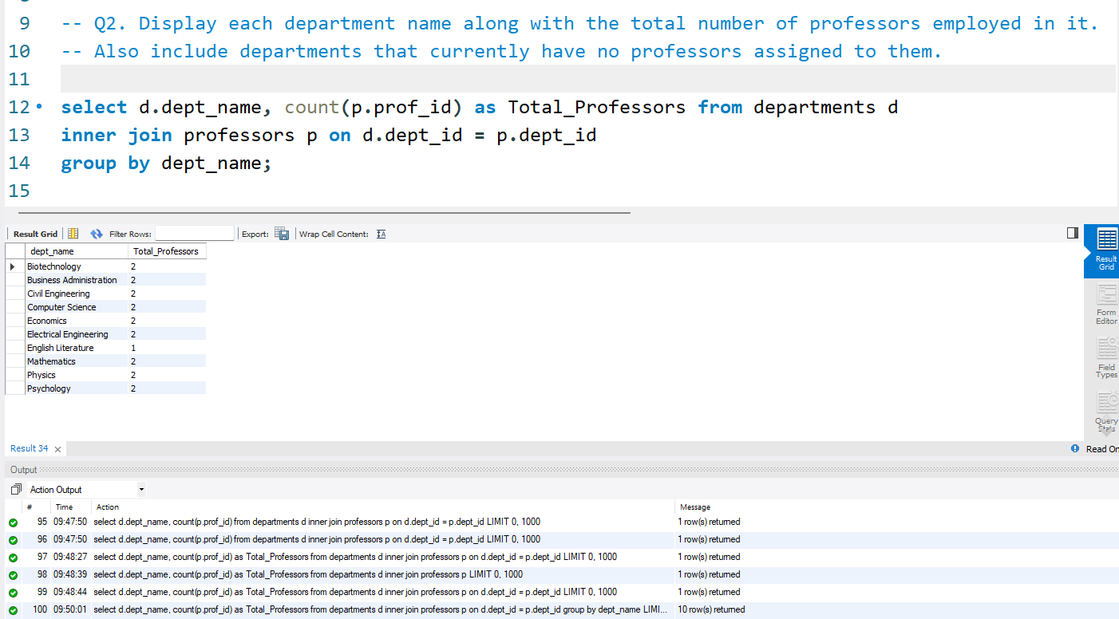

Q3. Show the course name and the full name of the professor teaching it. Display all courses even those that do not yet have a professor assigned

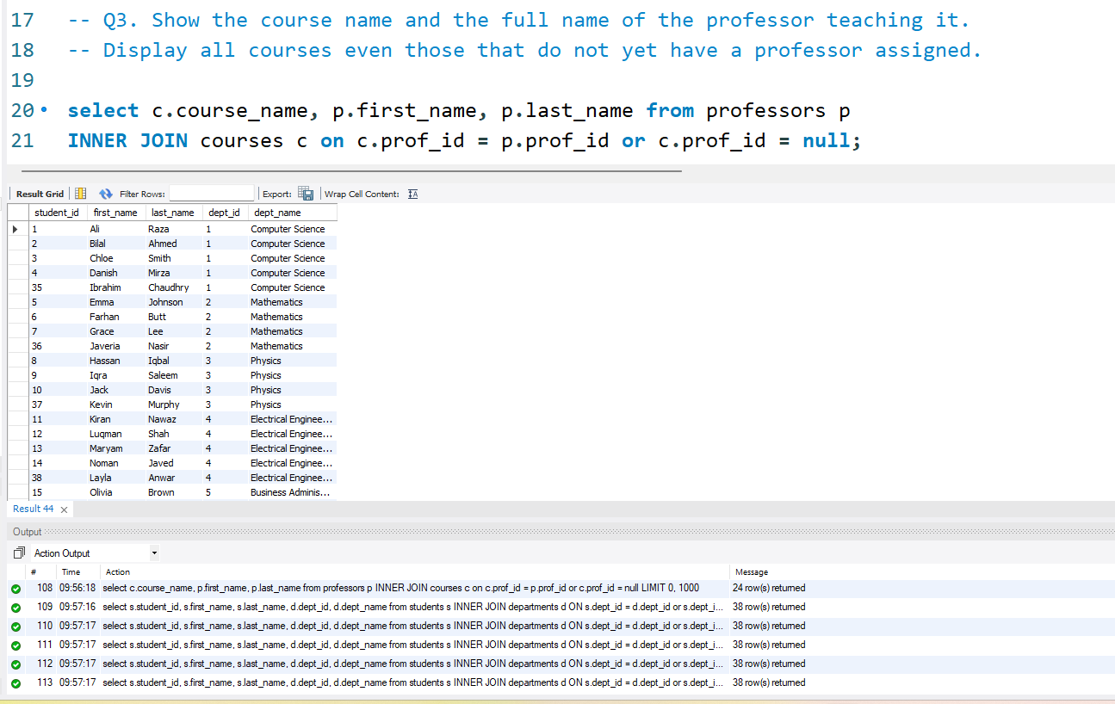

Q4. Find the average GPA of students in each department. Only include departments that actually have students enrolled in them. Show the department name and the average GPA rounded to 2 decimal places.

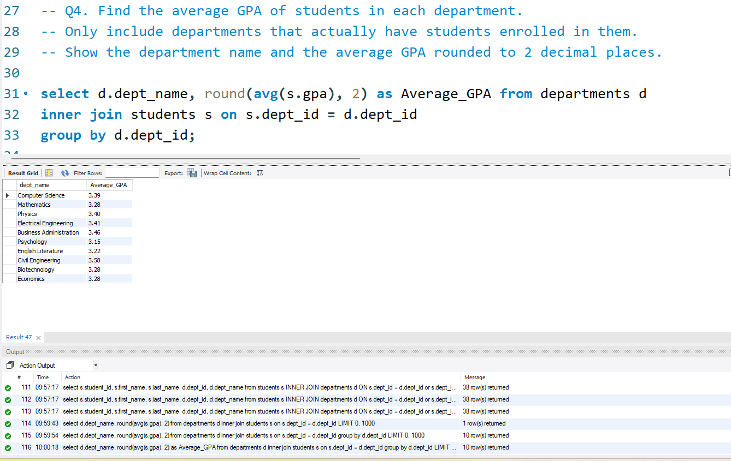

Q5. Produce a complete report of all students and all departments. Each row should show a student name and a department name. Rows where there is no match on either side should still appear (with NULLs where data is missing).
