Practice Lab 10

Sub Queries

- Artists who have more albums than the average number of albums per artist.
SELECT a.ArtistId, a.Name, COUNT(al.AlbumId) AS album_count
FROM Artist a
JOIN Album al ON a.ArtistId = al.ArtistId
GROUP BY a.ArtistId, a.Name
HAVING COUNT(al.AlbumId) > (
SELECT AVG(cnt)
FROM (
SELECT COUNT(*) AS cnt
FROM Album
GROUP BY ArtistId
) AS album_counts
);
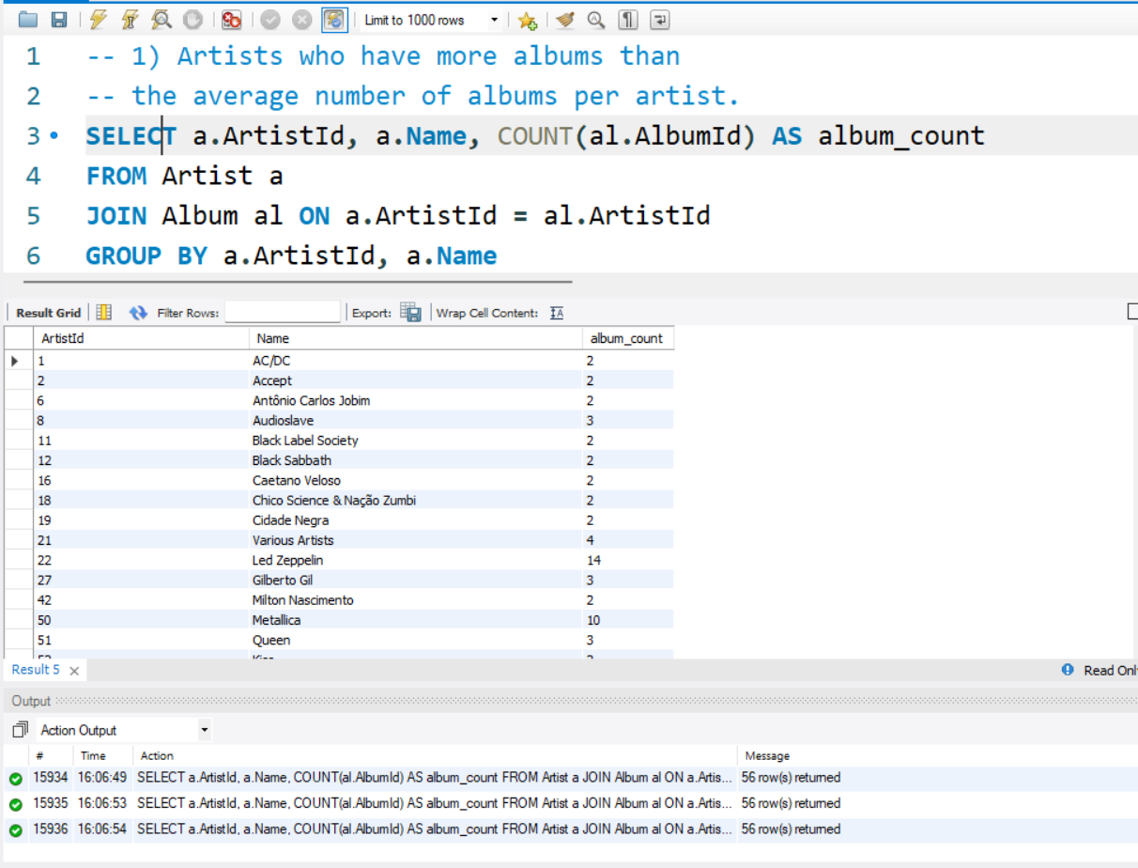
- Albums that have more tracks than the average tracks per album.
SELECT al.AlbumId, al.Title, COUNT(t.TrackId) AS track_count
FROM Album al
JOIN Track t ON al.AlbumId = t.AlbumId
GROUP BY al.AlbumId, al.Title
HAVING COUNT(t.TrackId) > (
SELECT AVG(cnt)
FROM (
SELECT COUNT(*) AS cnt
FROM Track
GROUP BY AlbumId
) AS track_counts
);
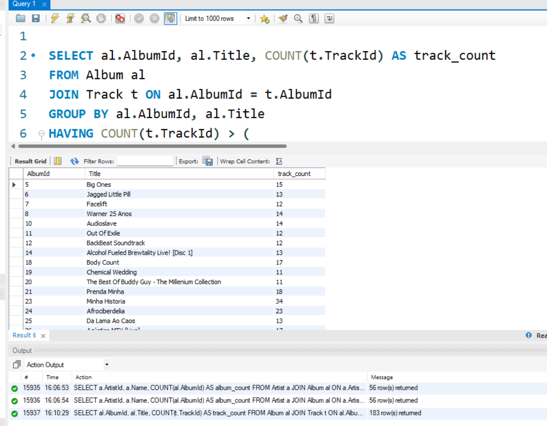

- Customers who have made at least one invoice.
SELECT c.CustomerId, c.FirstName, c.LastName
FROM Customer c
WHERE c.CustomerId IN (
SELECT CustomerId
FROM Invoice
);
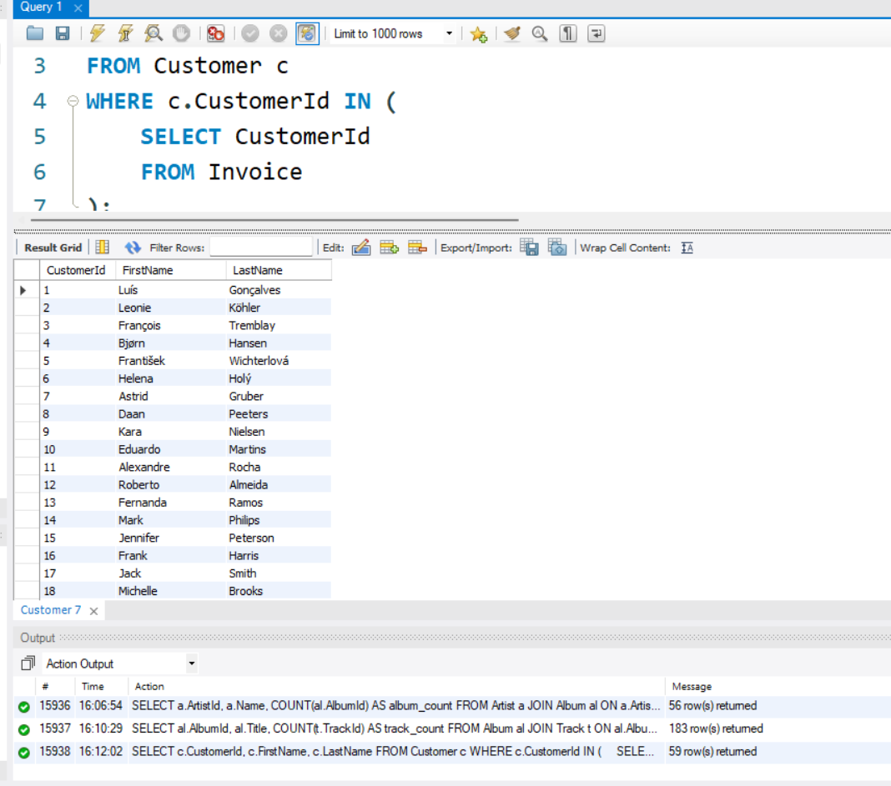

- Customers who have never made an invoice.
SELECT c.CustomerId, c.FirstName, c.LastName
FROM Customer c
WHERE c.CustomerId NOT IN (
SELECT CustomerId
FROM Invoice
);
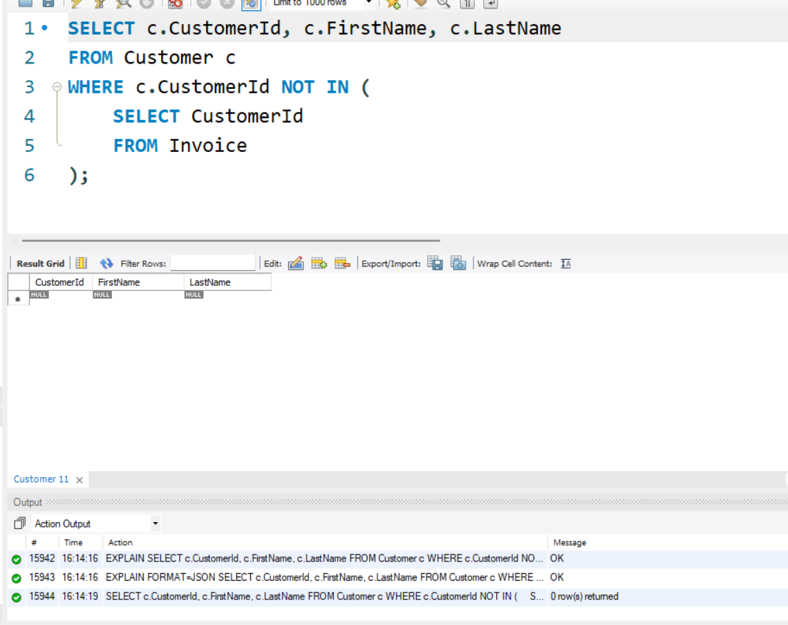

- Tracks that are more expensive than the average track price.
SELECT TrackId, Name, UnitPrice
FROM Track
WHERE UnitPrice > (
SELECT AVG(UnitPrice)
FROM Track
);
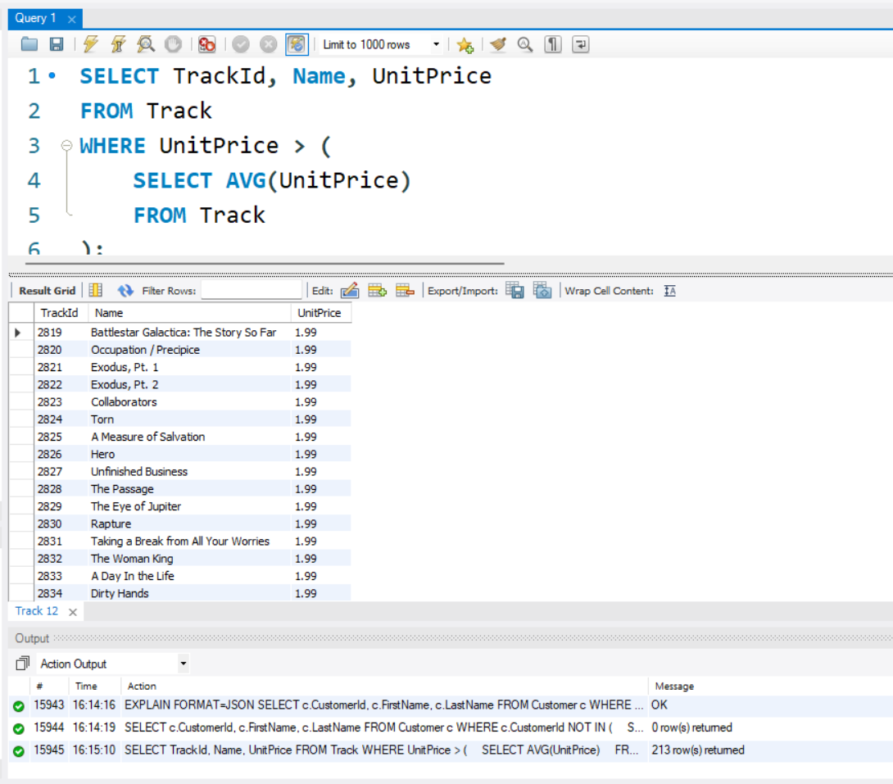

- Albums whose artist name starts with 'A' (subquery in WHERE).
SELECT AlbumId, Title, ArtistId
FROM Album
WHERE ArtistId IN (
SELECT ArtistId
FROM Artist
WHERE Name LIKE 'A%'
);
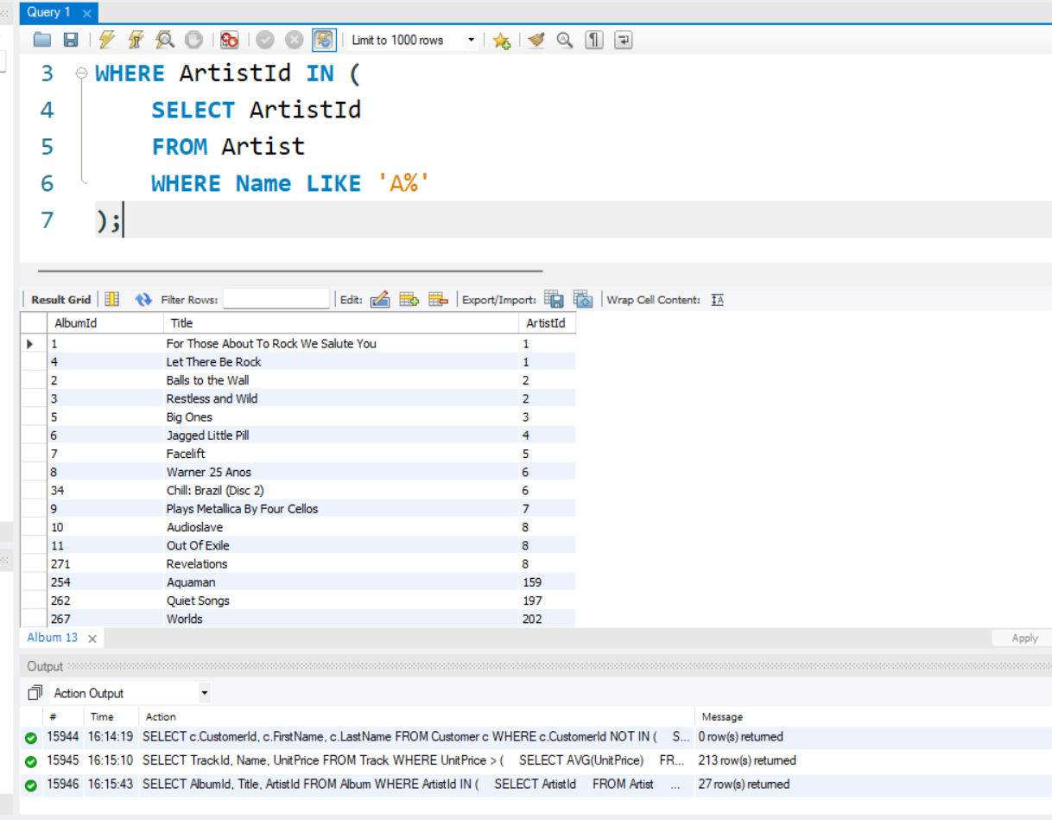

- Invoices with a total greater than the maximum invoice total of any customer from Canada.
SELECT InvoiceId, CustomerId, Total
FROM Invoice
WHERE Total > (
SELECT MAX(i.Total)
FROM Invoice i
JOIN Customer c ON i.CustomerId = c.CustomerId
WHERE c.Country = 'Canada'
);
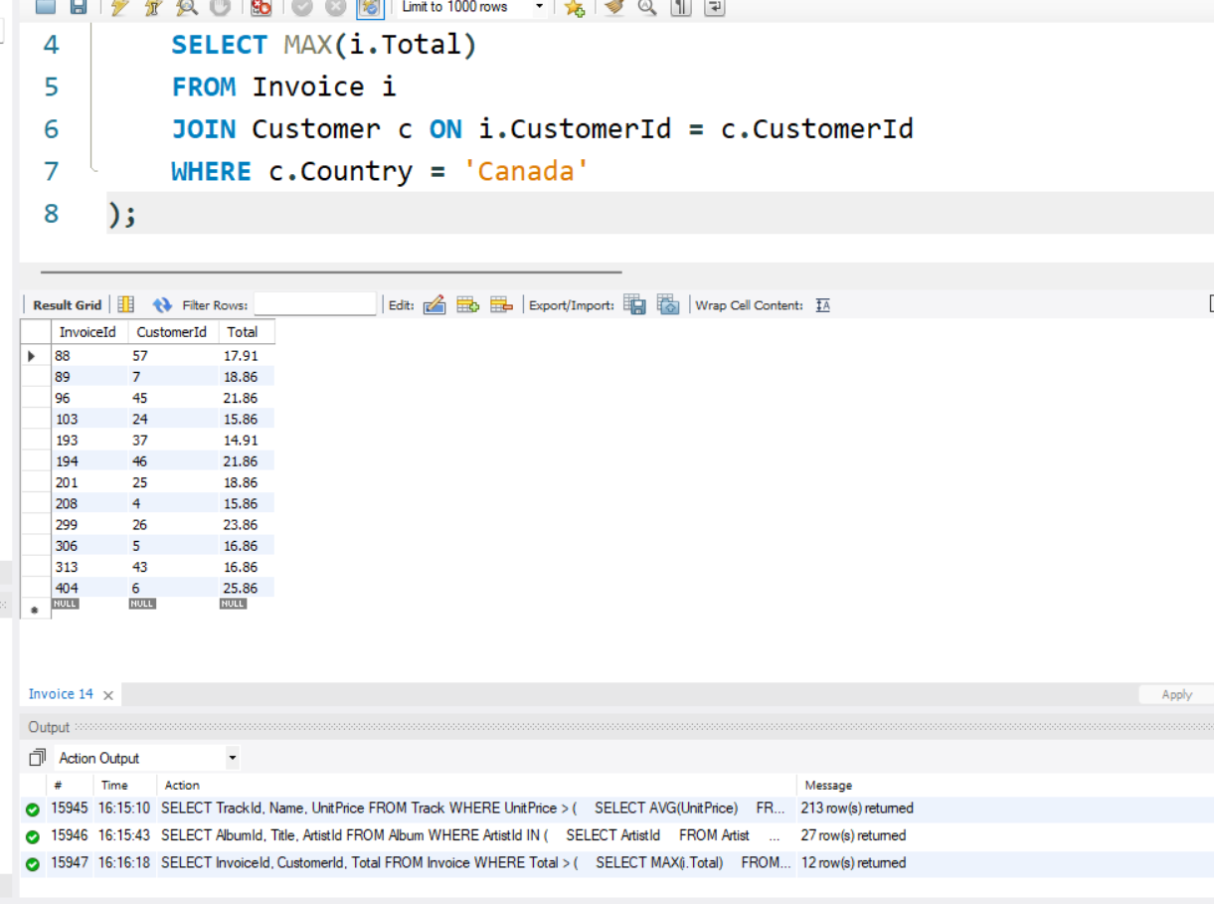

- Employees who do not support any customer.
SELECT EmployeeId, FirstName, LastName
FROM Employee
WHERE EmployeeId NOT IN (
SELECT SupportRepId
FROM Customer
WHERE SupportRepId IS NOT NULL
);
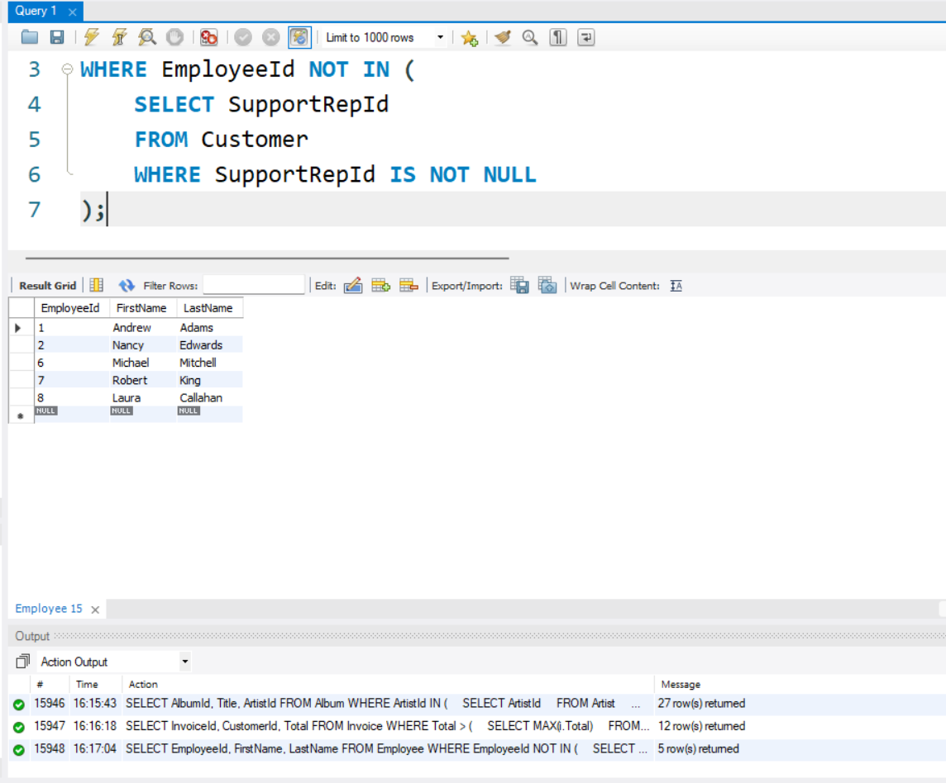

- Artists who have at least one album with more than 10 tracks (correlated subquery).
SELECT a.ArtistId, a.Name
FROM Artist a
WHERE a.ArtistId IN (
SELECT al.ArtistId
FROM Album al
WHERE (
SELECT COUNT(*)
FROM Track t
WHERE t.AlbumId = al.AlbumId
) > 10
);
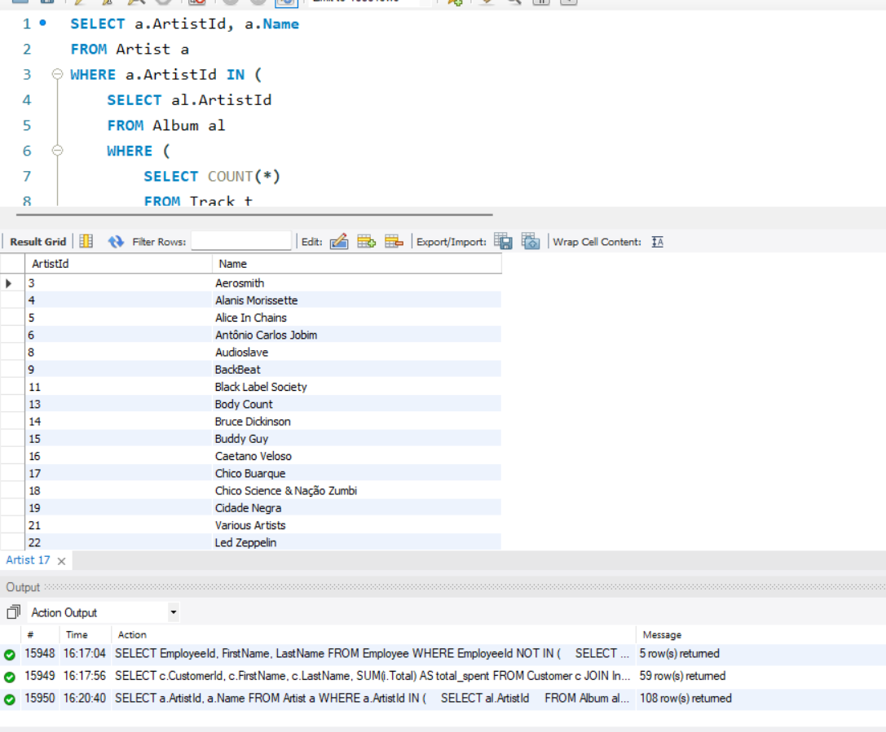
- Customers whose total invoice amount is greater than the overall average invoice total.
SELECT c.CustomerId, c.FirstName, c.LastName, SUM(i.Total) AS total_spent
FROM Customer c
JOIN Invoice i ON c.CustomerId = i.CustomerId
GROUP BY c.CustomerId, c.FirstName, c.LastName
HAVING SUM(i.Total) > (
SELECT AVG(Total)
FROM Invoice
);
