Introducation to database
Practice lab

Use Bank Scheme (banking database) using the concepts of JOINS, correlated queries, and aggregate functions.

1. List the name, account ID, and branch name of all customers who have an account.

SELECT c.customer_name, a.account_id, b.branch_name
FROM Customer c
JOIN Account a ON c.customer_id = a.customer_id
JOIN Branch b ON a.branch_id = b.branch_id;

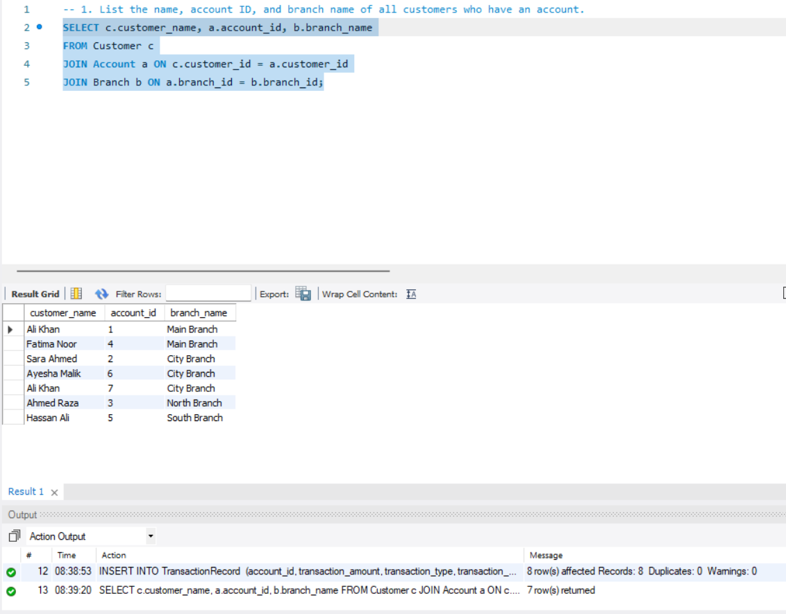

2. Find customers who have both a loan and an account in the same branch.

SELECT DISTINCT c.customer_name, b.branch_name
FROM Customer c
JOIN Account a ON c.customer_id = a.customer_id
JOIN Loan l ON c.customer_id = l.customer_id
AND a.branch_id = l.branch_id
JOIN Branch b ON a.branch_id = b.branch_id;

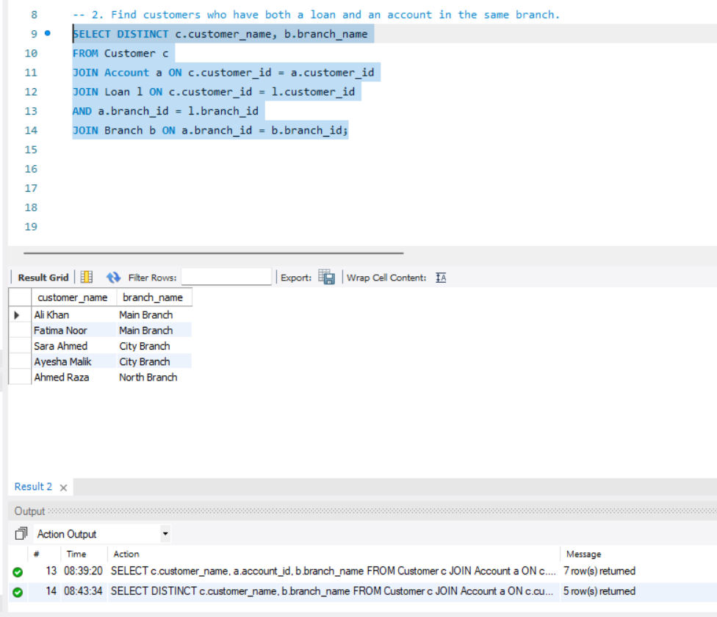

3. Show total balance held in each branch (branch-wise total balance of accounts).

SELECT b.branch_name, SUM(a.balance) AS total_balance
FROM Branch b
JOIN Account a ON b.branch_id = a.branch_id
GROUP BY b.branch_name;
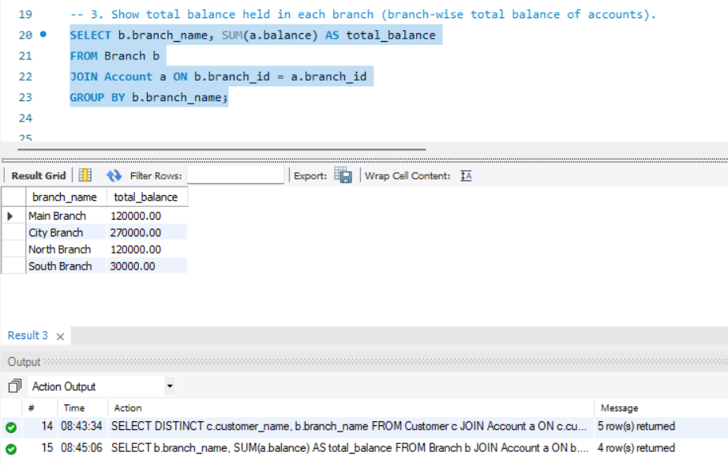

4. Find the customer(s) with the highest total balance across all their accounts.

SELECT c.customer_name, SUM(a.balance) AS total_balance
FROM Customer c
JOIN Account a ON c.customer_id = a.customer_id
GROUP BY c.customer_id, c.customer_name
HAVING SUM(a.balance) = (
SELECT MAX(total_balance)
FROM (
SELECT SUM(balance) AS total_balance
FROM Account
GROUP BY customer_id
) AS temp
);
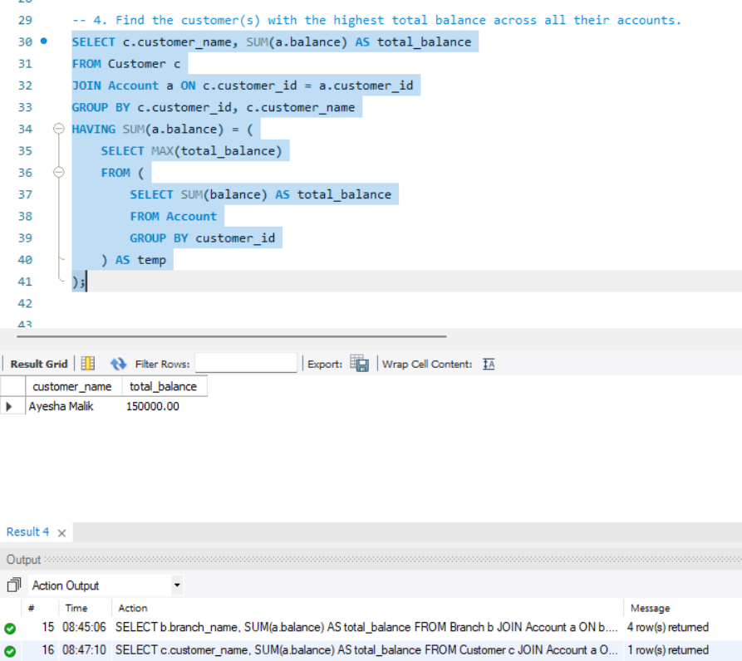

5. Find the average loan amount per branch.

SELECT b.branch_name, AVG(l.loan_amount) AS average_loan
FROM Branch b
JOIN Loan l ON b.branch_id = l.branch_id
GROUP BY b.branch_name;
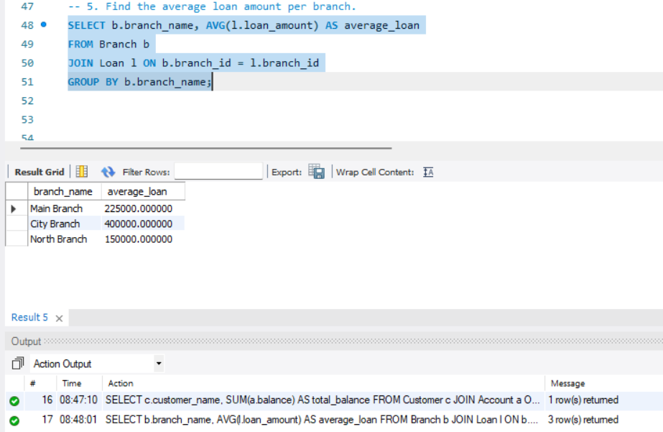

6. Count how many customers have taken a loan and how many have an account.

SELECT
(SELECT COUNT(DISTINCT customer_id) FROM Loan) AS customers_with_loan,
(SELECT COUNT(DISTINCT customer_id) FROM Account) AS customers_with_account;
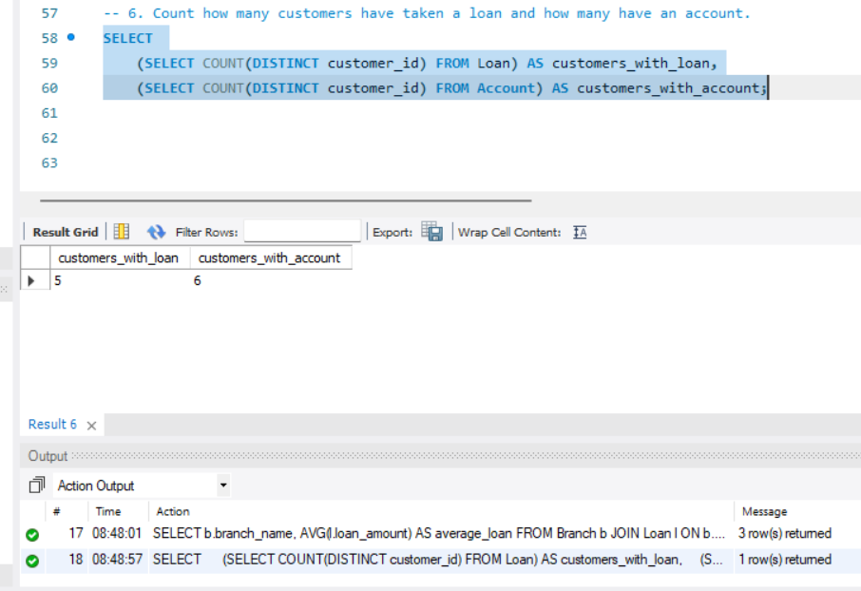

7. List all customers whose account balance is above the average balance of all accounts in their branch.

SELECT c.customer_name, a.account_id, b.branch_name, a.balance
FROM Customer c
JOIN Account a ON c.customer_id = a.customer_id
JOIN Branch b ON a.branch_id = b.branch_id
WHERE a.balance > (
SELECT AVG(a2.balance)
FROM Account a2
WHERE a2.branch_id = a.branch_id
);
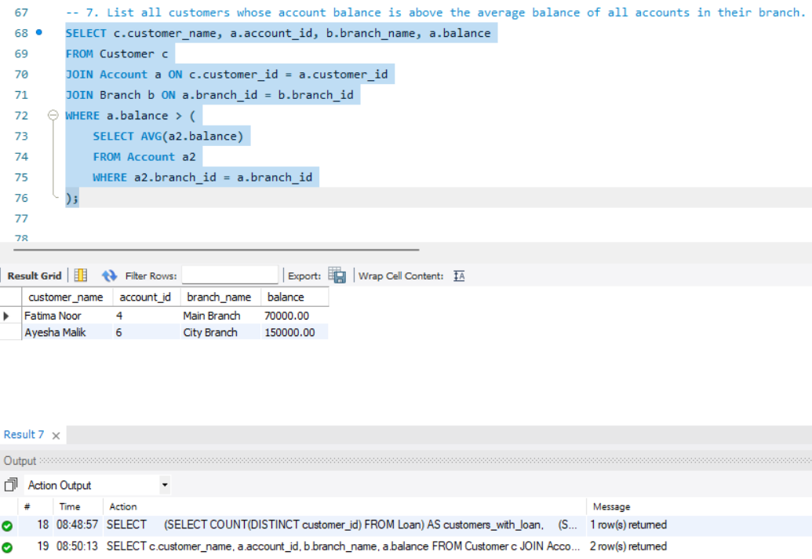

8. Find the customer(s) who made the highest transaction (by amount) in each branch.

SELECT c.customer_name, b.branch_name, t.transaction_amount
FROM TransactionRecord t
JOIN Account a ON t.account_id = a.account_id
JOIN Customer c ON a.customer_id = c.customer_id
JOIN Branch b ON a.branch_id = b.branch_id
WHERE t.transaction_amount = (
SELECT MAX(t2.transaction_amount)
FROM TransactionRecord t2
JOIN Account a2 ON t2.account_id = a2.account_id
WHERE a2.branch_id = a.branch_id
);
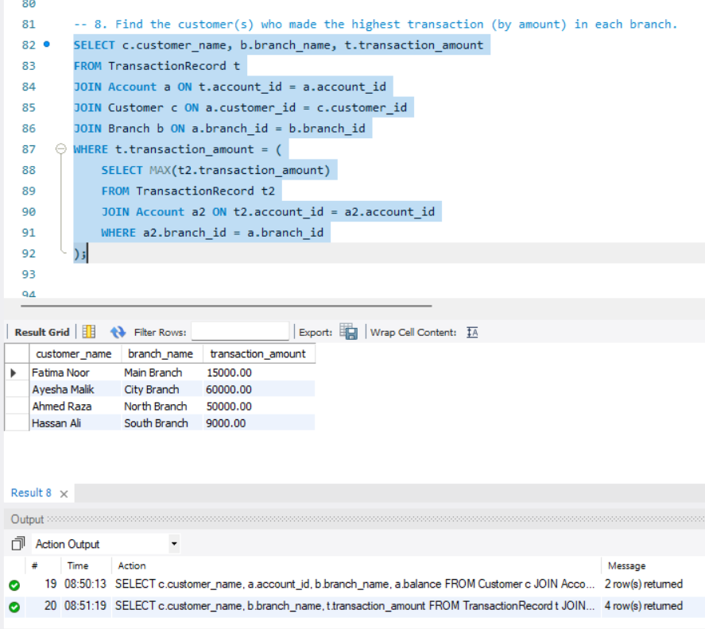

9. Display customer names who have made transactions only above 10,000.

SELECT c.customer_name
FROM Customer c
JOIN Account a ON c.customer_id = a.customer_id
JOIN TransactionRecord t ON a.account_id = t.account_id
GROUP BY c.customer_id, c.customer_name
HAVING MIN(t.transaction_amount) > 10000;

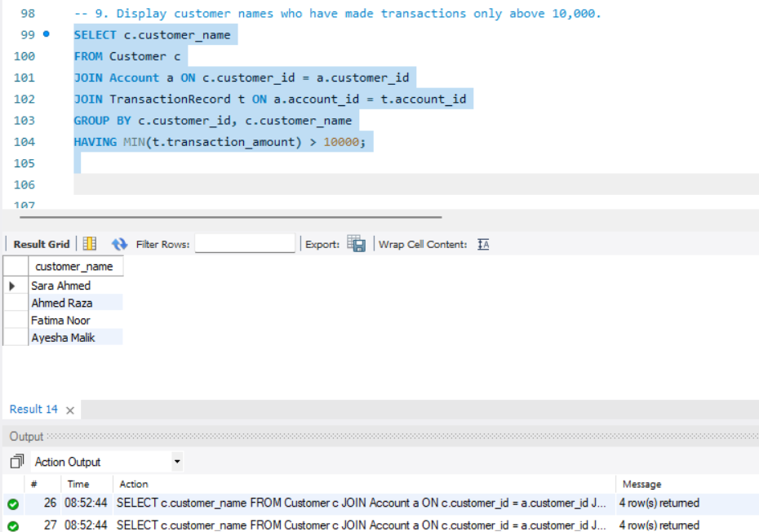

10. Show the top 3 branches with the highest total loan disbursement.

SELECT b.branch_name, SUM(l.loan_amount) AS total_loan_disbursement
FROM Branch b
JOIN Loan l ON b.branch_id = l.branch_id
GROUP BY b.branch_name
ORDER BY total_loan_disbursement DESC
LIMIT 3;
