Lab 13
1. Create a view to display customer_name and city from the Customers table.
CREATE VIEW vw_customer_city AS
SELECT customer_name, city
FROM Customers;

select * from vw_customer_city;

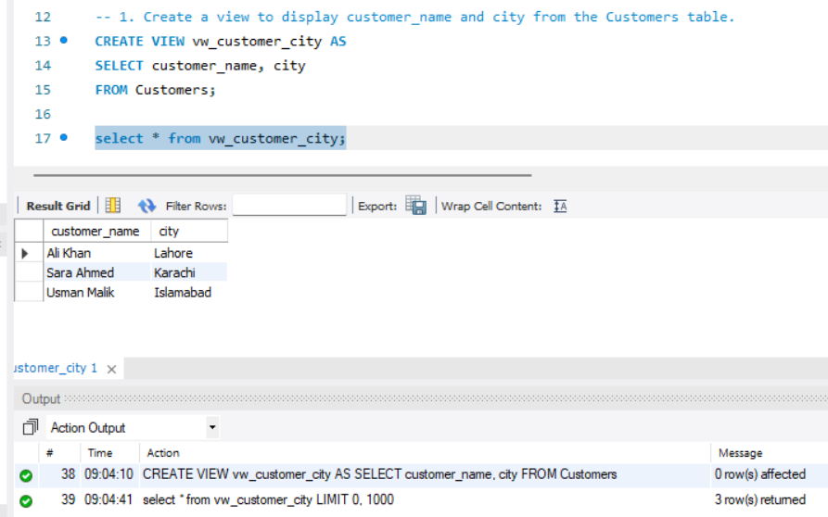

2. Create a view that displays account_id, account_type, and balance from Accounts table.

CREATE VIEW vw_account_info AS
SELECT account_id, account_type, balance
FROM Accounts;

select * from vw_account_info;
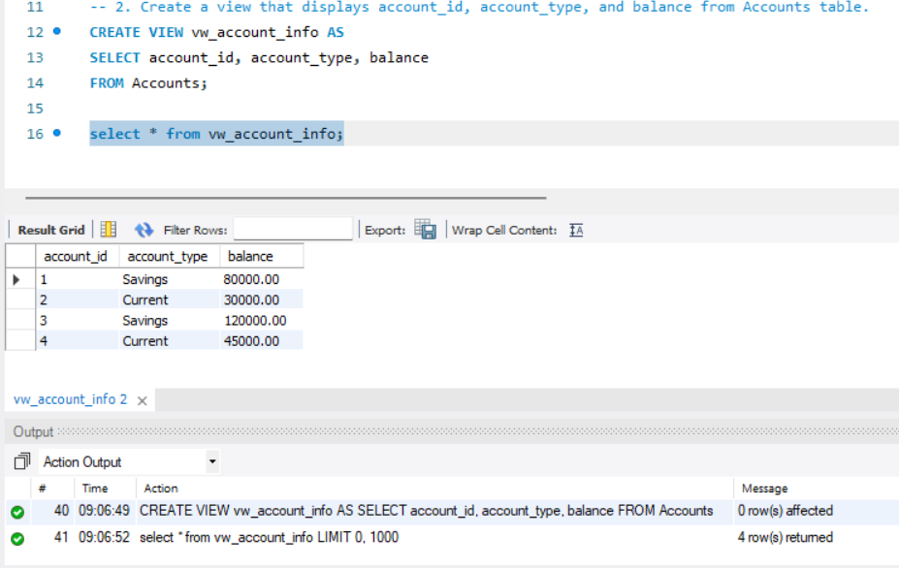

3. Create a view that joins Customers and Accounts to show customer_name and balance.
CREATE VIEW vw_customer_balance AS
SELECT c.customer_name, a.balance
FROM Customers c
JOIN Accounts a
ON c.customer_id = a.customer_id;

select * from vw_customer_balance;
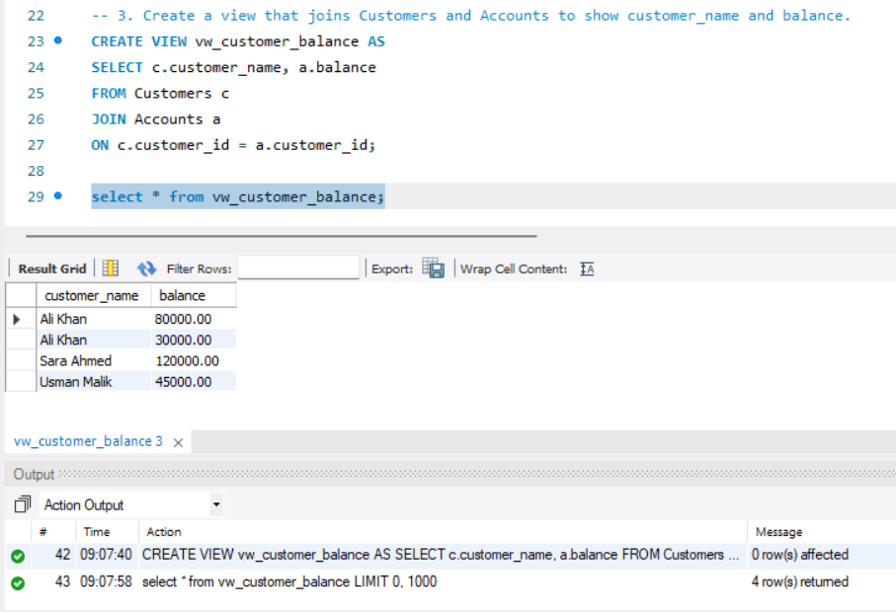

4. Create a view to display only savings accounts.
CREATE VIEW vw_savings_accounts AS
SELECT *
FROM Accounts
WHERE account_type = 'Savings';

select * from vw_savings_accounts;
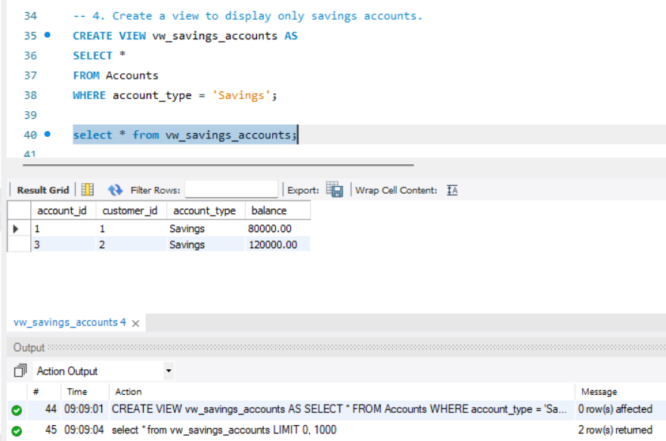

5. Create a view to show accounts with balance greater than 50000.
CREATE VIEW vw_high_balance_accounts AS
SELECT *
FROM Accounts
WHERE balance > 50000;

select * from vw_high_balance_accounts;
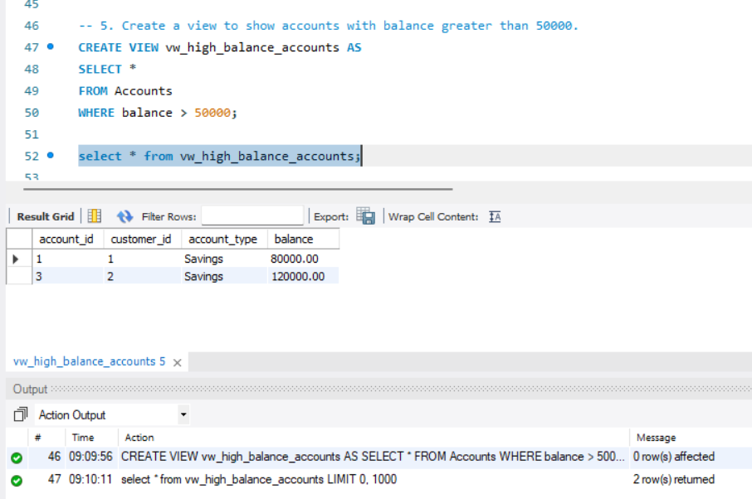

6. Create a view to display transaction details for each account.

CREATE VIEW vw_account_transactions AS
SELECT
a.account_id,
t.transaction_id,
t.transaction_date,
t.transaction_amount,
t.transaction_type
FROM Accounts a
JOIN Transactions t
ON a.account_id = t.account_id;

select * from vw_account_transactions;
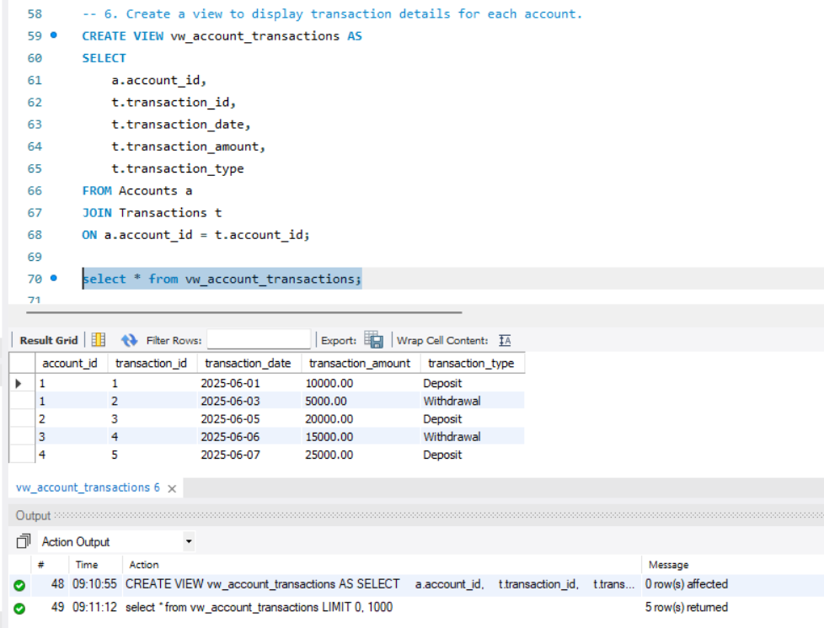

7. Create a view that shows customer_name, account_type, and transaction_amount.

CREATE VIEW vw_customer_transactions AS
SELECT
c.customer_name,
a.account_type,
t.transaction_amount
FROM Customers c
JOIN Accounts a
ON c.customer_id = a.customer_id
JOIN Transactions t
ON a.account_id = t.account_id;

select * from vw_customer_transactions;
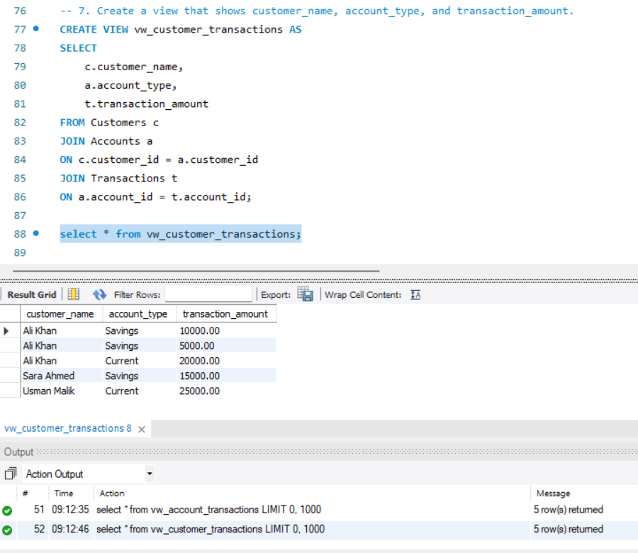

8. Create a stored procedure to display all records from Customers table.

DELIMITER $$

CREATE PROCEDURE ShowCustomers()
BEGIN
SELECT * FROM Customers;
END $$

DELIMITER ;

CALL ShowCustomers();
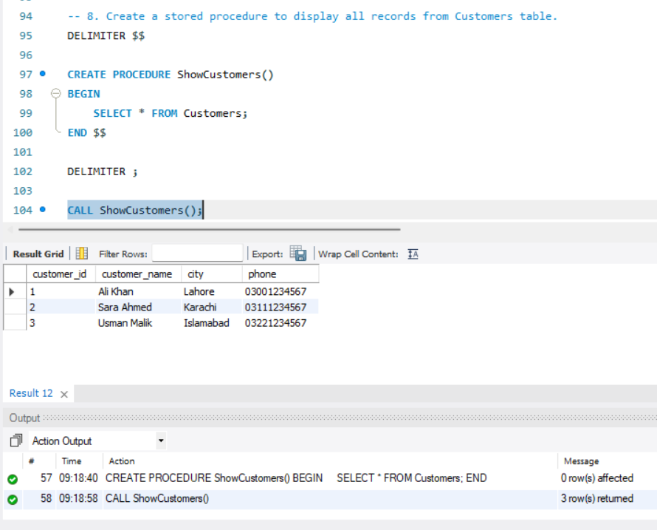

9. Create a stored procedure to display all records from Accounts table.
DELIMITER $$

CREATE PROCEDURE ShowAccounts()
BEGIN
SELECT * FROM Accounts;
END $$

DELIMITER ;

CALL ShowAccounts();
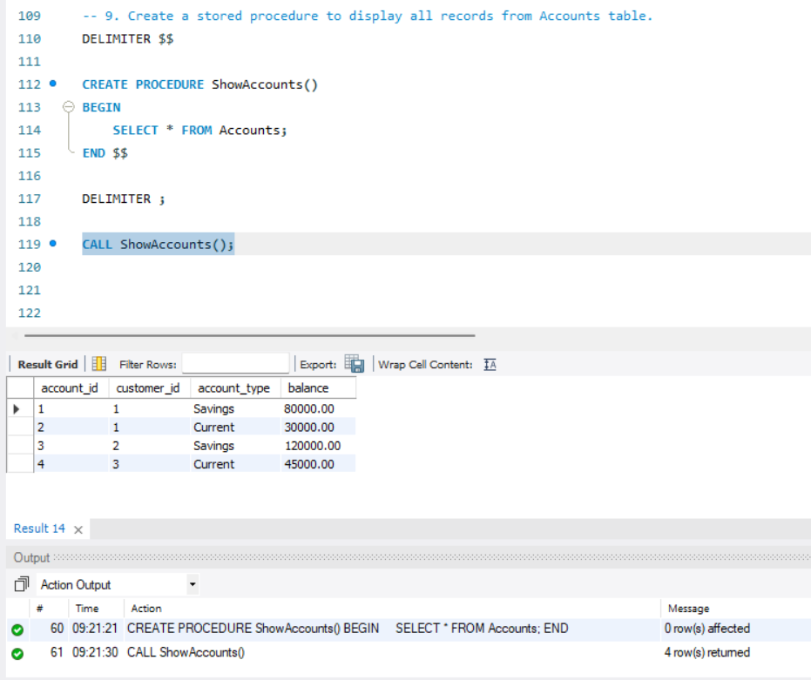

10. Create a stored procedure that accepts customer_id and displays related accounts.
DELIMITER $$

CREATE PROCEDURE GetCustomerAccounts(
IN p_customer_id INT
)
BEGIN
SELECT *
FROM Accounts
WHERE customer_id = p_customer_id;
END $$

DELIMITER ;

CALL GetCustomerAccounts(1);
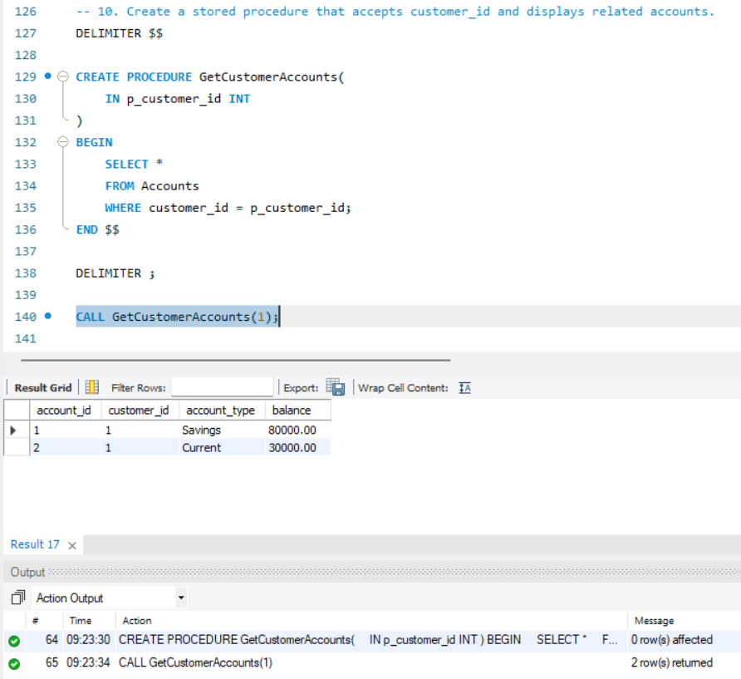

11. Create a stored procedure that accepts account_id and shows account balance.
DELIMITER $$

CREATE PROCEDURE GetAccountBalance(
IN p_account_id INT
)
BEGIN
SELECT balance
FROM Accounts
WHERE account_id = p_account_id;
END $$

DELIMITER ;

CALL GetAccountBalance(1);
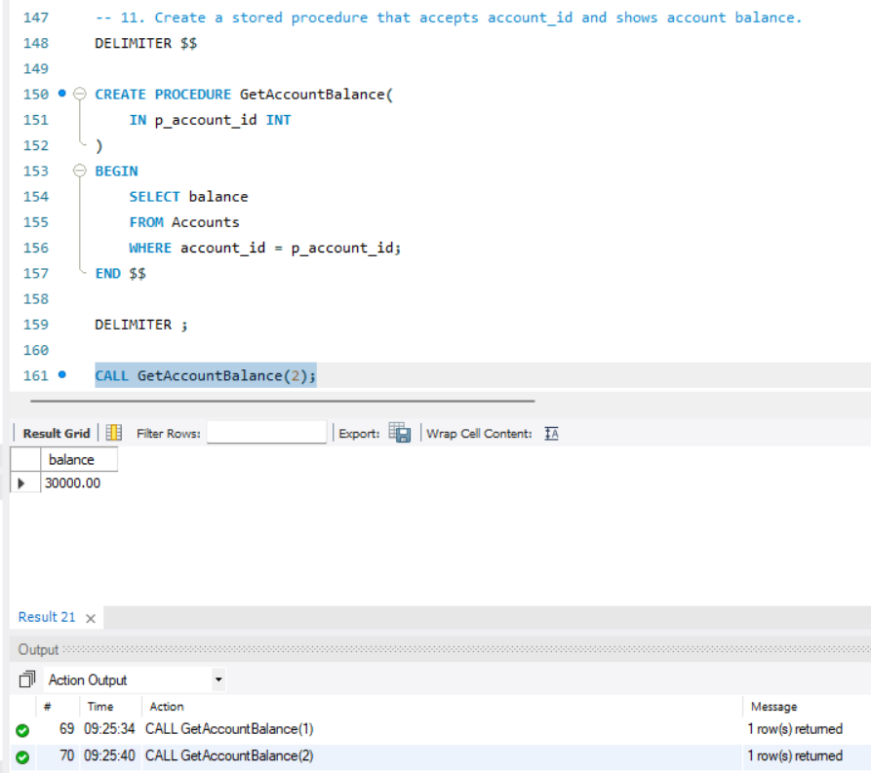
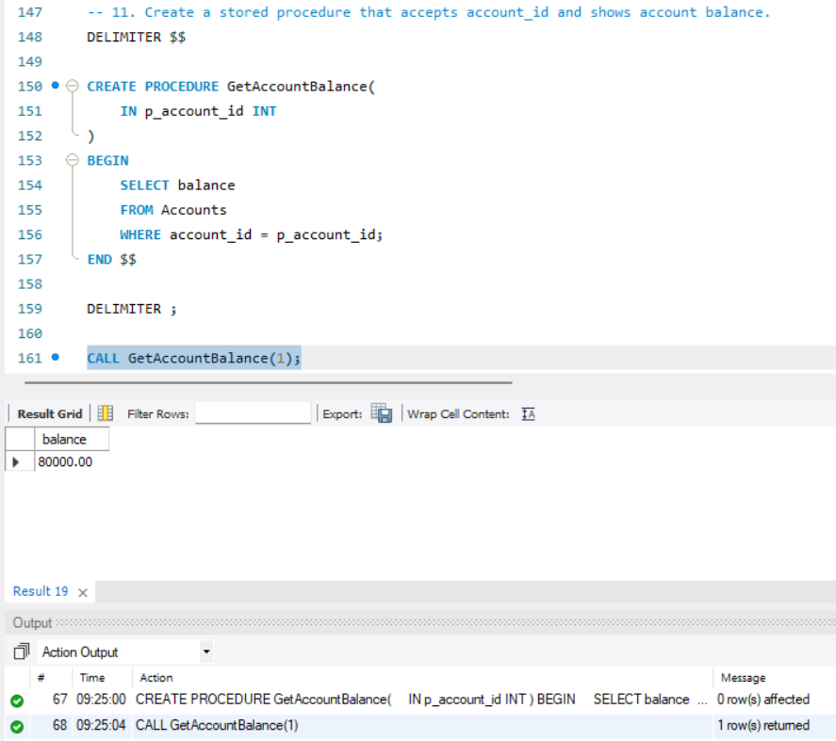

12. Create a stored procedure to display all transactions of a given account_id.
DELIMITER $$

CREATE PROCEDURE GetAccountTransactions(
IN p_account_id INT
)
BEGIN
SELECT *
FROM Transactions
WHERE account_id = p_account_id;
END $$

DELIMITER ;

CALL GetAccountTransactions(2);
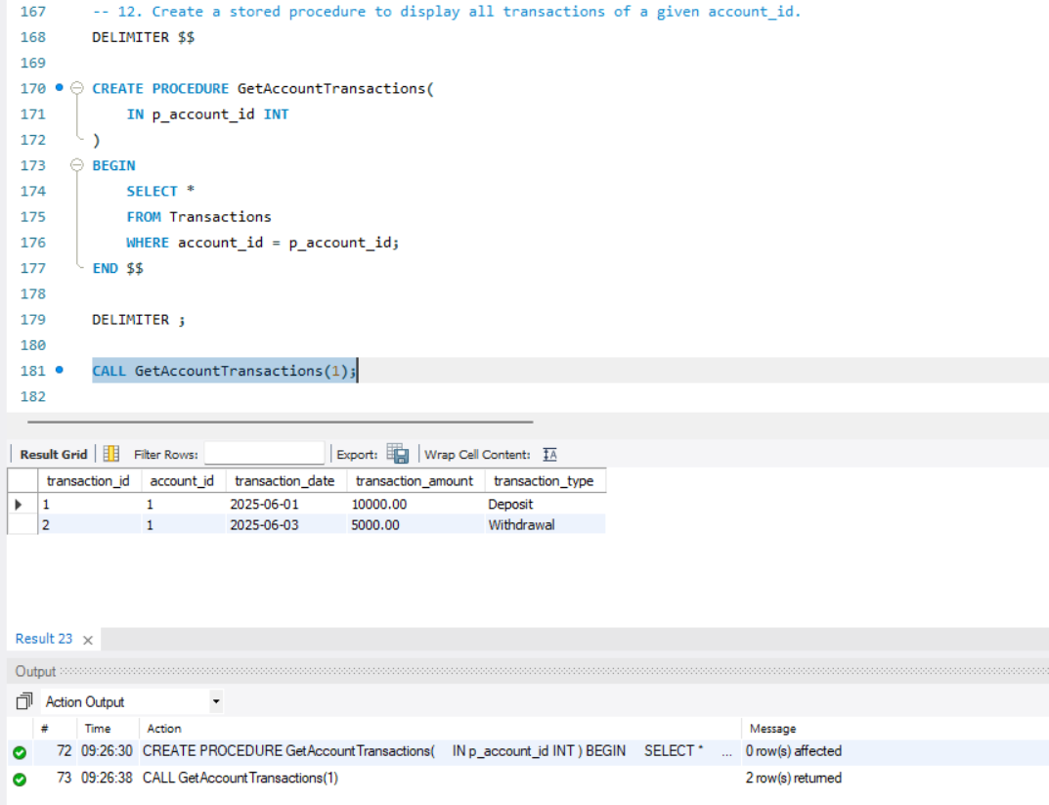
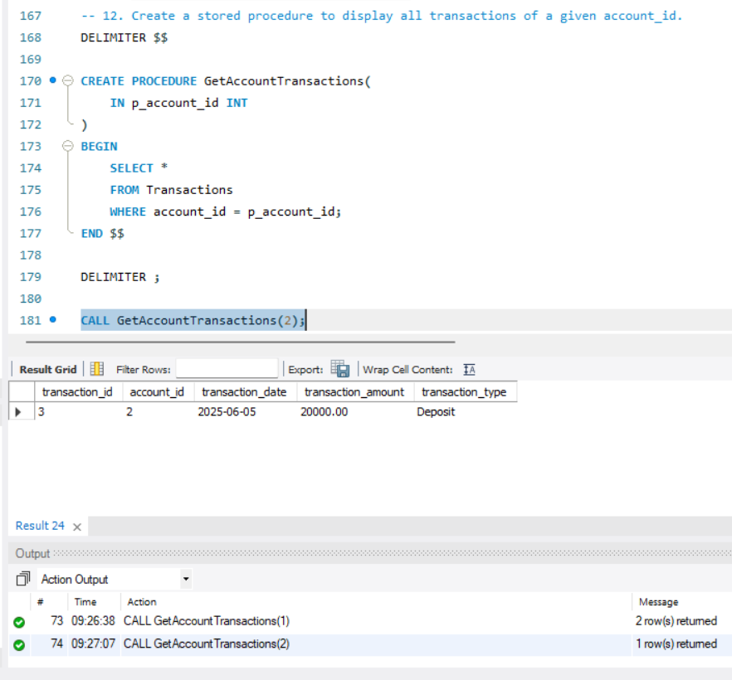

13. Create a stored procedure that displays transactions greater than a given amount.
DELIMITER //

CREATE PROCEDURE GetTransactionsGreaterThanAmount(
IN p_amount DECIMAL(12,2)
)
BEGIN
SELECT *
FROM Transactions
WHERE transaction_amount > p_amount;
END //

DELIMITER ;

CALL GetTransactionsGreaterThanAmount(10000);
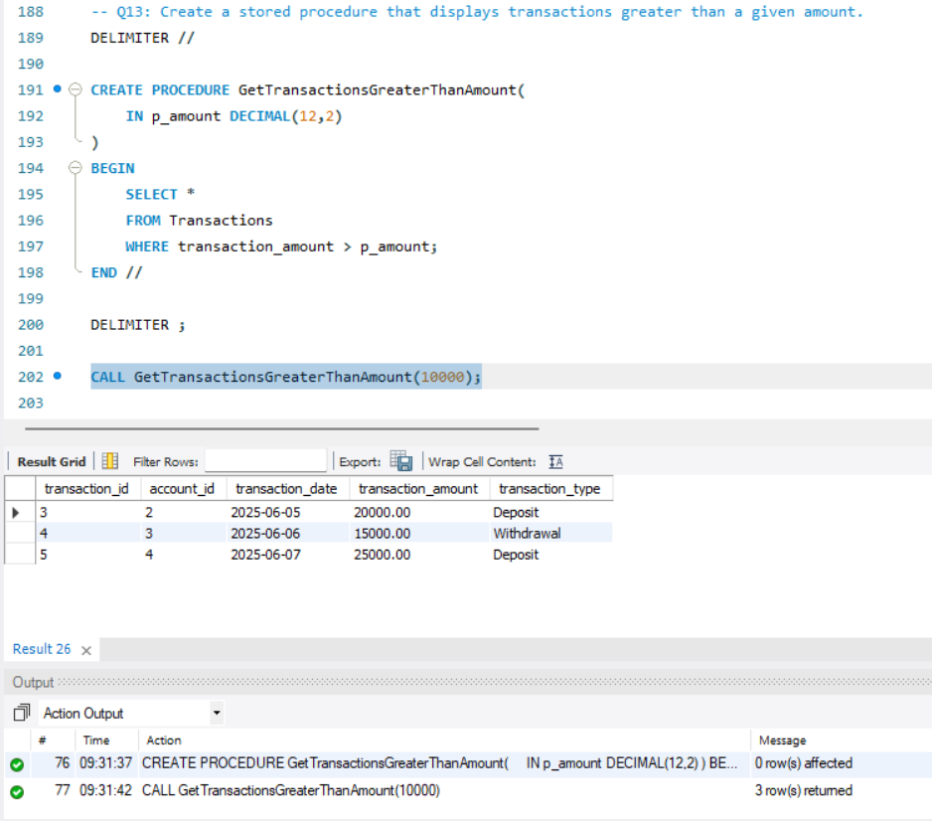

14. Create a stored procedure to display customers belonging to a specific city.
DELIMITER //

CREATE PROCEDURE GetCustomersByCity(
IN p_city VARCHAR(100)
)
BEGIN
SELECT *
FROM Customers
WHERE city = p_city;
END //

DELIMITER ;

CALL GetCustomersByCity('Lahore');
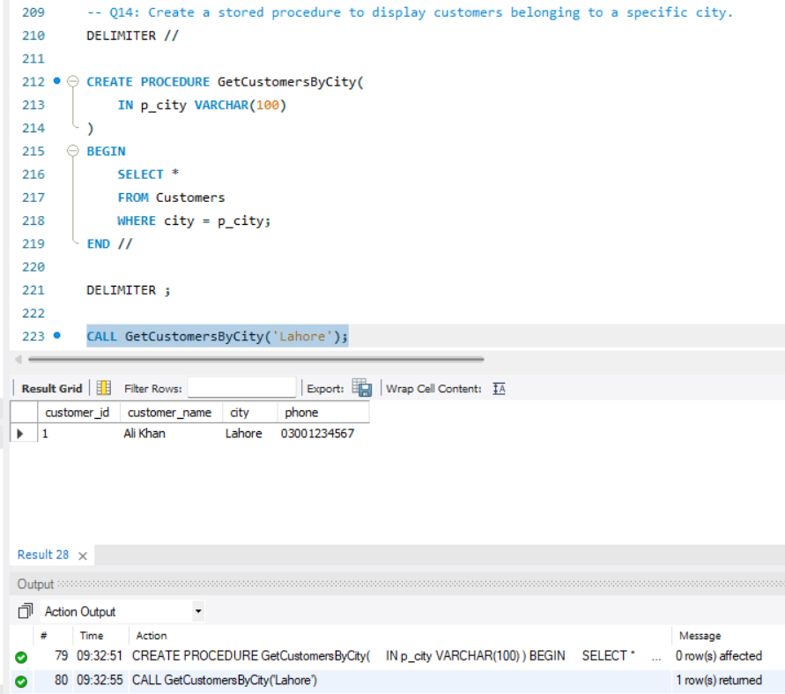

15. Create a stored procedure that accepts account_type and displays matching accounts.
DELIMITER //

CREATE PROCEDURE GetAccountsByType(
IN p_account_type VARCHAR(50)
)
BEGIN
SELECT *
FROM Accounts
WHERE account_type = p_account_type;
END //

DELIMITER ;

CALL GetAccountsByType('Savings');
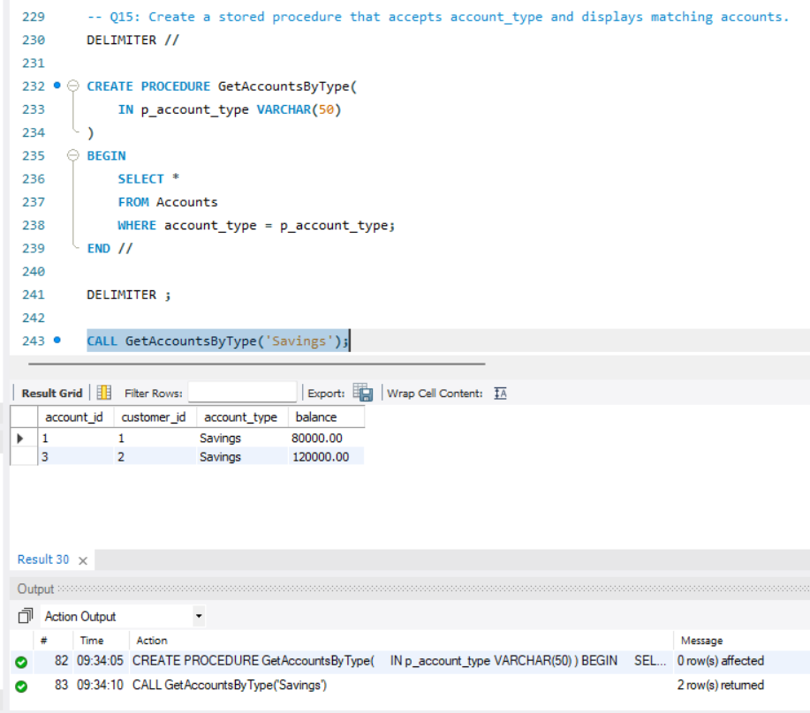

16. Create a view to display total balance of each customer.
CREATE VIEW CustomerTotalBalance AS
SELECT
c.customer_id,
c.customer_name,
SUM(a.balance) AS total_balance
FROM Customers c
JOIN Accounts a
ON c.customer_id = a.customer_id
GROUP BY c.customer_id, c.customer_name;

SELECT * FROM CustomerTotalBalance;

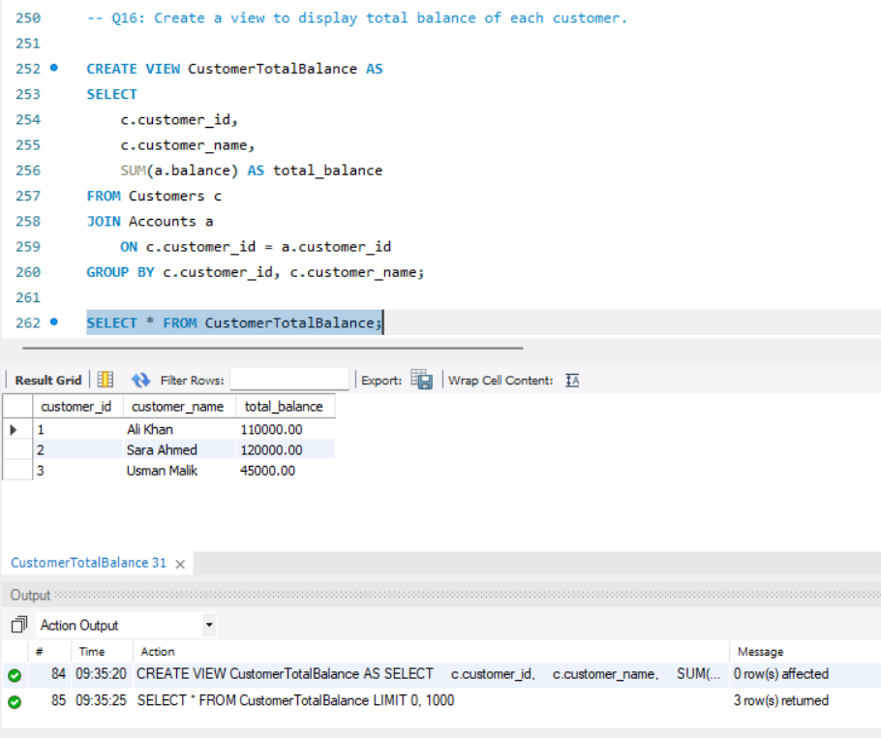

17. Create a stored procedure to count total number of accounts.
DELIMITER //

CREATE PROCEDURE CountTotalAccounts()
BEGIN
SELECT COUNT(*) AS Total_Accounts
FROM Accounts;
END //

DELIMITER ;

CALL CountTotalAccounts();

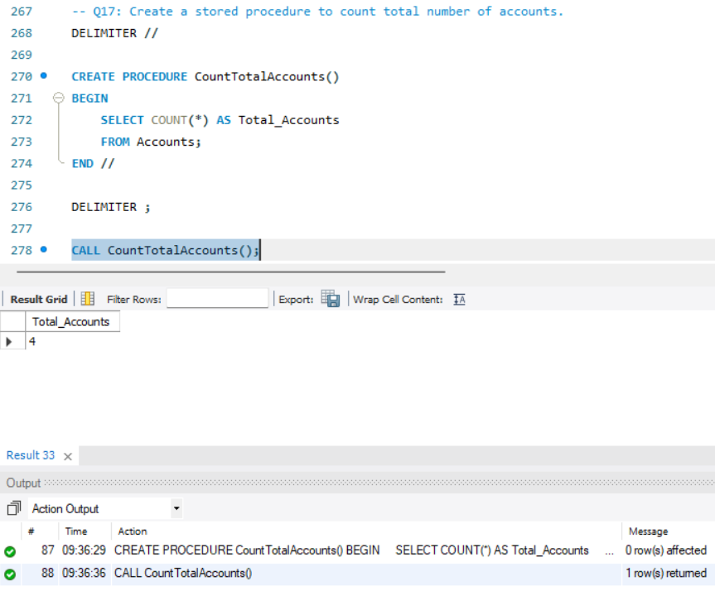

18. Create a stored procedure that accepts customer_id and counts total accounts of that customer.
DELIMITER //

CREATE PROCEDURE CountCustomerAccounts(
IN p_customer_id INT
)
BEGIN
SELECT
customer_id,
COUNT(*) AS Total_Accounts
FROM Accounts
WHERE customer_id = p_customer_id
GROUP BY customer_id;
END //

DELIMITER ;

CALL CountCustomerAccounts(1);
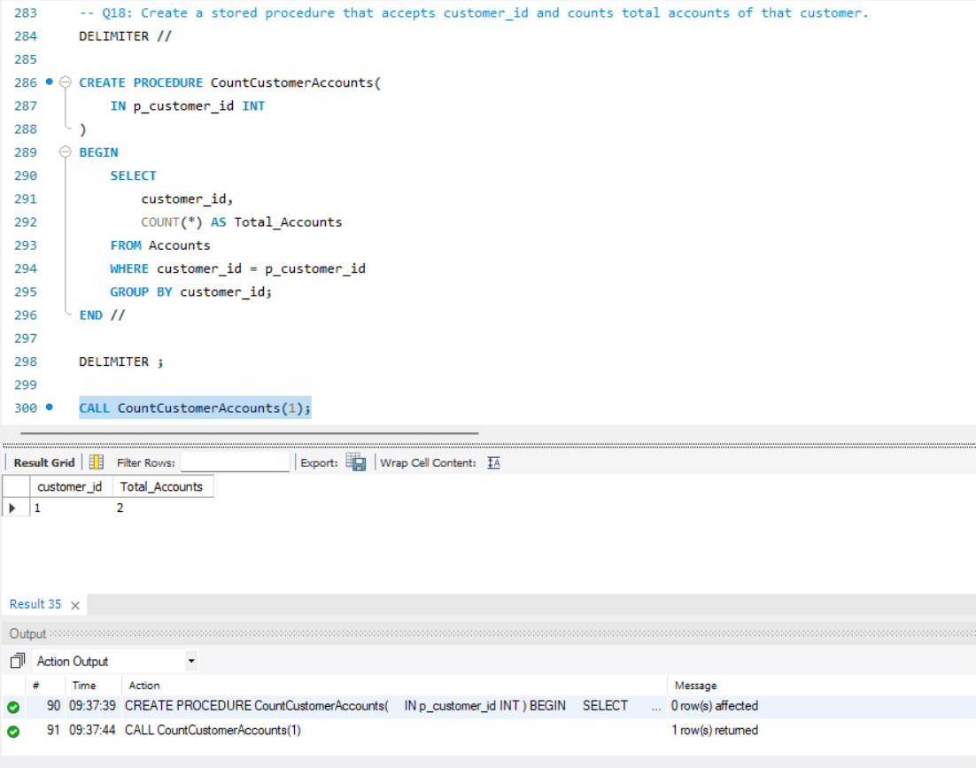

19. Create a view to display recent transactions.
CREATE VIEW RecentTransactions AS
SELECT *
FROM Transactions
WHERE transaction_date >= CURDATE() - INTERVAL 30 DAY;

SELECT * FROM RecentTransactions;
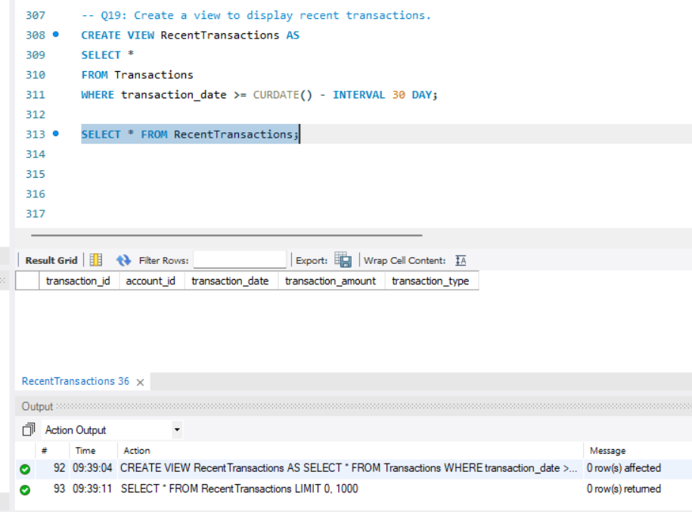

20. Create a stored procedure to display transactions between two dates.
DELIMITER //

CREATE PROCEDURE GetTransactionsBetweenDates(
IN p_start_date DATE,
IN p_end_date DATE
)
BEGIN
SELECT *
FROM Transactions
WHERE transaction_date
BETWEEN p_start_date AND p_end_date;
END //

DELIMITER ;

CALL GetTransactionsBetweenDates(
'2025-05-01',
'2025-06-30'
);

