Assignment # 2
DBMS
Total Marks: 20
Submission Date: 15/4/2026

Name: Hussain Durrani Roll No. L1F24BSCS0937 Section: D-7
Instructions:
I. Assignment should be done on MySql tool. Write a query along with its output screenshot and paste it on word file. Only soft form submission required. No copy paste.
II. You should create your own solution according to your logic. Any similarity with other student and internet will be consider as cheating and your assignment will be marked as ZERO.
III. Attach this page as front page of your assignment solution.

Question # 1: [20 Marks]
A new International company want to open online grocery store in Pakistan. They decided to first start with 3 big cities of Pakistan (Karachi, Lahore and Islamabad) and start their services in these cities. Their business modal is same as “my cart” and working structure is also same. You are required to design the database. For this purpose, you need define the Entities and their required attributes. The attributes that work as keys and each entity cardinality.
Task completed -Draw the ER-Diagram and convert in to Relational Model
For idea you can visit https://www.mycart.pk/ website.
Task to be done in Assignment 2
- Write DDL and DML for the tasks you have already done in Assignment 1.
- Insert at least 20 rows in each table, Apply all types of queries at least 2 times

All Queries:

create database online_store;
use online_store;

CREATE TABLE Address (
Address_ID INT PRIMARY KEY,
House_no VARCHAR(10),
Street_Address VARCHAR(100),
Area_Block VARCHAR(50),
Apartment_no VARCHAR(10),
City VARCHAR(50),
Postal_Code VARCHAR(10)
);

CREATE TABLE User (
User_ID INT PRIMARY KEY,
First_Name VARCHAR(50),
Last_Name VARCHAR(50),
Email VARCHAR(100) UNIQUE,
Password VARCHAR(100),
Account_Status VARCHAR(20),
Last_Visit_Date DATE,
Address_ID INT,
FOREIGN KEY (Address_ID) REFERENCES Address(Address_ID)
);

CREATE TABLE Category (
Category_ID INT PRIMARY KEY,
Category_Name VARCHAR(50),
Description VARCHAR(100)
);

CREATE TABLE Warehouse (
Warehouse_ID INT PRIMARY KEY,
Manager_Name VARCHAR(100),
Location VARCHAR(100),
City VARCHAR(50)
);

CREATE TABLE Product (
Product_ID INT PRIMARY KEY,
Product_Name VARCHAR(100),
Product_Description VARCHAR(200),
Brand_Name VARCHAR(50),
Price DECIMAL(10,2),
Unit VARCHAR(20),
Stock_Quantity INT,
Product_IMG_url VARCHAR(200),
Category_ID INT,
Warehouse_ID INT,
FOREIGN KEY (Category_ID) REFERENCES Category(Category_ID),
FOREIGN KEY (Warehouse_ID) REFERENCES Warehouse(Warehouse_ID)
);

CREATE TABLE Orders (
Order_ID INT PRIMARY KEY,
Order_Date DATE,
Delivery_Address VARCHAR(200),
City VARCHAR(50),
Total_Amount DECIMAL(10,2),
Order_Status VARCHAR(20),
Payment_Status VARCHAR(20),
Expected_Delivery_Time VARCHAR(50),
User_ID INT,
FOREIGN KEY (User_ID) REFERENCES User(User_ID)
);

CREATE TABLE Payment (
Payment_ID INT PRIMARY KEY,
Payment_Method VARCHAR(50),
Amount_Paid DECIMAL(10,2),
Transaction_Date DATE,
Order_ID INT,
FOREIGN KEY (Order_ID) REFERENCES Orders(Order_ID)
);

CREATE TABLE Order_Details (
Order_Details_ID INT PRIMARY KEY,
Quantity INT,
Price_at_Purchase DECIMAL(10,2),
Order_ID INT,
Product_ID INT,
FOREIGN KEY (Order_ID) REFERENCES Orders(Order_ID),
FOREIGN KEY (Product_ID) REFERENCES Product(Product_ID)
);

INSERT INTO Address VALUES
(1,'12','Street 1','A','-','Lahore','54000'),
(2,'45','Street 2','B','-','Karachi','74000'),
(3,'78','Street 3','C','-','Islamabad','44000'),
(4,'23','Street 4','D','-','Lahore','54001'),
(5,'67','Street 5','E','-','Karachi','74001'),
(6,'89','Street 6','F','-','Islamabad','44001'),
(7,'34','Street 7','G','-','Lahore','54002'),
(8,'56','Street 8','H','-','Karachi','74002'),
(9,'91','Street 9','I','-','Islamabad','44002'),
(10,'11','Street 10','J','-','Lahore','54003'),
(11,'22','Street 11','K','-','Karachi','74003'),
(12,'33','Street 12','L','-','Islamabad','44003'),
(13,'44','Street 13','M','-','Lahore','54004'),
(14,'55','Street 14','N','-','Karachi','74004'),
(15,'66','Street 15','O','-','Islamabad','44004'),
(16,'77','Street 16','P','-','Lahore','54005'),
(17,'88','Street 17','Q','-','Karachi','74005'),
(18,'99','Street 18','R','-','Islamabad','44005'),
(19,'100','Street 19','S','-','Lahore','54006'),
(20,'101','Street 20','T','-','Karachi','74006');
select * from Address;

INSERT INTO User VALUES
(1,'Hussain','Durrani','h1@gmail.com','123','Active','2026-04-01',1),
(2,'Ali','Hamza','h2@gmail.com','123','Active','2026-04-02',2),
(3,'Ahmed','Raza','h3@gmail.com','123','Active','2026-04-03',3),
(4,'Usman','Khan','h4@gmail.com','123','Active','2026-04-04',4),
(5,'Bilal','Sheikh','h5@gmail.com','123','Inactive','2026-04-05',5),
(6,'Zain','Malik','h6@gmail.com','123','Active','2026-04-06',6),
(7,'Saad','Qureshi','h7@gmail.com','123','Active','2026-04-07',7),
(8,'Farhan','Ali','h8@gmail.com','123','Active','2026-04-08',8),
(9,'Imran','Butt','h9@gmail.com','123','Inactive','2026-04-09',9),
(10,'Tariq','Mehmood','h10@gmail.com','123','Active','2026-04-10',10),
(11,'Ayesha','Khan','h11@gmail.com','123','Active','2026-04-11',11),
(12,'Fatima','Noor','h12@gmail.com','123','Active','2026-04-12',12),
(13,'Zara','Ahmed','h13@gmail.com','123','Active','2026-04-13',13),
(14,'Hina','Rashid','h14@gmail.com','123','Inactive','2026-04-14',14),
(15,'Maryam','Iqbal','h15@gmail.com','123','Active','2026-04-15',15),
(16,'Sana','Javed','h16@gmail.com','123','Active','2026-04-16',16),
(17,'Rabia','Shah','h17@gmail.com','123','Active','2026-04-17',17),
(18,'Nida','Hassan','h18@gmail.com','123','Active','2026-04-18',18),
(19,'Mehwish','Akram','h19@gmail.com','123','Inactive','2026-04-19',19),
(20,'Kiran','Aslam','h20@gmail.com','123','Active','2026-04-20',20);
select * from User;

INSERT INTO Category VALUES
(1,'Beverages','Drinks'),
(2,'Dairy','Milk products'),
(3,'Snacks','Chips & biscuits'),
(4,'Staples','Rice & flour'),
(5,'Frozen','Frozen food'),
(6,'Fruits','Fresh fruits'),
(7,'Vegetables','Fresh vegetables'),
(8,'Bakery','Bread items'),
(9,'Personal Care','Hygiene'),
(10,'Health','Supplements'),
(11,'Baby','Baby care'),
(12,'Cleaning','Household'),
(13,'Electronics','Devices'),
(14,'Men Fashion','Clothes'),
(15,'Women Fashion','Clothes'),
(16,'Kids','Kids wear'),
(17,'Home','Furniture'),
(18,'Kitchen','Appliances'),
(19,'Stationery','Office items'),
(20,'Books','Reading');
select * from Category;

INSERT INTO Warehouse VALUES
(1,'Ali Khan','Johar Town','Lahore'),
(2,'Ahmed Raza','Gulshan','Karachi'),
(3,'Usman Tariq','F-10','Islamabad'),
(4,'Bilal Khan','Model Town','Lahore'),
(5,'Zain Ali','Clifton','Karachi'),
(6,'Saad Ahmed','G-11','Islamabad'),
(7,'Farhan Malik','DHA','Lahore'),
(8,'Imran Butt','North Nazimabad','Karachi'),
(9,'Tariq Mehmood','F-11','Islamabad'),
(10,'Hassan Raza','Cantt','Lahore'),
(11,'Adeel Khan','Malir','Karachi'),
(12,'Omar Sheikh','G-13','Islamabad'),
(13,'Noman Ali','Township','Lahore'),
(14,'Shahid Khan','Korangi','Karachi'),
(15,'Kamran Raza','I-8','Islamabad'),
(16,'Junaid Malik','Bahria','Lahore'),
(17,'Waqar Ahmed','Defence','Karachi'),
(18,'Asad Ali','F-6','Islamabad'),
(19,'Sohail Khan','Garden Town','Lahore'),
(20,'Fahad Raza','PECHS','Karachi');
select * from Warehouse;

INSERT INTO Product VALUES
(1,'Milk','Fresh Milk','Nestle',220,'Litre',50,'img1',2,1),
(2,'Bread','Brown Bread','Dawn',120,'Piece',40,'img2',8,2),
(3,'Rice','Basmati','Guard',300,'Kg',60,'img3',4,3),
(4,'Juice','Mango Juice','Nestle',180,'Litre',70,'img4',1,4),
(5,'Eggs','Farm Eggs','Local',250,'Dozen',80,'img5',2,5),
(6,'Chips','Potato Chips','Lays',100,'Pack',90,'img6',3,6),
(7,'Apple','Fresh Apple','Local',200,'Kg',30,'img7',6,7),
(8,'Soap','Beauty Soap','Lux',90,'Piece',100,'img8',9,8),
(9,'Shampoo','Hair Care','Sunsilk',350,'Bottle',40,'img9',9,9),
(10,'Chicken','Fresh Chicken','Local',500,'Kg',25,'img10',7,10),
(11,'Flour','Wheat Flour','Ashraf',150,'Kg',80,'img11',4,11),
(12,'Ice Cream','Vanilla','Walls',400,'Tub',35,'img12',5,12),
(13,'Butter','Salted','Nurpur',250,'Pack',45,'img13',2,13),
(14,'Banana','Fresh Banana','Local',120,'Dozen',50,'img14',6,14),
(15,'Detergent','Washing Powder','Surf',500,'Kg',60,'img15',12,15),
(16,'Laptop','Basic Laptop','Dell',80000,'Piece',10,'img16',13,16),
(17,'Shirt','Men Shirt','Outfitters',2000,'Piece',25,'img17',14,17),
(18,'Dress','Women Dress','Khaadi',3500,'Piece',20,'img18',15,18),
(19,'Notebook','School Notebook','Local',100,'Piece',70,'img19',19,19),
(20,'Book','Story Book','Oxford',600,'Piece',30,'img20',20,20);
select * from Product;

INSERT INTO Orders VALUES
(1,'2026-04-01','Addr1','Lahore',500,'Delivered','Paid','2 Days',1),
(2,'2026-04-02','Addr2','Karachi',800,'Pending','Unpaid','3 Days',2),
(3,'2026-04-03','Addr3','Islamabad',600,'Delivered','Paid','2 Days',3),
(4,'2026-04-04','Addr4','Lahore',700,'Pending','Paid','3 Days',4),
(5,'2026-04-05','Addr5','Karachi',900,'Delivered','Paid','2 Days',5),
(6,'2026-04-06','Addr6','Islamabad',400,'Pending','Unpaid','3 Days',6),
(7,'2026-04-07','Addr7','Lahore',550,'Delivered','Paid','2 Days',7),
(8,'2026-04-08','Addr8','Karachi',650,'Pending','Paid','3 Days',8),
(9,'2026-04-09','Addr9','Islamabad',750,'Delivered','Paid','2 Days',9),
(10,'2026-04-10','Addr10','Lahore',850,'Pending','Unpaid','3 Days',10),
(11,'2026-04-11','Addr11','Karachi',950,'Delivered','Paid','2 Days',11),
(12,'2026-04-12','Addr12','Islamabad',300,'Pending','Paid','3 Days',12),
(13,'2026-04-13','Addr13','Lahore',450,'Delivered','Paid','2 Days',13),
(14,'2026-04-14','Addr14','Karachi',550,'Pending','Unpaid','3 Days',14),
(15,'2026-04-15','Addr15','Islamabad',650,'Delivered','Paid','2 Days',15),
(16,'2026-04-16','Addr16','Lahore',750,'Pending','Paid','3 Days',16),
(17,'2026-04-17','Addr17','Karachi',850,'Delivered','Paid','2 Days',17),
(18,'2026-04-18','Addr18','Islamabad',950,'Pending','Unpaid','3 Days',18),
(19,'2026-04-19','Addr19','Lahore',500,'Delivered','Paid','2 Days',19),
(20,'2026-04-20','Addr20','Karachi',600,'Pending','Paid','3 Days',20);
select * from Orders;

INSERT INTO Payment VALUES
(1,'Cash',500,'2026-04-01',1),
(2,'Card',800,'2026-04-02',2),
(3,'Cash',600,'2026-04-03',3),
(4,'Card',700,'2026-04-04',4),
(5,'Cash',900,'2026-04-05',5),
(6,'Card',400,'2026-04-06',6),
(7,'Cash',550,'2026-04-07',7),
(8,'Card',650,'2026-04-08',8),
(9,'Cash',750,'2026-04-09',9),
(10,'Card',850,'2026-04-10',10),
(11,'Cash',950,'2026-04-11',11),
(12,'Card',300,'2026-04-12',12),
(13,'Cash',450,'2026-04-13',13),
(14,'Card',550,'2026-04-14',14),
(15,'Cash',650,'2026-04-15',15),
(16,'Card',750,'2026-04-16',16),
(17,'Cash',850,'2026-04-17',17),
(18,'Card',950,'2026-04-18',18),
(19,'Cash',500,'2026-04-19',19),
(20,'Card',600,'2026-04-20',20);
select * from Payment;

INSERT INTO Order_Details VALUES
(1,2,220,1,1),
(2,1,120,2,2),
(3,3,300,3,3),
(4,2,180,4,4),
(5,1,250,5,5),
(6,4,100,6,6),
(7,2,200,7,7),
(8,3,90,8,8),
(9,1,350,9,9),
(10,2,500,10,10),
(11,3,150,11,11),
(12,1,400,12,12),
(13,2,250,13,13),
(14,3,120,14,14),
(15,2,500,15,10),
(16,1,80000,16,16),
(17,2,2000,17,17),
(18,1,3500,18,18),
(19,5,100,19,19),
(20,2,600,20,20);
select * from Order_Details;

SELECT * FROM Product
WHERE Price > (SELECT AVG(Price) FROM Product);
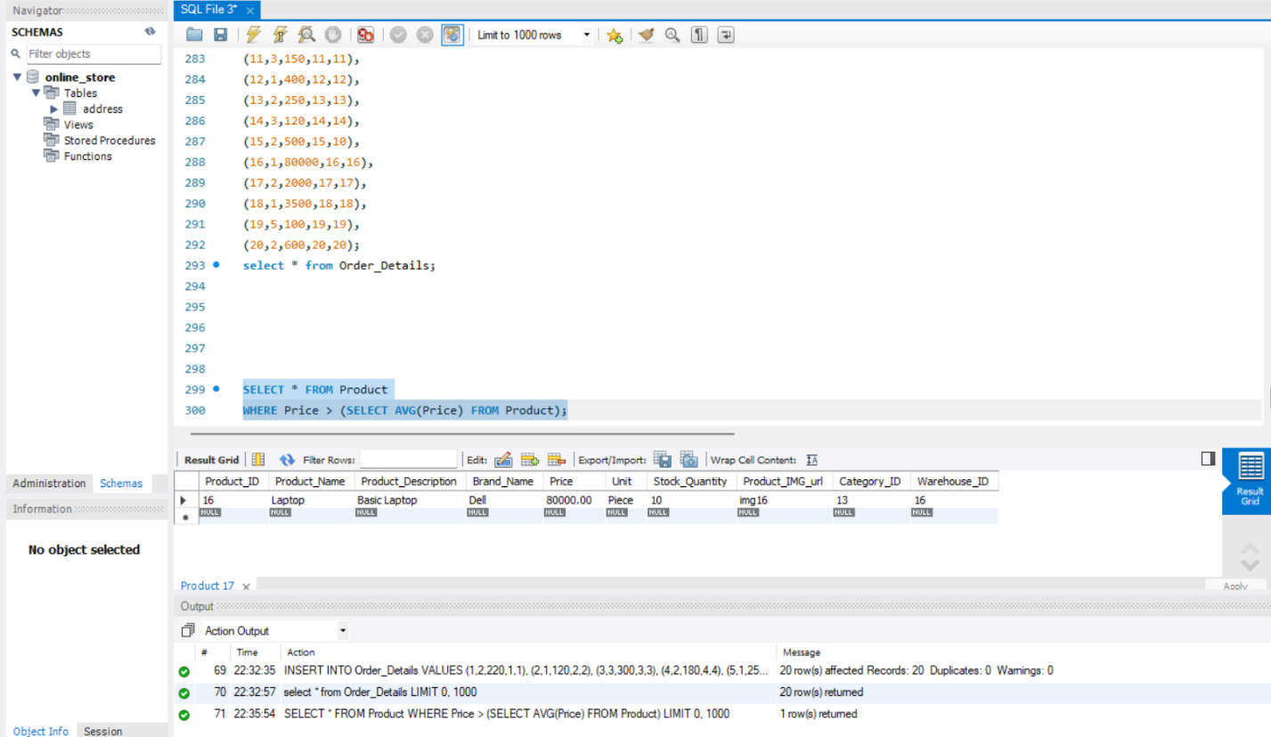

SELECT First_Name FROM User
WHERE User_ID IN (SELECT User_ID FROM Orders WHERE City='Lahore');

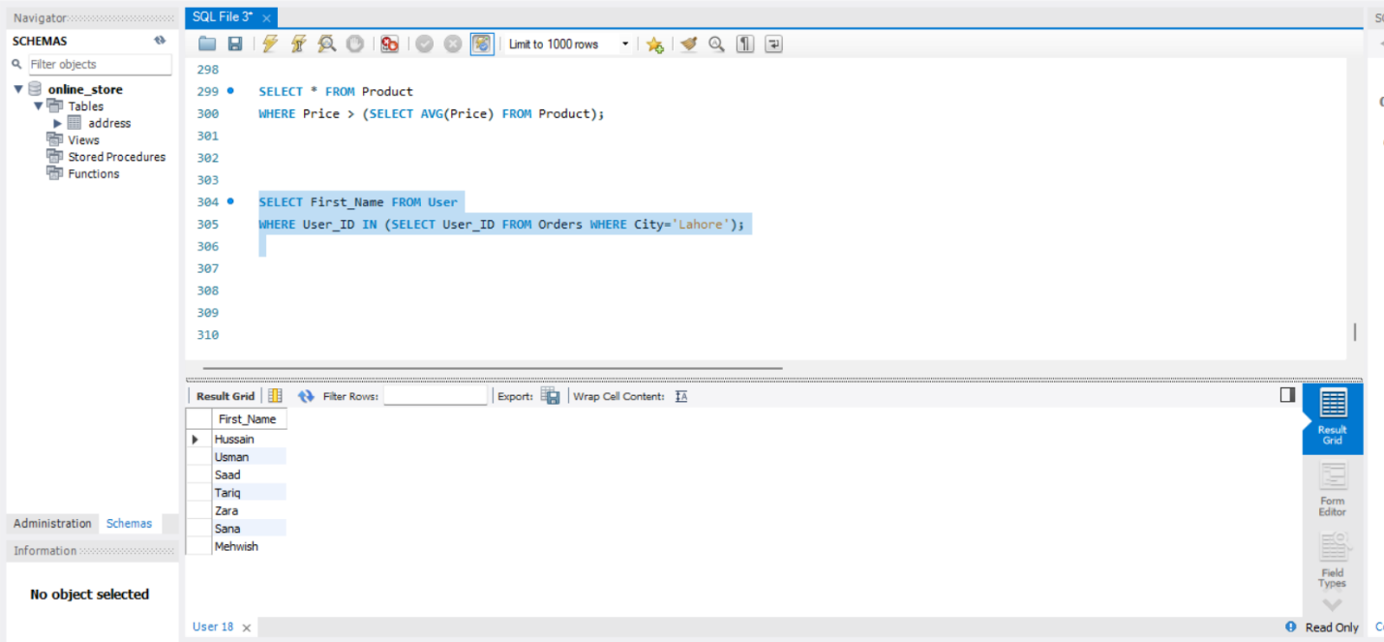

SELECT City, COUNT(*)
FROM Orders
GROUP BY City
HAVING COUNT(*) > 5;
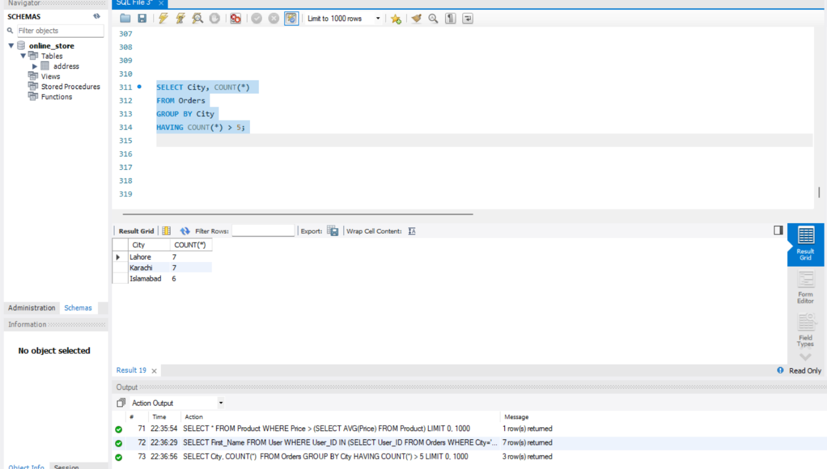

SELECT U.First_Name, P.Product_Name, O.Order_ID
FROM User U
JOIN Orders O ON U.User_ID = O.User_ID
JOIN Order_Details OD ON O.Order_ID = OD.Order_ID
JOIN Product P ON OD.Product_ID = P.Product_ID;
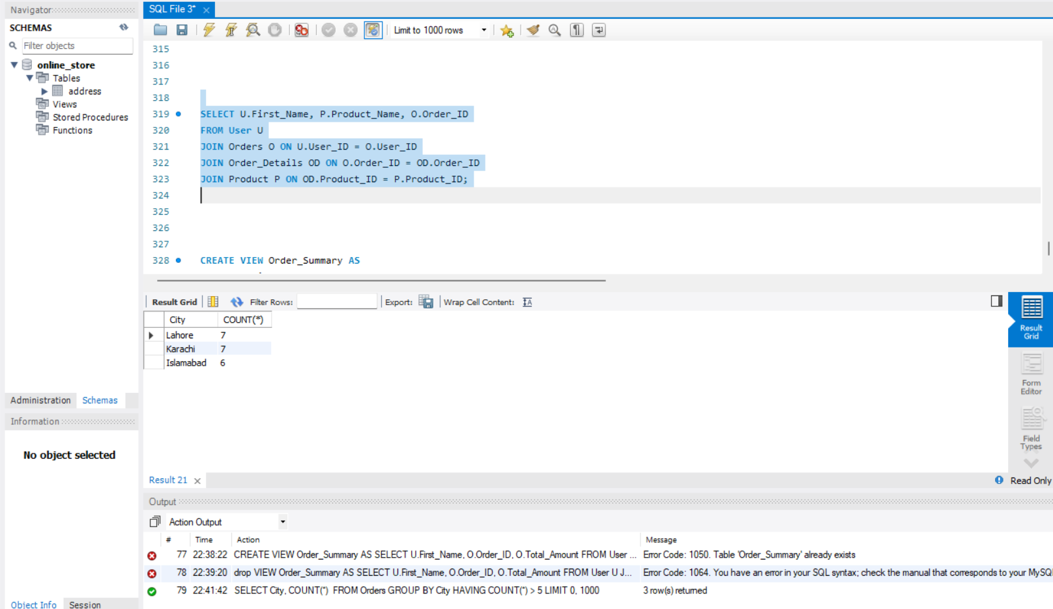

CREATE VIEW Order_Summary AS
SELECT U.First_Name, O.Order_ID, O.Total_Amount
FROM User U
JOIN Orders O ON U.User_ID = O.User_ID;
