Hussain Durrani
L1F24BSCS0937
DSA_GradedLab_03
Circular LinkedList

OUTPUT:
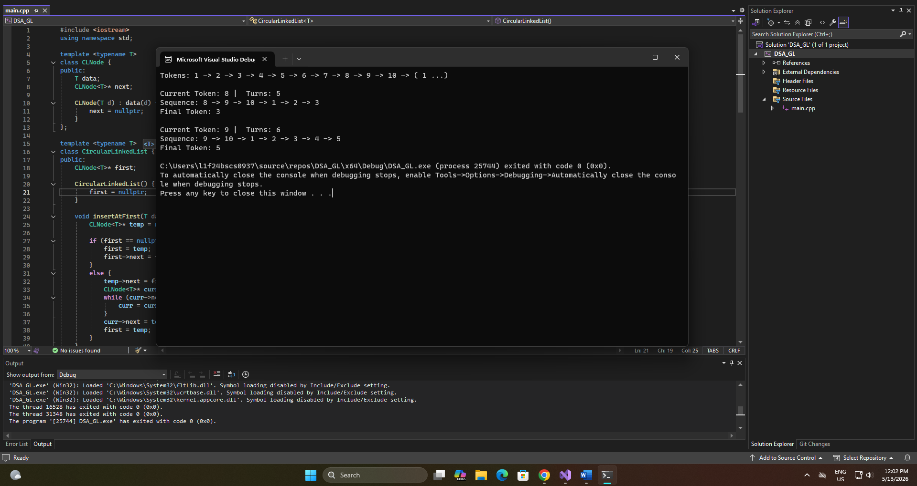
CODE:
// Hussain Durrani
// L1F24BSCS0937
#include <iostream>
using namespace std;

template <typename T>
class CLNode {
public:
T data;
CLNode<T>* next;

CLNode(T d) : data(d) {
next = nullptr;
}
};

template <typename T>
class CircularLinkedList {
public:
CLNode<T>* first;

CircularLinkedList() {
first = nullptr;
}

void insertAtFirst(T data) {
CLNode<T>* temp = new CLNode(data);

if (first == nullptr) {
first = temp;
first->next = first;
}
else {
temp->next = first;
CLNode<T>* curr = first;
while (curr->next != first) {
curr = curr->next;
}
curr->next = temp;
first = temp;
}
}

void insertAtLast(T data) {
CLNode<T>* temp = new CLNode<T>(data);

if (first == nullptr) {
first = temp;
first->next = first;
}
else {
CLNode<T>* curr = first;
while (curr->next != first) {
curr = curr->next;
}
curr->next = temp;
temp->next = first;
}
}

void displayAllTokens() {
cout << "Tokens: ";
CLNode<T>* curr = first;
cout << curr->data << " -> ";
curr = curr->next;
while (curr != first) {
cout << curr->data << " -> ";
curr = curr->next;
}
cout << "( " << curr->data << " ...)";
cout << "\n";
}

void printSequence(T currToken, int turns) {
cout << "\nCurrent Token: " << currToken << " | Turns: " << turns << "\n";
cout << "Sequence: ";
CLNode<T>* curr = first;
while (curr->data != currToken) {
curr = curr->next;
}
while (turns > 0) {
cout << curr->data << " -> ";
curr = curr->next;
turns--;
}
cout << curr->data << " ";
cout << "\n";
cout << "Final Token: " << curr->data << "\n";
}

};

int main() {
CircularLinkedList<int> tokenNumbers;
tokenNumbers.insertAtLast(1);
tokenNumbers.insertAtLast(2);
tokenNumbers.insertAtLast(3);
tokenNumbers.insertAtLast(4);
tokenNumbers.insertAtLast(5);
tokenNumbers.insertAtLast(6);
tokenNumbers.insertAtLast(7);
tokenNumbers.insertAtLast(8);
tokenNumbers.insertAtLast(9);
tokenNumbers.insertAtLast(10);

tokenNumbers.displayAllTokens();

tokenNumbers.printSequence(8, 5);

tokenNumbers.printSequence(9, 6);

return 0;
}

