Heap
Insertion, Deletion, Heap Sort — Array-based implementation

Topic
This lab focuses on the Heap data structure — a complete binary tree stored as an array, where every parent satisfies the heap property with respect to its children. You will practice: building a Max-Heap and Min-Heap using arrays, performing insertion with heapify-up, performing deletion (extract root) with heapify-down, and applying heap operations to sort an array in-place.

Objective
- Understand the Heap property and how a complete binary tree maps to an array.
- Implement Max-Heap insertion using the heapify-up algorithm.
- Implement root deletion (Extract Max / Extract Min) using heapify-down.
- Build a Min-Heap with input validation (duplicate detection).
- Apply heap operations to perform an in-place Heap Sort.

Outcomes
- Represent a heap as a plain integer array and compute parent/child indices correctly.
- Insert elements into a Max-Heap and restore the heap property after each insertion.
- Remove the root element and restore the heap property using heapify-down.
- Detect and skip duplicate values during Min-Heap insertion.
- Produce a fully sorted array using Heap Sort without extra memory.

Tasks

Task 1: Build a Max-Heap from User Input
- Take an array of integers as input from the user (up to 15 elements).
- Insert each element one by one into a Max-Heap stored as an integer array.
- After each insertion apply heapify-up: compare the new element with its parent at index (i-1)/2 and swap upward while the heap property is violated.
- Print the heap array after every insertion so the growth of the heap is visible.
Tests: parent-child index formula, heapify-up logic, understanding of the Max-Heap property (parent >= children).
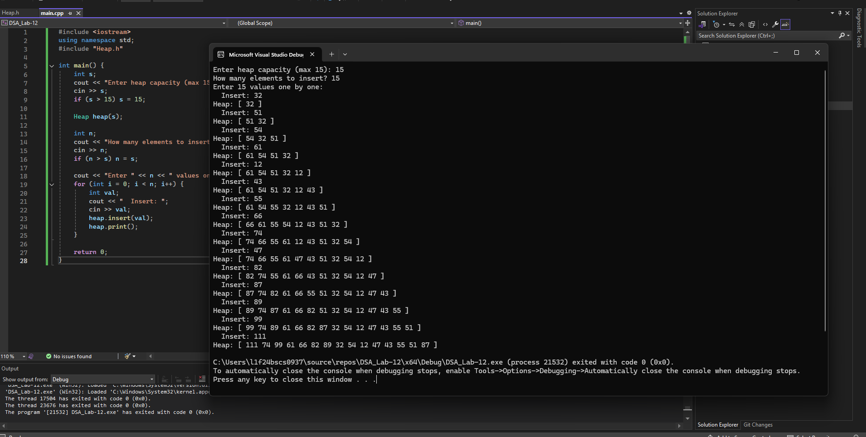

Task 2: Delete the Root (Extract Max) and Restore the Heap
- Given the Max-Heap built in Task 1, write a function extractMax() that removes the root (maximum element).
- Replace the root with the last element in the heap, then reduce the heap size by one.
- Apply heapify-down: compare the new root with its children at indices 2i+1 (left) and 2i+2 (right), swapping with the larger child until the heap property is restored.
- Print the extracted value and the resulting heap array after each extraction.
- Call extractMax() repeatedly until the heap is empty.
Tests: heapify-down logic, left/right child index calculation, correct heap size management.
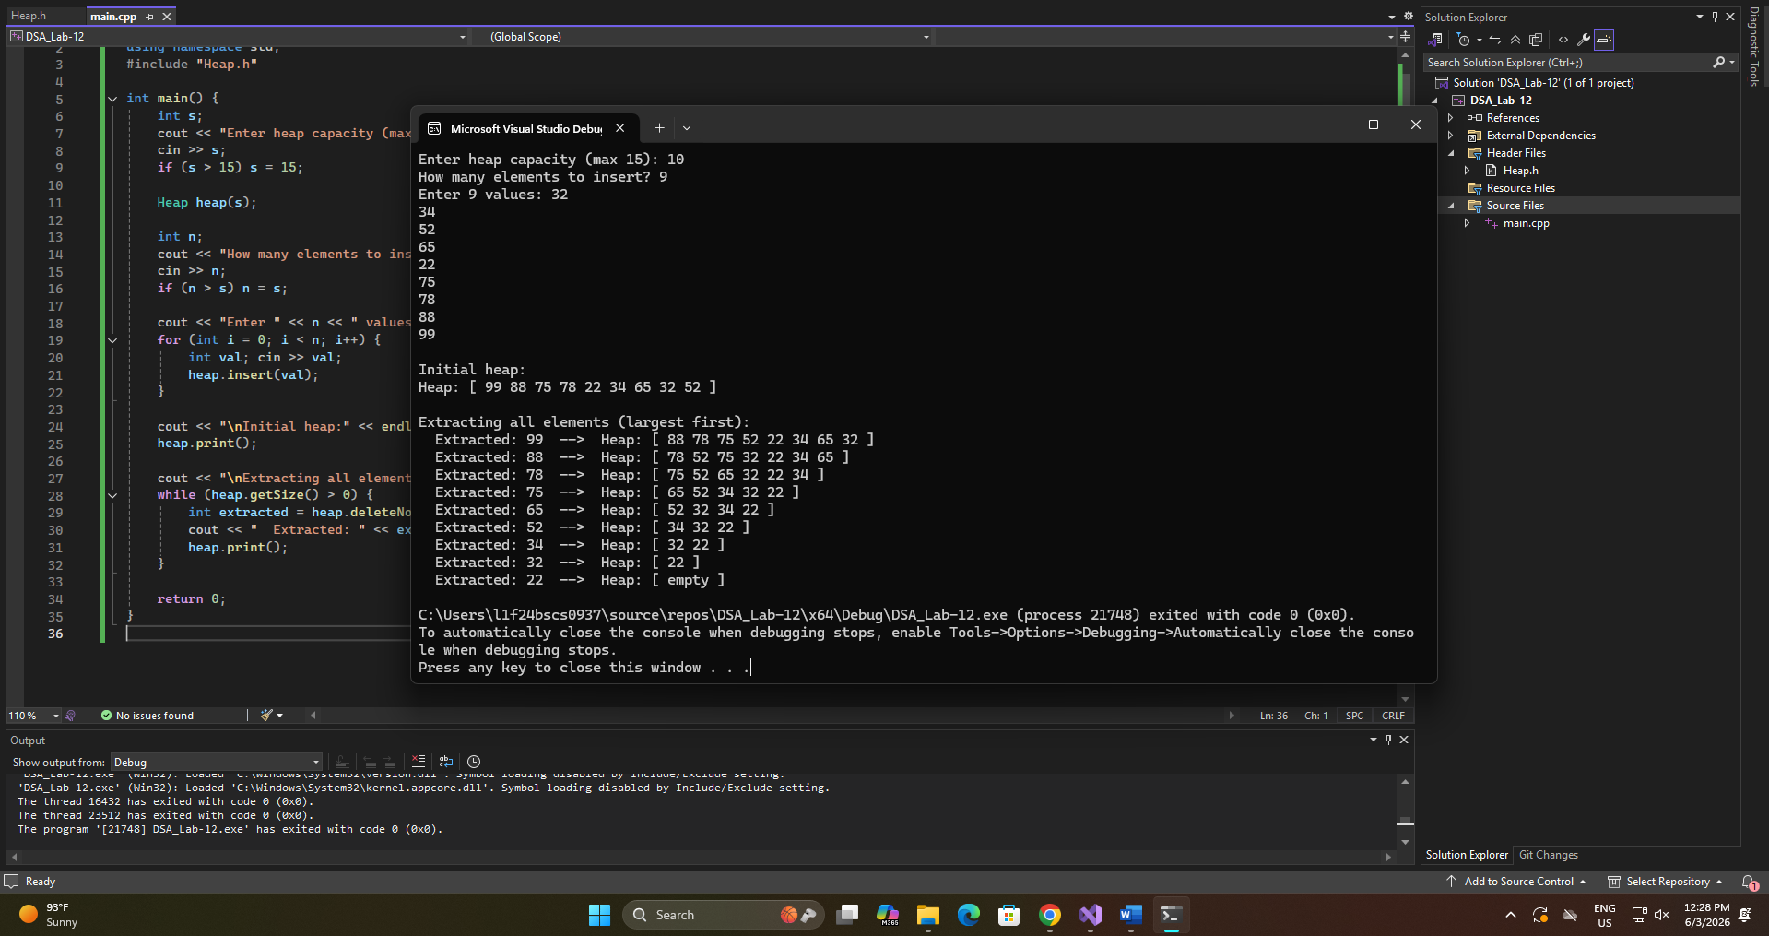

Task 3: Min-Heap Insertion with Duplicate Detection
- Write a C++ program that implements a Min-Heap using an integer array.
- Insert elements one by one from user input. Before inserting, check whether the value already exists in the heap array; if it does, skip it and print: "Duplicate value skipped."
- Apply heapify-up for Min-Heap property (parent <= children) after each successful insertion.
- After all insertions, print the final Min-Heap array.
Tests: Min-Heap property, heapify-up direction, simple validation logic, and distinguishing Max-Heap from Min-Heap.
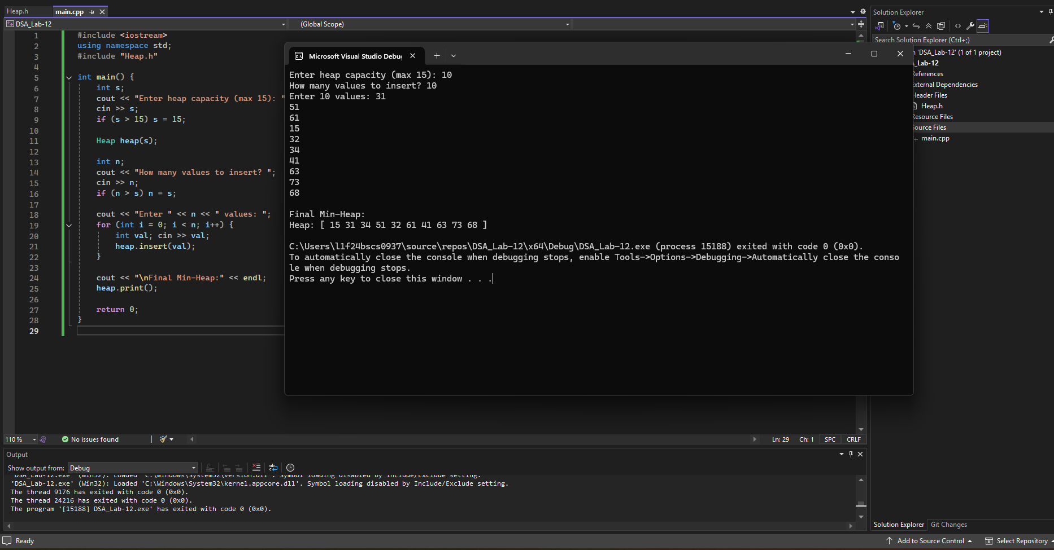

Task 4: Heap Sort Using an In-Place Array
- Start with an unsorted integer array entered by the user.
- Phase 1 — Build: convert the array into a Max-Heap in-place using heapify-down on all internal nodes from index n/2 - 1 down to 0. Print the array after this phase.
- Phase 2 — Sort: repeatedly swap the root (maximum) with the last unsorted element, reduce the heap size by one, and apply heapify-down to restore the heap. Repeat until one element remains.
- Print the final sorted array. No additional arrays or data structures may be used — everything must happen in the original array.
Tests: end-to-end heap understanding — construction + repeated deletion + sorted output in-place. This is the most challenging task and best distinguishes students who truly understand the structure.
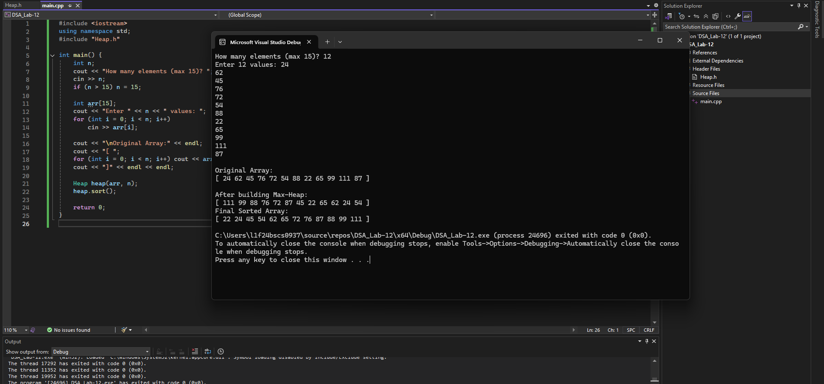
Great Job, Rest Time 🎉

