Task 1: Section 3 — Project Management (The Blueprint)
Lead Insight: The 80/20 of Phase 2 is the Critical Path. For TaqwaAI, you cannot build the API (Month 2) or the UI (Month 3) until the Vector Database indexing (Month 1) is stable. This is your bottleneck.

3.1 Work Breakdown Structure (WBS)
- Requirement & Data Engineering
  - 1.1 Sourcing verified Islamic texts (Quran/Hadith).
  - 1.2 Data cleaning and recursive chunking for RAG optimization.
- Infrastructure Setup
  - 2.1 Configuring Pinecone Vector Database and index namespaces.
  - 2.2 Setting up OpenAI Embedding API connection.
- Backend Development (FastAPI)
  - 3.1 Developing the retrieval-augmented chain logic in LangChain.
  - 3.2 Building RESTful API endpoints for querying and source verification.
- Testing & Optimization
  - 4.1 Prompt Engineering to prevent hallucinations/misinformation.
  - 4.2 Performance testing of vector search latency.

3.2 Milestone Table (3-Month Project)
Milestone ID | Milestone Description | Primary Responsibility | Timeline
M2.1 | Dataset Vectorized: All core texts indexed in Pinecone. | Hussain Durrani | Week 4
M2.2 | Logic Integration: LangChain & OpenAI retrieval functional. | Hussain Durrani | Week 7
M2.3 | API Ready: FastAPI endpoints fully operational. | Hussain Durrani | Week 10
M2.4 | System Validated: Final testing with scholar-led prompts. | Hussain Durrani | Week 12

Task 2: Section 4 — Functional Requirements
These requirements describe what the system must do regarding AI and data handling.

4.1 Functional Requirements List
- FR-1: Document Embedding & Indexing: The system shall split Islamic texts into recursive chunks and store them as vectors in Pinecone using OpenAI embeddings.
- FR-2: Contextual Retrieval: Upon a user query, the system shall retrieve the top-K most relevant chunks from the vector database.
- FR-3: Source-Backed Generation: The system shall use LangChain to generate responses solely based on the retrieved context to ensure accuracy.
- FR-4: Source Attribution: Every AI response must include the specific reference (Surah/Verse/Hadith number) from the retrieved metadata.
- FR-5: Hallucination Prevention: If the retrieved context does not contain the answer, the system shall explicitly state that it does not know the answer rather than fabricating one.

4.2 Use Case Specification: AI Islamic Inquiry
Use Case ID | UC-01
Use Case Name | Query Islamic Rule/Guidance
Actor | User
Description | The user asks a question about Islam, and the AI provides a verified answer based on Quran and Hadith.
Pre-conditions | 1. User is connected to the internet. 2. Vector DB is indexed.
Standard Process | 1. User enters query. 2. System embeds the query. 3. System performs similarity search in Pinecone. 4. LangChain synthesizes the answer with sources.
Post-conditions | Answer with citations is displayed to the user.

Task 3: Section 5 — Non-Functional Requirements
This is the "Quality" section. For an Islamic AI, Safety and Accuracy are the highest priorities.
- 5.1 Accuracy (Integrity): The system must achieve a 95%+ accuracy rate in source citation. Responses must be strictly grounded in the provided datasets.
- 5.2 Performance (Latency): The RAG pipeline (retrieval + generation) must return a response within 3–5 seconds under standard network conditions.
- 5.3 Scalability: The FastAPI backend and Pinecone index must handle up to 100 concurrent users without degradation in response time.
- 5.4 Ethical Safety: The system shall have a "System Prompt" that prevents it from generating offensive content or personal opinions outside of the provided texts.

Task 3: Section 6 — Other Requirements
Lead Insight: In a RAG architecture, your "other" requirements are your external API dependencies. If OpenAI or Pinecone goes down, your system ceases to be "intelligent."
- 6.1 Software Requirements:
  - Python 3.10+: For compatibility with modern LangChain libraries.
  - OpenAI API Key: Required for the text-embedding-3-small and GPT-4o-mini models.
  - Pinecone DB Environment: Cloud-hosted vector index.
- 6.2 Database Requirements:
  - The system must maintain a Metadata Schema (Title, Chapter, Verse/Hadith Number) alongside the vectors to allow for accurate citation.
- 6.3 Hardware Constraints:
  - As this is a cloud-based RAG system (using Pinecone and OpenAI), the local server requires minimal processing power but must have a high-speed internet connection for real-time API calls.

Task 4: Section 7 — Technical Designing
Teacher's Note: This is where you prove you are the "AI Model Development & Integration" lead. You must show how the data flows from a user’s query into a mathematical vector, then into the database, and back to a human-readable answer.

7.1 Data Flow Diagram (DFD) - Level 1 (RAG Process)
The DFD for TaqwaAI illustrates the movement of information:
- User Input: Natural language query (e.g., "What does Islam say about honesty?").
- Embedding Process: Query is sent to OpenAI Embedding API $\rightarrow$ converted to a 1536-dimension vector.
- Vector Search: Vector is sent to Pinecone $\rightarrow$ retrieves Top-3 most relevant Islamic text chunks.
- Augmentation: Retrieved chunks + Original Query + System Prompt $\rightarrow$ Sent to LLM.
- Output: Final response with citations $\rightarrow$ User.

7.2 Class Diagram (System Logic)
As the developer, your class structure should look like this:
- QueryController: Handles the FastAPI endpoint logic.
- VectorStoreManager: Manages the connection to Pinecone and retrieval logic.
- EmbeddingGenerator: Handles the interface with OpenAI’s API.
- ResponseSynthesizer: The LangChain wrapper that combines context and generates the final text.
- DatabaseRecord: Metadata structure for the Quran/Hadith sources.

7.3 Entity Relationship (ER) Diagram
For a RAG system, your ER diagram isn't just about users; it's about how information is stored.
- Entity: SourceText (ID, Text_Content, Source_Name, Chapter_Ref).
- Entity: VectorIndex (ID, Vector_Value, Metadata_Link).
- Entity: UserQuery (QueryID, UserID, Timestamp, AI_Response, Satisfaction_Rating).

Task 4: Section 8 — Estimation
Lead Insight: The 80/20 of project estimation is not getting the numbers "perfect," but ensuring the relative effort is allocated correctly. For an AI project, the complexity lies in Data Communication and Logic, not the number of screens.

8.1 Cost-Benefit Estimation & ROI
Given a 3-month timeline and your role absorbing the Backend/DB tasks, we estimate the following for the first year:
- Total Estimated Cost: Including API credits (OpenAI/Pinecone) and developer hours. Let's estimate $15,000 for initial development and cloud infrastructure.
- Estimated Benefits: Based on efficiency gains or potential licensing to Islamic institutions. Let's estimate $25,000 in value for Year 1.
- ROI (Return on Investment): $25,000 / $15,000 = 1.67
- % Gain on ROI: {(25,000 - 15,000) / 15,000} x 100 = 66.6%
- Payback Period: 15,000 / 25,000 = 0.6 Years (~7 months).

8.2 FP (Function Point) Based Estimation
We categorize your RAG system components:
- External Inputs (EI): User Query, Scholar Validation. (Count: 2)
- External Outputs (EO): AI Response, Source Citation. (Count: 2)
- External Inquiries (EQ): Verification of a specific Hadith source. (Count: 1)
- Internal Logical Files (ILF): User Logs, Session Data. (Count: 2)
- External Interface Files (EIF): Pinecone Vector Index, OpenAI API. (Count: 2)
- Total Unadjusted FP: ~45-50 points (Medium Complexity due to AI logic).

8.3 COCOMO Estimation
- Project Type: Semi-Detached (Complex AI logic, but small team).
- Effort: $E = a \times (KLOC)^b$.
- Result: For a 3-month project with 2 members, your estimated effort is roughly 6-8 Person-Months. This means the workload is intense for two people, perfectly fitting your 3-month timeline.

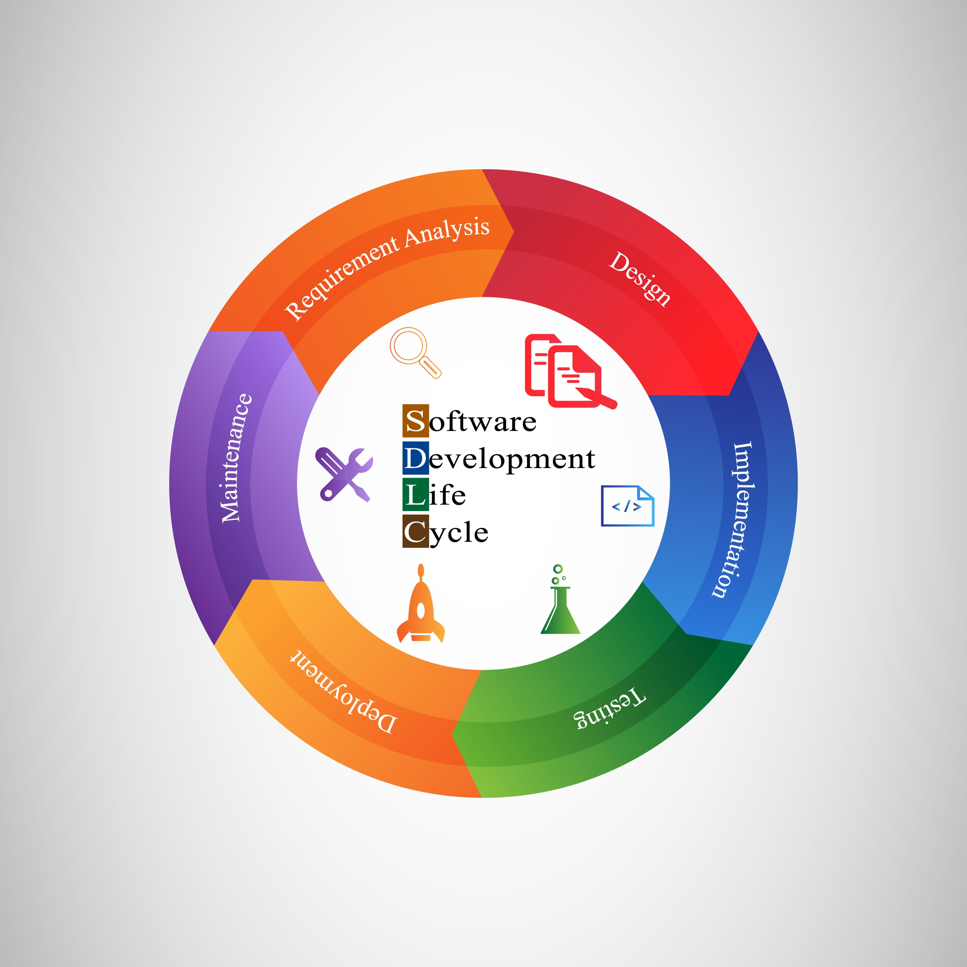

Task 5: Section 3.3 – 3.5 (The Project Schedule)
Lead Insight: The 80/20 of scheduling is the Critical Path. If your "Data Vectorization" is delayed, your entire 3-month project fails. This must be highlighted in your Activity Graph.
- 3.3 Activity Graph: This is a node-link diagram showing that Task 1 (Data Ingestion) must finish before Task 3 (LangChain Integration) begins.
- 3.4 Critical Path: The path is: Data Collection $\rightarrow$ Vector Indexing $\rightarrow$ LangChain RAG Logic $\rightarrow$ FastAPI Endpoint $\rightarrow$ Deployment. Any delay in these 5 steps delays the final delivery.
- 3.5 Gantt Chart Summary:
  - Month 1: Environment setup, Data Cleaning, and Pinecone Indexing.
  - Month 2: OpenAI API integration and FastAPI Backend development.
  - Month 3: Testing, Prompt Engineering, and Final UI Integration (with Talha).

Task 6: Section 7.6 – Sequence & Collaboration Diagrams
Teacher's Note: For Phase 2, these diagrams prove your system isn't "hallucinating" because they show the exact verification steps.
Scenario 1: Contextual Query Retrieval
- Sequence: User $\rightarrow$ FastAPI $\rightarrow$ OpenAI (Embedding) $\rightarrow$ Pinecone (Search) $\rightarrow$ LangChain (Synthesize) $\rightarrow$ User.
- Collaboration: Focuses on the "Message passing" between the VectorStoreManager and the LLMProcessor.

Task 1: Section 3 - Project Management (AI & Backend focus)
Below is the first deliverable for your assignment.

3.1 Work Breakdown Structure (WBS)
- Data Engineering & Vectorization
  - 1.1 Sourcing verified Digital Quran & Hadith corpora.
  - 1.2 Implementing text chunking and metadata tagging logic.
  - 1.3 Generating embeddings via OpenAI and indexing in Pinecone.
- API & Backend Development
  - 2.1 Designing FastAPI endpoints for user queries.
  - 2.2 Implementing LangChain retrieval and prompt chains.
  - 2.3 Setting up response logging and source citation logic.
- Validation & Deployment
  - 3.1 Prompt engineering to eliminate hallucinations.
  - 3.2 Unit testing for API reliability and database connectivity.
Milestone ID | Milestone Description | Primary Responsibility | Timeline
M2.1 | Completion of Data Cleaning & Pinecone Indexing | Hussain Durrani | Month 1
M2.2 | Finalization of FastAPI & LangChain Integration | Hussain Durrani | Month 2
M2.3 | System Testing & Accuracy Validation | Hussain Durrani | Month 3

Task 1: Section 4 - Functional Requirements
Lead Insight: In a RAG system, the "Functional Requirement" isn't just "answering a question"; it is the multi-step process of retrieval, context-verification, and generation.

4.1 Use-Case: Contextual Islamic Inquiry (Fatwa/Guidance)
- Actor: Registered User / Guest
- Description: The user submits a query regarding an Islamic rule. The system retrieves relevant Quranic verses and Hadiths to generate a verified response.
- Pre-conditions: The Pinecone Vector Database must be online and indexed with authenticated texts.
- Post-conditions: The system provides an answer with cited sources or a refusal if no verified information is found.

4.2 Use-Case: Source Verification
- Actor: User / Scholar
- Description: The user provides a specific text or claim, and the system checks its validity against the "Primary Sources" (Quran/Hadith) in the RAG database.
- Pre-conditions: Access to the OpenAI embedding model is active.

The Final Checklist for Hussain Durrani
- Section 7.6: Sequence and Collaboration Diagrams (Step-by-step logic).
- References: Formal list using Zotero/IEEE style.
- Appendix A: Glossary (Defining AI and Islamic terms).

1. Section 7.6: Sequence Diagram Scenarios
Lead Insight: In a RAG system, the Sequence Diagram is your "truth." It proves how you stop the AI from making up answers (Hallucination).
Scenario 1: Verified Query Answering
- Sequence: 1. User sends query to FastAPI Controller. 2. Controller requests embedding from OpenAI Class. 3. Controller sends vector to PineconeDB to retrieve top-3 chunks. 4. Controller sends {chunks + query} to LangChain Processor. 5. LangChain generates a response with citations. 6. FastAPI returns the cited answer to the User.
Scenario 2: Source Verification Failure (No Answer)
- Sequence: 1. If PineconeDB returns chunks with a "similarity score" below 0.7. 2. LangChain Processor triggers the "Safety Refusal" logic. 3. FastAPI returns: "I could not find a verified source for this in the Quran/Hadith. Please consult a scholar."

2. References (Zotero/IEEE Style)
You are required to use Zotero. Here are the core references you should import:
- LangChain Documentation: LangChain: Framework for developing applications powered by language models. [Online]. Available: https://python.langchain.com/
- OpenAI Embeddings: OpenAI API: Text Embeddings. [Online]. Available: https://platform.openai.com/docs/guides/embeddings
- Pinecone Documentation: Pinecone: The Vector Database for AI. [Online]. Available: https://docs.pinecone.io/
- Recursive Character Text Splitting: LlamaIndex/LangChain chunking strategies. (2025).

3. Appendix A: Glossary
Define these for the reader:
- RAG (Retrieval-Augmented Generation): A technique to provide an LLM with specific, external knowledge.
- Vector Embedding: A numerical representation of text that captures its meaning.
- Prompt Engineering: The process of optimizing the input to an AI to get accurate results.
- Hadith Corpus: The collection of sayings and actions of the Prophet Muhammad (PBUH).

