ISD TERM PROJECT
Software Requirements Specification

TaqwaAI



Project Advisor

Malik Junaid Aziz

Presented by:
Group ID: GID2026

Student Reg# Student Name

L1F24BSCS0938 Talha Khurram
L1F24BSCS0937 Hussain Durrani
L1F24BSCS1037 Ali Hamza

Faculty of Information Technology

University of Central Punjab

Software Requirements Specification

Version 1.0

TaqwaAI

Advisor: Malik Junaid Aziz

Group GID2026

Member Name | Primary Responsibility | % Contribution | Roll No | Serial # | Sign
Talha Khurram | Frontend Development & UI Design | 30% | L1F24BSCS0938 | 1
Hussain Durrani | AI Model Development & Integration | 30% | L1F24BSCS0937 | 2
Ali Hamza | Backend Development & Database Management | 30% | L1F24BSCS1037 | 3

Table of Contents
Table of Contents iii
List of Figures v
List of Tables vi
Revision History vii
1. Introduction and Background 1
1.1 Product (Problem Statement) 1
1.2 Background 1
1.3 Scope 1
1.4 Objective(s)/Aim(s)/Target(s) 1
1.5 Challenges 1
1.6 Learning Outcomes 1
1.7 Nature of End Product 1
1.8 Completeness Criteria 1
1.9 Business Goals 1
1.10 Related Work/ Literature Survey/ Literature Review 1
1.11 Document Conventions 1
2. Overall Description 2
2.1 Product Features 2
2.2 User Classes and Characteristics 2
2.3 Operating Environment 2
2.4 Design and Implementation Constraints 2
2.5 Assumptions and Dependencies 2
3. Project Management. 3
3.1 Work Breakdown Structure (WBS). 3
3.2 Create Milestone table 3
3.3 Develop an Activity Graph. 3
3.4 Find the Critical Path. 3
3.5 Create a Gantt chart. 3
~~~~~~~~~~ Phase II ~~~~~~~~~~ 4
4. Functional Requirements 4
4.1 Name of Use-Case 1 4
4.2 Name of Use-Case 2 (and so on) 4
Requirements Analysis and Modeling 5
5. Nonfunctional Requirements* 6
5.1 Performance Requirements 6
5.2 Safety Requirements 6
5.3 Security Requirements 6
5.4 Additional Software Quality Attributes 6
6. Other Requirements 7
7. Designing 8
7.1 Complete class diagram 8
7.2 Complete Data Flow Diagram (DFD) 8
7.3 Complete ER Diagram 8
7.4 Physical design of your database 8
7.5 Information on use of design patterns while designing the modules 8
7.6 Make a Sequence and a Collaboration diagram of following. 8
7.6.1 Scenario 1 8
7.6.2 Scenario 2 8
8. Estimation 9
8.1 Cost Benefit Estimation 9
8.1.1 Return of Investment (ROI) {1st year} 9
8.1.2 %gain on ROI {1st year} 9
8.1.3 Payback Period in years 9
8.2 FP based Estimation 9
8.3 COCOMO Estimation 9
9. References 10
Appendix A: Glossary 11

List of Figures

Figure 1 – System Architecture Diagram ..................................................................................... 5
Figure 2 – User Interaction Flowchart .......................................................................................... 6
Figure 3 – AI Response Processing Flow ..................................................................................... 7
Figure 4 – Use Case Diagram ....................................................................................................... 8
Figure 5 – Database Structure Diagram ........................................................................................ 9

List of Tables

Table 1 – Project Team Members and Responsibilities ............................................................... 4
Table 2 – Functional Requirements ............................................................................................. 10
Table 3 – Non-Functional Requirements ..................................................................................... 11
Table 4 – User Characteristics ..................................................................................................... 12
Table 5 – Database Tables Overview .......................................................................................... 13

Revision History
Name | Date | Reason For Changes | Version
Talha Khurram | 15-03-2026 | Initial draft of Phase 1 | 1.0
Hussain Durrani | 17-03-2026 | Draft of Phase 2 | 1.0

Introduction and Background
TaqwaAI is an Islamic AI bot that allows users to ask questions related to Islam and receive accurate answers. Many people face difficulty finding trustworthy Islamic information online. This project uses AI to provide a reliable, fast, and user-friendly way to access Islamic knowledge. The motivation is to make learning about Islam easier and more accessible for everyone.

Product (Problem Statement)
TaqwaAI is an AI-based Islamic assistant that provides reliable answers to users’ questions about Islam. Many users struggle to find authentic and quick Islamic guidance online. This software addresses that problem by offering a fast, trustworthy, and easy-to-use platform for accessing Islamic knowledge.

Background
The domain of this project is Islamic knowledge and education. Many people seek quick and reliable answers about Islam online, but available resources are often scattered or inaccurate. Using AI and natural language processing, TaqwaAI can understand user questions and provide accurate guidance, making Islamic learning easier and more accessible.

Scope
The scope of TaqwaAI includes providing users with reliable answers to Islamic questions, including Quranic verses, Hadith explanations, prayer timings, and general guidance. The system will support multiple users simultaneously, ensure accurate responses using AI, and provide a simple, interactive interface. This SRS covers the functional and non-functional requirements, user interactions, and system architecture of TaqwaAI.

Objective(s)/Aim(s)/Target(s)
• To provide users with accurate answers to Islamic questions using AI.
• To make Islamic knowledge easily accessible and reliable online.
• To offer an interactive and user-friendly platform for learning about Islam.
• To support multiple users and handle queries simultaneously.
• To ensure the system provides fast, trustworthy, and relevant responses.

Challenges
• Ensuring the AI provides accurate and authentic Islamic information.
• Handling different types of user questions in natural language.
• Designing a user-friendly interface for users of all ages.
• Managing database and AI response efficiency for multiple simultaneous users.
• Maintaining system security and privacy of user data.

Learning Outcomes
• Gain practical experience in AI and Natural Language Processing for real-world applications.
• Improve frontend and backend development skills using React.js and database management.
• Learn to design and implement an interactive chatbot system.
• Understand the process of gathering, validating, and organizing Islamic knowledge.
• Develop skills in software project documentation and SRS preparation.

Nature of End Product
TaqwaAI will be an AI-powered Islamic chatbot accessible via a web or mobile interface. The system will allow users to ask questions about Islam and receive fast, accurate, and reliable answers. It will include a user-friendly interface, a backend AI engine for processing queries, and a database to store relevant Islamic knowledge. The end product is designed to be interactive, scalable, and easy to use for people of all ages.

Completeness Criteria
The project will be considered complete if:
- The AI bot can accurately answer Islamic questions from users.
- The system has a functional and user-friendly interface.
- The backend and database are properly connected and storing information correctly.
- Multiple users can access and interact with the bot simultaneously without errors.
- All functional and non-functional requirements outlined in the SRS are met.
- The system is tested, documented, and deployable.

Business Goals
• Provide a reliable digital platform for accessing Islamic knowledge.
• Make Islamic learning accessible and convenient for users worldwide.
• Promote the use of AI technology in educational and religious domains.
• Ensure a scalable system that can handle increasing numbers of users.
• Enhance user engagement and satisfaction by providing accurate and fast responses.

Related Work/ Literature Survey/ Literature Review
Several AI-based chatbots exist for general knowledge and customer support, such as ChatGPT and Google Assistant, which can answer questions using natural language processing. In the Islamic domain, some apps provide Quran verses, Hadith collections, or prayer timings, but they are often limited in scope, not interactive, or lack AI-based question answering. TaqwaAI aims to combine these functionalities by providing a reliable, AI-powered interactive assistant specifically for Islamic knowledge, offering fast, accurate, and context-aware responses to user queries.

Document Conventions
This document follows a standard SRS format with clear section headings and numbering. Bold text is used for headings and important terms, while normal text is used for descriptions. Tables and figures are labeled and numbered for easy reference. All requirements are written in simple and clear language to ensure better understanding.

Overall Description

Product Features
• The system allows users to ask questions related to Islam and receive accurate answers.
• It provides information such as Quranic verses, Hadith explanations, and general Islamic guidance.
• The system uses AI and natural language processing to understand user queries.
• It offers a simple and user-friendly interface for easy interaction.
• The system supports multiple users simultaneously.
• It ensures fast and reliable responses to user queries.

User Classes and Characteristics
The TaqwaAI system is designed for different categories of users based on their purpose of interaction, level of expertise, and system privileges. Each user class has different responsibilities and levels of access within the system.

1. General Users (Primary Users)
General users are individuals who want to ask questions related to Islam and receive accurate guidance. These users typically interact with the system through a web or mobile interface. They may have basic technical knowledge and primarily use the system to obtain quick answers about Quranic verses, Hadith explanations, and Islamic teachings. Since they represent the majority of system users, their usability requirements are given the highest priority.

2. Students and Researchers
Students and researchers use the system for deeper learning and academic purposes. They may frequently query the system to study Islamic topics, verify sources, or explore references related to Quran and Hadith. These users may require more detailed responses, reliable citations, and structured information. Their interaction with the system is more frequent compared to general users.

3. Scholars / Knowledge Validators
Scholars or Islamic knowledge validators are advanced users who may review the responses generated by the system and verify the authenticity of sources. They have strong domain knowledge in Islamic studies and may help improve the dataset by validating Quranic and Hadith references. These users require access to detailed metadata and source references.

4. System Administrator
The system administrator manages the technical operation of the platform. This includes maintaining the database, managing AI models, monitoring system performance, and ensuring the accuracy and security of stored information. Administrators have full access privileges and require advanced technical knowledge of the system.

Operating Environment
- General Users:
Individuals who want to ask questions about Islam and get guidance. They have basic knowledge of using mobile or web apps and are the primary users of the system.
- Students/Learners:
Users who want to learn Islamic knowledge in detail. They may use the system more frequently for study purposes and require more accurate and detailed responses.
- Admin:
Responsible for managing the system, updating data, and ensuring the accuracy of information. Requires technical knowledge and has full access to system features.

Design and Implementation Constraints
• The system must use AI and natural language processing technologies for handling user queries.
• Development will be limited to web or mobile platforms using technologies like React.js and backend APIs.
• The system depends on internet connectivity for processing and retrieving responses.
• There may be limitations in ensuring 100% accuracy of AI-generated answers.
• The system must follow basic security and privacy standards for user data.
• Hardware and performance constraints may affect response time and scalability.

Assumptions and Dependencies
• It is assumed that users will have internet access to use the system.
• The system depends on AI models and APIs for processing user queries and generating responses.
• It is assumed that the data sources (Quran, Hadith, etc.) are accurate and reliable.
• The system depends on modern web or mobile platforms for proper functioning.
• It is assumed that users have basic knowledge of using digital applications.

Project Management.

Work Breakdown Structure (WBS).
1. Project Planning
- Requirement gathering
- SRS documentation
- Project design planning
2. System Design
- UI/UX design
- System architecture design
- Database design
3. Development Phase
- Frontend development
- Backend development
- AI model integration
4. Testing Phase
- Unit testing
- Integration testing
- Bug fixing
5. Deployment
- System deployment
- Final configuration
- User testing
6. Documentation and Maintenance
- Final documentation
- System maintenance
- Future improvements

Create Milestone table
Milestone No | Activity | Description | Completion Time
1 | Project Planning | Requirement gathering & idea finalization | Week 1
2 | SRS Documentation | Preparing and submitting SRS | Week 2
3 | System Design | UI/UX and architecture design | Week 3
4 | Development Phase | Frontend, backend & AI integration | Week 4 – 6
5 | Testing Phase | Testing and bug fixing | Week 7
6 | Deployment | Final system deployment | Week 8
7 | Final Submission | Project submission and presentation | Week 9

Develop an Activity Graph.

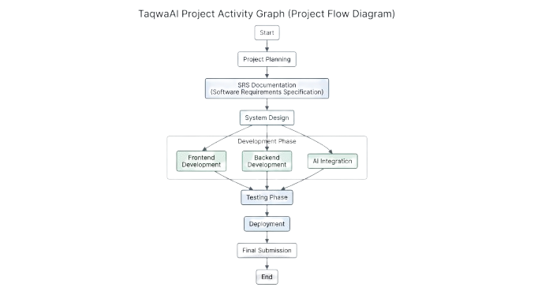

Find the Critical Path.
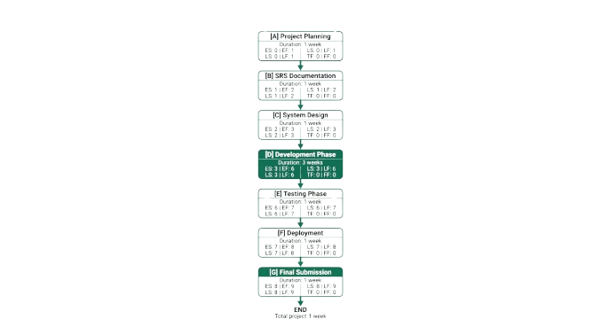

Create a Gantt chart.

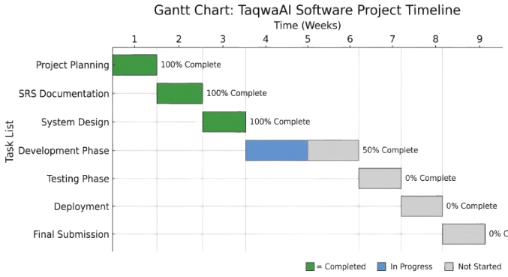

Functional Requirements
- FR-1: Document Embedding & Indexing: The system shall split Islamic texts into recursive chunks and store them as vectors in Pinecone using OpenAI embeddings.
- FR-2: Contextual Retrieval: Upon a user query, the system shall retrieve the top-K most relevant chunks from the vector database.

- FR-3: Source-Backed Generation: The system shall use LangChain to generate responses solely based on the retrieved context to ensure accuracy.
- FR-4: Source Attribution: Every AI response must include the specific reference (Surah/Verse/Hadith number) from the retrieved metadata.
- FR-5: Hallucination Prevention: If the retrieved context does not contain the answer, the system shall explicitly state that it does not know the answer rather than fabricating one.

Name of Use-Case 1

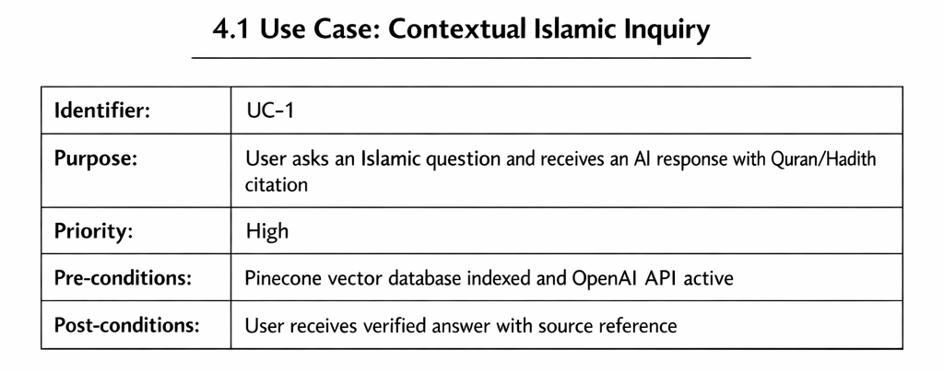

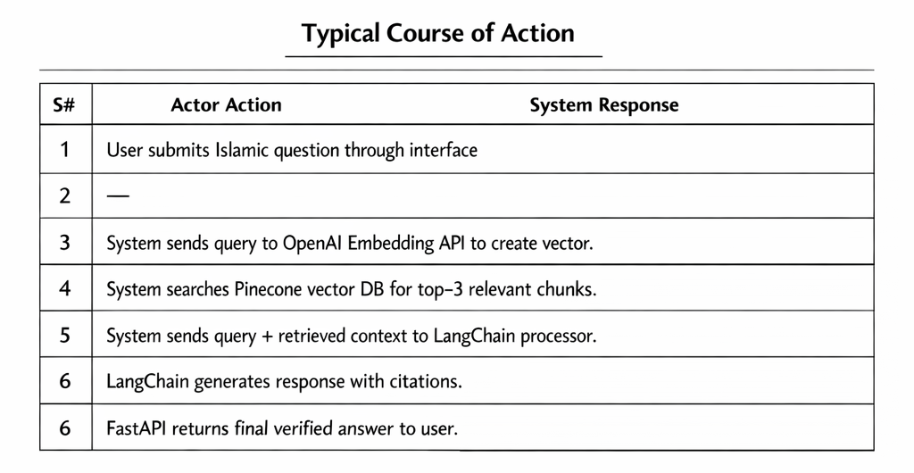

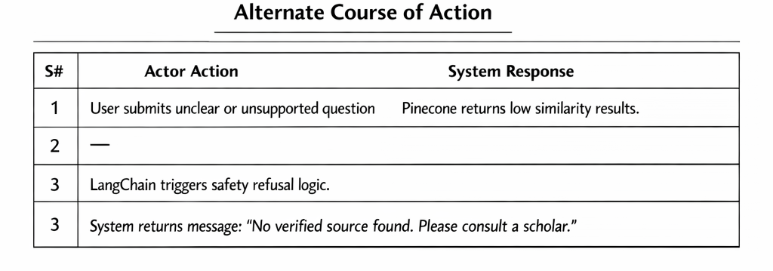
Table 1: UC-1

Name of Use-Case 2 (and so on)

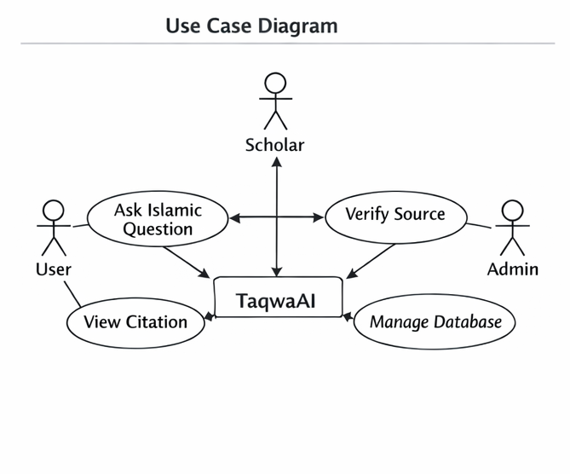

Requirements Analysis and Modeling

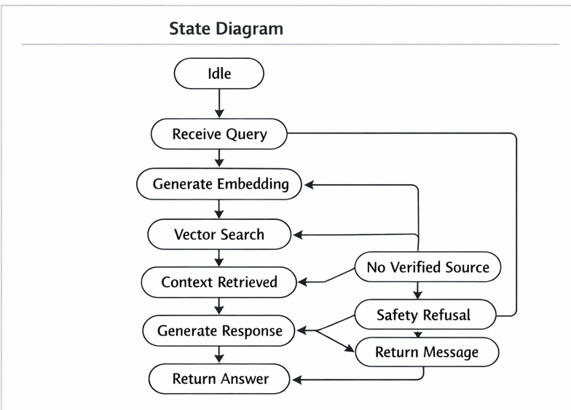

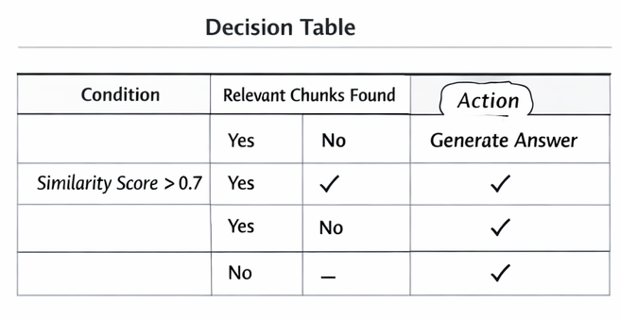

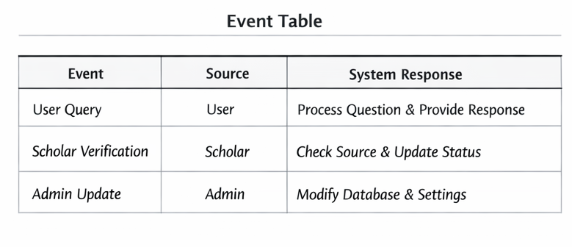

Nonfunctional Requirements*
This is the "Quality" section. For an Islamic AI, Safety and Accuracy are the highest priorities.
- 5.1 Accuracy (Integrity): The system must achieve a 95%+ accuracy rate in source citation. Responses must be strictly grounded in the provided datasets.
- 5.2 Performance (Latency): The RAG pipeline (retrieval + generation) must return a response within 3–5 seconds under standard network conditions.
- 5.3 Scalability: The FastAPI backend and Pinecone index must handle up to 100 concurrent users without degradation in response time.
- 5.4 Ethical Safety: The system shall have a "System Prompt" that prevents it from generating offensive content or personal opinions outside of the provided texts.

Performance Requirements
- Response Time: The system shall respond to user queries within 3 seconds under normal load.
- Concurrent Users: The system shall support at least 50 simultaneous users without performance degradation.
- Data Retrieval: Retrieval of relevant chunks from the vector database shall complete within 2 seconds per query.
- Accuracy: AI responses shall be source-backed and accurate, minimizing hallucinations or incorrect answers.
- System Availability: The system shall maintain 99% uptime during operational hours.
- Scalability: The system shall be able to handle increased user traffic and growing database size with minimal changes to architecture.

Safety Requirements
• The system shall prevent misinformation or incorrect religious guidance by using only source-backed content.
• Users shall not be able to delete or alter core Islamic content to avoid accidental or intentional harm.
• The system shall provide a clear message when an answer is not available, preventing misleading responses.
• All operations shall follow general data safety standards, ensuring no loss or corruption of user queries or system data.

Security Requirements
• Users shall authenticate via secure login if storing personal queries or settings.
• All user data shall be encrypted in transit and at rest.
• The system shall restrict admin access to only authorized personnel.
• AI response generation shall not expose internal API keys or sensitive data.
• The system shall comply with basic privacy policies and digital data protection standards.

Additional Software Quality Attributes
• Usability: The system shall provide a simple and intuitive interface suitable for users of all ages.
• Reliability: The system shall maintain 99% uptime and handle unexpected errors gracefully.
• Maintainability: The system shall allow easy updating of Islamic content and AI models.
• Scalability: The system shall handle growing numbers of users and database expansion without major redesign.
• Accuracy: All AI responses shall be source-backed and contextually correct.
• Robustness: The system shall gracefully handle invalid inputs or incomplete queries.
• Testability: Functional and non-functional requirements shall be verifiable through standard testing procedures.

Other Requirements
• Database Requirements: The system shall use a vector database (Pinecone) to store and retrieve Islamic text embeddings efficiently.
• External Interface Requirements: The system shall integrate with OpenAI API for embeddings and AI processing, and LangChain for context-based response generation.
• Platform Requirements: The system shall be accessible via web and mobile platforms, supporting major browsers and Android/iOS devices.
• Legal & Compliance: The system shall not store or share personal user data without consent and comply with basic digital privacy standards.
• Internationalization: The system shall support English initially, with the ability to add other languages in future updates.
• Reuse Objectives: Modular design shall allow easy reuse of AI integration, database setup, and frontend components in other projects.

Designing

Complete class diagram
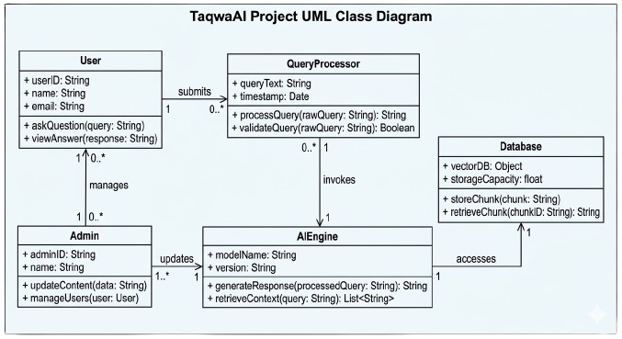
7.2 Complete Data Flow Diagram (DFD)
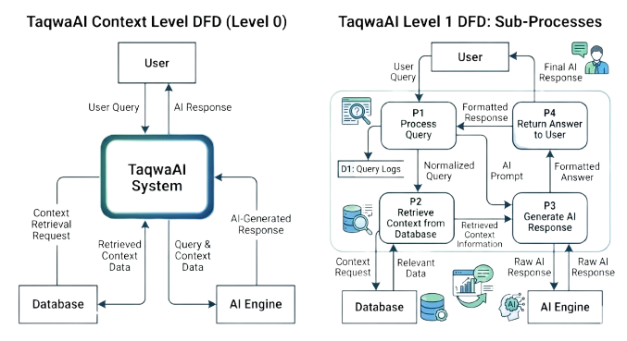

Complete ER Diagram
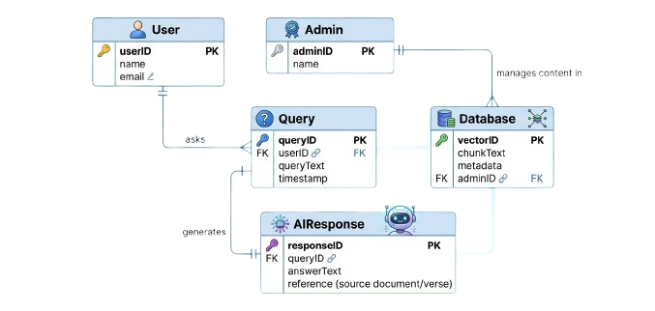

Physical design of your database
Table Name | Attributes (Name : Type) | Description
User | userID : INT (PK), name : VARCHAR(50), email : VARCHAR(50) | Stores user information
Admin | adminID : INT (PK), name : VARCHAR(50), email : VARCHAR(50) | Stores admin information
Query | queryID : INT (PK), userID : INT (FK), queryText : TEXT, timestamp : DATETIME | Stores user queries
AIResponse | responseID : INT (PK), queryID : INT (FK), answerText : TEXT, reference : VARCHAR(50), timestamp : DATETIME | Stores AI responses
DatabaseChunk | chunkID : INT (PK), chunkText : TEXT, metadata : VARCHAR(100) | Stores embedded Islamic text chunks
Logs | logID : INT (PK), userID : INT (FK), action : VARCHAR(100), timestamp : DATETIME | Stores system logs

Information on use of design patterns while designing the modules

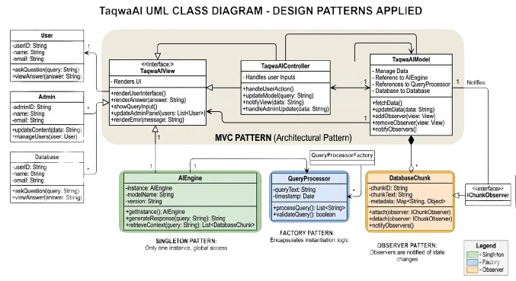

Make a Sequence and a Collaboration diagram of following.

Scenario 1:

Verified Query Answering
Flow:

User sends query → FastAPI Controller

FastAPI → OpenAI Embedding API (convert query to vector)

FastAPI → Pinecone DB (retrieve top‑3 relevant chunks)

FastAPI → LangChain Processor (send query + chunks)

LangChain generates response with citations

FastAPI → User (final answer)

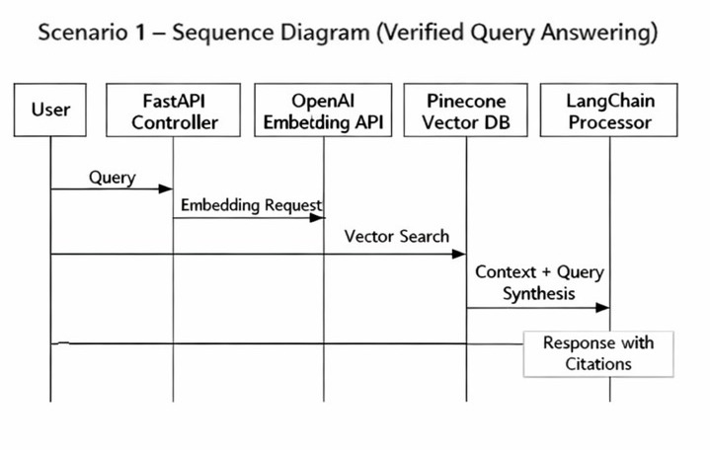

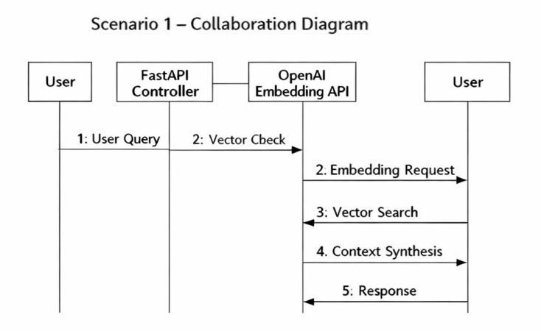

Scenario 2
Source Verification Failure
Flow:

User sends query

Pinecone returns results with similarity score < 0.7

LangChain triggers Safety Refusal logic

FastAPI returns message:
“No verified source found in Quran/Hadith. Please consult a scholar.

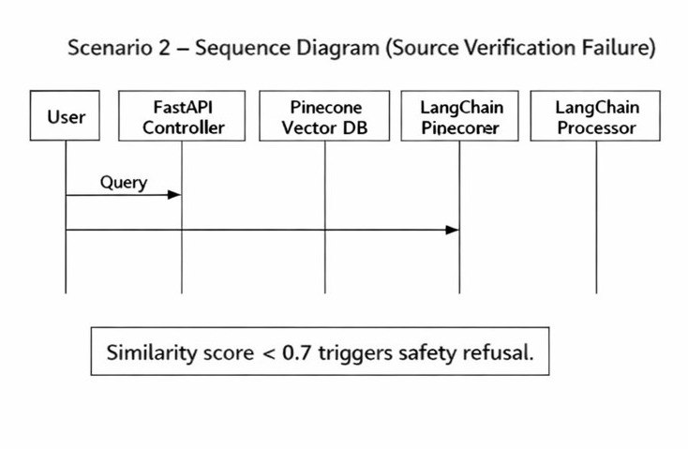”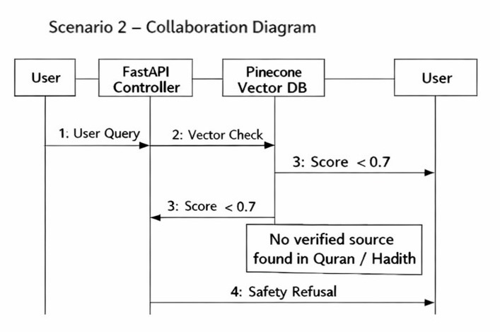
8. Estimation
8.1 Cost‑Benefit Estimation
The development of TaqwaAI requires investment in development time, AI infrastructure, and cloud services. The benefits include providing reliable Islamic knowledge through an AI‑powered platform and potential future use by Islamic institutions or educational platforms.

Estimated Cost (First Year)
The approximate development and operational costs include:

AI API usage (OpenAI API credits)

Pinecone vector database hosting

Development effort and maintenance

Cloud hosting and deployment

Estimated Total Cost:
$15,000

Estimated Benefits (First Year)
The estimated benefits include:

Value generated from providing Islamic AI services

Possible licensing or institutional adoption

Educational and community value

Estimated Total Benefit:
$25,000

8.2 Return on Investment (ROI)
Formula:

ROI = Benefits / Cost

ROI = 25,000 / 15,000

ROI = 1.67

This means the system is expected to return 1.67 times the initial investment in the first year.

8.3 Percentage Gain on ROI
Formula:

% Gain on ROI = {(Benefits − Cost) / Cost} × 100

% Gain on ROI = {(25,000 − 15,000) / 15,000} × 100

% Gain on ROI = (10,000 / 15,000) × 100

% Gain on ROI = 66.6%

This indicates a 66.6% profit gain in the first year.

8.4 Payback Period
Formula:

Payback Period = Cost / Benefit

Payback Period = 15,000 / 25,000

Payback Period = 0.6 years

This means the initial investment is expected to be recovered in approximately 0.6 years (about 7 months).

8.5 Function Point (FP) Based Estimation
Function Point estimation measures the functionality delivered by the system.

Identified Components
External Inputs (EI)

User Query Input

Scholar Validation Input

Count: 2

External Outputs (EO)

AI Generated Response

Source Citation Output

Count: 2

External Inquiries (EQ)

Source Verification Query

Count: 1

Internal Logical Files (ILF)

User Logs

Session Data

Count: 2

External Interface Files (EIF)

Pinecone Vector Database

OpenAI API

Count: 2

Total Function Points
Estimated Unadjusted Function Points:

≈ 45 – 50 FP

This indicates medium system complexity due to AI processing and database interaction.

8.6 COCOMO Estimation
The Constructive Cost Model (COCOMO) is used to estimate the development effort required.

Project Type
The project is classified as:

Semi‑Detached Project

Because:

Moderate system complexity

Small development team

AI integration and database management

Effort Estimation Formula
E = a × (KLOC)^b

Where:

E = Effort in person‑months
KLOC = Thousands of lines of code
a,b = Constants for semi‑detached projects

Using approximate estimation for the system size:

Estimated Effort = 6 – 8 Person‑Months

Development Timeline
With a 2‑member team working for 3 months, the workload distribution becomes:

Backend & AI Integration → Hussain

Frontend & System Interface → Talha

This estimation fits within the planned 3‑month project timeline.

References
The following sources were used in the preparation of this Software Requirements Specification (SRS) for the TaqwaAI system. These references include documentation related to AI frameworks, vector databases, and natural language processing technologies used in the development of the system.

[1] LangChain, “LangChain: Framework for Developing Applications Powered by Language Models.” 2024. [Online]. Available: https://python.langchain.com/

[2] OpenAI, “OpenAI API Documentation: Text Embeddings Guide.” 2024. [Online]. Available: https://platform.openai.com/docs/guides/embeddings

[3] Pinecone Systems Inc., “Pinecone: The Vector Database for AI Applications.” 2024. [Online]. Available: https://docs.pinecone.io/

[4] T. Brown et al., “Language Models are Few‑Shot Learners,” Advances in Neural Information Processing Systems (NeurIPS), vol. 33, pp. 1877–1901, 2020.

[5] I. Goodfellow, Y. Bengio, and A. Courville, Deep Learning., MIT Press, 2016.

[6] M. Fowler, UML Distilled: A Brief Guide to the Standard Object Modeling Language, 3rd ed., Addison‑Wesley, 2004.

[7] R. S. Pressman and B. R. Maxim, Software Engineering: A Practitioner’s Approach, 8th ed., McGraw‑Hill Education, 2015.

[8] S. Russell and P. Norvig, Artificial Intelligence: A Modern Approach, 4th ed., Pearson Education, 2021.

Appendix A: Glossary
This section defines important technical terms, acronyms, and abbreviations used throughout the Software Requirements Specification (SRS) for the TaqwaAI system.

AI (Artificial Intelligence):
A field of computer science that focuses on creating systems capable of performing tasks that normally require human intelligence, such as understanding language and answering questions.

RAG (Retrieval‑Augmented Generation):
A technique used in AI systems where an external knowledge source is retrieved and combined with a language model to generate accurate and context‑aware responses.

Vector Embedding:
A numerical representation of text that captures its semantic meaning, allowing machines to compare and search text based on similarity.

LangChain:
An open‑source framework used to build applications powered by large language models (LLMs), enabling retrieval, reasoning, and chaining of AI processes.

Pinecone Vector Database:
A cloud‑based vector database used to store and search embeddings efficiently for fast similarity search.

FastAPI:
A modern Python web framework used for building APIs that allow communication between the user interface and backend services.

Prompt Engineering:
The process of designing and optimizing input prompts to guide an AI model to produce accurate and relevant responses.

Embedding Model:
A machine learning model that converts text into numerical vectors that represent the meaning of the text.

Hadith Corpus:
A collection of recorded sayings, actions, and approvals of Prophet Muhammad (PBUH), used as an important source of Islamic knowledge.

API (Application Programming Interface):
A set of rules that allows different software systems to communicate and exchange data.

LLM (Large Language Model):
An advanced AI model trained on large datasets to understand and generate human‑like text.

