Name : Mohammad Hussain

Roll NO: 18040

Exame: ISA2

//Starts code

<!DOCTYPE html>

<html>

<head>

<title>Fitness club</title>

<link rel="stylesheet" type="text/css" href="style.css">

<link href="https://stackpath.bootstrapcdn.com/font-awesome/4.7.0/css/font-awesome.min.css" rel="stylesheet" integrity="sha384-wvfXpqpZZVQGK6TAh5PVlGOfQNHSoD2xbE+QkPxCAFlNEevoEH3Sl0sibVcOQVnN" crossorigin="anonymous">

</head>

<body>

<div class="box">

<div class="icon">

<a href="#" class="fa fa-facebook"></a>

<a href="#" class="fa fa-twitter"></a>

<a href="#" class="fa fa-instagram"></a>

</div>

</div>

<div class="main">

<ul>

<li><a href="">Home</a></li>

<li><a href="">About us</a></li>

<li><a href="">Programs</a></li>

<li><a href="">Pricing</a></li>

<li><a href="">Class Shedule </a></li>

<li><a href="file:///C:/Users/hussain/Desktop/fitness/registrantion.html">Register</a></li>

<li><a href="file:///C:/Users/hussain/Desktop/fitness/login.html">Log In </a></li>

<li><a href="">Contact</a></li>

</ul>

</div>

<div class="letter">

<h2><i class="fa fa-align-center" aria-hidden ="true"></i>Follow Us <i class="fa fa-align-center"aria-hidden="true"></i></h2>

</div>

<div class="menu">

<div class="submenu">

<img src="3.jpg" height="280"width="315">

<h1> <i class="fa fa-check"aria-hidden="true">Young woman doing well<i class="fa fa-hand-peace-o"aria-hidden="true"></h1>

</div>

</div>

</body>

</html>

//css part for home page

.box

{

border: 1px solid black;

padding: 5px;

background-color: black;

box-shadow: 29px 18px 21px;

}

.icon a

{

width: 50px;

color: white;

padding-left: 1px;

}

ul{

float: right;

font-family: candara;

font-size: 17px;

}

ul li

{

float: left;

width: 120px;

text-decoration: none;

list-style-type: none;

}

ul li a

{

text-decoration: none;

color: white;

}

ul li a:hover

{

color: yellow;

}

.main ul

{

border: 1px solid black;

padding: 10px;

margin-top: 0px;

background-color: transparent;

box-shadow: 19px,18px 21px;

}

body

{

background: linear-gradient(rgba(0,0,0,0,65),rgba(0,0,0,0,65),rgba(0,0,0,0,38),rgba(0,0,0,0));

background: url(6.jpg)no-repeat ;

background-size: cover;

}

.letter{

border: 1px solid black;

width: 300px;

box-shadow: 5px 4px 8px 9px;

background-color: black;

border-radius: 2px;

}

.letter h2{

color: white;

font-family: candara;

text-align: left;

}

.fa-align-center{

color: yellow;

}

.submenu{

border: 1px solid transparent;

width: 320px;

color: white;

background-color:black;

position: absolute;

left: 2%;

top: 30%;

font-family: latha;

box-shadow: 9px 10px 8px;

border-radius: 23px;

font-size: 12px;

}

.menu{

font-size: 12px;

font-family: cursive;

font-weight: normal;

color: black

}

.submenu:hover{

color :yellow;

box-shadow: 1px 2px 2px 3px;

}

img{

border-radius: 23px;

}

//Registration part

<!DOCTYPE html>

<html>

<head>

<title>Registration</title>

<link rel="stylesheet" type="text/css" href="regis.css">

<link href="https://stackpath.bootstrapcdn.com/font-awesome/4.7.0/css/font-awesome.min.css" rel="stylesheet" integrity="sha384-wvfXpqpZZVQGK6TAh5PVlGOfQNHSoD2xbE+QkPxCAFlNEevoEH3Sl0sibVcOQVnN" crossorigin="anonymous">

</head>

<body>

<div class="box">

<div class="icon">

<a href="#" class="fa fa-facebook"></a>

<a href="#" class="fa fa-twitter"></a>

<a href="#" class="fa fa-instagram"></a>

</div>

</div>

<div class="main">

<ul>

<li><a href="file:///C:/Users/hussain/Desktop/fitness/Home.html">Home</a></li>

<li><a href="">About us</a></li>

<li><a href="">Programs</a></li>

<li><a href="">Pricing</a></li>

<li><a href="">ClassShedule </a></li>

<li><a href="file:///C:/Users/hussain/Desktop/fitness/registrantion.html">Register</a></li>

<li><a href="file:///C:/Users/hussain/Desktop/fitness/login.html">Login page </a></li>

<li><a href="">Contact</a></li>

</ul>

</div>

<div class="letter">

<h2><i class="fa fa-align-center" aria-hidden ="true"></i>Follow Us <i class="fa fa-align-center"aria-hidden="true"></i></h2>

</div>

<header class="profile">Customer profile</header>

<form class="in">

<input type="text" name="name" placeholder="enter the name"><br>

<input type="text" name="username" placeholder="enter the username"><br>

<input type="password" name="password" placeholder="enter the password"><br>

<input type="address" name="address" placeholder="enter the address"><br>

<input type="number" name="age" placeholder="age"><br>

<input type="email" name="email" placeholder="Enter the email"><br>

<input type="textarea" name="Goal" rows="10" cols="30" placeholder="what is your goal"><br>

<div class="gender">

<input type="radio" name="gender" value="female" id="1"> <label for="1">Male</label>

<input type="radio" name="gender" value="male" id="2"> <label for="2">Famale</label>

<input type="radio" name="gender" value="male" id="3"> <label for="3">Other</label>

</div>

<input type="submit">

</form>

</body>

</html>

//css part for registration

.box

{

border: 1px solid black;

padding: 5px;

background-color: black;

box-shadow: 29px 18px 21px;

}

.icon a

{

width: 50px;

color: white;

padding-left: 1px;

}

ul{

float: right;

font-family: candara;

font-size: 17px;

}

ul li

{

float: left;

width: 120px;

text-decoration: none;

list-style-type: none;

}

ul li a

{

text-decoration: none;

color: white;

}

ul li a:hover

{

color: yellow;

}

.main ul

{

border: 1px solid black;

padding: 10px;

margin-top: 0px;

background-color: transparent;

box-shadow: 19px,18px 21px;

}

.icon a

{

width: 50px;

color: white;

padding-left: 1px;

}

ul{

float: right;

font-family: candara;

font-size: 17px;

}

ul li

{

float: left;

width: 120px;

text-decoration: none;

list-style-type: none;

}

ul li a

{

text-decoration: none;

color: white;

}

ul li a:hover

{

color: yellow;

}

.main ul

{

border: 1px solid black;

padding: 10px;

margin-top: 0px;

background-color: transparent;

box-shadow: 19px,18px 21px;

}

body{

background:url(7.jpg);

background-size: cover;

}

.letter h2{

color: white;

font-family: candara;

text-align: left;

}

.fa-align-center{

color: yellow;

}

.profile{

text-align: center;

color: white;

margin-top: 4%;

font-size: 36px;

padding: 10px;

}

.in{

text-align: center;

}

.in input{

padding: 10px;

margin: 3px;

width: 30%;

}

input[type="radio"]

{

width: 1%;

padding: 13px;

margin: 12px;

}

.gender label{

color: white;

}

.gender label:hover{

border: 1px solid black;

color: yellow;

}

//login part

<!DOCTYPE html>

<html>

<title>login page</title>

<link rel="stylesheet" type="text/css" href="log.css">

<link href="https://stackpath.bootstrapcdn.com/font-awesome/4.7.0/css/font-awesome.min.css" rel="stylesheet" integrity="sha384-wvfXpqpZZVQGK6TAh5PVlGOfQNHSoD2xbE+QkPxCAFlNEevoEH3Sl0sibVcOQVnN" crossorigin="anonymous">

</head>

<body>

<div class="box">

<div class="icon">

<a href="#" class="fa fa-facebook"></a>

<a href="#" class="fa fa-twitter"></a>

<a href="#" class="fa fa-instagram"></a>

</div>

</div>

<div class="main">

<ul>

<li><a href="file:///C:/Users/hussain/Desktop/fitness/Home.html">Home</a></li>

<li><a href="">About us</a></li>

<li><a href="">Programs</a></li>

<li><a href="">Pricing</a></li>

<li><a href="">ClassShedule </a></li>

<li><a href="file:///C:/Users/hussain/Desktop/fitness/registrantion.html">Register</a></li>

<li><a href="">Log In </a></li>

<li><a href="">Contact</a></li>

</ul>

</div>

<div class="letter">

<h2><i class="fa fa-align-center" aria-hidden ="true"></i>Follow Us <i class="fa fa-align-center"aria-hidden="true"></i></h2>

</div>

<div class="container">

<label for="uname"><b>Username </b></label>

<input type="text" placeholder="Enter Username" name="uname" id="uname" required><br>

<label for="psw"><b>Password </b></label>

<input type="password" placeholder="Enter Password" name="psw" id="psw" required><br>

<input type="button" value="login" style="margin-left: 140px; width: 23%;" ><br>

<div style="padding-bottom: 10px; font-size: 20px;">

<input type="checkbox" checked="checked" name="remember" id="l" style="margin-left: 140px; " > <label for="l" style="color:white;background-color:grey">Remember me

</label>

</div>

<div class="cancel">

<span class="psw" style="

margin-left: 170px;background-color:grey"><a href="#">Forgot password?</a></span>

</div>

</div>

</div>

</body>

</html>

//css part for registration

.box

{

border: 1px solid black;

padding: 5px;

background-color: black;

box-shadow: 29px 18px 21px;

}

.icon a

{

width: 50px;

color: white;

padding-left: 1px;

}

ul{

float: right;

font-family: candara;

font-size: 17px;

}

ul li

{

float: left;

width: 120px;

text-decoration: none;

list-style-type: none;

}

ul li a

{

text-decoration: none;

color: white;

}

ul li a:hover

{

color: yellow;

}

.main ul

{

border: 1px solid black;

padding: 10px;

margin-top: 0px;

background-color: transparent;

box-shadow: 19px,18px 21px;

}

body

{

background: linear-gradient(rgba(0,0,0,0,65),rgba(0,0,0,0,65),rgba(0,0,0,0,38),rgba(0,0,0,0));

background: url(4.jpg)no-repeat ;

background-size: cover;

}

.letter{

border: 1px solid black;

width: 300px;

box-shadow: 5px 4px 8px 9px;

background-color: black;

border-radius: 2px;

}

.letter h2{

color: white;

font-family: candara;

text-align: left;

}

.fa-align-center{

color: yellow;

}

.letter{

border: 1px solid black;

width: 300px;

box-shadow: 5px 4px 8px 9px;

background-color: black;

border-radius: 2px;

}

input[type="text"],input[type="password"],input[type="button"]

{

width: 25%;

padding: 10px;

margin: 12px;

}

.container{

margin-left : 30%;

margin-top: 150px;

}

.container label{

margin: 40px 20px;

}

Home page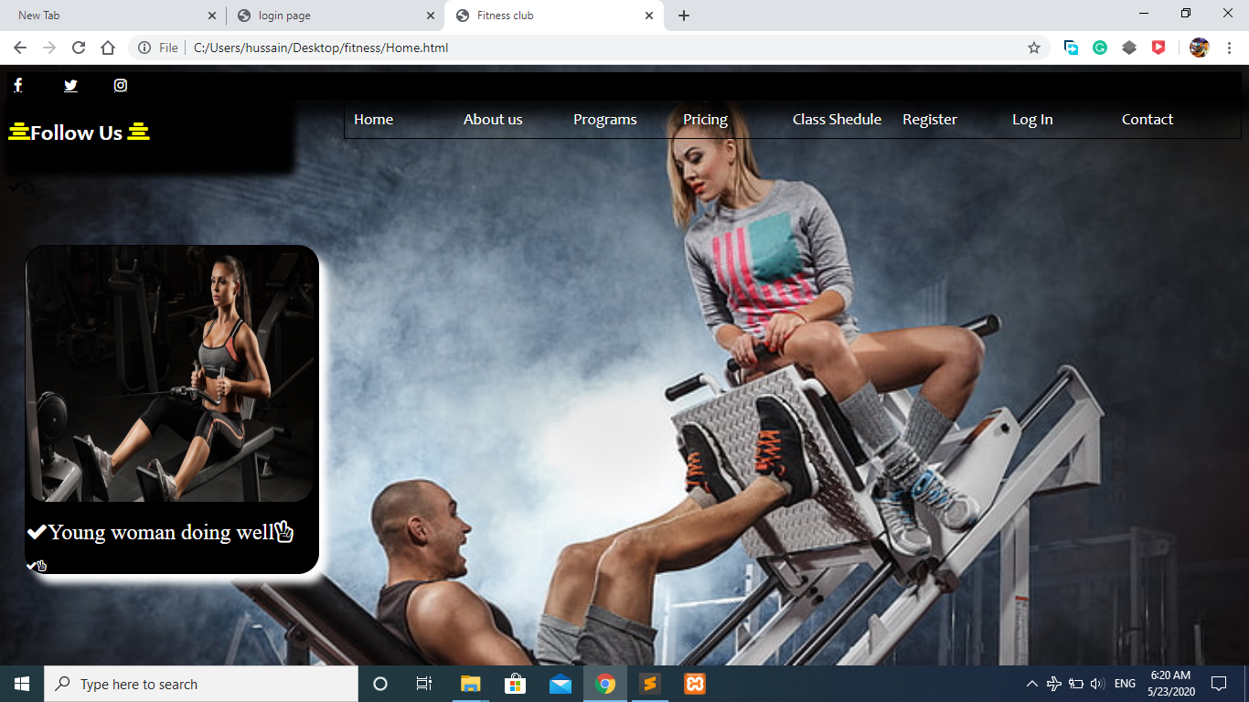

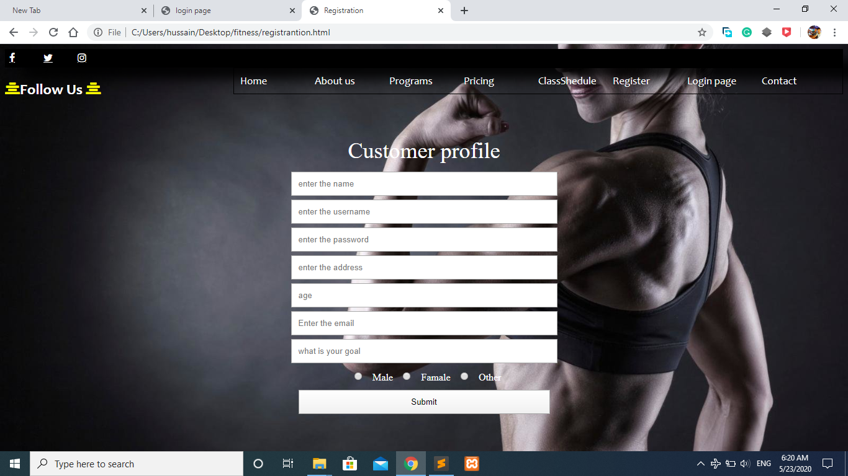

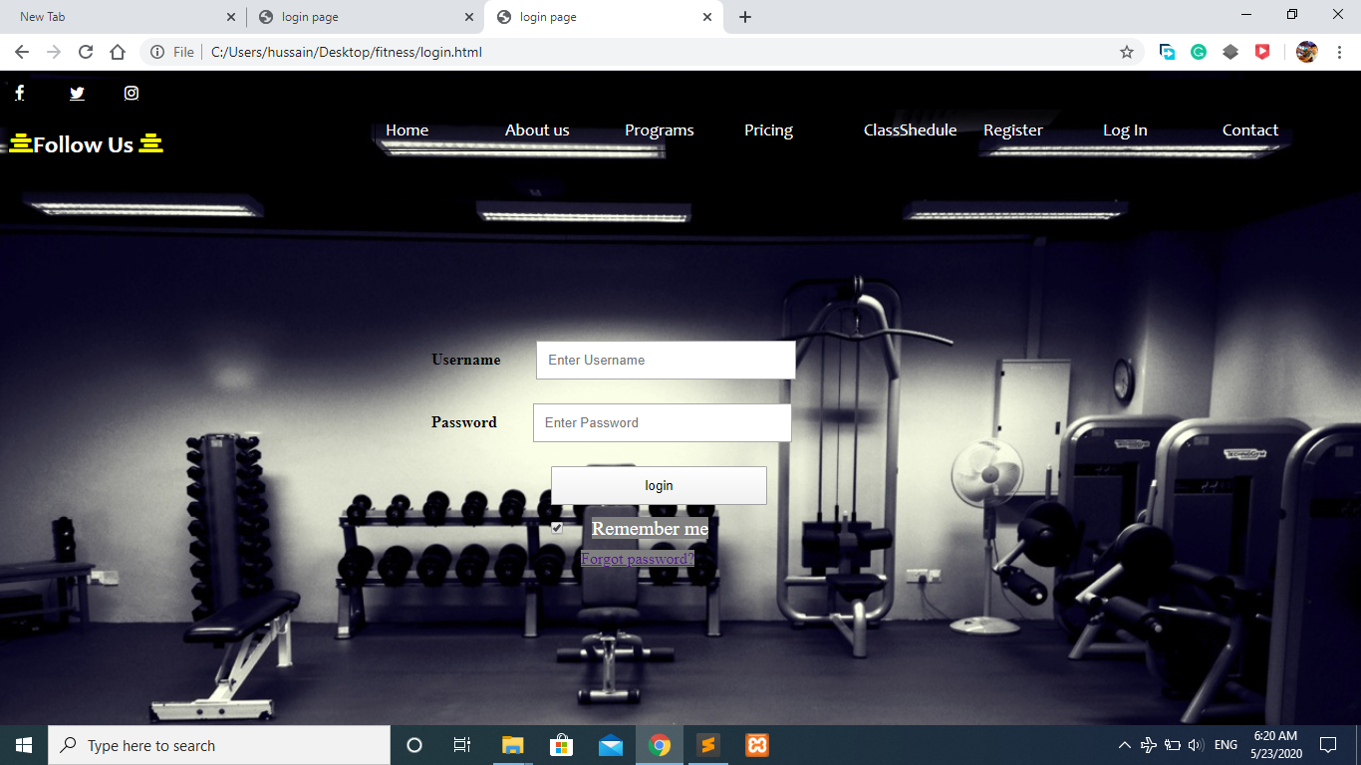

2) Second question age part

<!DOCTYPE html>

<html>

<body>

<head>

<style type="text/css">

.center{

margin: auto;

width: 50%;

border: 3px solid green;

padding: 50px;

text-align: center;

vertical-align: middle;

height: 150px;

}

</style>

</head>

<div class="center">

<p>Enter your age.</p>

<form>

<input type="text" id="age">

</form>

<button onclick="myFunction()">Ok</button>

</div>

<script>

function myFunction() {

x = document.getElementById("age").value;

y = parseInt(x);

if(y<=50){

alert("Junior");

}

else{

alert("Senior");

}

}

</script>

</body>

</html>

