# The Assignment: Election Algorithm

The aim of this assignment to gain insight into the design of a distributed system. The objective is to design and implement an election algorithm to elect one of a set of processes organized in a ring to play the role of Coordinator

# Design:

**The Design of the Assignment will be the Ring Algorithm structure**

* A Server class will create a register
* Processes will be created by getting the register of the server and gets added to the ring array
* Processes will share the same files but different objects
* You can openly create as much as you like of processes
* Each Process will have a GUI that implements the function of the Project class that implements from the Process Interface
* The process will enter it’s ID into the Process Class then cast the Process Class to a Process Interface then transfer it to Server Interface which transfer the data to Server Class which will add the process as a new process
* The first Process is automatically set as the coordinator
* If the coordinator is deactivated the system will automatically perform election
* The highest ID number will win the election and will be the new coordinator

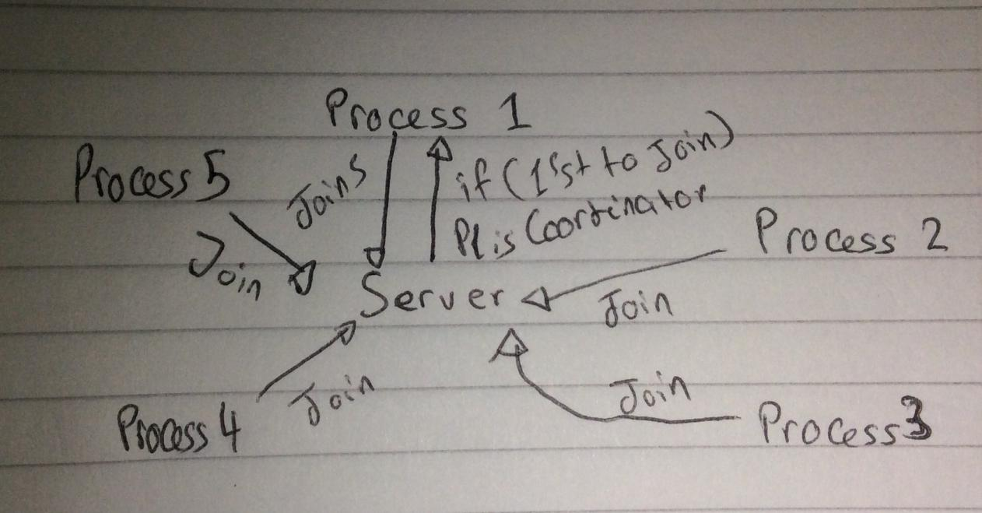

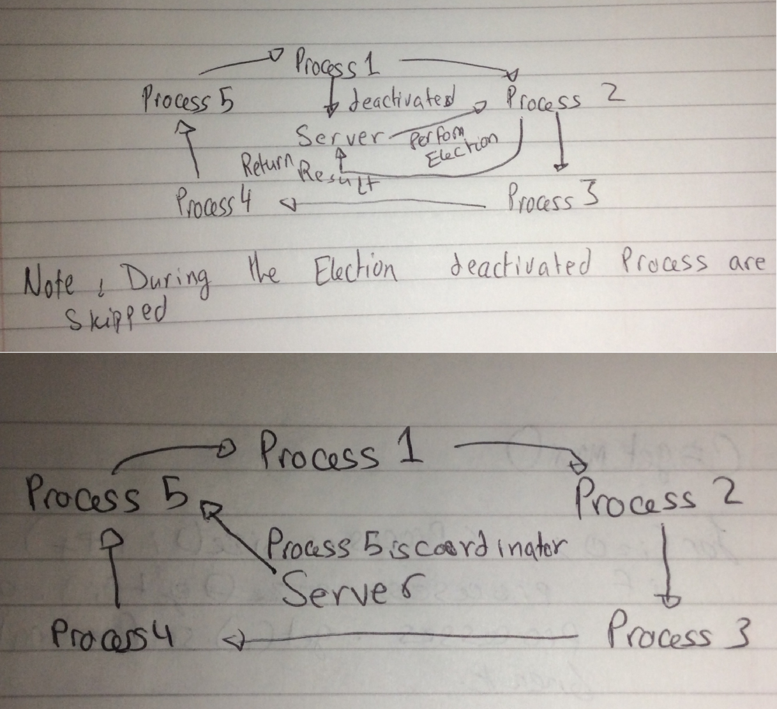

# GUIs

**Coordinator GUI**

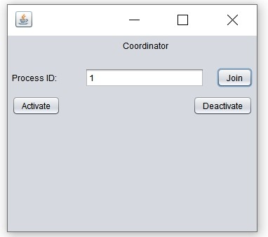

**Process GUI**

