**The Assignment: Message Broker**

The aim of this assignment to gain insight into Message Oriented Communication in distributed systems. The objective is to design and implement a simple message queuing and brokering system

**Design:**

**The Design is considered as Centralized Simple client-server architecture**

* Each worker will have it’s own class and GUI.
* Worker’s classes will be multithreaded class.
* Each worker will have its server socket that will receive and store the messages that's does receives.
* The broker will act as a middleware that does receive the messages and does send them to the final destination
* The messages will be sent as strings and each message will be divided into 3 part which are the sender, the message, and the receiver.
* The worker will send three strings to the broker the first string will be the sender, the second string will be the message, and the third-string will be the receiver.
* The broker will read the receiver string and compare it to the list of workers that it has and if the broker has the receiver in the list it will send the message to its destination.
* The receiver in the worker’s GUI will not be open and it will be a closed list so no errors can be made
* If the socket is not connected the broker keeps trying for an infinite timeout until the socket connects
* The worker can only send message to **ONLY**one target there’s no public chatting

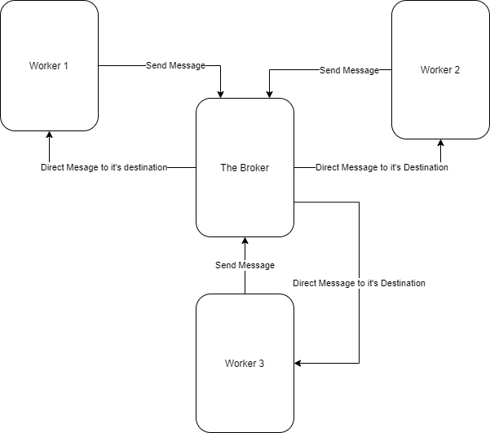

**GUI screenshots**

**The Broker GUI**

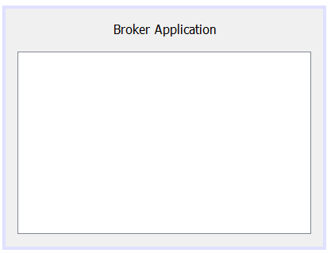

**Worker 1 GUI**

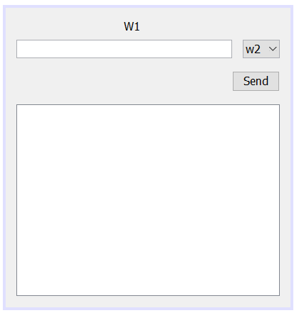

**Worker 2 GUI**

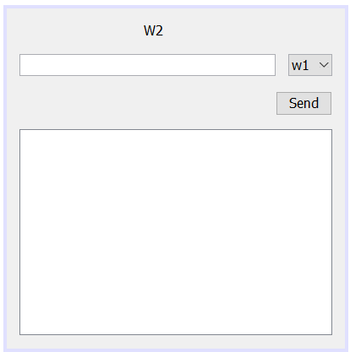

**Worker 3 GUI**

