Diagrams Document
This document compiles three key system diagrams. Each diagram includes an explanation summarizing its purpose, structure, and relevance to the overall backend architecture. These diagrams illustrate different design viewpoints: deployment, data modeling (ERD), and functional backend use cases.

Backend Deployment Diagram
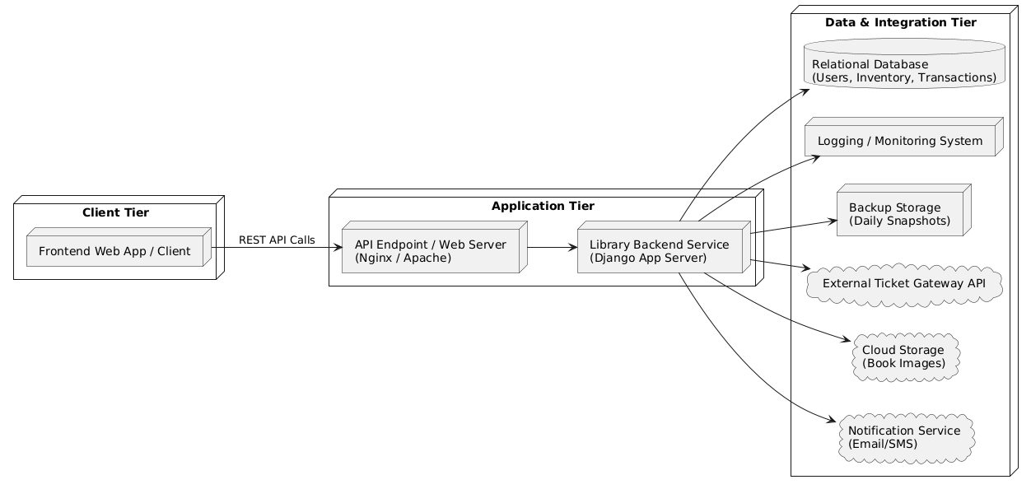
This diagram illustrates the three-tier architecture of the system—client, application, and data tiers. It shows how the frontend interacts with the backend through REST APIs, which then communicates with external services such as the ticket gateway, cloud storage, and notification services. It also shows internal system components like the Django app, web server, database, backup storage, and logging system.

Entity Relationship Diagram (ERD)
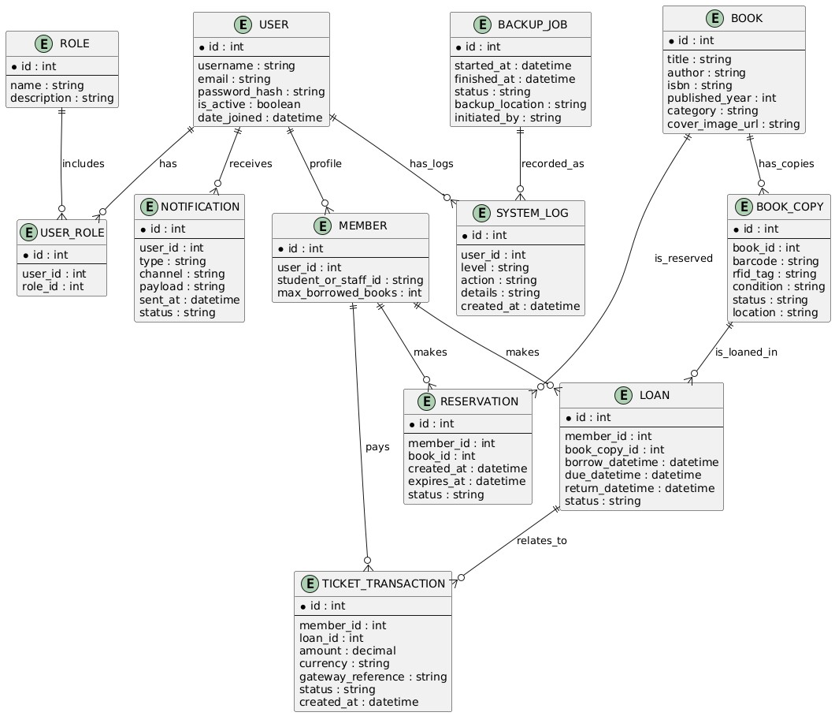
This ERD represents the internal data model of the system. It defines entities such as User, Member, Book, BookCopy, Loan, Reservation, and TicketTransaction, along with their attributes and relationships. This model ensures data consistency, supports system functionalities, and maintains referential integrity.

Backend Functional Use Case Diagram
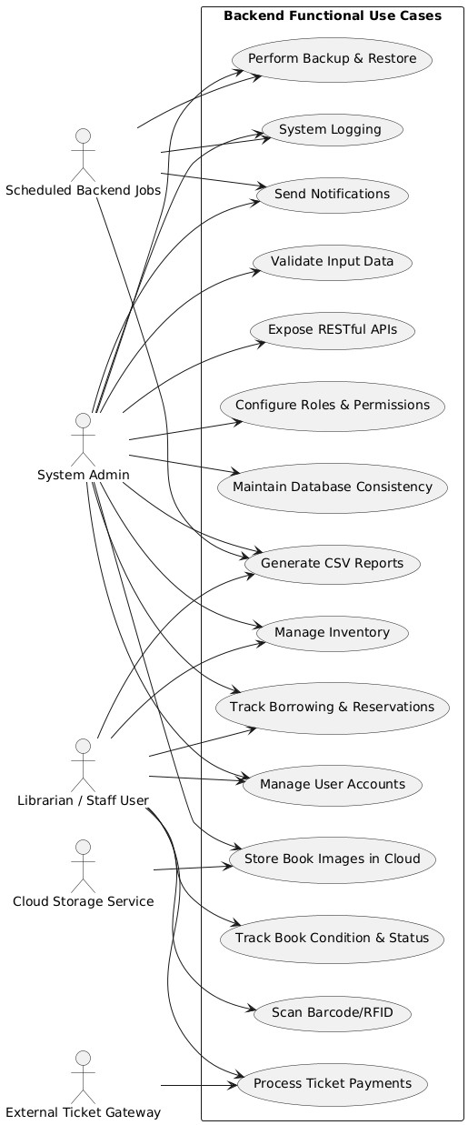
This use case diagram captures all backend functional requirements, illustrating how different actors—System Admin, Librarian/Staff User, Scheduled Jobs, and external services—interact with various backend functions. It highlights core operations such as user management, inventory handling, report generation, API exposure, system logging, and integration with external services.

