UI Design Prototype Document
This document presents the UI prototype. It is important to note that this is not the final product. The design elements, layout, and user interface components shown here are part of a preliminary prototype created to visualize the system’s structure and user experience. All elements are subject to change as the project evolves, feedback is collected, and additional requirements emerge.

Login Screen
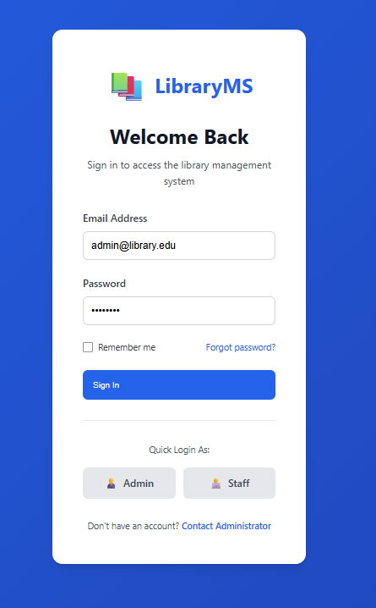

Dashboard
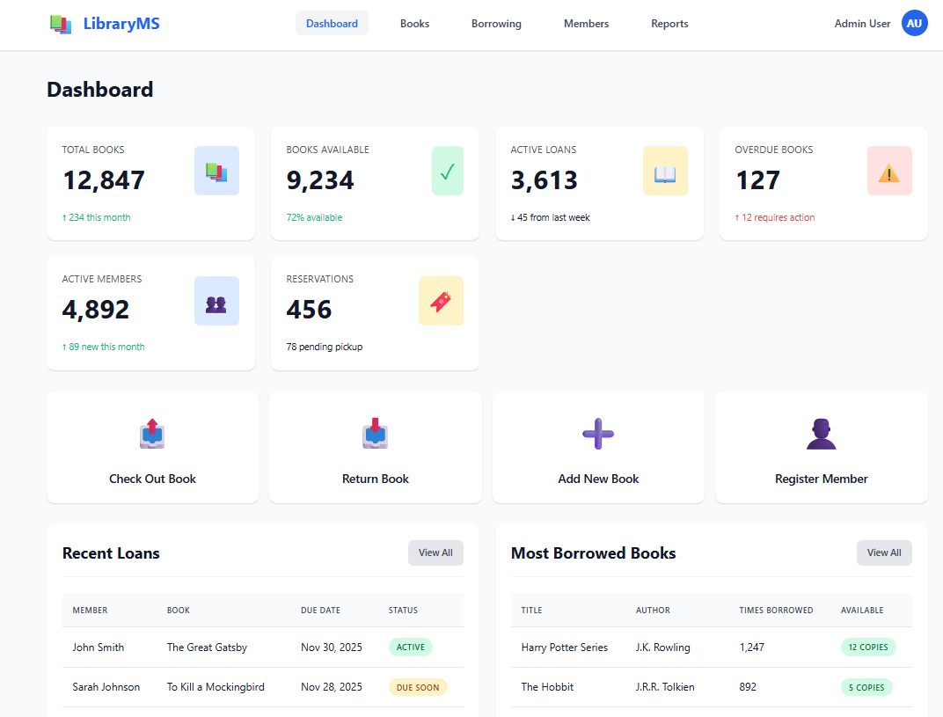

Book Inventory
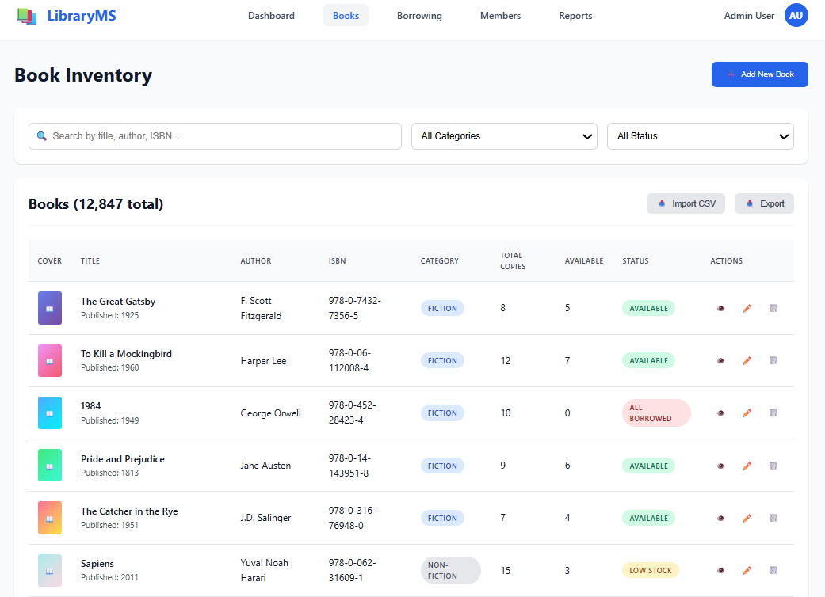

Borrowing & Returns
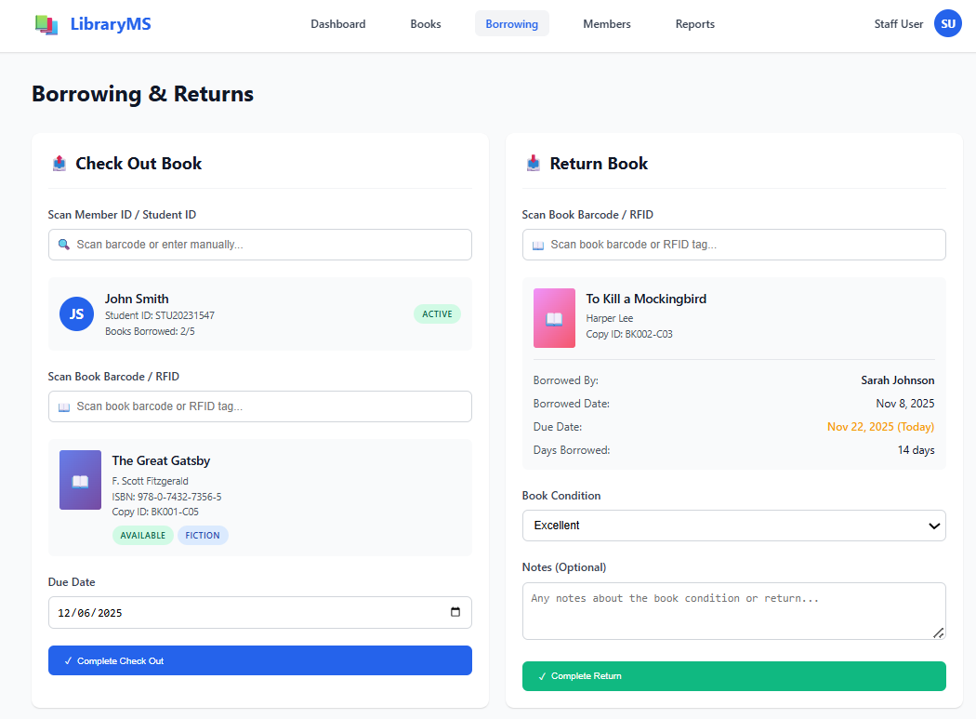

Active Loans
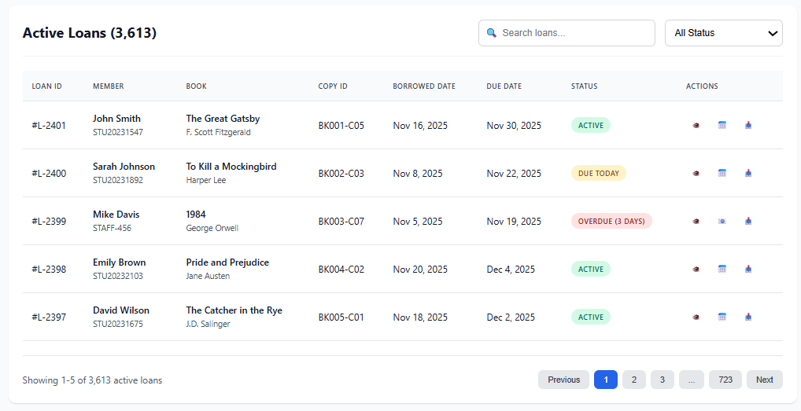

Library Members
