ORIGINAL IMAGE LAPLACIAN
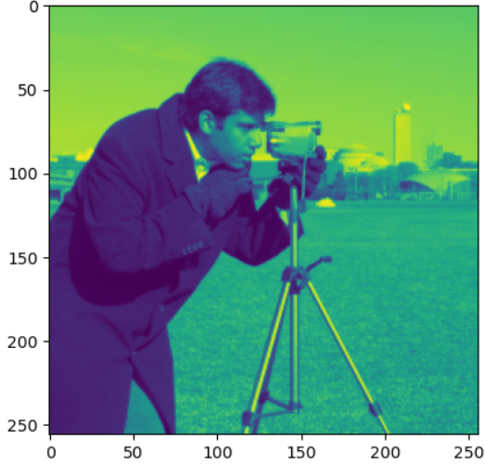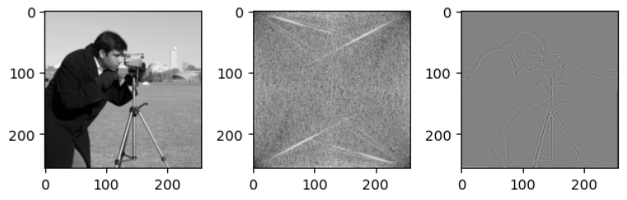
SOBEL
