

National Textile University
Department of Computer Science
Subject
Mobile App Development
Submitted to:
Sir Rehan Sarwar

Submitted by:
Hussain Naweed
Registration Number
23-NTU-CS-1165

Lab Task
05
Semester
6th

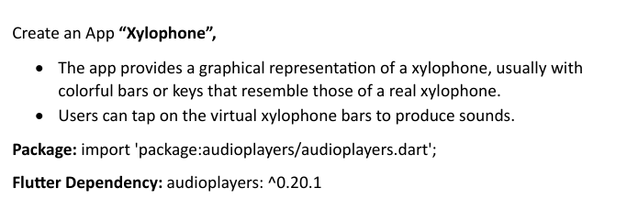
Code:
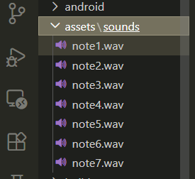
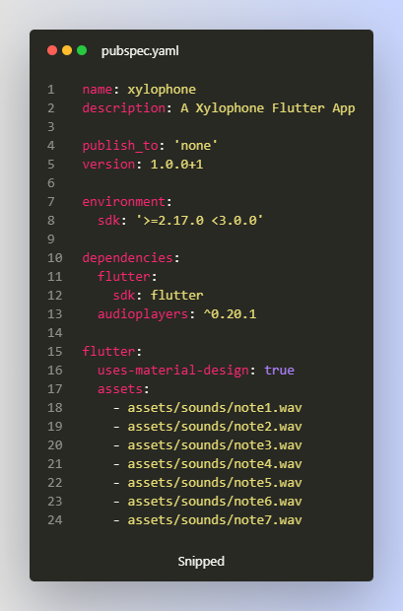
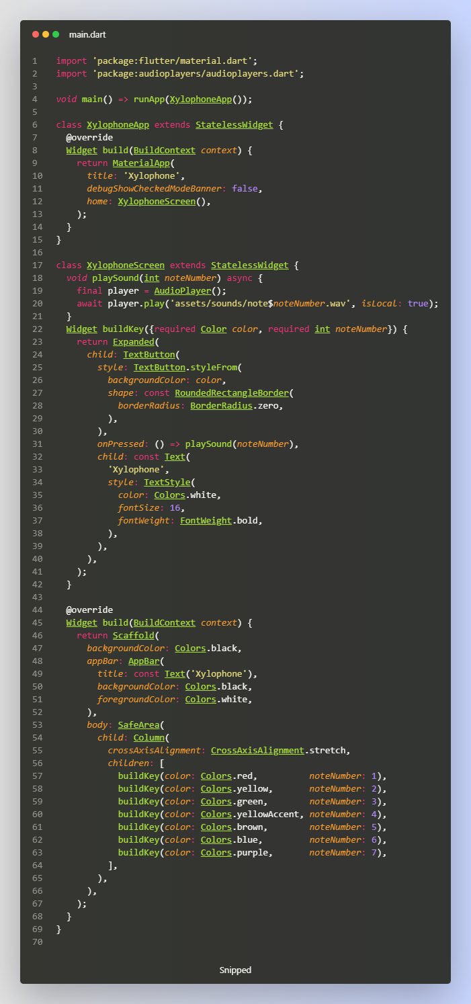

Output:
