LIBRARY MANAGEMENT SYSTEM

**(Java Project)**



SIR ZUBAIR



It is not possible to prepare a project without the assistance encouragement of other people. This one is certainly no exception.

We are extremely thankful to our faculty Sir Zubair for his valuable guidance and support on completion of this project.

We extend our gratitude to Aptech Garden Center for giving us this opportunity.



1. About Project
2. Project Members
3. Role Of Members
4. Project Design
5. Project Screen Shots
6. Room for Betterment



# ➢ DEVELOPMENT PURPOSE:

Our purpose for this software is to provide our client with a properly functioning desktop application which can be used for library.With this it would be easy for save the record of issue or return record from this application

# ➢ SOFTWARE DEVELPED ON:

Software developed on:

1. Java
2. SQL server 2012.

# ➢ SOFTWARE’S USED FOR DEVELOPING:

Software’s used for developing this application is:

1. Net Beans 8.0.1
2. SQL SERVER 2012



* ATIQ FAISAL
* MUHAMMAD HUSSAIN
* USAMA NAEEM
* ABDULLAH WAHID



|  |  |  |
| --- | --- | --- |
|  |  |  |
| HUSSAIN | PROGRAMMING JAVA AND SQL |  |
| ATIQ | DESIGNING |  |
| ABDULLAH | PROGRAMMING JAVA |  |

SCREENSHOTS



**MAIN SCREEN**

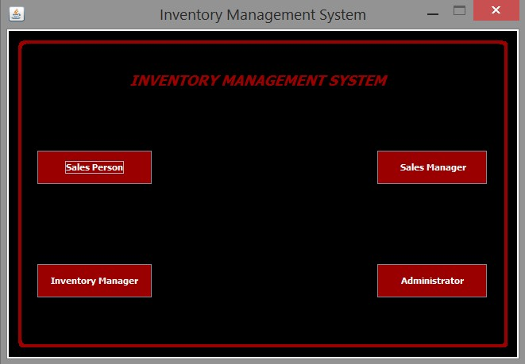

**LOGIN SCREEN**

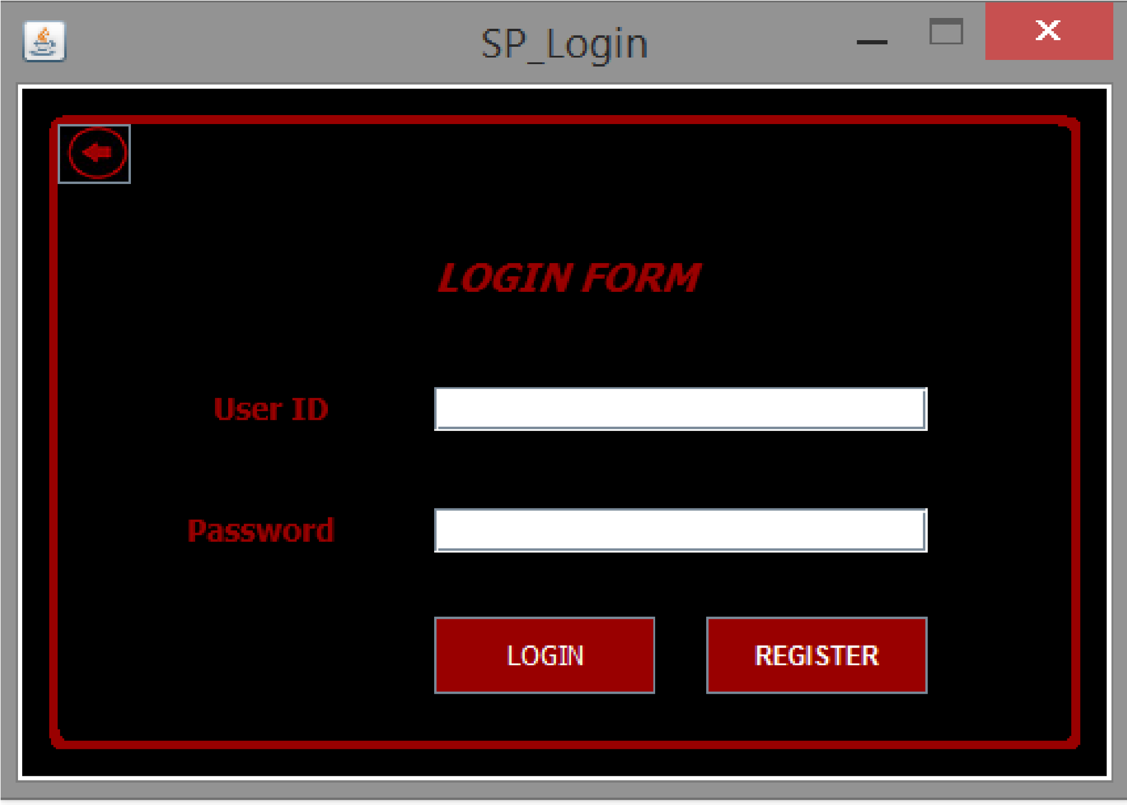

**REGISTER SCREEN**

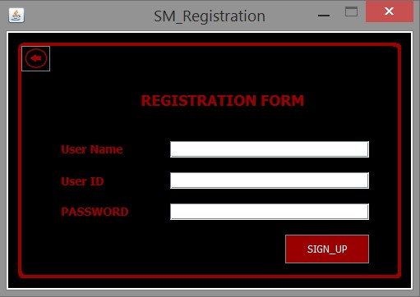

**ADMIN DASHBOARD**

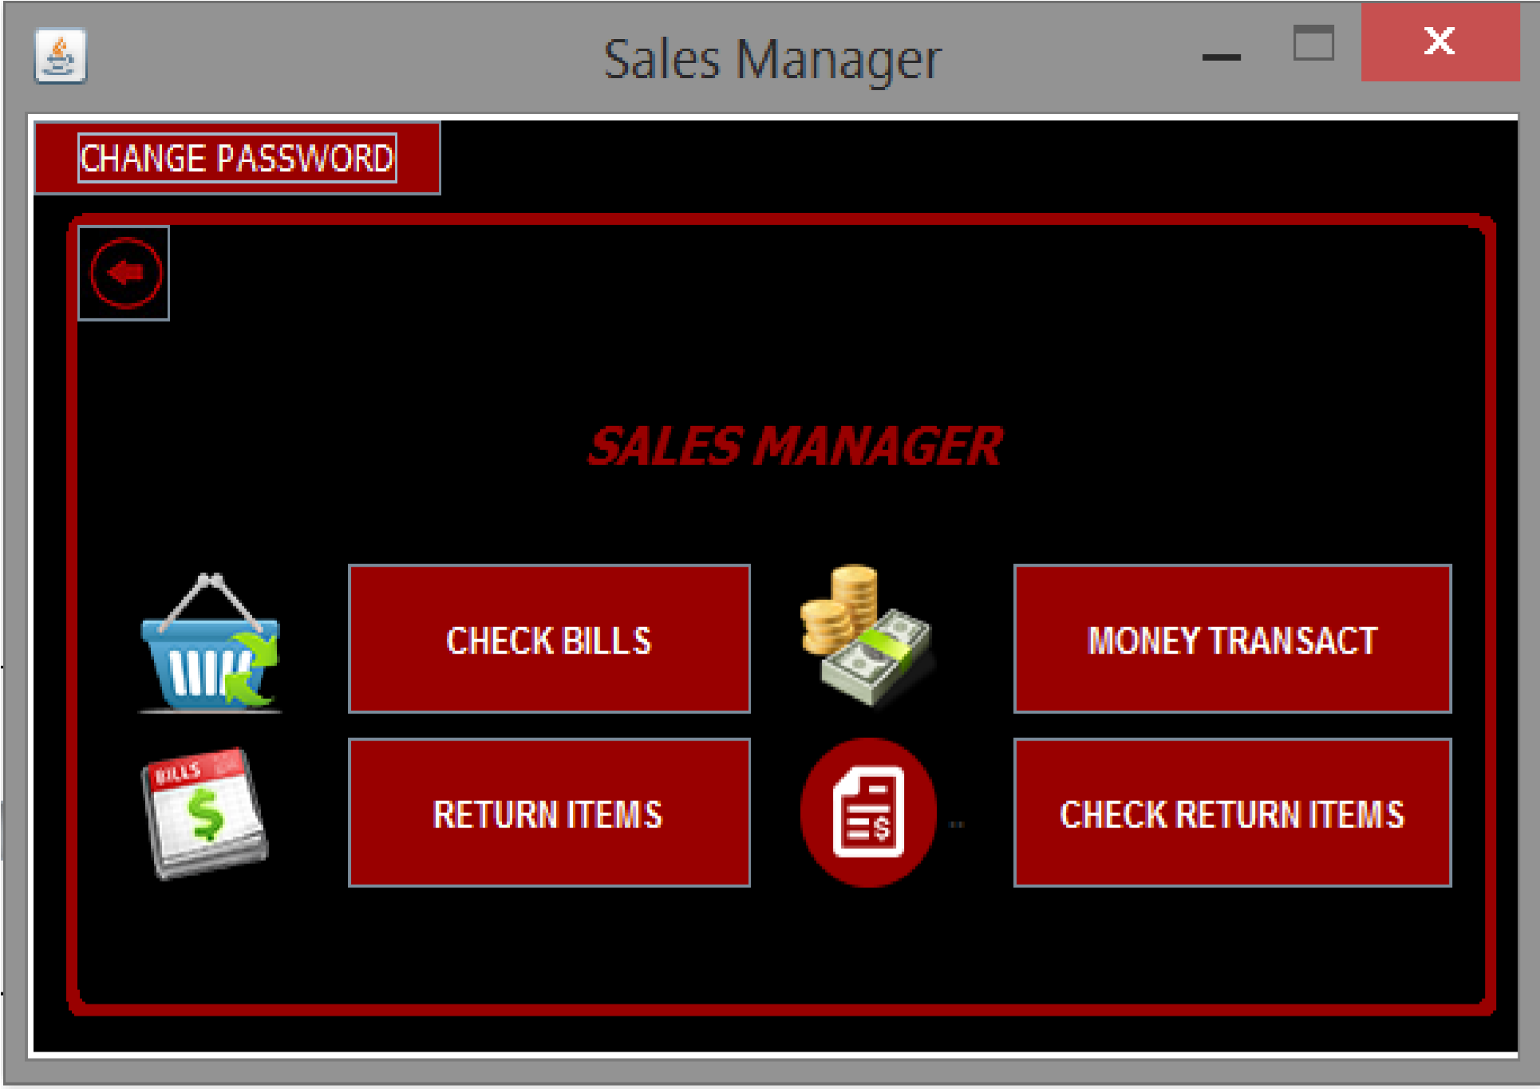



This project still has a lot space for betterment and to make it more interesting and so it can be worked further on as well.

**THANK YOU**