**Use Cases**

1. Send Message

* Users can send messages within a hive.

1. Create Hive

* Users can create a new hive, set a topic and add members

1. Manage Hive (update and delete)

* Owner and Admins can update description, topics and the title for the hive

1. Search Hive and Topic

* Bee(Users), Admin, Queen can search for hives using their titles or descriptions

1. Send Real-Time Notification

* Messages will trigger real-time notifications for all users in that hive (Users may choose to opt out of notifications)

1. Set Hive Status (public or private)

* Some hives may not appear on the search or recommended hives page, instead users can only join through the link that admins may share

1. Set User Role

* Default roles a vailable are Queen and Bee. The Queens of the Hive act as moderators/administrators for the Bees of the Hive.
* Queens may also introduce new roles for their hive

1. Set Hive Moderation Rule

* Administrators(Queen) may set rules for the Hive which act as filters. If any Member uses keywords mentioned in the filter, their message will be removed and they may receive a warning.
* Administrators(Queen) may also manually do this i.e. delete messages sent by other users
* Bees can be stinged (kicked)

1. Reply to Conversation

* Users may reply to a message, creating a thread of messages

1. Add Pole and Vote

* Administrators(Queen) may start polls for the Hive which other users can vote for

1. Pin Message And Make Announcement

* Administrators(Queen) can pin messages or mention all Hive members (announcements) by using @everyone feature

1. Set Custom Theme for Hive (colors, fonts)

* Administrators(Queen) may change the background and font for the Hive, creating an aesthetic for the community

1. Encrypt Message

* All messages will be hashed and cannot be read outside of the Hive

1. Start Audio/Video call

* Users can start calls (audio and video) which others may join in and participate in

1. Send Voice Message

* Users can send voice messages to better express their ideas

1. Manage Profile

* Users can create their profiles, set a profile picture, and add a short introductory bio

1. Share File

* Users may send files or photos to a Hive

1. Edit Photo

* Users can take a photo using their system’s camera and then edit the photo (draw on it or crop it)

1. Enable Vanish Mode (disappearing messages)

* Hives may choose to not save any conversations in the chat and have them delete after 1 hour or 24 hours

1. Play Spotify Music

* Using the Spotify API, hive members may play music for everyone to listen to together

1. Play JavaScript Game

* Hive members may play JavaScript games together

**Use Case Diagram**

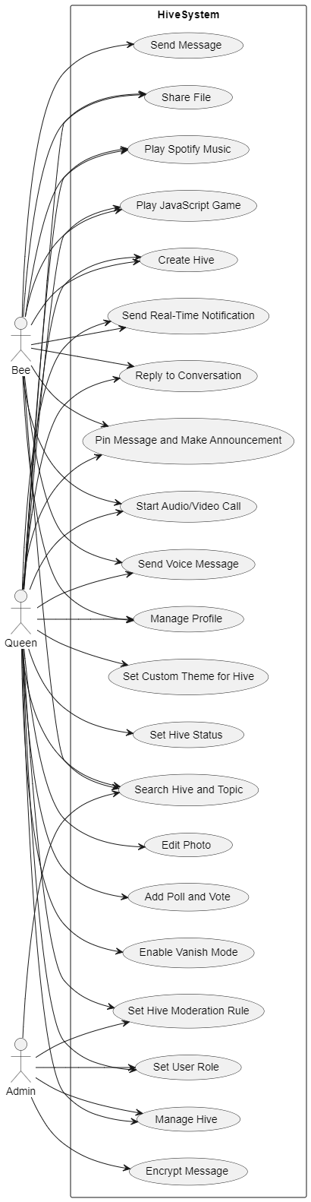

**Analysis Class Diagram**

