Linux fundamental knowledge:

$PATH is to find path of commands

`which <command>` can tell you where the command path is

Format:`command <-options> <inputs>`

Some options have their own input



Some options need a `=` to be connected to their inputs

Manual:

We’d mostly use section 1, 5 and 8 of the manual structure.

`man -k which`searches for the manual for the which command

In a manual page in the synopsis: [] means optional option, <> means mandatory option, [ | ] pipe inside square brackets means the options inside can’t go together so u have to pick one or the other and … means can have more than one input

You can use man to find new commands that you may want to use (you may need to try different words to find what you want) use `man -k “<text for what you are looking for>”`

Some commands don’t have a manual page so use `help` instead

Command input and output:

You can direct standard output (1) with



And do the same for standard error(2),

Redirection`>` overwrites current contents, do append `>>` to add to content.

You can do both at the same time:



Piping:



Tee command:

Advanced piping technique that lets you allow data to flow in two directions.

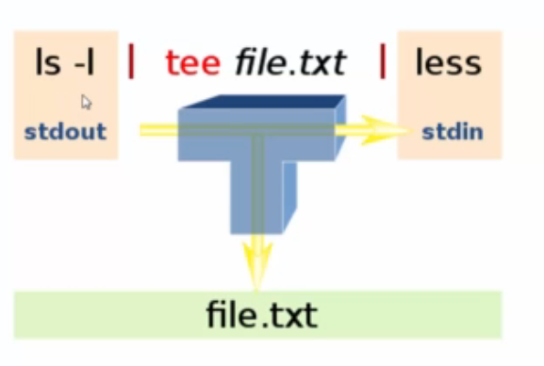

Xargs – convert pipe data into command line arguments, so it converts it from standard input into command line arguments

A dot `.` makes a file hidden if added to the front.

.bash_aliases to make aliases in linux

Makes alias with `alias <alias_name>=’<command_and_arg>’`



Test it works in a new terminal:

