Technical Report
Introduction
This dataset is important because it provides a reliable basis for analyzing how emissions change over time, which essential for understanding trends, identifying emerging risks, and guiding better environmental decisions.

Problem Statement
The global emissions from major industries increased by about 4628% since 1950, driven by production expansion

Objectives
1- To highlight where the highest contributions come from and why certain entities impact the environment more than others
2- To see how ownership structures might influence emission performance
3- To identify the worst entities in operation

Target Audience
- Decision Makers
- Environmental Analysts
- Operational planners
Dataset(s)
Carbon Majors is a database of historical production data from 180 of the world’s largest oil, gas, coal, and cement producers. This data is used to quantify the direct operational emissions and emissions from the combustion of marketed products that can be attributed to these entities. These entities include:
104 Investor-owned Companies, 70 State-owned Companies, 6 Nation States,
88 Oil Producing Entities, 87 Gas Entities, 103 Coal Entities, 8 Cement Entities
The data spans back to 1854 and contains over 1.39 trillion tonnes of CO₂e covering 69% of global fossil fuel and cement emissions since the start of the Industrial Revolution in 1751.

Data Dictionary
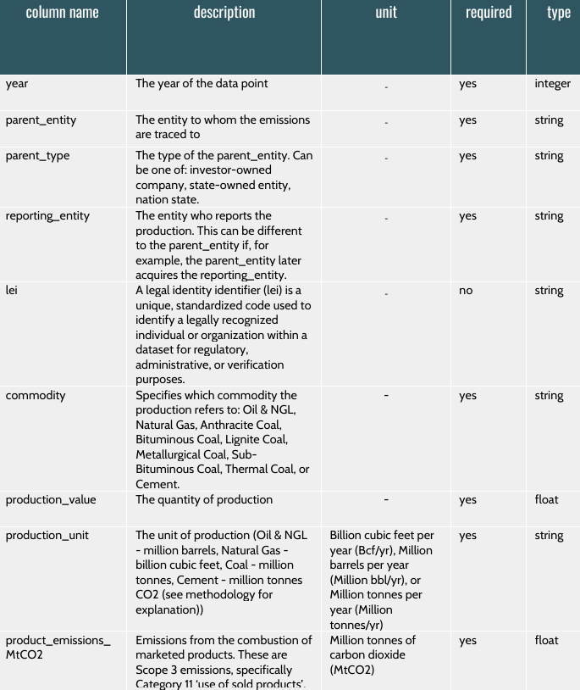

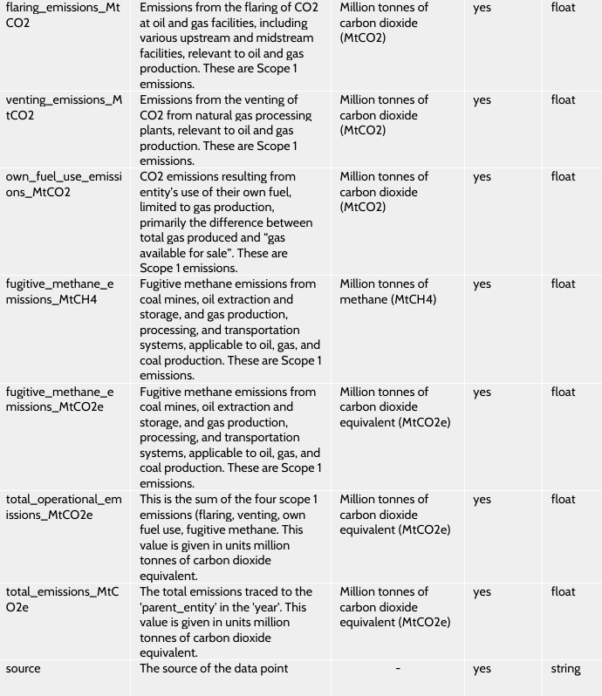

Data Handling
- I have blanks in the column “lei” and column “source” but I didn’t remove them because these two columns were not used in the analysis.
- I removed the rows of commodity “cement” because the production unit was typed incorrectly as I concluded.
- I added column “Country Grouping” that write the country in which each industry placed
- I added column “Production_Energy_PJ” that convert the production amount from each written unit to the corresponding value in energy (Peta Joule)
- I added the columns:
Total Emissions(Billions tonne of CO2)
Total Operational Emissions(Billions tonne of CO2)
Products Emissions(Billions tonne of CO2)
Flaring Emissions(Billions tonne of CO2)
Venting Emissions (Billions tonne of CO2)
Methane Emissions(Billions tonne of CO2)
Fuel Emissions(Billions tonne of CO2)
These columns show the emissions in billion instead of million

- I added column “Emission Intensity” that calculate the emission intensity by dividing the total emissions in billion by production value

Analysis and Findings:
1- Total Emissions are rapidly increasing due to industrial growth by both the state and investors
2- Emission intensity is a good KPI to measure the industrial efficiency
3- Products emissions is contributing the most to total emissions
4- Usage of Oil and natural gas caused the highest total emissions

Recommendations
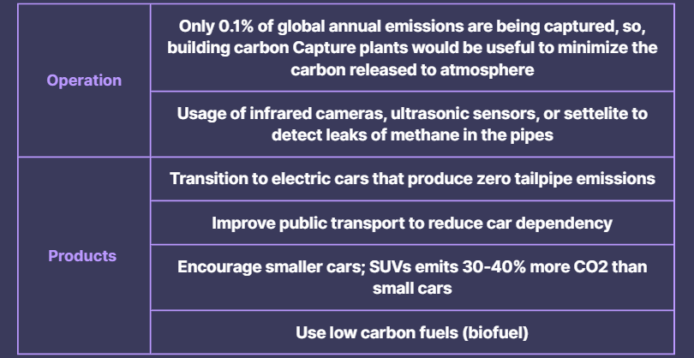
Limitations and Assumptions
- The industries did not mention which countries they belong to, so I took a lot of time trying to create extra column that writes about the country for each industry
- The dataset was focusing only in production and emissions, there is no policy or regulatory context to evaluate the impact of carbon taxes, effectiveness of environmental regulations, and compliance levels
References
Carbon Majors Home

