Deliverable 1

Database 420-231-VA

Due date: Sunday, March 22, 2022

Scenario 2: Car Rental System

Hussain Amin, Mubeen Khan, Sayem Shah, Maxym Galenko

# Description:

The company Car2Go is a car rental company that has several locations and offers a multitude of classes such as subcompact, compact, sedan and luxury. Each car has a different make, model, year made and color. Also, they each have a unique identification number and a unique license plate. When a car is rented, the company keeps track of the mileage, tank and the date (before and after a car is rented). The rented car can be returned to a different location. A customer can only rent one car at a time and request a specific class. For every customer, the company keeps record of their full name, mailing address, zero or more phone numbers, zero or more email addresses and the driver’s license number (unique for each customer). If the company does not have a vehicle of the class requested, the customer can get a higher class for the same price (free upgrade). All cars of the same class are priced the same. The drop-off charge is calculated by the car’s class, the duration in days (minimum 1) and if there is any weekly promotion. In certain weeks of the year, the company has a promotion (usually 50%, not always) that only affects a single class of car at a time.

# Business Rules and Assumptions:

* Each car has a unique license plate
* Customer can only rent one car at a time
* If the car requested by the customer is not available, they can get a car of higher class at the same price as the car requested
* Company keeps track of the rented cars
* Company keeps record of the customer
* All cars in the same class have the same price
* The company keeps track of fuel tank and when the car is returned, they only indicate if the tank is empty, quarter full, half full, three quarters full, or full.
* Drop-off charge can be found with the price of the car, duration in days, and promotion, if there are any.
* For every car rented, the company keeps the odometer reading before it is rented and after it is returned
* The cars rented in a particular location may be returned to a different location

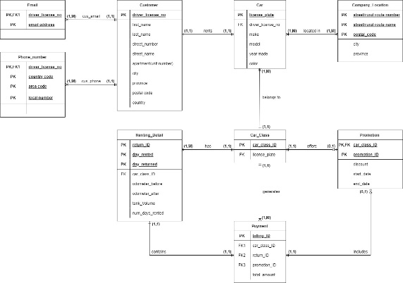

# Relation schema

* **Email (**driver_license_no, email_address**)**
* **Phone_Number (**driver_license_no, country_code, area_code, local_number**)**
* **Customer (**driver_license_no, first_name, last_name, street_number, street_name, apartment/unit_number, city, province, postal_code, country**)**
* **Car (**license_plate, car_class_ID, make, model, year_made, color**)**
* **Company_Location (**street/rural route number, street/rural route name, postal_code, city, province**)**
* **Car_Class (**car_class_ID, license_plate, class_description, car_class_price**)**
* **Renting_Detail (**return_ID, day_rented, day_returned, car_class_ID, driver_license_no, odometer_before, odometer_after, tank_volume, num_days_rented, pickup_company_location, dropoff_company_location**)**
* **Payment (**billing_ID, car_class_ID, return_ID, promotion_ID, total_amount**)**
* **Promotion (**promotion_ID, car_class_ID, discount, start_date, end_date**)**

# Normalization

## 1NF:

The following tables are the changes we made after 1NF. Green being the old table and White being the new tables.

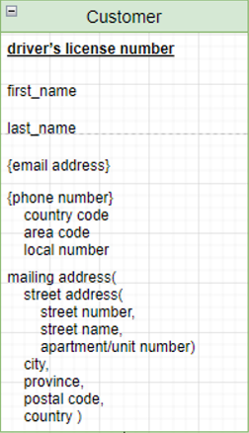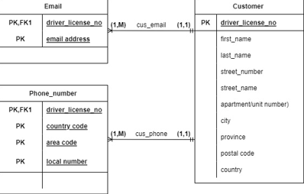

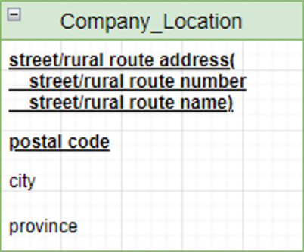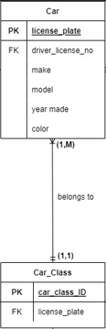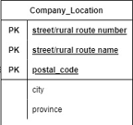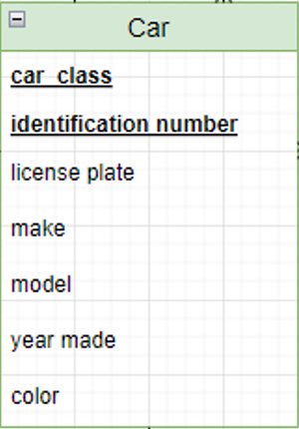

## 2NF:

2NF should be showing solution of any partial dependency not separating tables as a result of composite and multivalued attributes

## 3NF:

We don’t have any