# PNEUMVENT SYSTEM DIASSEMBLED

Please Note that the following document shows the components required for assembling Pneumvent (the ventilator). This document doesn’t show the spirometer kit (how the machine is connected to the patient) but rather shows the modularity of the machine , ease of assembly, maintenance and ease of remove and installation of the battery.

Please reference the block diagram section for how to hookup the machine to the patient.

# Front Section

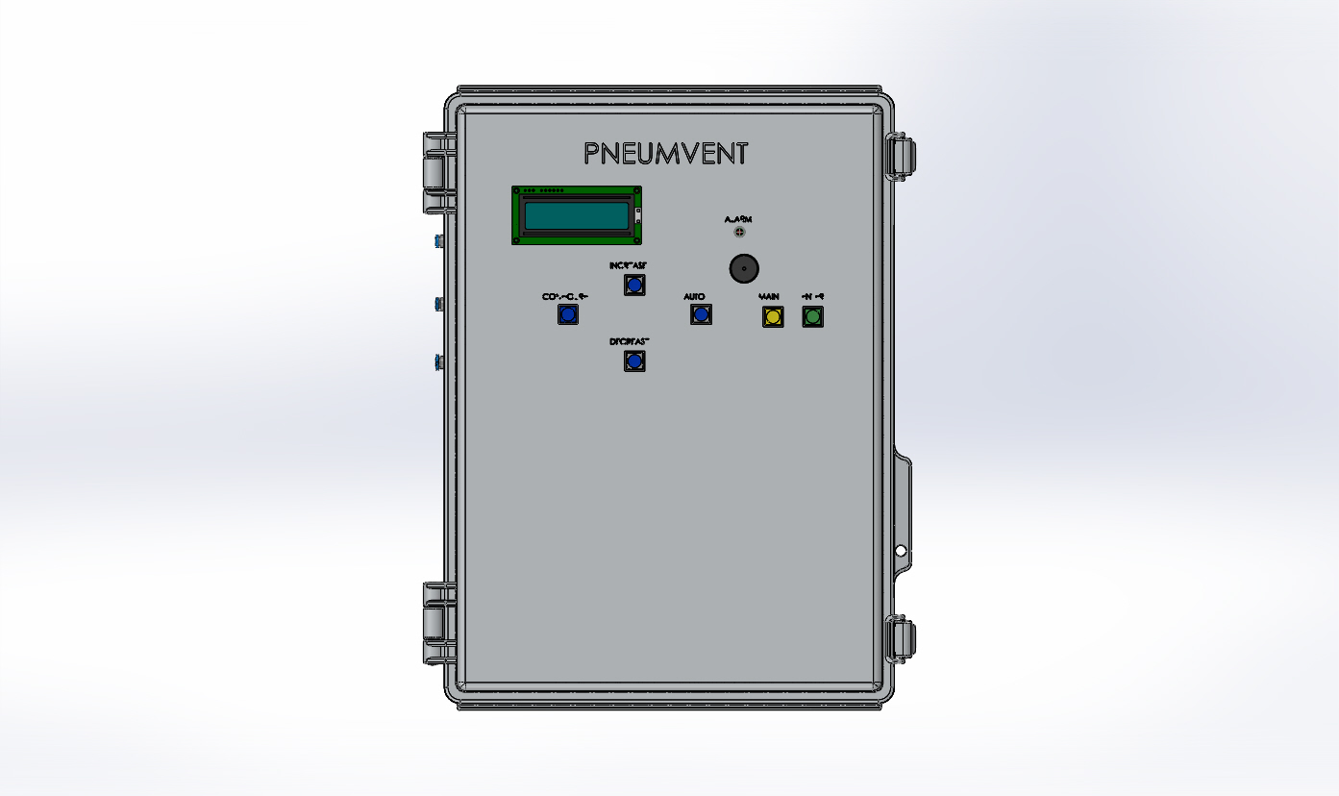

# Control Panel- Human Machine Interface

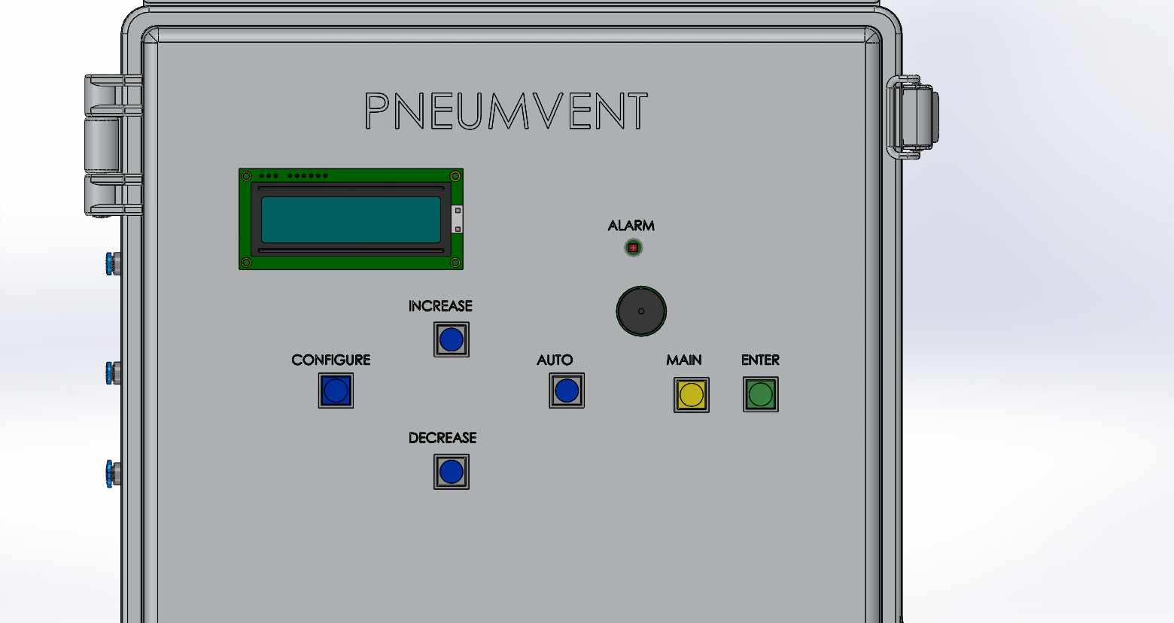

# Pneumatic System Inlets

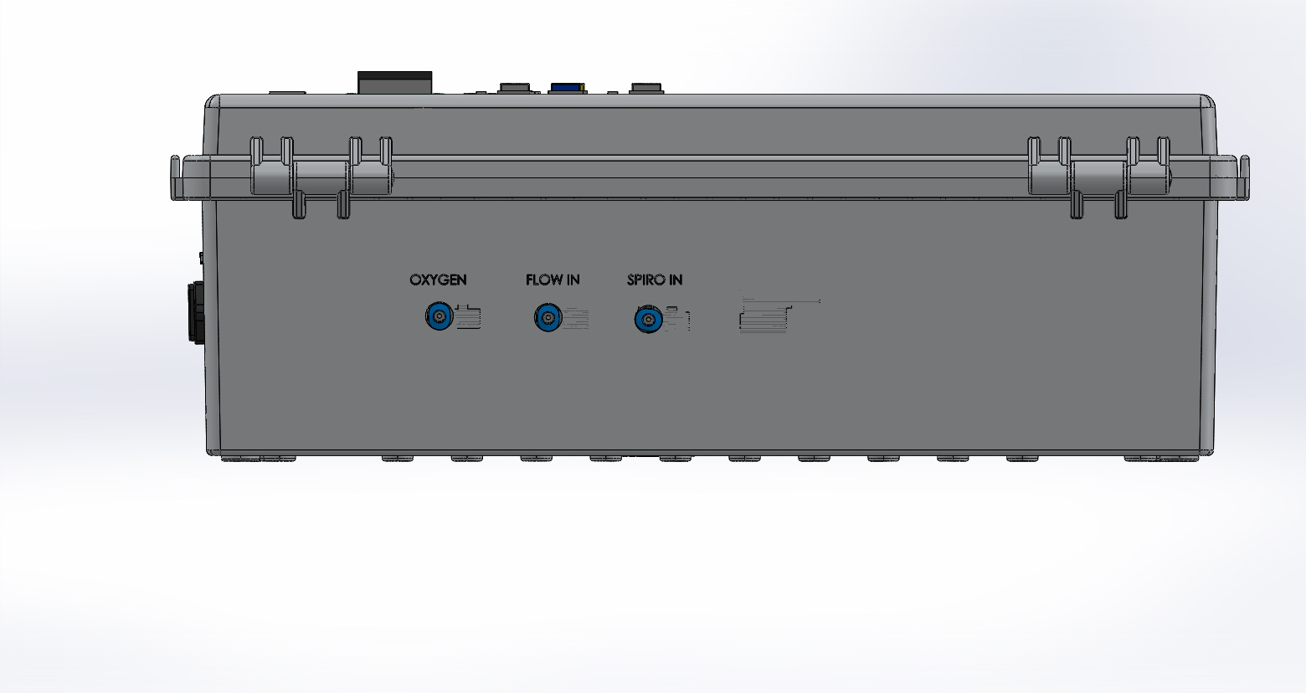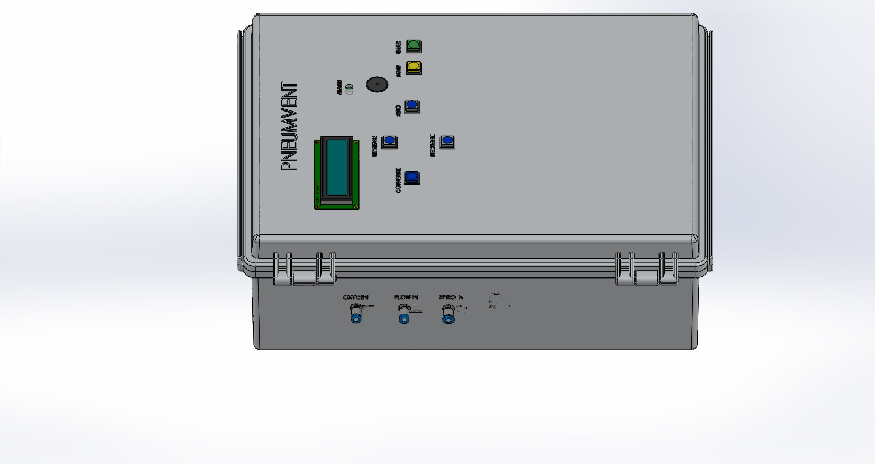

# 110/220 VAC Power Receptacle Input

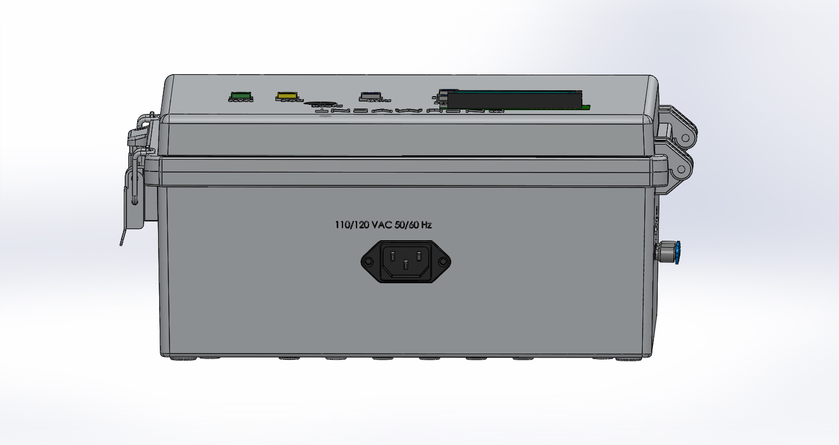

# Inside of Enclosure

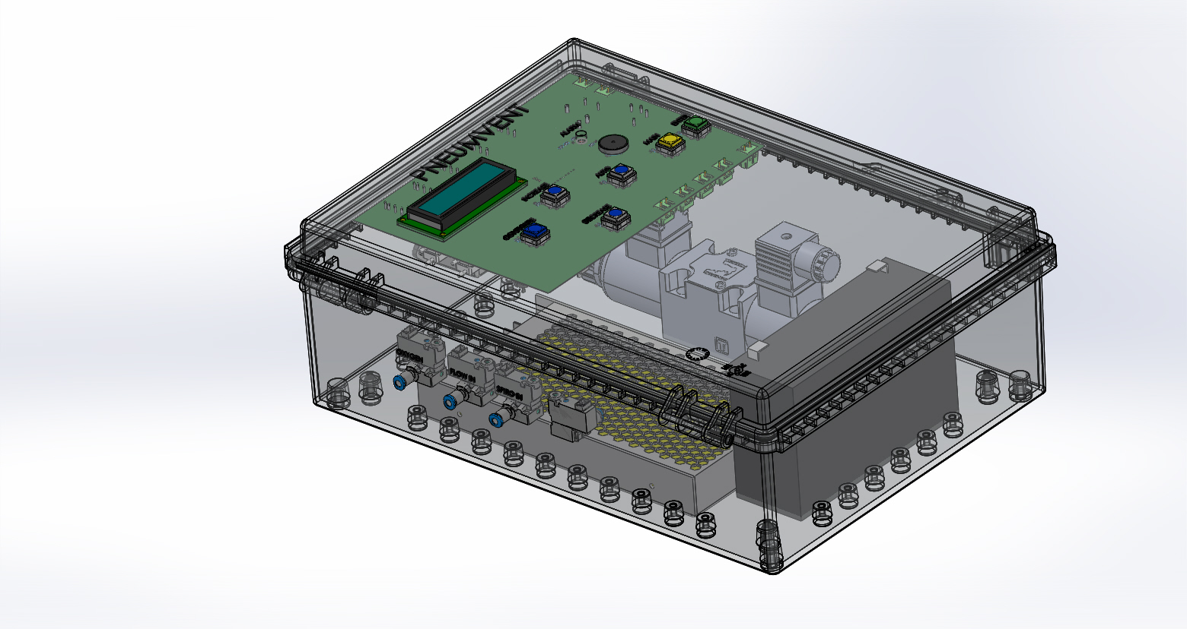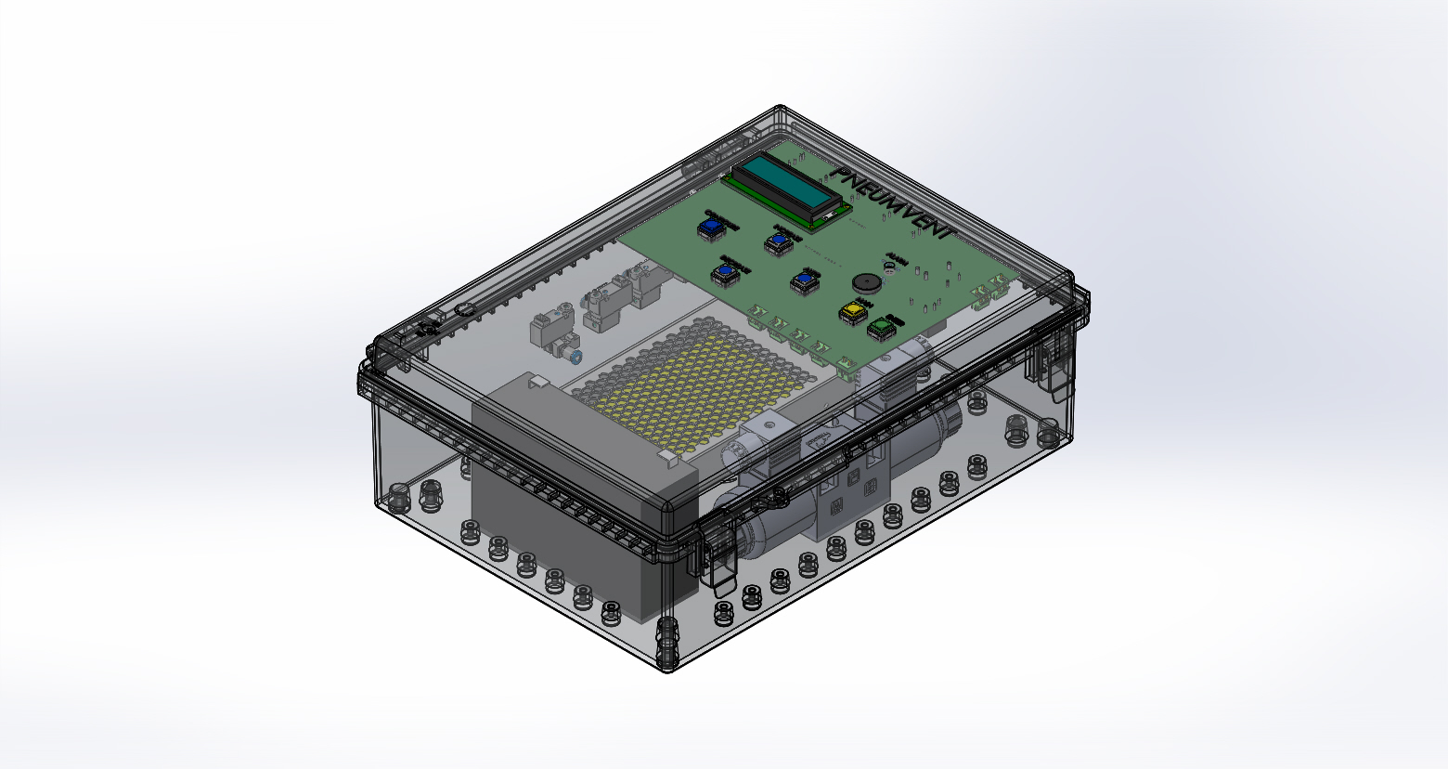

# Pneumatic System

