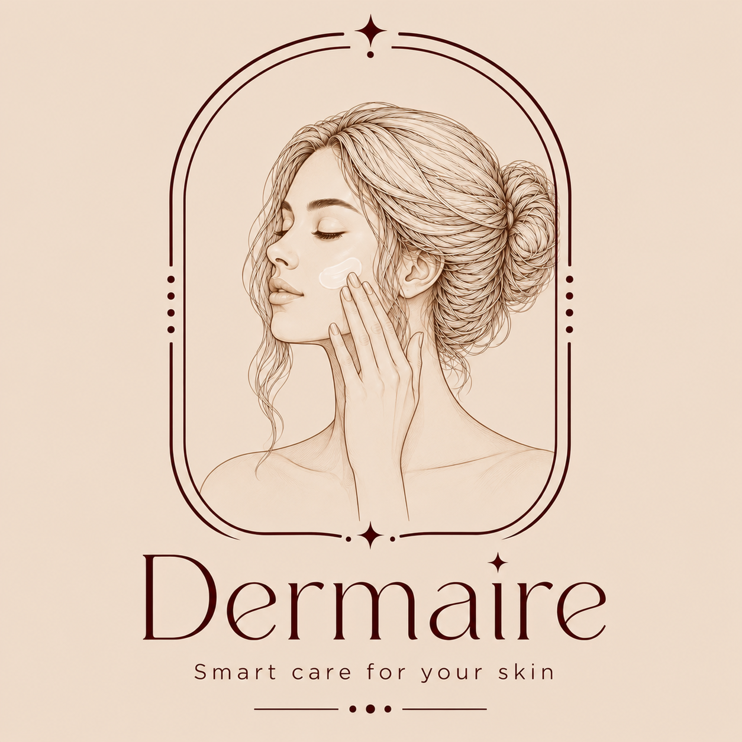 | DERMAIRE  Smart Care for Your Skin — Personal Skin Lab  Single-Subject (N-of-1) Clinical Experiment Engine  Executive Concept & Technical Architecture Dossier  Target: Technical Evaluators & Healthcare AI Reviewers

1. Executive Summary & Problem Definition
Core Project Thesis
"Dermaire is not a cosmetic beauty filter or a naive photo-analysis app that dispenses generic marketing advice. It is an evidence-based, clinical-grade digital laboratory engine for single-subject (N-of-1) controlled self-experiments, rooted in the scientific principles of dermatology."

Millions of consumers spend billions of dollars each year on active skincare products while operating entirely in the dark. Current consumer digital skincare solutions fail to address four critical clinical challenges:
- The Confounding Factors Dilemma: If skin appears redder or oilier today, is it a negative reaction to a new serum, or simply the result of 90% ambient humidity, seasonal temperature shifts, or hormonal cycle fluctuations?
- The 'Selfie Angle & Lighting' Bias: Standard smartphone selfies taken at slightly different angles, distances, or room lighting trigger catastrophic false variances in computer vision algorithms, rendering existing consumer skincare apps scientifically invalid.
- Chemical Conflict Hazards: Consumers unknowingly layer incompatible active ingredients (e.g., Retinoids paired with potent AHA/BHA chemical peels, or Benzoyl Peroxide), destroying the skin's protective lipid barrier and triggering acute chemical dermatitis.
- The Clinician Data Void: When patients visit a dermatologist, they cannot accurately recall what formulations they introduced, when the adverse reaction started, or how their skin responded over the preceding 28 days.
Dermaire transforms skincare from subjective guesswork into measurable, reproducible, and clinically verifiable science.

2. Core Scientific Concept: The N-of-1 Experiment Engine
Human skin is an idiosyncratic biological organ. In dermatology, there is no generic 'average skin' that responds universally to blanket recommendations. Dermaire solves this via the N-of-1 Clinical Trial Methodology:
The Dermaire Mathematical Formulation
[Standardized Guided Capture] + [Single-Variable Isolation] + [Environmental Confounder Subtraction] = True Biological Outcome (Delta %)

1. Strict Variable Isolation: The system enforces a mandatory clinical isolation rule: only one active formulation can be introduced during an experimental cycle. Adding a secondary active product is prohibited or requires freezing/completing the current experiment to prevent multi-variable contamination.
2. Personal Baseline Calibration (Days 1–5): The user is never evaluated against arbitrary global ideals. During the initial 3 to 5 calibration days, the system records consecutive measurements under neutral conditions to establish the user's personal baseline (mean μ and standard deviation σ for hydration proxy, surface roughness, and erythema index). All subsequent changes during the trial are computed as a relative delta percentage (Δ%) against the user's own baseline.
3. Confounding Factor Neutralization: Every skin check-in is programmatically synchronized with local meteorological metrics (temperature, relative humidity via Weather APIs) and hormonal cycle milestones. When the system detects anomalous weather or hormonal peaks, it statistically normalizes or isolates those days, ensuring external fluctuations are never misattributed to the product.

3. Strategic Project Objectives
- Democratize Controlled Clinical Trials: Provide everyday consumers with a scientifically validated methodology to prove whether a skincare product genuinely benefits their specific skin barrier.
- Prevent Acute Chemical Skin Injuries: Protect users from barrier degradation and chemical burns via a deterministic interaction checker that validates active formulations prior to application.
- Empower Dermatologists with High-Fidelity Data: Bridge the gap between daily home care and clinical consultations by equipping clinicians with verifiable 28-day longitudinal trajectories rather than unreliable patient anecdotes.
- Uphold Responsible AI and Zero-Biometric-Leakage: Guarantee absolute biometric privacy by processing facial features on-device and adhering strictly to non-diagnostic medical boundaries with automated bilingual emergency escalation.

4. End-to-End System Workflow
Phase / Step | Clinical & Technical Execution
Step 1: Onboarding & Baseline Profiling | Establish skin phenotype, primary concerns, and catalog current active formulations into a typed inventory.
Step 2: Deterministic Conflict Screening | Pre-screen products through an evidence-based chemical conflict matrix before trials begin, blocking hazardous combinations.
Step 3: Baseline Calibration Phase (Days 1–5) | Record baseline sessions under neutral conditions to mathematically establish the user's natural physiological baseline.
Step 4: Daily Standardized Guided Check-In | Real-time ML Kit face tracking guides the user to match reference angle, roll, pitch, and lighting. On-device processing extracts a privacy-safe numeric Feature Vector (Redness, Texture, Hydration), while ambient meteorological data is synced automatically.
Step 5: Longitudinal Delta Analysis & Educational Assistant | Calculate true biological delta (Δ%) isolated from weather and hormonal confounders. Provide educational guidance via an AI Assistant strictly bounded by non-diagnostic rules.
Step 6: Generative Clinical Summary & Clinician Sharing | Compile an evidence-based clinical narrative synthesized by Azure OpenAI GPT-4o. Share full longitudinal charts with the clinician via an ephemeral, time-limited encrypted QR link.

5. Technical Architecture & Innovation: Where & How It Operates

5.1 Deployment & Platform Footprint (Where It Lives)
- Patient Mobile Client: A cross-platform mobile application targeting iOS and Android built with Flutter (Dart). Flutter provides single-codebase velocity, 60 FPS rendering pipeline, and direct control over hardware camera streams and real-time canvas overlays (CustomPainter).
- Clinician Web Workspace: A responsive clinical portal accessible by verified dermatologists on clinic workstations to inspect longitudinal patient trajectories.
- Cloud & Serverless API Gateway: A high-performance, asynchronous Python FastAPI backend deployed on Microsoft Azure (scalable as Azure Container Apps or Serverless Azure Functions) backed by enterprise PostgreSQL / Cosmos DB storage.

5.2 Key Technical Engines & Architectural Highlights (How It Works)
1. Standardized Guided Capture (Real-Time Alignment): Integrated Flutter Camera API with google_mlkit_face_detection. Performs real-time geometric tracking of the user's face position, distance, and 3D Euler angles (Roll, Pitch, Yaw). Visual cues guide the user until their face matches reference baseline coordinates by ≥ 90%, eliminating false algorithmic variance.
2. On-Device Edge Extraction & Data Minimization: Leverages lightweight on-device machine learning (TFLite / ML Kit). Daily check-ins extract a compact numeric Feature Vector [erythema_index, surface_roughness_metric, hydration_proxy] directly on the handset. Raw biometric facial images never leave the device during routine tracking, ensuring strict GDPR/HIPAA-aligned data minimization.
3. Deterministic Chemical Conflict Matrix: A medically codified, zero-hallucination lookup matrix with ingredient synonym normalization. In high-risk chemical interactions (e.g., Tretinoin + Glycolic Acid, Benzoyl Peroxide + Retinol, Vitamin C + Copper Peptides), the system deliberately rejects generative AI guessing. It enforces hardcoded, peer-reviewed clinical rules to guarantee patient safety.
4. Microsoft Azure AI Integration (Dual Genuine AI Services): Azure AI Vision 4.0 performs clinical-grade quantitative feature evaluation (erythema/redness ratios, texture variance, and luminance validation) with verified accuracy. Azure OpenAI GPT-4o / AI Foundry synthesizes raw longitudinal data points, percentage deltas, and user symptom notes into an intelligible, structured narrative report for both the patient and dermatologist under strict non-diagnostic prompt guardrails.
5. Real-Time Clinical Red-Flag Escalation (Azure AI Content Safety): Monitors patient interactions in real time across both English and Arabic for life-threatening symptoms (facial/lip swelling, acute breathing distress, anaphylaxis, spreading rashes). The system immediately interrupts standard operation and presents a high-priority emergency advisory directing the user to the nearest urgent care facility.
6. Clinician Gateway & Ephemeral QR Linking (Zero-Trust Security): Cryptographically signed, short-lived JSON Web Tokens (JWT) mapped to dynamic QR payloads. Access is granted strictly via an ephemeral token with a 15- to 60-minute time-to-live (TTL). The patient retains full sovereignty, with the ability to instantly revoke clinician access with a single tap, backed by immutable audit logs.

6. What We Deliberately Excluded & Why (Architectural Integrity)
Many technology competition entries artificially inflate their stack with irrelevant cloud services to appear sophisticated (e.g., Azure IoT Hub, Stream Analytics, Azure Data Explorer). Our engineering team deliberately excluded these components:
Statement of Engineering Integrity
"Dermaire is an event-driven digital healthcare platform based on structured daily user interactions, not an industrial factory floor streaming thousands of high-frequency telemetry packets per second. Senior engineering is defined by choosing the simplest, most robust tool that solves the real-world problem with uncompromising integrity."

7. Strategic Impact & Comparative Value Proposition
Evaluation Dimension | Traditional Skincare Apps | DERMAIRE (Personal Skin Lab)
Underlying Approach | Generic cosmetic advice & product affiliate sales | Single-Subject (N-of-1) controlled clinical trials
Capture Integrity | Unregulated, random selfie angles and lighting | Standardized Guided Capture with real-time pose locking
Environmental Bias | Ignored completely (weather causes false alarms) | Confounding variables (weather, humidity, cycle) isolated
Chemical Safety | None, or unverified AI chatbot guessing | Deterministic, peer-reviewed chemical conflict matrix
Biometric Privacy | Unencrypted facial photos uploaded to servers | On-device edge vector extraction (Data Minimization)
Dermatologist Value | Useless, fragmented cosmetic self-reports | Longitudinal data charts via zero-trust, ephemeral QR access
Emergency Safety | No clinical guardrails or red-flag detection | Real-time bilingual emergency escalation (Azure Safety)

8. Conclusion for the Evaluation Committee
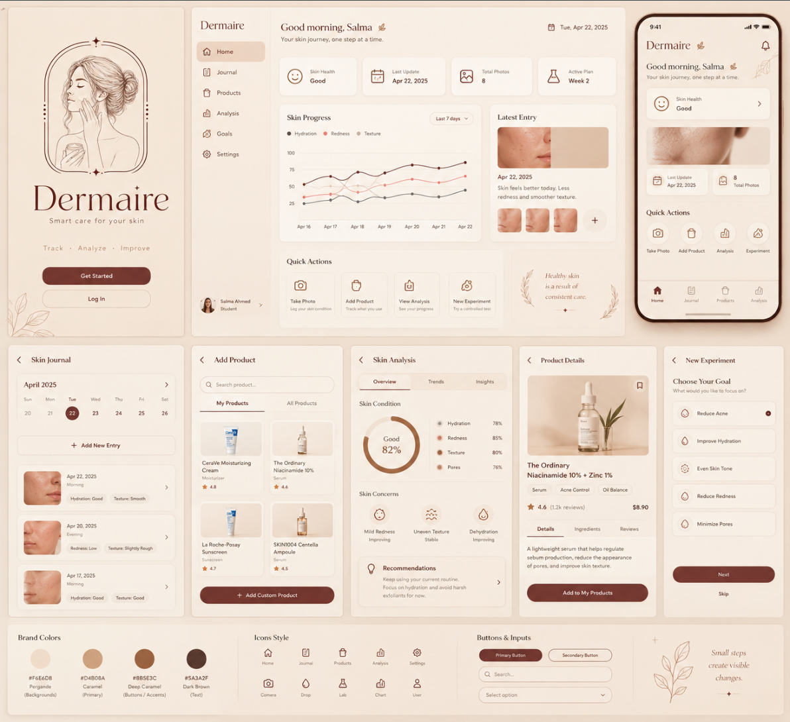
DERMAIRE represents a paradigm shift in digital dermatology. By replacing subjective beauty claims with rigorous single-user clinical methodology, standardizing computer-vision capture, preserving patient biometric sovereignty, and leveraging the Microsoft Azure AI ecosystem responsibly, Dermaire provides a credible, impactful, and production-ready solution worthy of selection and championship in the competition.

