Software Requirements Specification for Governmental complaint system

Prepared by:

* + Ahmed Mohammed Abd El-Ghani
  + Ahmed Mahmoud Agamy
  + Hussein Muhammad El-Sayed

# Table of Contents

Table of Contents 2

1. Preface 4

2. Introduction 4

2.1 Scope 4

3. System Users 5

3.1 System stakeholders 5

3.2 Users objectives 6

4. User Requirements definitions 6

4.1 System Functions 6

4.2 Constraints 6

5. System Architecture 7

6. System Functional requirements 7

6.1 Add new Account (sign up) 7

6.2 Authenticate (log in) 7

6.3 Create new complaint 7

6.4 Reply to complaint 7

6.5 Filter in progress complaint 7

6.6 Filter solved complaint 8

6.7 Filter not read complaint 8

6.8 Sort complaint list 8

6.9 See replied complaints 8

6.10 Log out 8

7. Interface requirements 9

7.1 website wire frames 9

8. System Features: 14

9. Non-functional requirements 16

9.1 Availability: 16

9.2 Security: 16

10. System Model and Diagrams 17

11. System evolution: 17

12. Time plan 18

12.1 Gantt chart 18

13. Reference 18

List of Figures

Figure 1: System Functions hierarchy 6

Figure 2 System Architecture 8

Figure 3: Sign up Page 10

Figure 4: Sign in Page 11

Figure 5: Home Page 12

Figure 6: Post complaint Page 13

Figure 7: Use case diagram 15

Figure 8: Sequence 1 16

Figure 9: Sequence 2 17

Figure 10: Class diagram 18

Figure 11: Gantt chart table 19

Figure 12: Gantt chart 19

# Preface

* 1. Documentation Purpose

The purpose of this document is to provide a detailed and complete specification for the student project of the first term Governmental complaint site (idea #9) for the Faculty of Engineering, Helwan University computer department.

* 1. Target users

This documentation is intended to be viewed and graded by the subject professor and his assistants

|  |  |  |  |
| --- | --- | --- | --- |
|  |  |  |  |

# Introduction

## Scope

Governmental complaint site (Student 1st term project #9) purpose is to ensure the following:

* Keep records of the people complaints and its details
* Assist in simplifying the admin (complaint solver) work to increase the complainant satisfaction
* Easy to access from any device connected to internet

### System Functionality

* Mange complaints data
* Add new complaint
* Replay and mark complaint as solved
* Mark complaint as read
* Sorting of complaint according to priority, alphabetically or date
* Notify the user about the replied complaint
* Filter in progress complaint
* Filter solved complaint
* Filter not read complaint
* Mange user data
  + Add user
* Mange admin data
  + Add admin

### System Functionality as diagram

Figure 1: System functionality

### System Data

|  |  |
| --- | --- |
| Name | Description |
| User | List of authorized users and admins |
| Complaint | List of complaint |
| Details | List contain the complaint data |

# System Users

## System stakeholders

* System Engineers
  + Responsible for requirements gathering
  + Responsible for development
  + Responsible for deployment and support
* Complainants
  + Post Complaints to the Admin
  + See the replies of his complaints if Admin answered them
* Admins
  + See Complaints and its details
  + Reply a complaint

## Users objectives

* System Engineer
  + Gain Experience in software engineering and development
* Complainants
  + Easily post a complaint
  + Save more time using website from any available place
  + Easily Communication with Admin
* Admin
  + Replay in an Effectively with Employees
  + See and solve employee’s complaints in an easy manner

# User Requirements definitions

## System Functions

1. Add new Account (sign up)
2. Authenticate (log in)
3. Create new complaint
4. Reply to complaint
5. Sort complaint list alphabetically
6. Sort complaint list due date
7. Sort complaint list due to priority
8. See replied complaints
9. Filter in progress complaint
10. Filter solved complaint
11. Filter not read complaint
12. Log out

## Constraints

* Governmental Policies
  + All data should be Private
* Cultural Constraints
  + All Code must follow Team standards
* Technologies Limitations
  + Must use django

# System Architecture

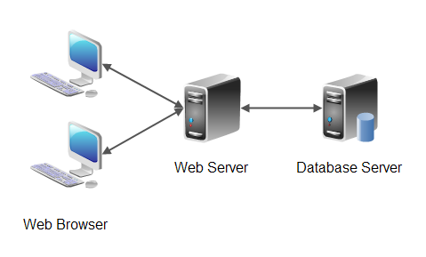

Figure 2 System Architecture

# System Functional requirements

## Add new Account (sign up)

The user can add a new account by adding the following information:

* User Name
* Password
* Confirm Password
* ID number
* Code (Required for admin only)

## Authenticate (log in)

The user can log in the website by adding the following information:

* + User name
  + Password
* *And then system should authenticate its account information*

## Create new complaint

A user can add new complaint by adding the following information:

* + Title
  + Description
  + Message
  + Priority (Integer from 1 to 10)
* *And post it to the admin.*

## Reply to complaint

The Admin can reply a Complaint then he doesn’t see this Complaint in his home page again

## Filter in progress complaint

Both user and admin can see the complaint whose state is in progress only in separate page

## 6.6 Filter solved complaint

Admin can see the complaint whose state is solved only separate page

## 6.7 Filter not read complaint

User can see the complaint whose admin replied in separate page



## Sort complaint list

The Admin can sort the complaint list in his homepage

* + 1. Sort complaint list alphabetically

according to alphabetical of complaint title

* + 1. Sort complaint list due date

according to late complaints

* + 1. Sort complaint list due to priority

according to priority of complaints

## See replied complaints

A user can see the state of his complaint as replied or not and once its replied he can see the reply.

## Log out

A user can log out his account so system need to re-authenticate him in next time he tried to enter the website.

# Interface requirements

## 7.1 website wire frames

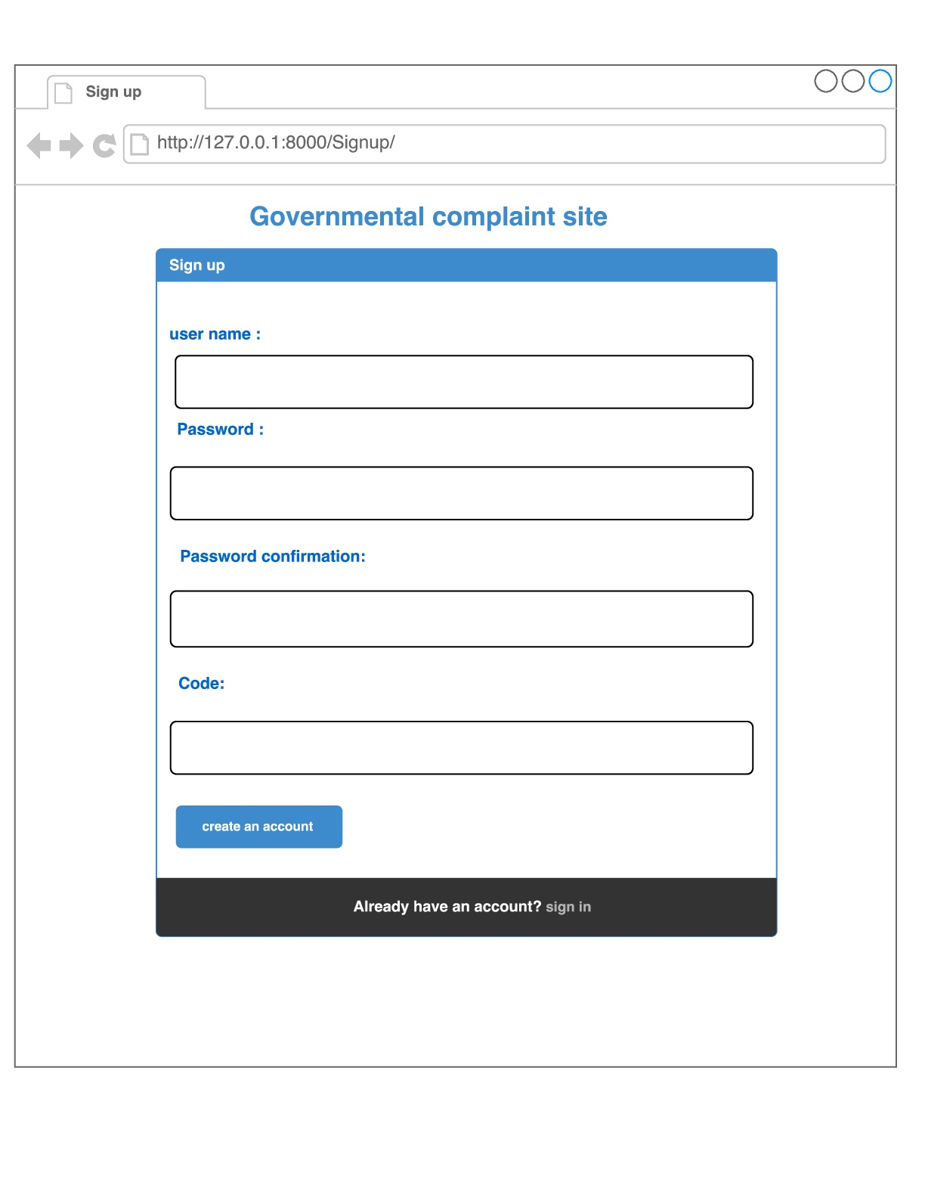

Figure 2: sign up Page

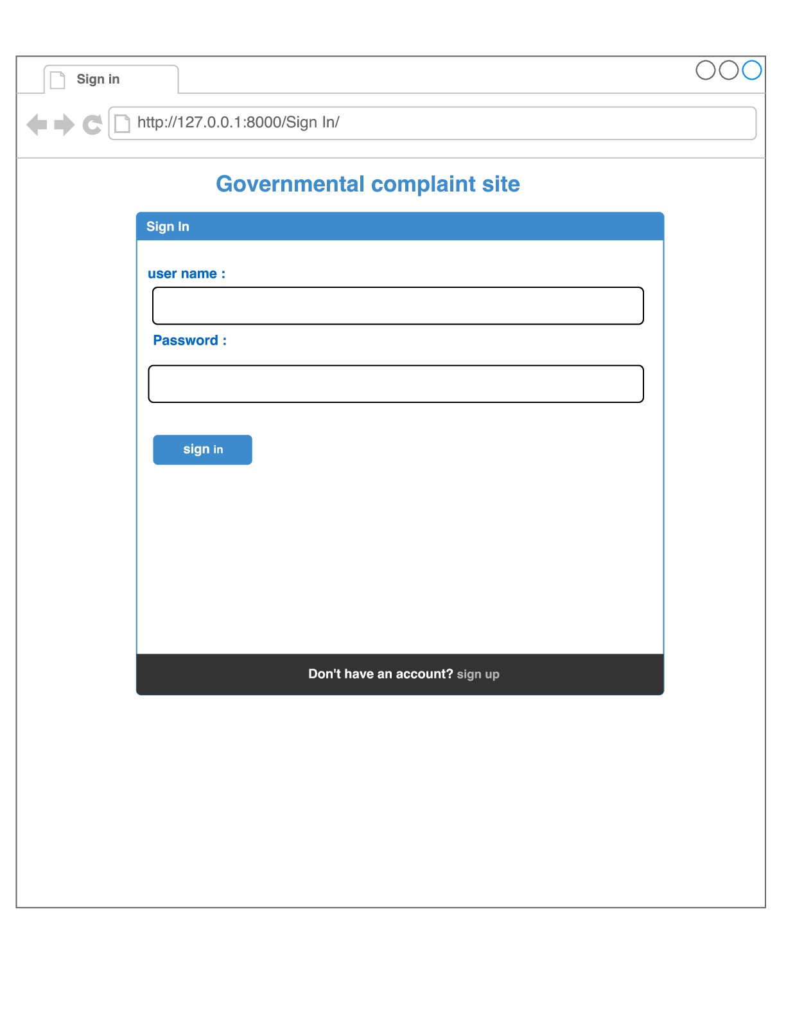

Figure 3: sign in Page

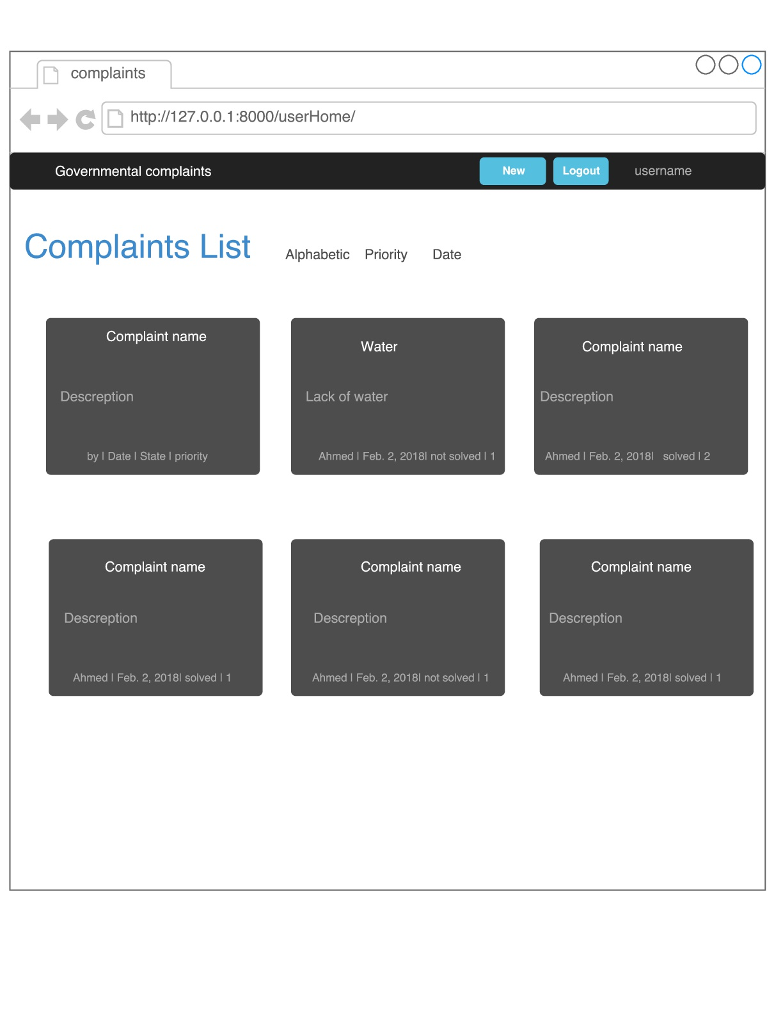

Figure 4: user Home Page

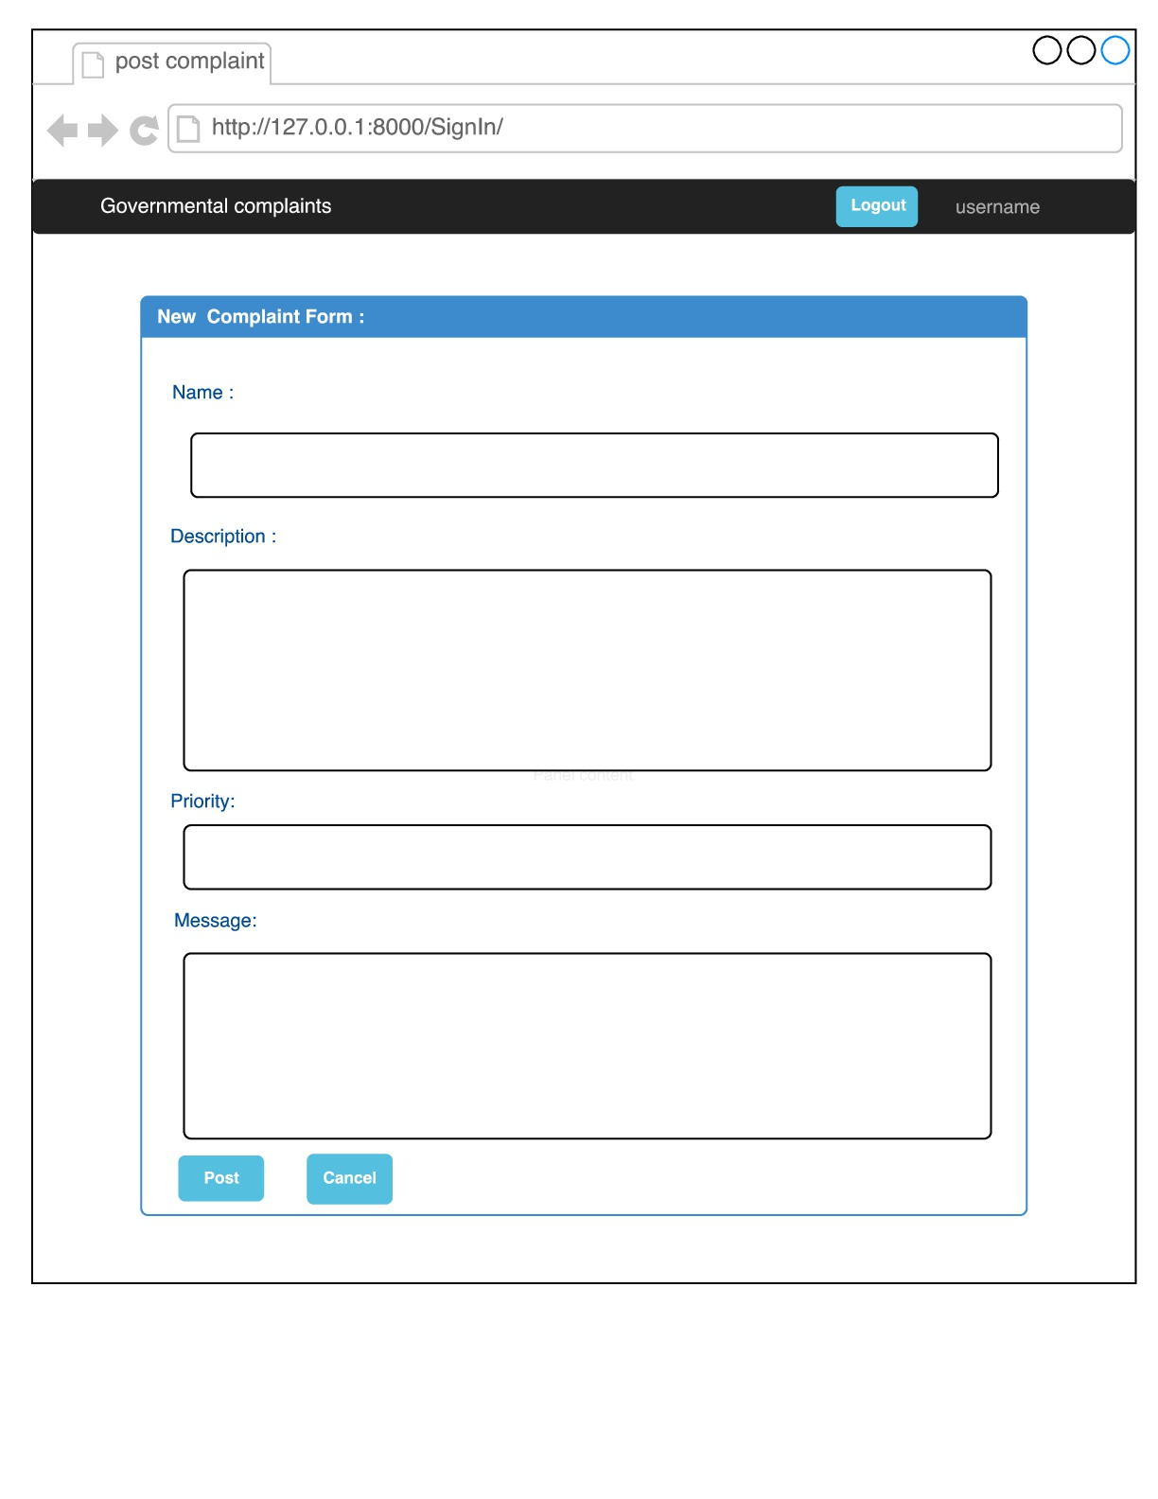

Figure 5: post complaint Page

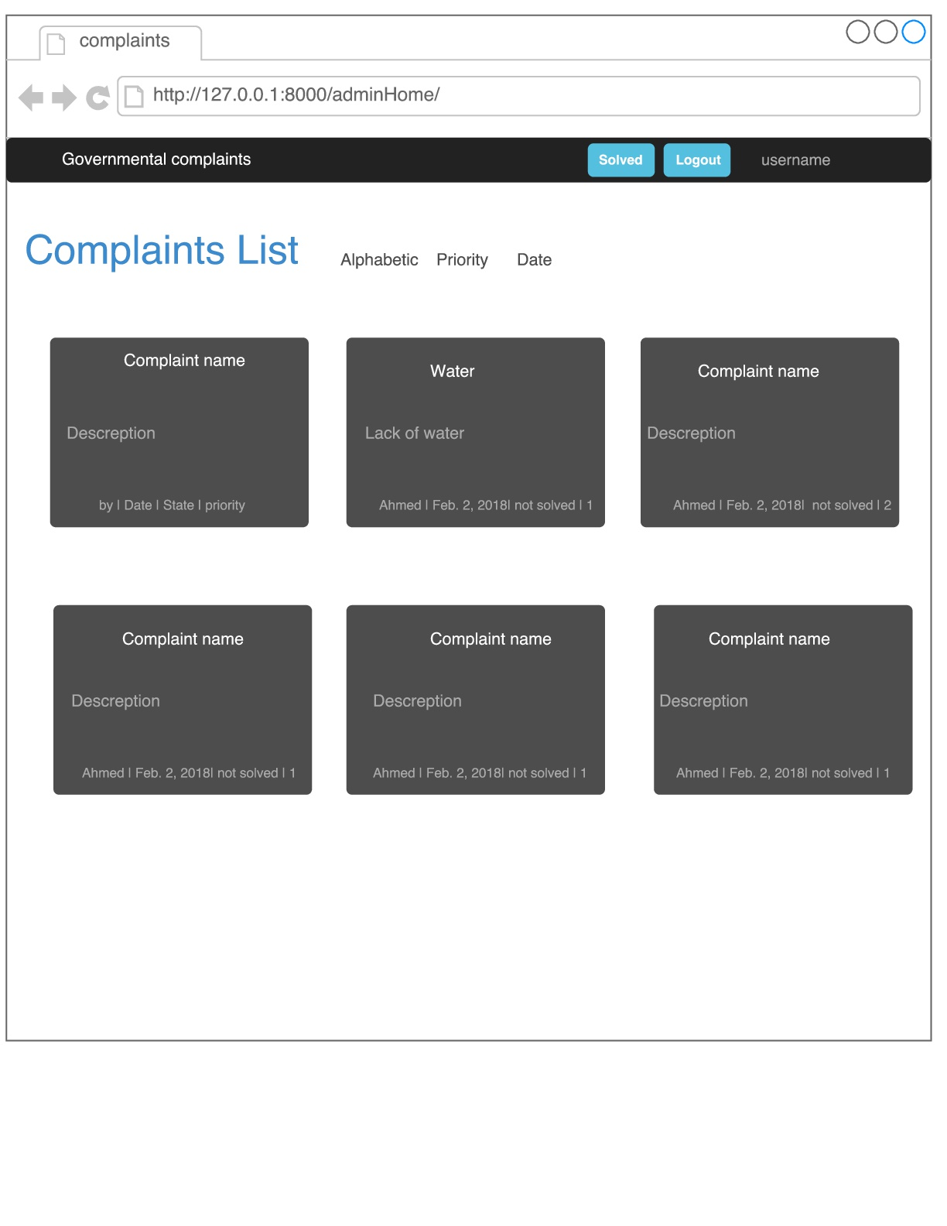

Figure 6: admin Home Page

# System Features:

* 1. use case diagram

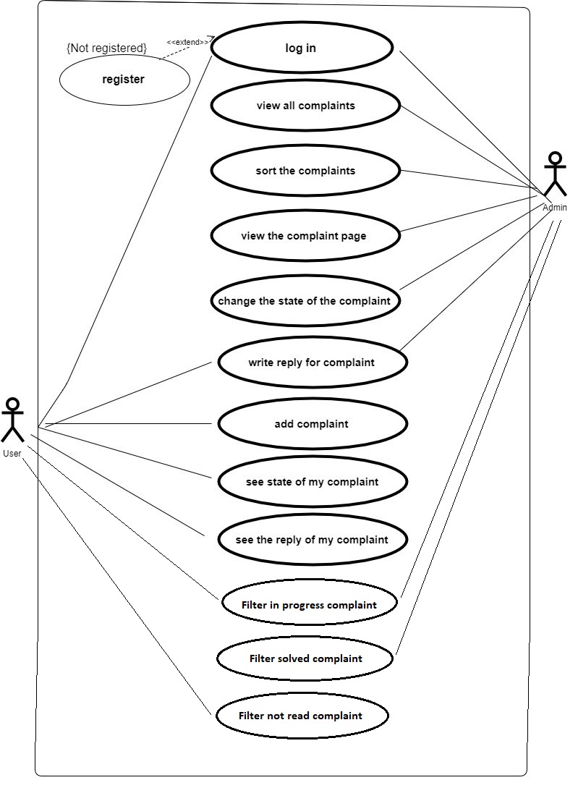

Figure 7: Use case diagram

* 1. Sequence diagram

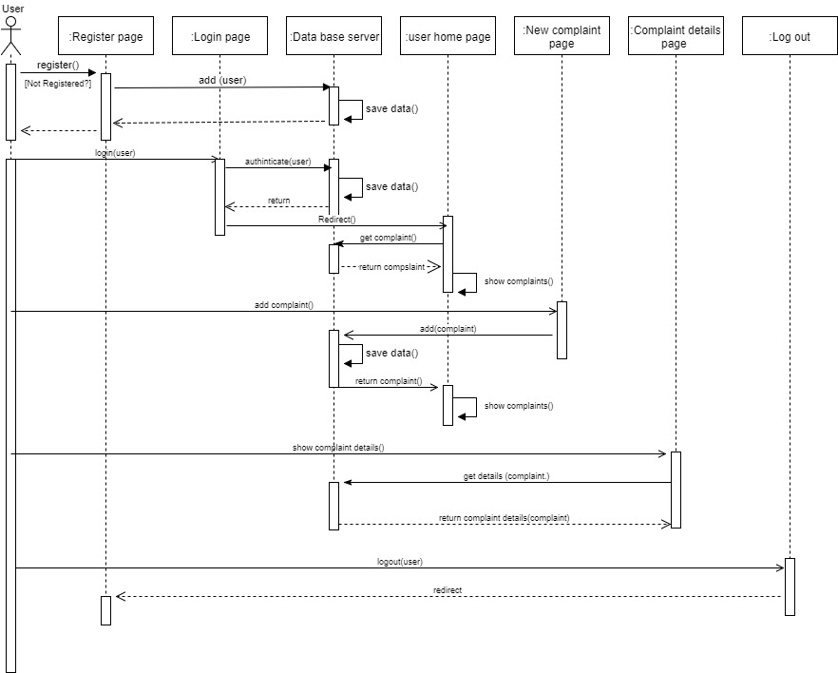

Figure 8: Sequence diagram for a User

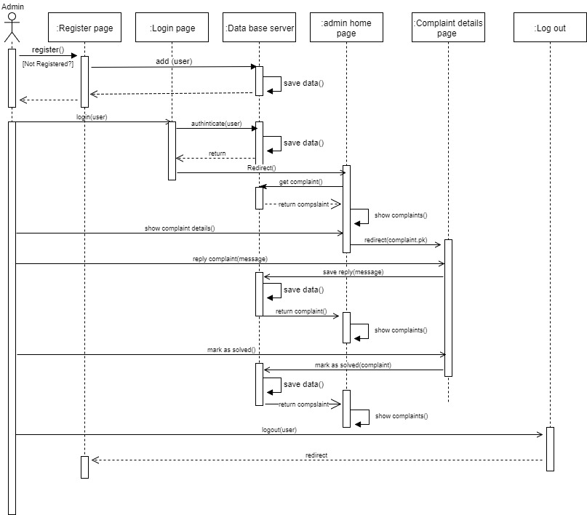

Figure 9 : Sequence diagram for an Admin

# Non-functional requirements

## Availability:

The system should be available 24/7.

## Security:

Authenticated users only can post complaint

Authenticated users can see their own complaint only

Admin can change the state of any complaint

# System Model and Diagrams

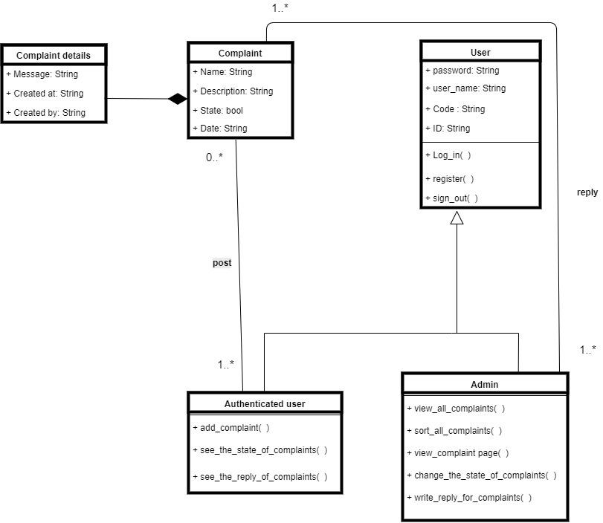

Figure 10: Class diagram

# System evolution:

* System should be available for different types of devices .
* System should be linked with citizen identity number database
* System should be available with different languages
* UI improvements

# Time plan

## 12.1 Gantt chart

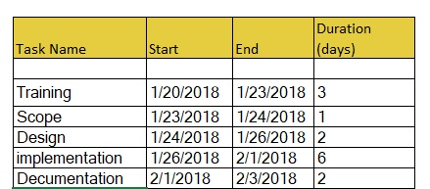

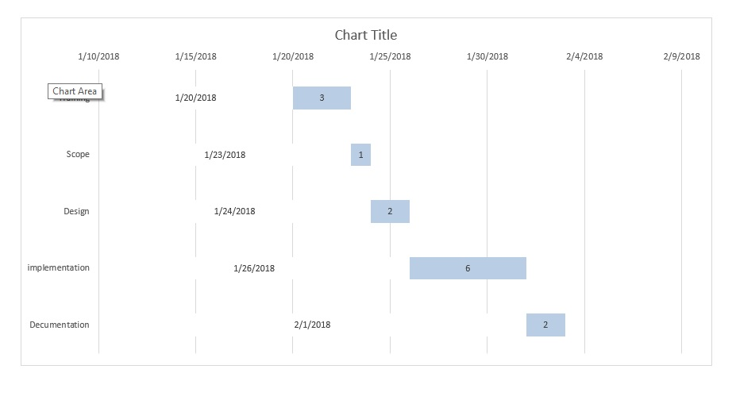 Figure 11: Gantt chart table

Figure 12: Gantt chart

# Reference

* Stack Over Flow website
* Guide by: **Vitor Freitas**

At <https://simpleisbetterthancomplex.com/>