
  - MANSOURA UNIVERSITY
  - FACULTY OF ENGINEERING
  - MECHATRONICS ENGINEERING PROGRAM



Vertical Axis Wind Turbine

Project members ID number
Ahmed Mohamed Abo Elenein 803089392
Ahmed Mohamed Hamza Shokrof 803089507
Aser Amr El-Sayed Gabr 803089272
Eyad Medhat Mohamed Abdeljawad 803089397
Faris El-Sayed Nabeeh Elasaly 806096665
Hussain Ahmed Ibrahim Abdelaziz 803084842
Kareem Abdelaziz Ibrahim Abdallah 803089481
Mohamed Ahmed Fouad Ahmed Mansy 805771560
Mohamed Elsayed Mohamed Elfagal 803091617
Supervisors:
Asst. Prof. Yahia M. Fouda
Eng. Ahmed Elwan
Academic Year: Spring 2023-2024

Acknowledgement
We would like to express our deepest gratitude to Dr. Yahia Fouda for his continues guidance and mentorship throughout the project, we also thank Eng. Ahmed Elwan for being the consultant and advisor we needed. The recommendations we got were of upmost value and dramatically improved the quality of our project. We cannot forget our friends and colleagues who provided us with their prior experiences, we thank every single one of you all. Last but not least, we are obligated to mention our families, their constant encouragement and support during our study years in this faculty will always be the driving force for every success we make, for that, we are so thankful.

Abstract
This project investigates the design, implementation, and performance analysis of a Vertical Axis Wind Turbine (VAWT). Unlike traditional Horizontal Axis Wind Turbines (HAWTs), VAWTs feature a vertically oriented rotor shaft and blades, enabling them to capture wind from any direction, which makes them particularly suitable for urban settings and turbulent wind conditions. The study includes a thorough review of existing VAWT designs, highlighting their advantages and challenges. A prototype VAWT is developed, incorporating advanced materials and aerodynamic optimizations to enhance efficiency and durability. The performance of the turbine is analyzed using QBlade simulation software, supplemented by real-world testing. The results demonstrate that VAWTs can achieve competitive efficiency levels, with additional benefits such as lower noise, ease of maintenance, and better adaptation to varying wind patterns. This project contributes to the expanding research on wind energy technologies, showcasing the potential of VAWTs to complement traditional energy systems and support sustainable urban energy solutions.

Table of contents

Table of Contents
Chapter 1: Project Description 1
1. introduction 1
2. wind turbines effect on climate 2
3. project scope 3
3.1 Objective 3
3.2 Key Deliverables 3
3.3 Project Phases: 3
3.3.1 Research and Planning: 3
3.3.2 Design and Development: 4
3.3.3 Testing and Evaluation: 4
3.3.4 Economic and Environmental Analysis: 4
3.3.5 Documentation and Reporting: 4
3.3.6 Deployment Strategy: 4
4 suitable locations 4
4.1 Suitable sites in egypt for wind energy 5
5 Advantages and disadvantages 6
5.1 Advantages 6
5.2 Disadvantages 6
Chapter 2: Aerodynamic Analysis 7
2.1 Introduction: 7
2.2 Wind turbine design parameters: 7
2.2.1 Swept area: 7
2.2.2 Power and power coefficient: 8
2.2.3 Tip Speed Ratio $λ$ : 8
2.2.4 Blade chord: 9
2.2.5 Number of blades: 9
2.2.6 Solidity: 9
2.2.7 Initial angle of attack $α$ 11
2.2.8 Coefficient of moment $Cm$ 11
Chapter 3: Design Approach 15
3.1 Introduction 15
3.2 studying airfoil characteristics 15
3.2.1 The aerodynamic criteria affecting the airfoil selection 15
3.2.2 Desirable geometric feature of an air foil 16
3.2.3 Selection of optimal airfoil 17
3.3 Qblade hAWT study 19
3.3.1 Q-blade model 19
3.4 Qblade vAWT study and prototype 23
3.4.1 Q-blade model 23
3.5 Design of the prototype 24
Chapter 4: economics of wind energy 32
4.1 Introduction 32
4.2 Wind energy cost analysis 32
4.3 cost analysis of the project . 34
References 35

List of Figure

Figure ‎1-1 CE Certification Innovative H-Type Vertical Axis Wind Turbine – Clean Energy Solution for Residential and Commercial Use Manufacturer and Product | Shenghuang 1
Figure ‎1-2: Carbon emissions vs wind turbines. 2
Figure ‎1-3: Wind turbines farm site 5
Figure ‎1-4: Best location sites for wind energy in Egypt 5
Figure ‎2-1 blade chord 9
Figure ‎2-2 Solidity effect on power coefficient 10
Figure ‎2-3 angle of attack 11
Figure ‎2-4 force and velocities acting on vertical wind turbine for various azimuth angles. 12
Figure ‎2-5 Angle of attack variation in a blade revolution for different tip speed ratio. 13
Figure ‎3-1 geometric feature of an air foil 16
Figure ‎3-2 results in the Qblade software 22
Figure ‎3-3 the output blades geometry 22
Figure ‎3-4 lift coefficient vs Angel of attack 23
Figure ‎3-5 glide ratio vs Angel of attack 23
Figure ‎3-6 power coefficient $Cp$ vs tip speed ratio $λ$ 24
Figure ‎3-7 prototype simulation run 25
Figure ‎3-8 render of the prototype in SolidWorks 26
Figure ‎3-9 prototype shot 1 27
Figure ‎3-10 prototype shot 2 28
Figure ‎3-11prototype shot 3 29
Figure ‎3-12 prototype shot 4 30
Figure ‎3-13 prototype shot 5 31

List of Tables

Table ‎3-1 HAWT study for NACA 1408 airfoil 20
Table ‎3-2 HAWT study for NACA 2412 airfoil 20
Table ‎3-3 HAWT study for NACA 6409 airfoil 21
Table ‎3-4 HAWT study for NACA 6412 airfoil 21
Table ‎3-5 simulation parameters 24
Table ‎3-6 prototype geometry 25

List of Abbreviations
$$Symbol$$ | Definition
$$AOA$$ | Angle of attack
$$CFD$$ | Computational fluid dynamics
$$GR$$ | Glide ratio
$$HAWT$$ | Horizontal axis wind turbine
$$VAWT$$ | Vertical axis wind turbine
$$A$$ | Swept area
$$N$$ | Number of blades
$$NACA$$ | National advisory committee for aeronautics
$$Re$$ | Reynolds number
$$Rpm$$ | Revolution per minutes
$$λ$$ | Tip speed ratio
$$C$$ | Chord of airfoil
$$C_{D}$$ | Drag coefficient
$$C_{L}$$ | Lift coefficient
$$C_{m}$$ | Pitching moment coefficient
$$C_{p}$$ | Power coefficient
$$D$$ | Drag force
$$F$$ | Force
$$F_{max}$$ | Maximum thurst force
$$F_{T}$$ | Thurst force
$$L$$ | Lift force
$$M$$ | Moment
$$P_{w}$$ | Power
$$P$$ | Pressure
$$U$$ | Wind velocity
$$T_{s}$$ | Starting torque
$$V_{0}$$ | Upstream speed
$$V_{∞}$$ | Mean wind speed over a suitable time period
$$A$$ | Angle of attack
$$L$$ | Tip speed ratio
$$µ$$ | Fluid viscosity
$$R$$ | Fluid density

Project Description
Figure ‎1-1 CE Certification Innovative H-Type Vertical Axis Wind Turbine – Clean Energy Solution for Residential and Commercial Use Manufacturer and Product | Shenghuang

introduction
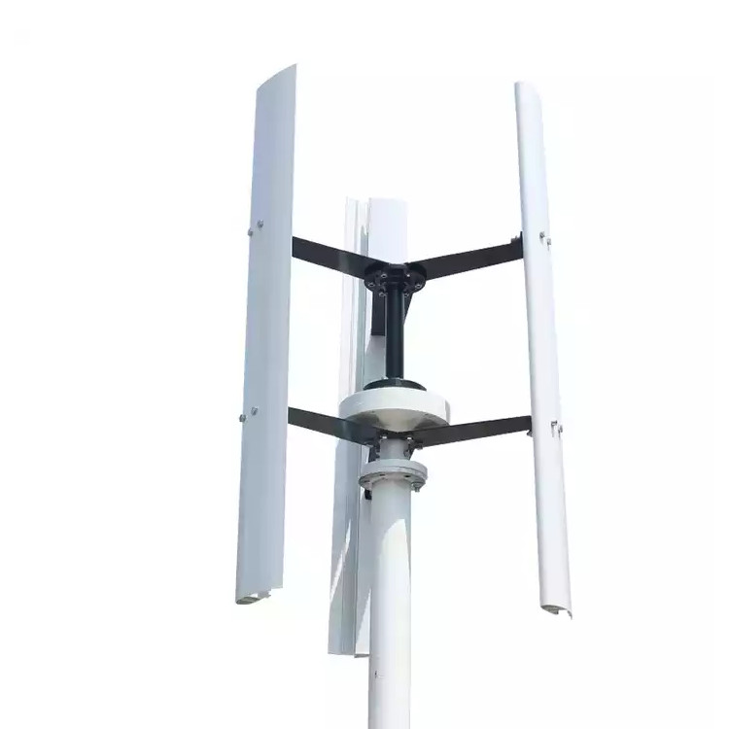
As the world confronts the escalating challenges of climate change and the depletion of fossil fuels, the quest for sustainable and renewable energy sources has never been more critical. Among the myriad of solutions being explored, wind energy stands out as a particularly promising option due to its abundance and potential for reducing carbon emissions. Within this sphere, vertical wind turbines (VAWTs) are garnering increasing attention as an innovative alternative to the more traditional horizontal-axis wind turbines (HAWTs).

This project book delves into the intricacies of vertical wind turbines, examining their design, functionality, and potential impact on the renewable energy landscape. Unlike their horizontal counterparts, VAWTs feature blades that rotate around a vertical axis, a design that imparts several unique advantages and poses distinct challenges. Throughout this book, we will explore these aspects in detail, offering a comprehensive overview of the benefits and drawbacks associated with VAWTs.

wind turbines effect on climate
Wind turbines play a crucial role in combating climate change by providing a clean, renewable source of energy that significantly reduces greenhouse gas emissions. Unlike fossil fuels, which release large amounts of carbon dioxide and other harmful pollutants into the atmosphere when burned, wind energy harnesses the natural power of the wind to generate electricity without producing any direct emissions. This transition from fossil fuels to wind energy is essential in mitigating the effects of global warming, as it helps to decrease our carbon footprint and reliance on non-renewable energy sources. Additionally, wind turbines contribute to energy diversification and security, reducing the vulnerability of energy systems to geopolitical tensions and price fluctuations associated with fossil fuels. By enabling a sustainable and environmentally friendly energy infrastructure, wind turbines are a vital component in the global strategy to address and reverse the impacts of climate change.


Figure ‎1-2: Carbon emissions vs wind turbines.

project scope

Objective
The objective of this project is to design, develop, and evaluate a Vertical Axis Wind Turbine (VAWT) that is efficient, cost-effective, and suitable for use in both urban and rural settings. The project aims to address the unique challenges associated with VAWTs while maximizing their advantages to contribute to sustainable energy solutions.

Key Deliverables
Design Specifications: Detailed blueprints and specifications for the VAWT, including blade design, materials, and structural components.
Prototype Development: Construction of a working prototype based on the finalized design specifications.
Performance Analysis: Comprehensive testing of the prototype under various wind conditions to assess efficiency, durability, and energy output.
Cost-Benefit Analysis: Economic analysis comparing the cost of production, installation, and maintenance of the VAWT with traditional Horizontal Axis Wind Turbines (HAWTs) and other renewable energy sources.
Environmental Impact Assessment: Evaluation of the environmental benefits and potential impacts of deploying VAWTs on a larger scale.
Implementation Plan: A strategic plan for scaling up production and deployment, including site selection criteria, installation guidelines, and maintenance schedules.

Project Phases:

3.3.1 Research and Planning:
  - Conduct literature review and feasibility studies.
  - Define project goals, scope, and deliverables.
  - Develop initial design concepts and select the most promising approach.

Design and Development:
  - Create detailed engineering designs and simulations.
  - Select appropriate materials and manufacturing techniques.
  - Develop and assemble the prototype.

Testing and Evaluation:
  - Perform laboratory and field tests to measure performance metrics such as efficiency, durability, and power output.
  - Analyze data to refine design and improve performance.

Economic and Environmental Analysis:
  - Conduct a cost-benefit analysis to determine economic viability.
  - Assess environmental impacts and benefits.

Documentation and Reporting:
  - Compile a comprehensive project report detailing the design process, testing results, and analysis.
  - Prepare user manuals and maintenance guidelines.

Deployment Strategy:
  - Develop a detailed plan for scaling up production and installation.
  - Identify potential sites and market opportunities.

suitable locations
Site Selection for wind farms represents a challenging contradiction for spatial analysts. The ideal location should be somewhere remote but not too remote. Not too close to residents, but with sufficient power and transport infrastructure able to support construction and operations. A site should experience high wind speeds (often found in upland areas) but should not be ecologically sensitive to avoid the energy development causing negative environmental impacts.
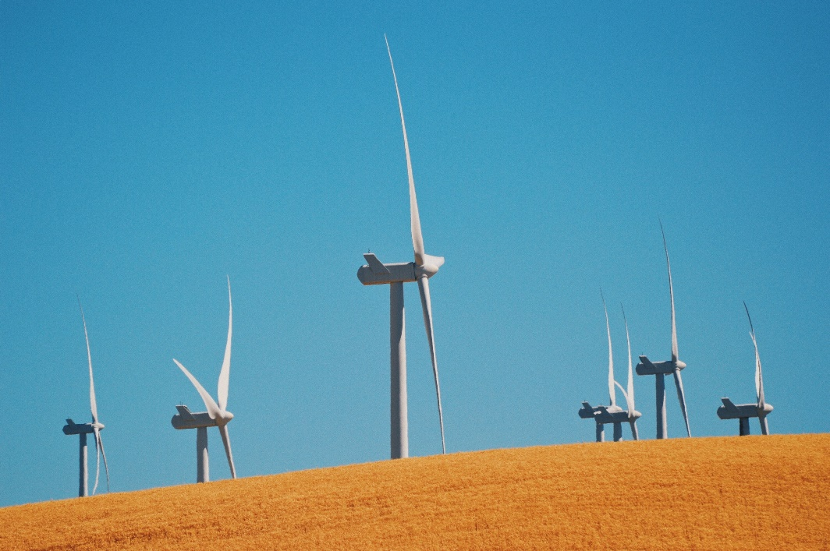
Figure ‎1-3: Wind turbines farm site

Suitable sites in egypt for wind energy

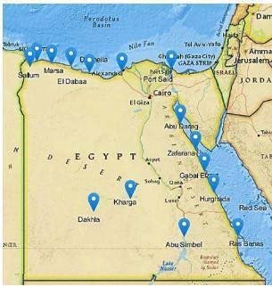
Figure ‎1-4: Best location sites for wind energy in Egypt

Advantages and disadvantages

Advantages
One of the primary advantages of VAWTs is their ability to operate in a variety of wind conditions, including turbulent and low-speed winds, which makes them suitable for urban and residential areas. Their omnidirectional design allows them to capture wind from any direction without requiring a yaw mechanism to align the rotor. This simplicity in design can lead to lower maintenance costs and increased durability. Additionally, VAWTs generally have a smaller physical footprint and can be installed closer to the ground, reducing installation complexity and visual impact.

Disadvantages
However, VAWTs are not without their limitations. They often suffer from lower efficiency compared to HAWTs, primarily due to the less aerodynamic design of their blades and the additional drag forces encountered during operation. This can result in lower energy output, which may limit their viability in large-scale energy projects. Furthermore, the structural stresses and mechanical wear unique to the vertical design can pose engineering challenges, potentially affecting longevity and reliability.

This project book aims to provide a balanced examination of vertical wind turbines, assessing both their potential to contribute to sustainable energy solutions and the technical hurdles that must be overcome. By exploring real-world case studies, innovative design improvements, and future prospects, we seek to offer a thorough understanding of where VAWTs fit into the broader context of renewable energy technologies.

As we embark on this exploration, it is crucial to maintain a forward-looking perspective, recognizing that the advancement of renewable energy technologies like vertical wind turbines will be pivotal in shaping a sustainable and resilient future.

Aerodynamic Analysis

Introduction:
In this section, the rotor design parameters are described as well as the model used to calculate its aerodynamic performance, so to understand the behavior of the wind turbine blades, there should be a good understanding of the wind characteristics and the aerodynamics of air foil.

Wind turbine design parameters:
The wind turbine parameters considered in the design process are:
• Swept area
• Power and power coefficient
• Tip speed ratio
• Blade chord
• Number of blades
• Solidity
• Initial angle of attack

Swept area:
The swept area is the section of air that encloses the turbine in its movement, the shape of the swept area depends on the rotor configuration, this way the swept area of an HAWT is circular shaped while for a straight-bladed vertical axis wind turbine the swept area has a rectangular shape and is calculated:
$$S= 2RL$$
where $S$ is the swept area [m²], $R$ is the rotor radius [m], and $L$ is the blade length [m].
The swept area limits the volume of air passing by the turbine. The rotor converts the energy contained in the wind in rotational movement so the larger the area, the larger the power output in the same wind conditions.

Power and power coefficient:
The power available from wind for a vertical axis wind turbine can be found from
the following formula: $P_{w}=\frac{1}{2}ρsU^{3}$
where $U$ is the velocity of the wind [m/s] and $ρ$ is the air density [kg/m³], the reference density used is standard sea level value (1.225 kg/m³ at 15ºC). Note that available power is dependent on the cube of the airspeed.
The power the turbine takes from wind is calculated using the power coefficient:
$$C_{p}=\frac{Captured mechanical power by blades}{Available power in wind {(P}_{w})}$$
$C_{p}$ value represents the part of the total available power that is taken from wind, which can be understood as its efficiency.
There is a theoretical limit in the efficiency of a wind turbine determined by the deceleration the wind suffers when going across the turbine.
For HAWT, the limit is 19/27 (59.3%) and is called Lanchester-Betz limit. Often this limit is also applied to vertical axis wind turbines (VAWT). However, a literature review reveals that early analytical and recent numerical approaches predicted values for the maximum power output of VAWTs close to or even higher than the Betz limit. For VAWT, the limit is 16/25 (64%).
This power coefficient only considers the mechanical energy converted directly from wind energy, it does not consider the mechanical-into-electrical energy conversion, which involves other parameters like the generator efficiency.

Tip Speed Ratio $λ$ :
The power coefficient is strongly dependent on tip speed ratio, defined as the ratio between the tangential speed at blade tip and the actual wind speed:
$$λ =\frac{RΩ}{U}$$
where $Ω$ is the angular speed [rad/s], $R$ the rotor radius [m] and $U$ the ambient wind speed [m/s]. Each rotor design has an optimal tip speed ratio at which the maximum power extraction is achieved. This optimal $λ$ presents a variation depending on ambient wind speed.

Blade chord:
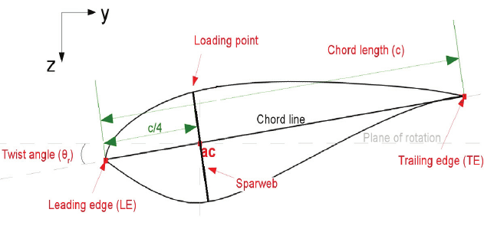
The chord is the length between the leading edge and trailing edge of the blade profile.
The blade thickness and shape are determined by the air foil used, in this case it will be a NACA air foil, where the blade curvature and maximum thickness are defined as percentage of the chord.
Figure ‎2-1 blade chord

Number of blades:
The number of blades has a direct effect in the smoothness of rotor operation as they can compensate cycled aerodynamic loads. For easiness of building, four and three blades have been contemplated.

Solidity:
The solidity σ is defined as the ratio between the total blade area and the projected turbine area.
It is an important non-dimensional parameter which affects self-starting capabilities and for VAWTs is calculated with:
$σ=\frac{Nc}{R}$
where $N$ is the number of blades, $c$ is the blade chord, $R$ is the radius; it is considered that each blade sweeps the area twice.
This formula is not applicable for HAWT as they have different shape of swept area.
Solidity determines when the assumptions of the momentum models are applicable, and only when using $σ ≥ 0.4$ a self-starting turbine is achieved.
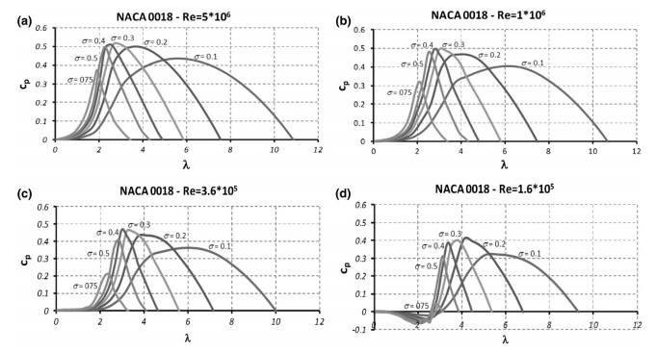
Figure ‎2-2 Solidity effect on power coefficient

Initial angle of attack $α$
The initial angle of attack is the angle the blade has regarding its trajectory, considering negative the angle that locates the blade’s leading edge inside the circumference described by the blade path.
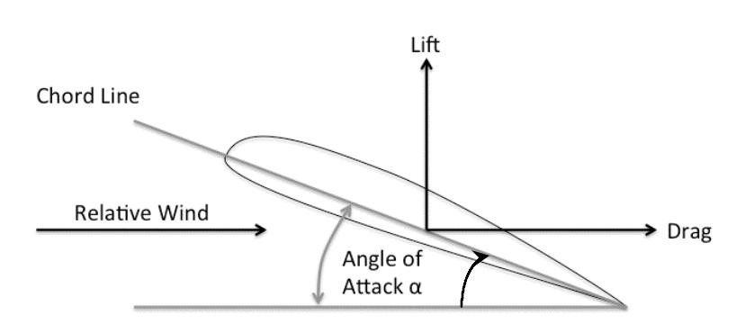
Figure ‎2-3 angle of attack

Coefficient of moment $C_{m}$
The moment coefficient is the percentage of torque received by the wind turbine through the swept area of the turbine blades.
Equation depicts how to calculate the coefficient of moment:
$C_{m}=\frac{T_{B}}{0.5 ρ\left|\left|U\right|\right|2SR}$
Where $U$ is the wind velocity [m/s], $T_{B}$ is the shaft torque [N.m].

2.3 Physics of the Vertical Axis Wind Turbine:
The wind exerts a force on the blade. This force can be split up into a drag force $F_{L}$ along the effective wind vector $v_{re_{l}}$ and a lift force $F_{L}$ perpendicular to it.
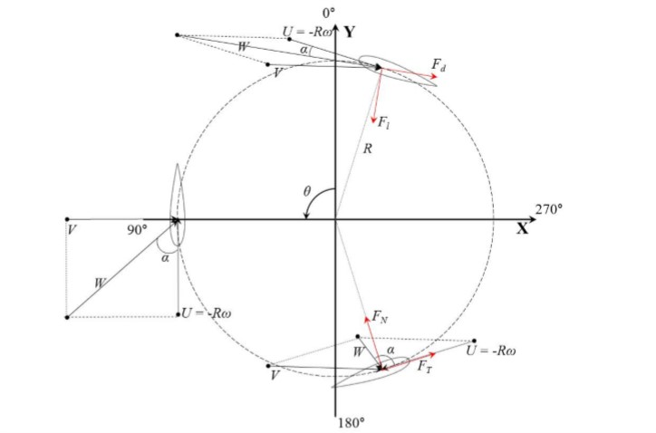
Figure ‎2-4 force and velocities acting on vertical wind turbine for various azimuth angles.

Figure 2-4 shows a picture of the basic parameters of the small wind turbine system, and the velocity proﬁle $V(Z)$ is shown in the next Equation:
$V(Z)=v_{rel}{\left(\frac{z}{z_{rel}}\right)}^{a}$
The wind shear power index $a$ can be varied according to the surface roughness.
Figure 2.4 presents the tip velocity vector and the lift, and the drag vectors generated by the rotation of the turbine blade. The angle of attack changes with the blade tip velocity vector and the inﬂux wind velocity vector. The vector sum $W$ of the tip velocity vector and incoming wind velocity vector $V$ is calculated by the next equation. The maximum value occurs at θ = 0◦, and the minimum value occurs at θ = 180◦.
$$W=\sqrt{v^{2}\left[{\left(λ-{\sin{θ}}^{2}\right)}^{2}+{\cos{θ}}^{2}\right]}=v\sqrt{1+2λ\cos{θ+λ^{2}}}$$
The angle of attack $α$ is the angle between the vector sum and the direction of the chord length. As the vector sum changes, the angle of attack has a positive value in the upstream region of the rotor and a negative value in the downstream region. The angle of attack can be expressed as in follows:
$$α=\tan^{-1}{(\sin{θ/(cos{θ}}}+λ))$$
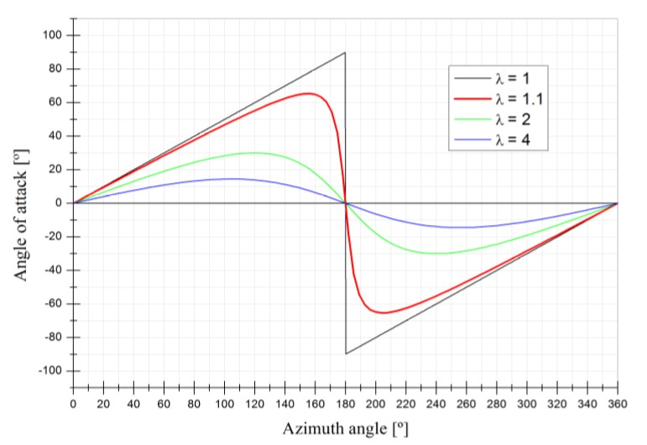
As shown in the equation the dominant variable that affects the angle of attack is the tip speed ratio. Figure 2-4 shows the angle of attack as the blade rotates according to the tip speed ratio. The larger the tip speed ratio, the smaller the range of the angle of attack the airfoil receives during rotation. The larger the blade tip velocity vector is, the larger the tip speed ratio is. This occurs because the vector sum direction approaches the direction of the blade’s forward velocity vector, and the angle of attack becomes smaller. The range of the angle of attack of the airfoil is about ±66.5◦ in one rotation of the rotor.
Figure ‎2-5 Angle of attack variation in a blade revolution for different tip speed ratio.

The lift force $F_{L}$ is orthogonal to the vector $v_{rel}$ and the drag force $F_{D}$ is parallel to $v_{rel}$. The lift and drag forces can be estimated as:
$$F_{L} = 0.5 ρ A_{blade} v_{rⅇL}^{2}CL$$
$$F_{D} = 0.5 ρ A_{blade} v_{rⅇL}^{2} CD$$
Since these coefficients are proportional to their respective forces, the following also holds for the coefficients of the tangential force and normal force:
$$C_{t} = C_{L} sin(α) - C_{D} cos(α)$$
$$C_{n} = C_{L} cos(α) + C_{D} sin(α)$$
$ρ$ : is the flow density.
$A_{blade}$ is the blade area.
$C_{L}$ and $C_{D}$ : are the lift and drag coefficients, which mainly are the functions of the angle of attack, aspect ratio, the Reynolds number and the air foil profile.

Design Approach

Introduction
As mentioned earlier, there are main two types of VAWTs.
In this chapter, we will discuss two designs of them and make a small-scale 3D model for each one; in order to achieve an efficient and reliable product for budgeted cost.
To select the proper design to be a final product, we have got a primary data about the two types to make a comparison between them.
The following steps are taken to select the proper design.

studying airfoil characteristics
One of the most important factors affecting the wind turbine is the air foil profile selection. Which should have the optimal ratio of lift to drag force glide ratio $C_{l}/C_{d}$ .

The aerodynamic criteria affecting the airfoil selection
- The glide ratio $C_{l}/C_{d}$
- The glide ratio $C_{l}/C_{d}$ shows the total efficiency of any air foil and inevitably, it is ideal to be higher over a large range of angle of attack $α$ to increase the aerodynamic performance
- Maximum lift coefficient $C_{l}$
- This would improve the starting torque and more positive torque will be produced.
- Wide drag bucket
- The airfoils have the lowest drag over a small spectrum of angle of attack $α$ which is called the drag bucket, and the form of the airfoil defines the shape and location of the drag bucket.
- Low drag coefficient $C_{d}$
- The required airfoil should have the least amount of drag, particularly the zero-lift-drag coefficient $C_{d0}$ which is a reflection of parasitic drag “realize how pure or smooth the aerodynamics of the VAWTs is”.
- High stall angle at small Reynolds number
- Should be as large as possible in the low Reynolds number operation.

Desirable geometric feature of an air foil
We should consider these features while selecting an air foil:
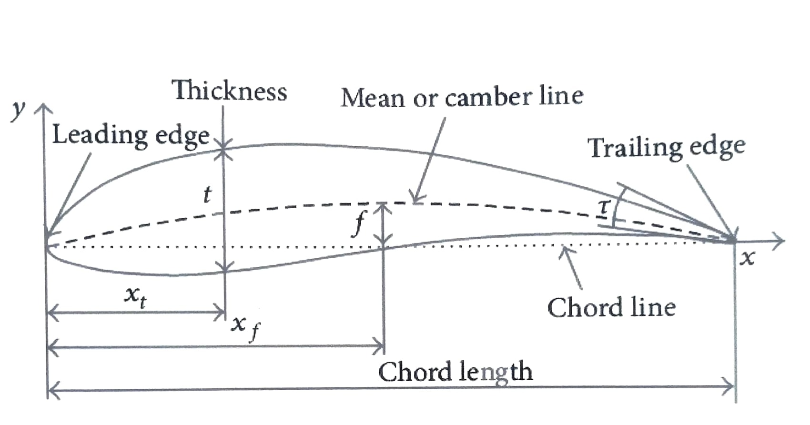
Figure ‎3-1 geometric feature of an air foil

- Cambered airfoil
- Will generate a high tangential thrust over a boarder range of $α$, more energy per revolution, and therefore the VAWT would self-start using the cambered blade.
- Large leading-edge radius
- The greater leading-edge radius would result in less susceptible to roughness, better VAWT energy harness when the blade gets dirty due to being prone to the elements of nature, and also increased airfoil lift-drag ratio at a wide range of $α$.
- Sharp trailing edge
- Which greatly decrease the minimum drag coefficient. It should notice that the manufacturing of sharp trailing edges is always complicated and expensive.
- Greater thickness
- Blades with thicker airfoils shapes have several advantages:
  - Increasing in starting torque
  - Increasing in width of the drag bucket
  - Improvement of structural strength
  - Improvement of the performance of VAWT

Selection of optimal airfoil
In addition to selection of air foil profile, there are parameters must be considered are following
- Average wind speed
- Air density
- Reynolds number
- Atmospheric pressure

In the next section of this chapter we are going to study the two different design studies, analysis, and comparison between them will be executed on Qblade software.

Qblade HAWT study

Q-blade model
The selection of airfoil and different design parameters to make an efficient design are shown in the next steps.
We chose three airfoils from the NACA to find which one has the highest lift-drag ratio at low Reynolds number, all of them satisfy the desired geometric features discussed before.
these airfoils are [NACA 1408, NACA 2412, NACA 6409, NACA 6412]

the $λ$ is chosen that it makes the highest cord length to be 20% of the radius
$$λ= ΩR/U$$
$$λ_{r}= Ωr/U = λr/R$$
$$φ=\tan^{-1}(\frac{2}{3λ_{r}})$$
$$c=\frac{8pir\sin{φ}}{3BC_{l}λ_{r}}$$
$$R_{e}=\frac{UL}{ν}$$
$Ω$ Where is the angular velocity, $R$ is the radius of the blade, $λ$ is the tip speed ratio, $λ_{r}$ is the local tip speed ratio, $φ$ is the twist angle, $c$ is the chord length, $B$ is the number of blades, and $C_{l}$ is the lift cofftient
We apply the previous equations to obtain the chord length $c$ and twist angle $φ$ for each airfoil in excel to the next results:

Table ‎3-1 HAWT study for NACA 1408 airfoil
Tip Speed Ratio (TSR) |  |  | 9 | Wind Speed |  | 5
NO. of Rotor Blades (B) |  |  | 3 | Kinematic Viscosity |  | 1.48E-05
Blade length (R) |  |  | 1 | Lift coefficient (C_{L}) |  | 0.62
Angle of Attack (AOA)  for MAX Glide Ratio |  |  | 4 | Air Foil |  | NACA 1408
 | Fraction of Rotor  Radius r/R | Chord  (C) | Angle of rel. wind (deg) ɸ_{i} | Twist Angle (deg) ɵ_{T,i} | Reynlods  Number (Re) | Tip Speed  Ratio Range
1 | 0.1 | 0.298 | 36.55 | 32.55 | 103485.98 | 0.9
2 | 0.2 | 0.174 | 20.33 | 16.33 | 60383.91 | 1.8
3 | 0.3 | 0.120 | 13.88 | 9.88 | 41676.64 | 2.7
4 | 0.4 | 0.091 | 10.50 | 6.50 | 31657.95 | 3.6
5 | 0.5 | 0.073 | 8.43 | 4.43 | 25478.88 | 4.5
6 | 0.6 | 0.061 | 7.04 | 3.04 | 21302.41 | 5.4
7 | 0.7 | 0.053 | 6.04 | 2.04 | 18295.68 | 6.3
8 | 0.8 | 0.046 | 5.29 | 1.29 | 16029.54 | 7.2
9 | 0.9 | 0.041 | 4.71 | 0.71 | 14261.21 | 8.1
10 | 1 | 0.037 | 4.24 | 0.24 | 12843.30 | 9
Table ‎3-2 HAWT study for NACA 2412 airfoil
Tip Speed Ratio (TSR) |  |  | 8 | Wind Speed |  | 5
NO. of Rotor Blades (B) |  |  | 3 | Kinematic Viscosity |  | 1.48E-05
Blade length (R) |  |  | 1 | Lift coefficient (C_{L}) |  | 0.83
Angle of Attack (AOA)  for MAX Glide Ratio |  |  | 6 | Air Foil |  | NACA 2412
 | Fraction of Rotor  Radius r/R | Chord  (C) | Angle of rel. wind (deg) ɸ_{i} | Twist Angle (deg) ɵ_{T,i} | Reynlods  Number (Re) | Tip Speed  Ratio Range
1 | 0.1 | 0.269 | 39.83 | 33.83 | 93534.05 | 0.8
2 | 0.2 | 0.162 | 22.63 | 16.63 | 56194.17 | 1.6
3 | 0.3 | 0.113 | 15.53 | 9.53 | 39104.07 | 2.4
4 | 0.4 | 0.086 | 11.77 | 5.77 | 29798.71 | 3.2
5 | 0.5 | 0.069 | 9.47 | 3.47 | 24019.49 | 4
6 | 0.6 | 0.058 | 7.91 | 1.91 | 20099.41 | 4.8
7 | 0.7 | 0.050 | 6.79 | 0.79 | 17271.48 | 5.6
8 | 0.8 | 0.044 | 5.95 | -0.05 | 15137.35 | 6.4
9 | 0.9 | 0.039 | 5.29 | -0.71 | 13470.61 | 7.2
10 | 1 | 0.035 | 4.77 | -1.23 | 12133.35 | 8

Table ‎3-3 HAWT study for NACA 6409 airfoil
Tip Speed Ratio (TSR) |  |  | 6 | Wind Speed |  | 5
NO. of Rotor Blades (B) |  |  | 3 | Kinematic Viscosity |  | 1.48E-05
Blade length (R) |  |  | 1 | Lift coefficient (C_{L}) |  | 1.334
Angle of Attack (AOA)  for MAX Glide Ratio |  |  | 8 | Air Foil |  | NACA 6409
 | Fraction of Rotor  Radius r/R | Chord  (C) | Angle of rel. wind (deg) ɸ_{i} | Twist Angle (deg) ɵ_{T,i} | Reynlods  Number (Re) | Tip Speed  Ratio Range
1 | 0.1 | 0.259 | 48.04 | 40.04 | 90092.02 | 0.6
2 | 0.2 | 0.169 | 29.07 | 21.07 | 58863.04 | 1.2
3 | 0.3 | 0.121 | 20.33 | 12.33 | 42096.73 | 1.8
4 | 0.4 | 0.093 | 15.53 | 7.53 | 32440.16 | 2.4
5 | 0.5 | 0.076 | 12.54 | 4.54 | 26293.36 | 3
6 | 0.6 | 0.063 | 10.50 | 2.50 | 22070.39 | 3.6
7 | 0.7 | 0.055 | 9.02 | 1.02 | 19001.23 | 4.2
8 | 0.8 | 0.048 | 7.91 | -0.09 | 16674.17 | 4.8
9 | 0.9 | 0.043 | 7.04 | -0.96 | 14851.01 | 5.4
10 | 1 | 0.039 | 6.34 | -1.66 | 13385.01 | 6
Table ‎3-4 HAWT study for NACA 6412 airfoil
Tip Speed Ratio (TSR) |  |  | 7 | Wind Speed |  | 5
NO. of Rotor Blades (B) |  |  | 3 | Kinematic Viscosity |  | 1.48E-05
Blade length (R) |  |  | 1 | Lift coefficient (C_{L}) |  | 1.299
Angle of Attack (AOA)  for MAX Glide Ratio |  |  | 9 | Air Foil |  | NACA 6412
 | Fraction of Rotor  Radius r/R | Chord  (C) | Angle of rel. wind (deg) ɸ_{i} | Twist Angle (deg) ɵ_{T,i} | Reynlods  Number (Re) | Tip Speed  Ratio Range
1 | 0.1 | 0.212 | 43.62 | 34.62 | 73579.62 | 0.7
2 | 0.2 | 0.132 | 25.48 | 16.48 | 45869.80 | 1.4
3 | 0.3 | 0.093 | 17.62 | 8.62 | 32282.30 | 2.1
4 | 0.4 | 0.071 | 13.40 | 4.40 | 24711.70 | 2.8
5 | 0.5 | 0.057 | 10.79 | 1.79 | 19963.07 | 3.5
6 | 0.6 | 0.048 | 9.02 | 0.02 | 16725.60 | 4.2
7 | 0.7 | 0.041 | 7.75 | -1.25 | 14383.19 | 4.9
8 | 0.8 | 0.036 | 6.79 | -2.21 | 12612.19 | 5.6
9 | 0.9 | 0.032 | 6.04 | -2.96 | 11227.31 | 6.3
10 | 1 | 0.029 | 5.44 | -3.56 | 10115.22 | 7
Then we use the results from the tables in the Qblade software as shown for each study:
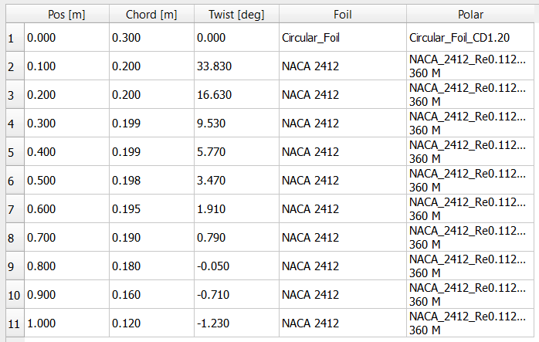
Figure ‎3-2 results in the Qblade software
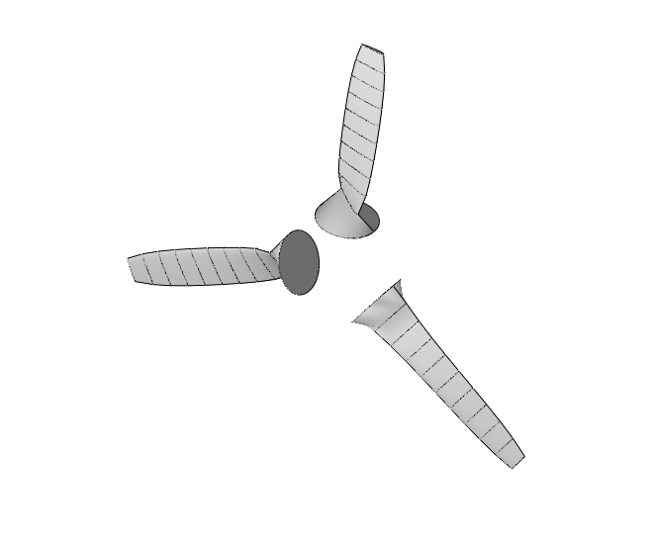
Figure ‎3-3 the output blades geometry

Qblade vAWT study and prototype

Q-blade model
The selection of airfoil and different design parameters to make an efficient design are shown in the next steps.
- We chose three airfoils from the NACA series and compared to find which one has the highest lift-drag ratio and the power coefficient, all of them satisfy the desired geometric features discussed before.
these airfoils are [NACA 0012, NACA 0015, NACA 0018, NACA 0020]
- The airfoils will be analyzed for conditions of: $Re=6.4×{10}^{4}$, and average wind speed $U= 5 m/s$.
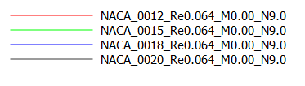
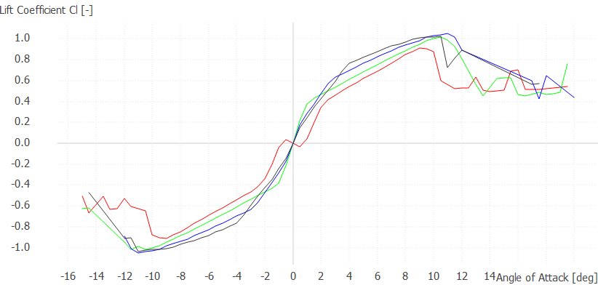
Figure ‎3-4 lift coefficient vs Angel of attack
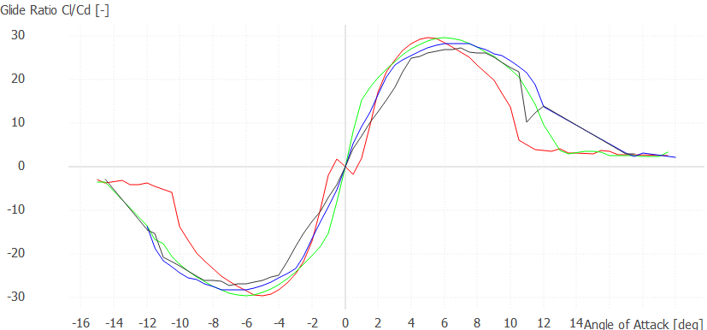
Figure ‎3-5 glide ratio vs Angel of attack
From the simulations we obtained that the airfoil NACA 0018 is the most suitable for the chosen geometry.

Design of the prototype
A prototype is built depending on simulation in Q-blade software as shown in Table 3.5 and 3.6
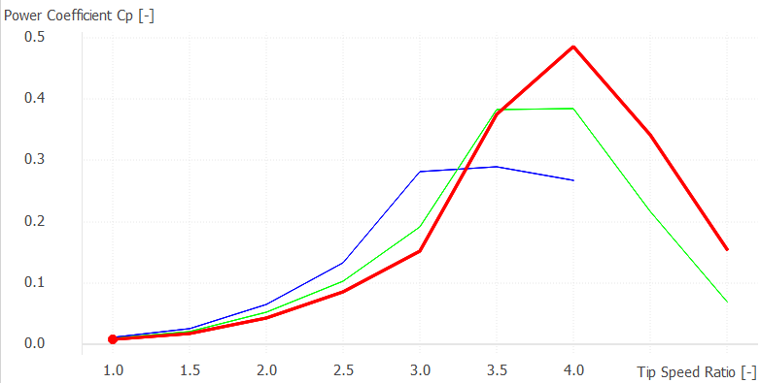
Figure ‎3-6 power coefficient $C_{p}$ vs tip speed ratio $λ$
Table ‎3-5 simulation parameters
Solidity $σ$ | 0.8
Reynold Number $Re$ | 64000
Tip- speed ratio $λ$ | 4
Swept area $A$ | 0.3 m²
Number of blades $B$ | 3
Average wind velocity $U$ | 10 m/s
Aspect ratio | 1
Power coefficient $C_{p}$ | 0.485
Power | 40 w

Table ‎3-6 prototype geometry
Height (m) | Chord (m) | Radius (m) | Circ Angle
0 | 0.3 | 0.3 | 0
0.5 | 0.3 | 0.3 | 0

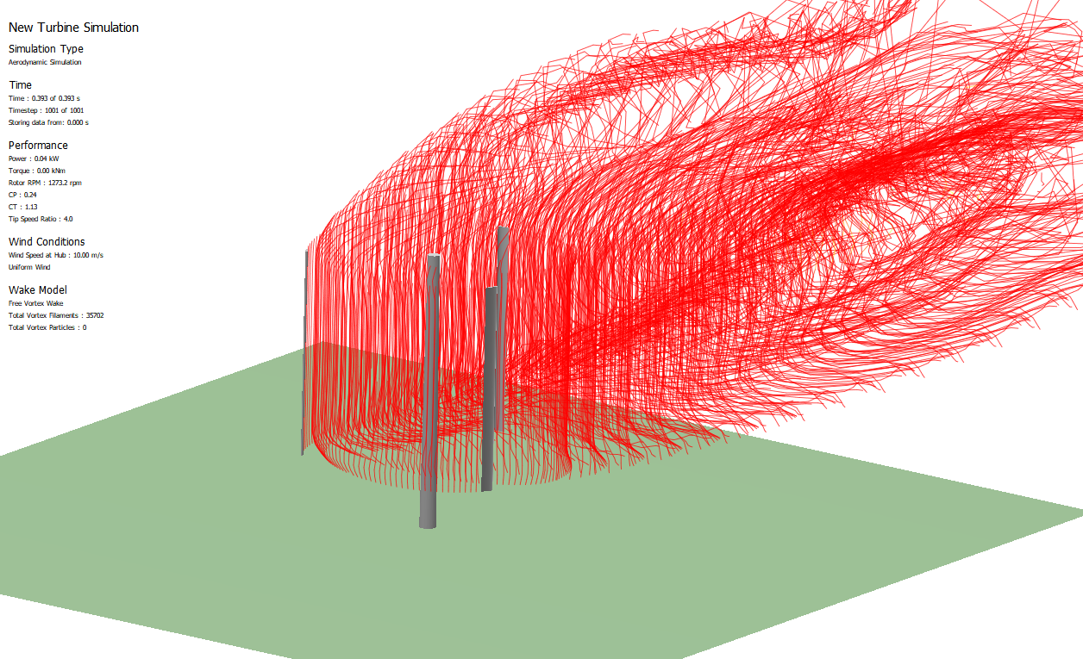
Figure ‎3-7 prototype simulation run
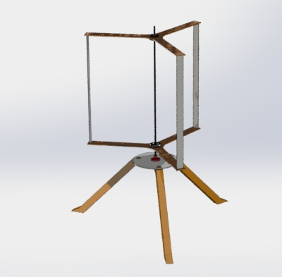
Figure ‎3-8 render of the prototype in SolidWorks

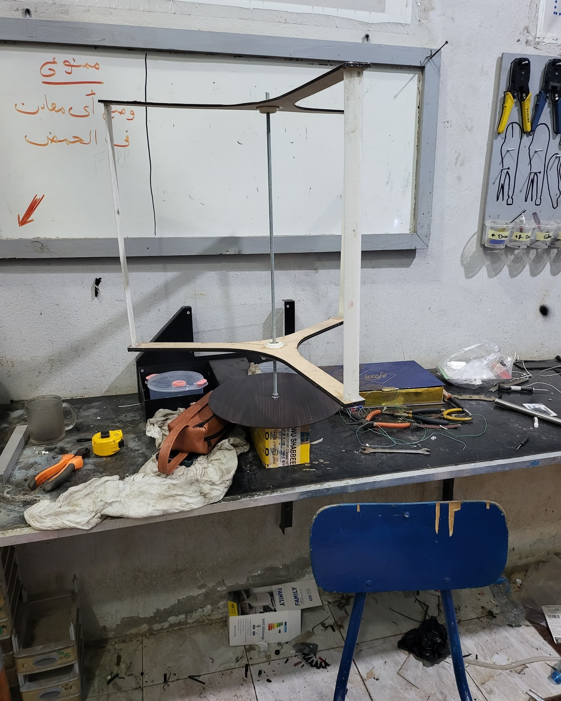
Figure ‎3-9 prototype shot 1
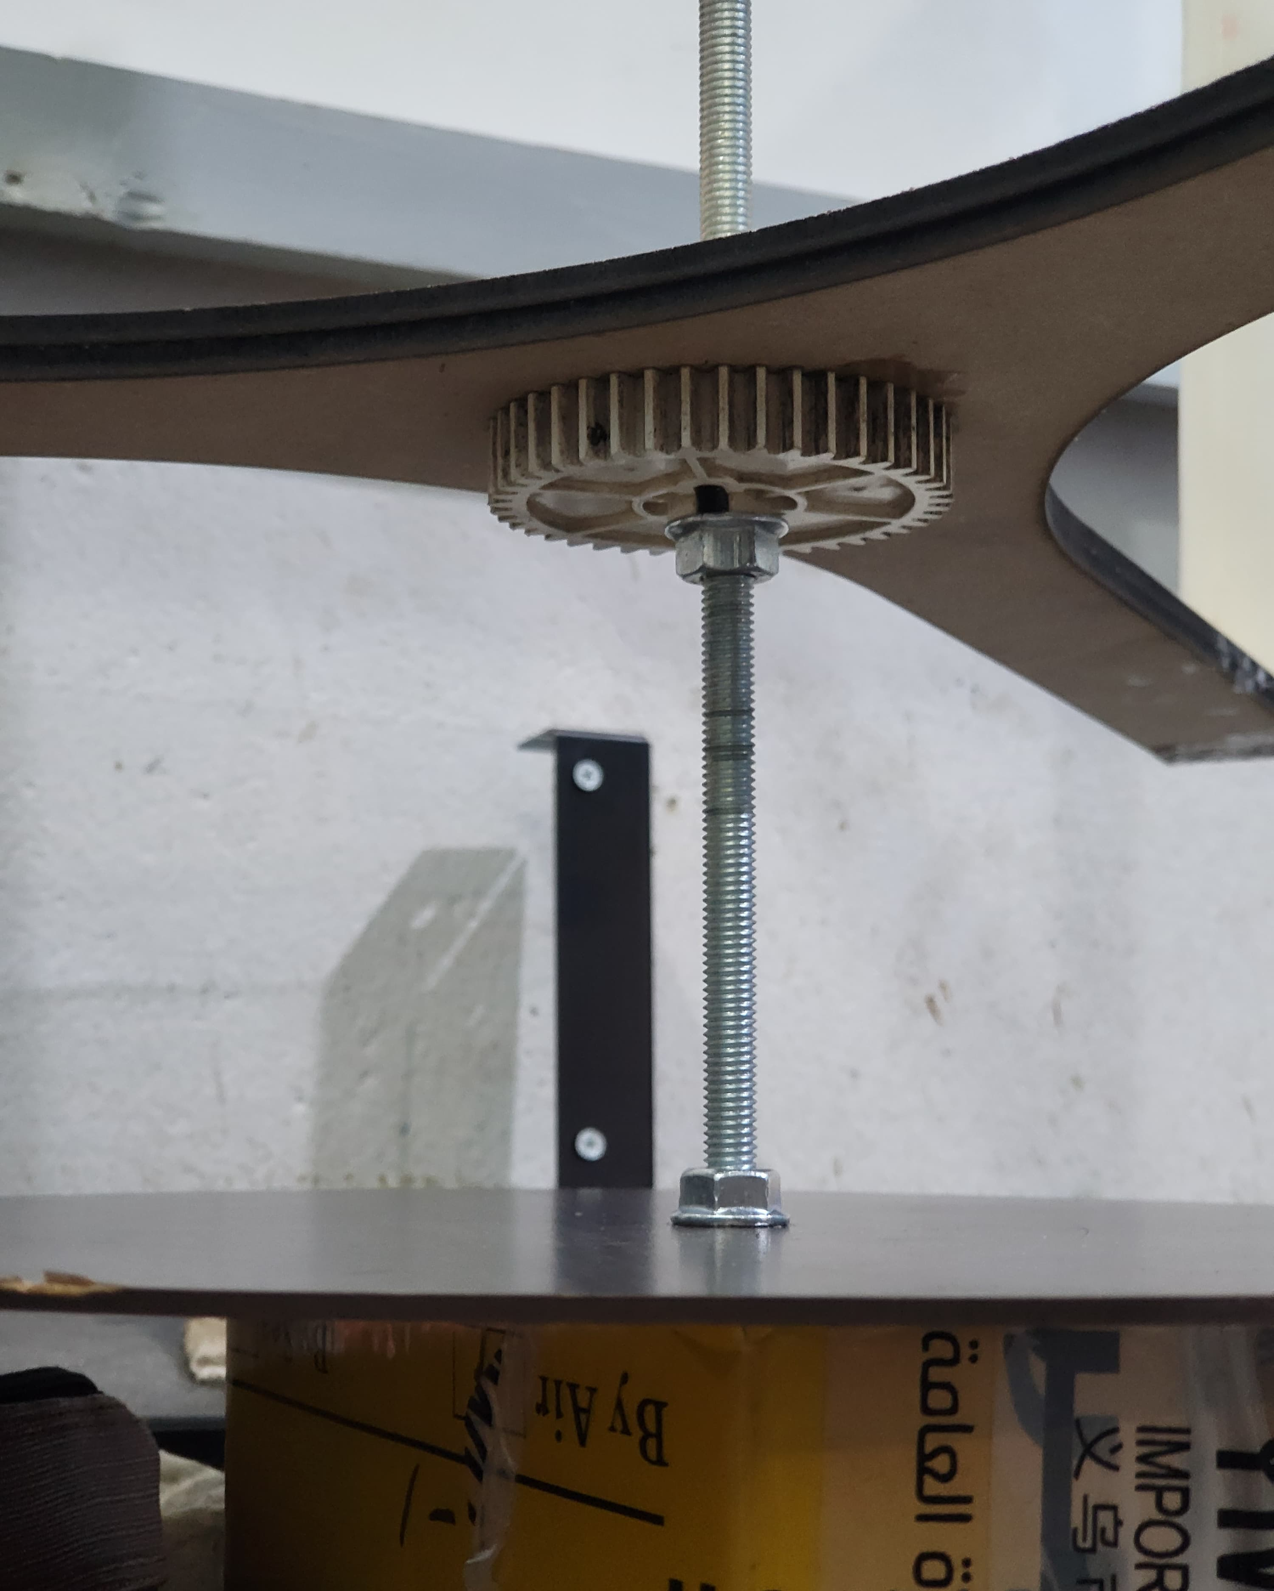
Figure ‎3-10 prototype base shot 2
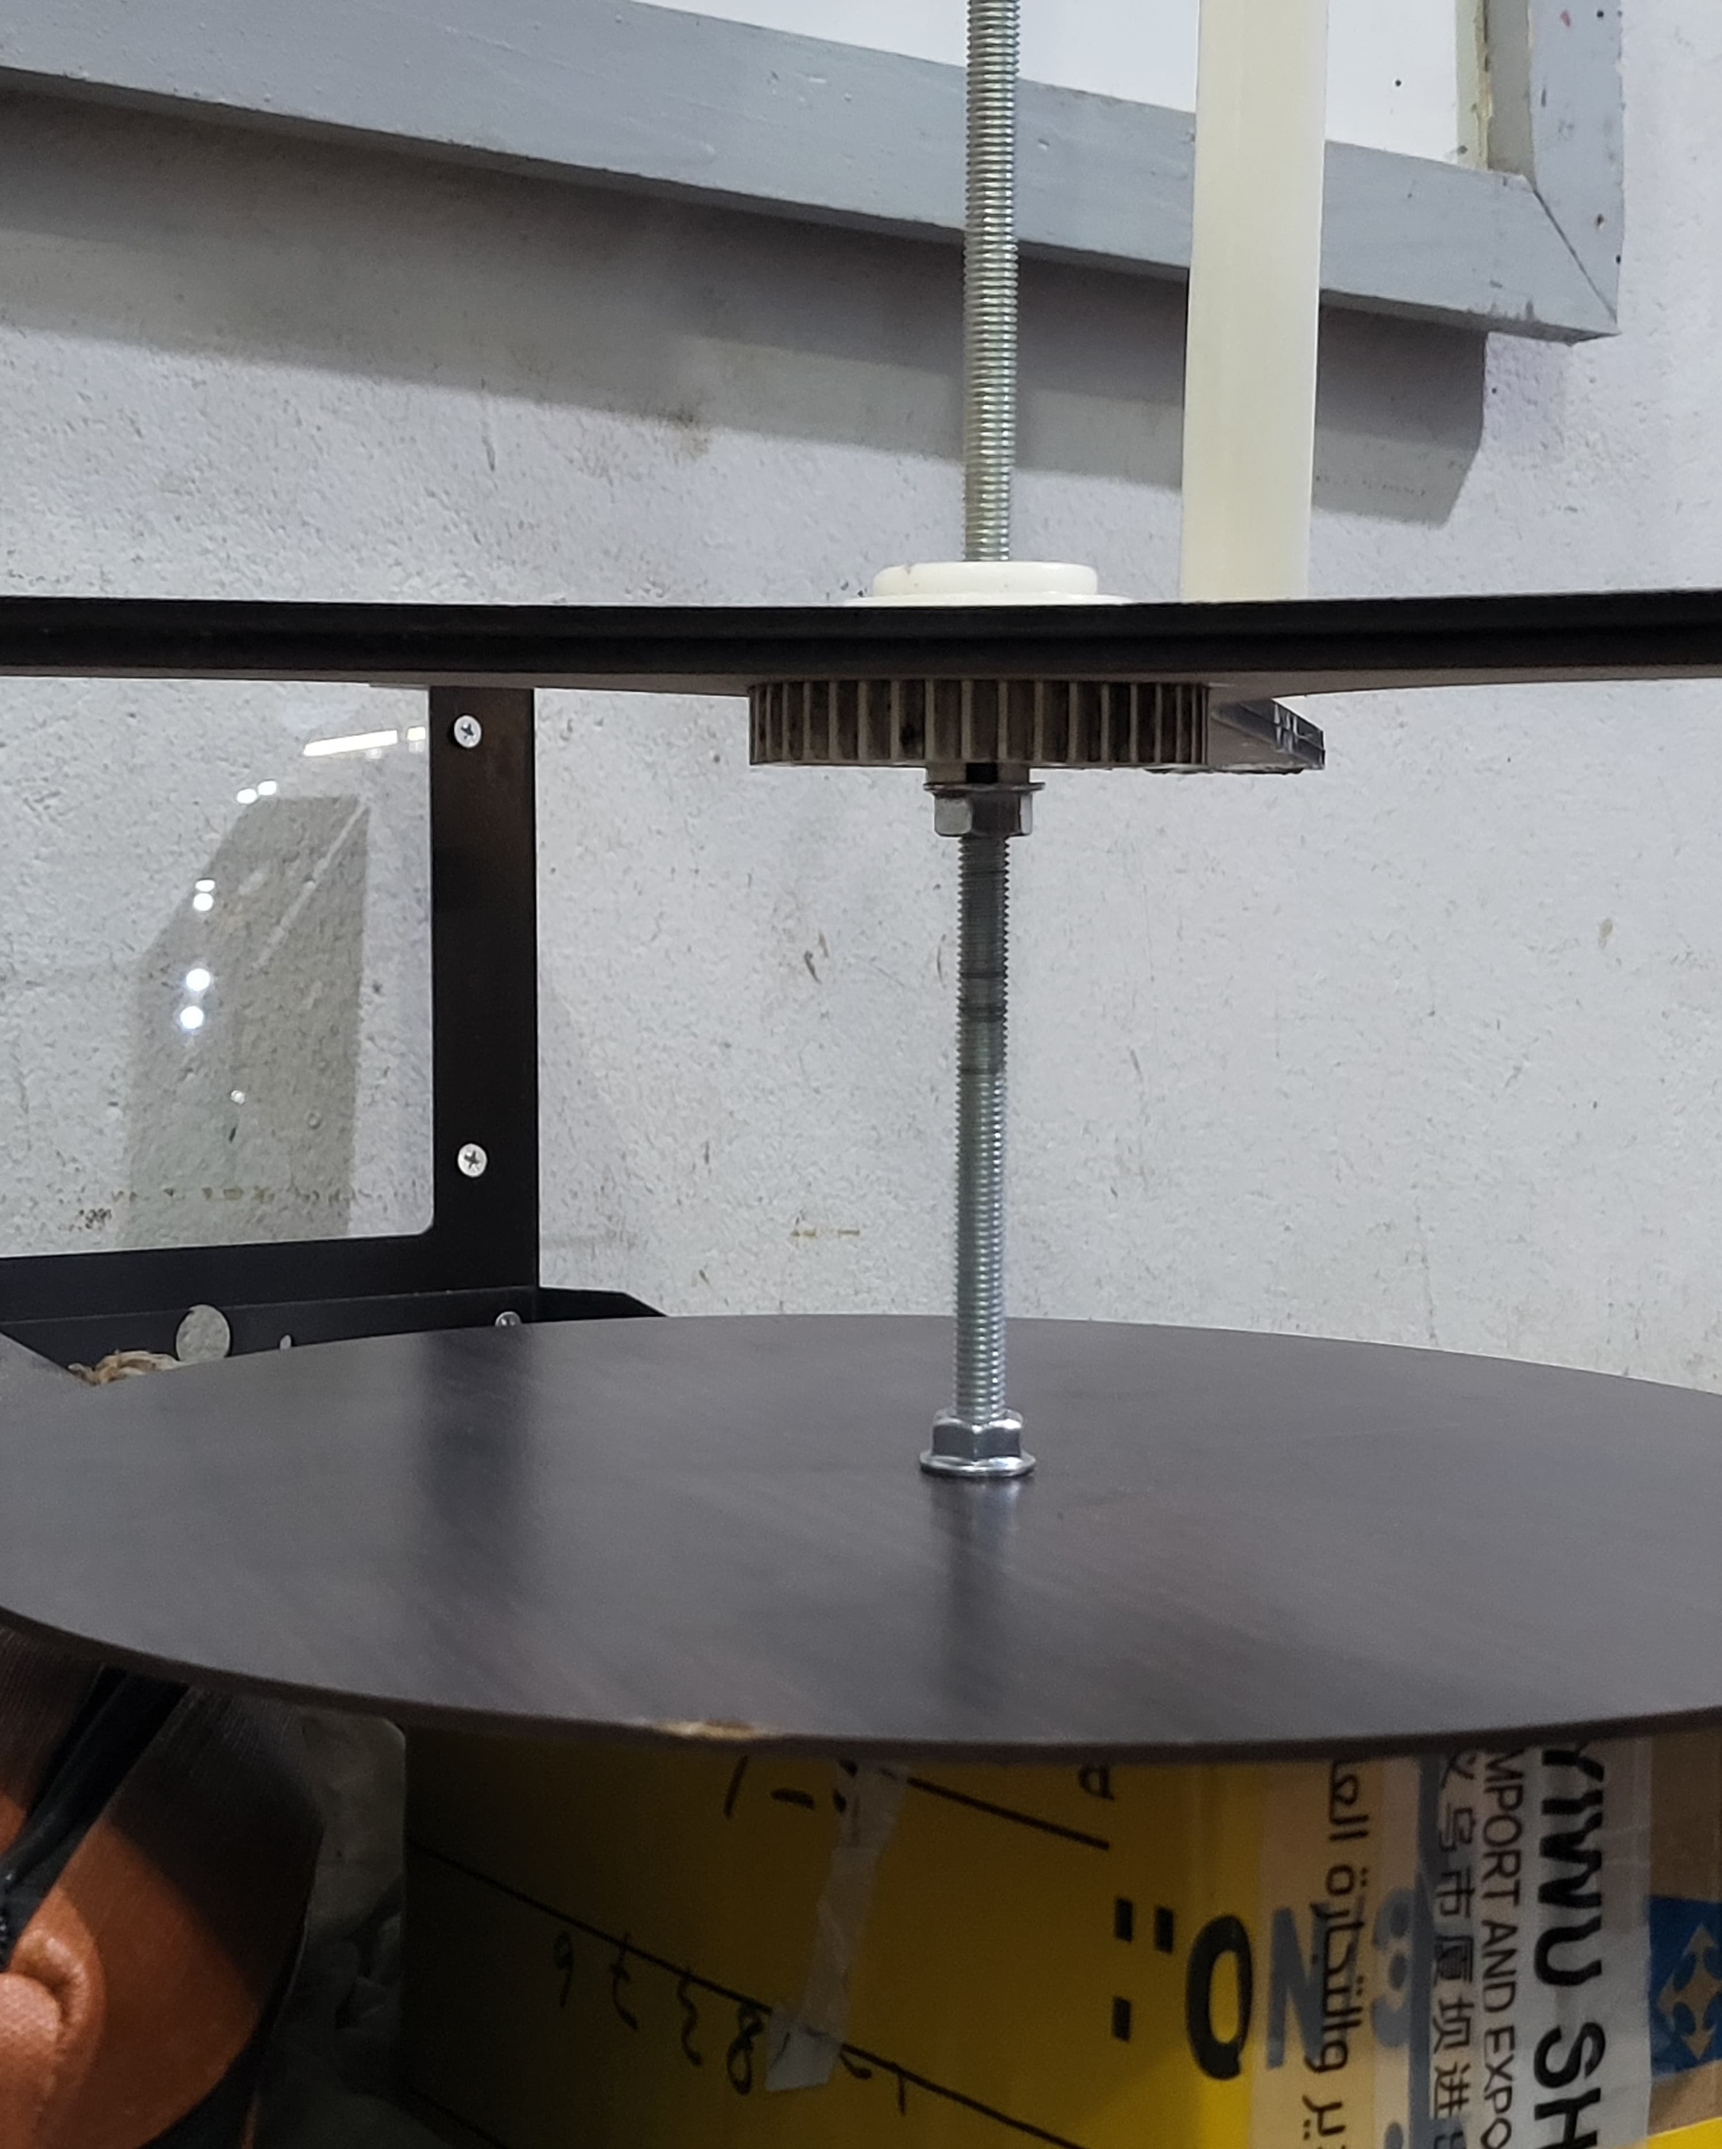
Figure ‎3-11 prototype base shot 3
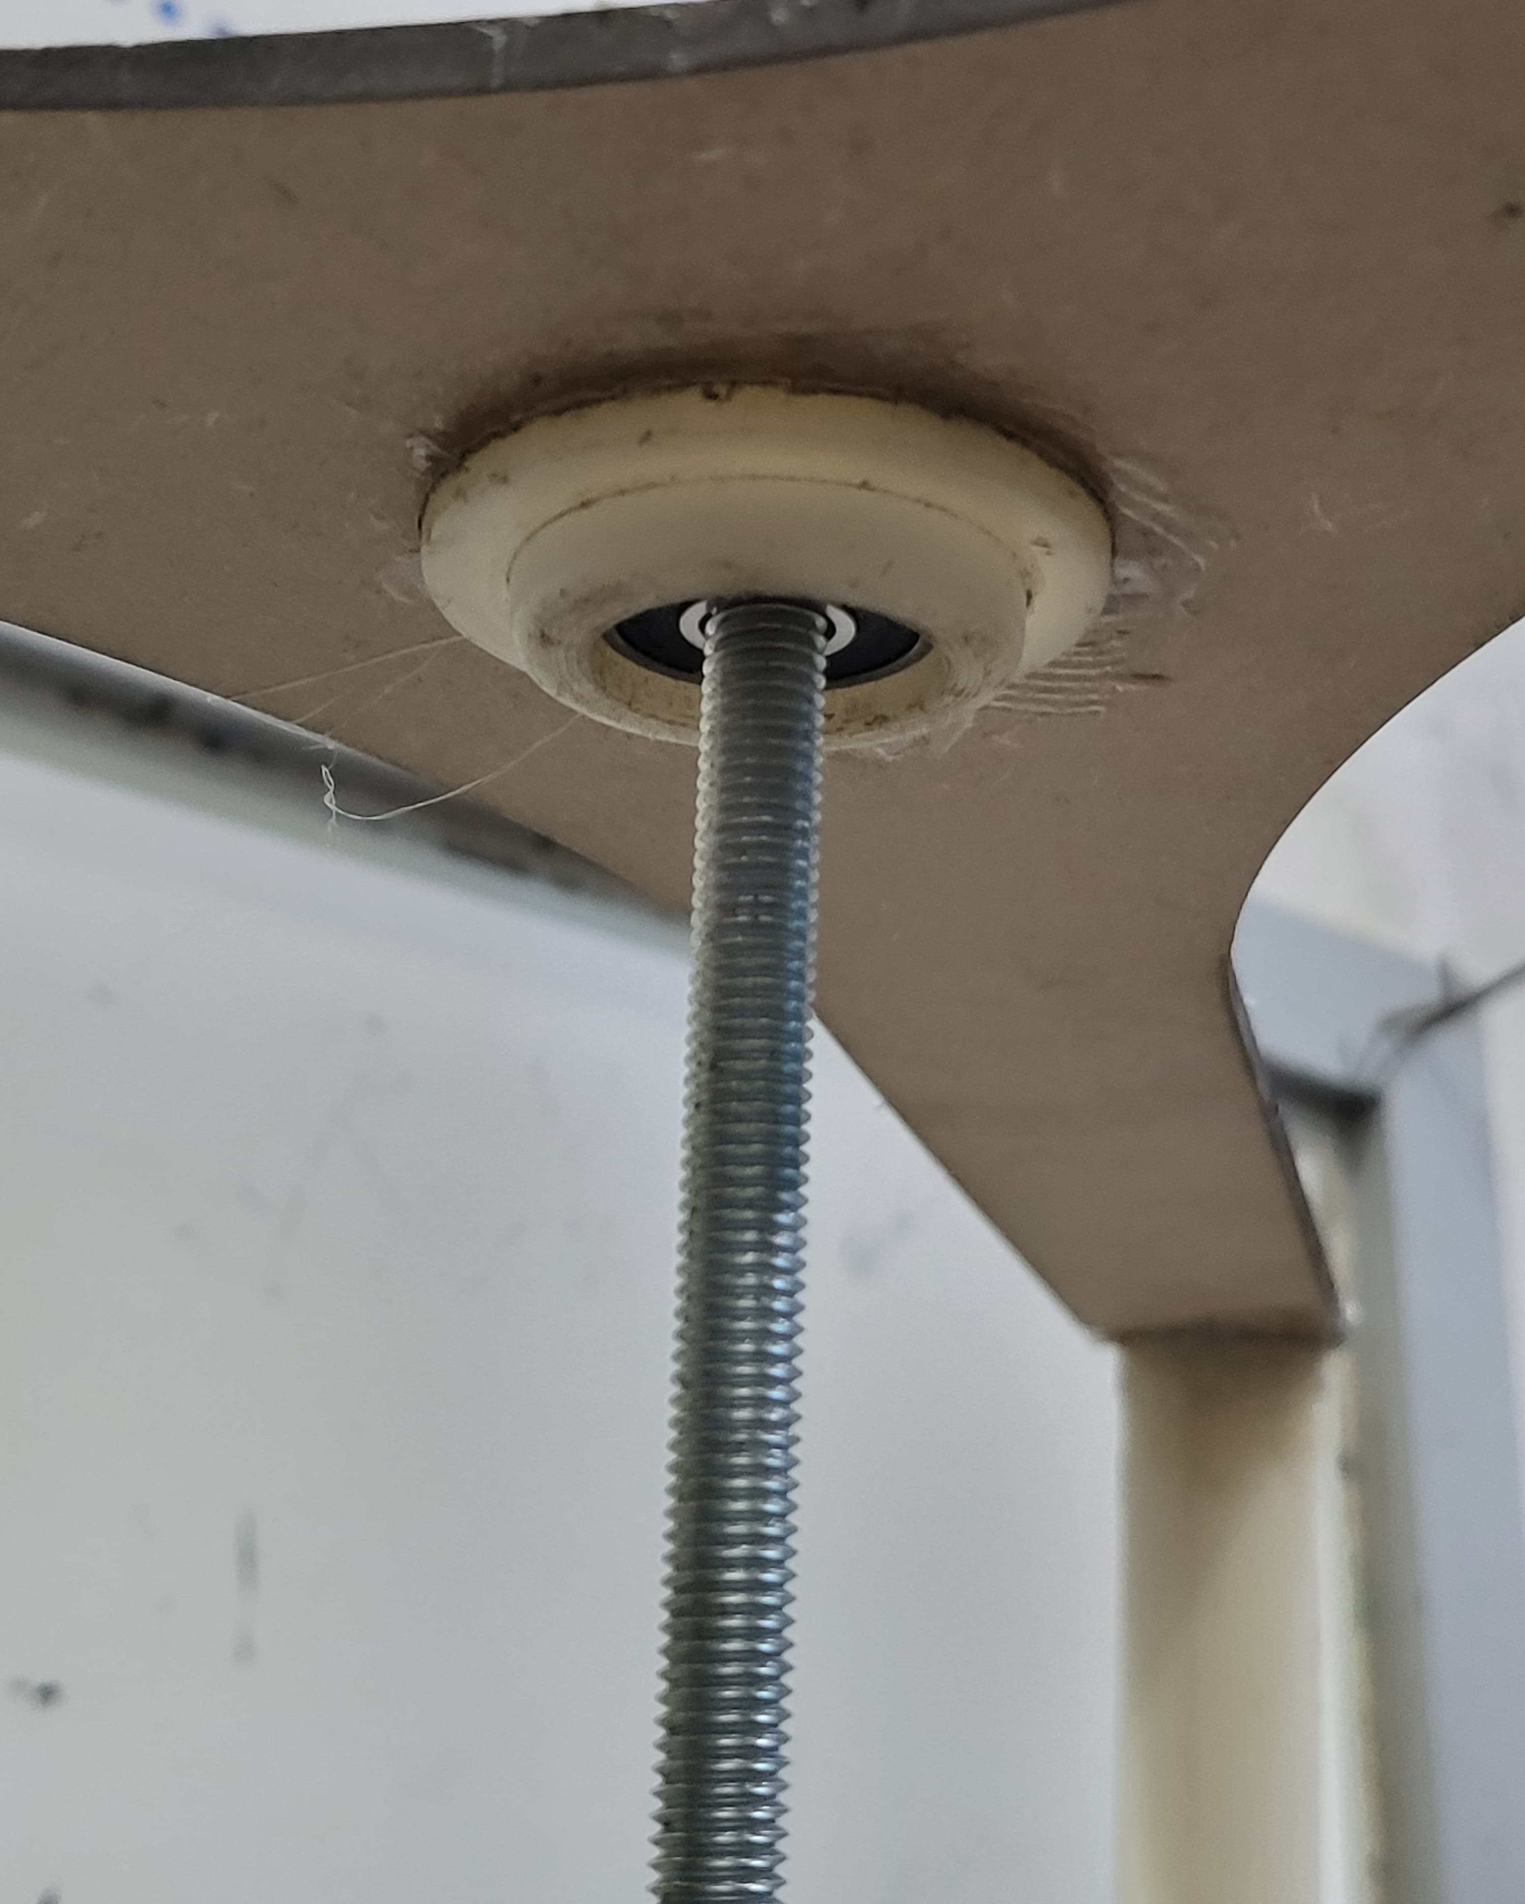
Figure ‎3-12 prototype fixation shot 4
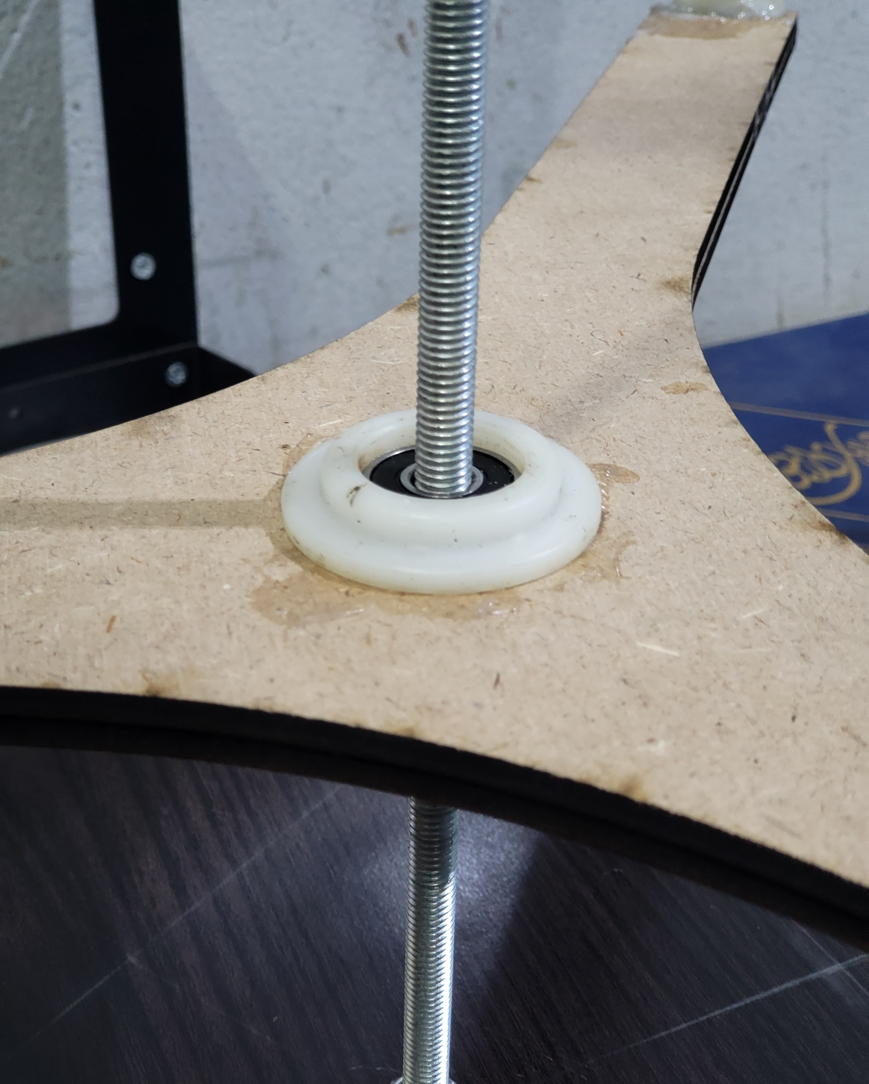
Figure ‎3-13 prototype shot 5

Economics of wind energy

Introduction
In this chapter, we will introduce the cost of electricity from the wind energy including the factors affect the cost and the methods of calculating it. In addition, we will summarize the total cost of our design and compare it with the commercial wind turbines used in bulk generation of electricity.
After that, we will mention simple calculations to predict the number of wind turbines of our design enough for a commercial place like small factory or apartment .

Wind energy cost analysis
The key parameters governing wind power economics are the:
  - Investment costs (including those associated with project financing).
  - Operation and maintenance costs (fixed and variable).
  - Capacity factor (based on wind speeds and turbine availability factor).
  - Economic lifetime.
  - Cost of capital.
There are four phases of a typical wind farm time line “the major components of the cost of a wind farm “
- Identify Site
- Development
- Construction
- Operation and Maintenance

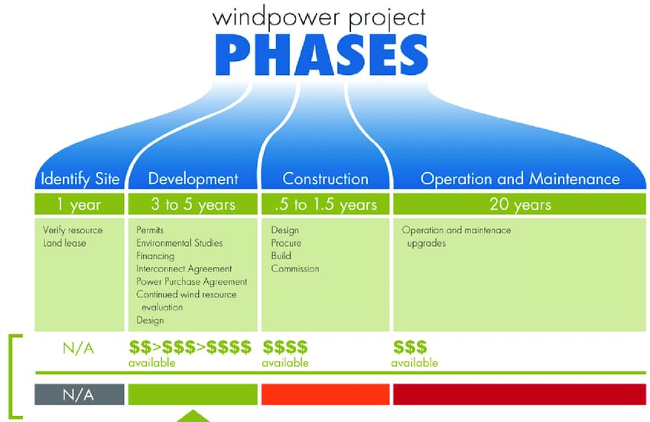
Figure ‎4-1 Time line for developing and operating a typical wind farm
From above , it is obvious that the wind turbines cost a lot . Therefore , the investment in wind energy is to be considered over a long period of time .
According to weather guard wind website in 2024:
1-The Breakdown of Initial Wind Turbine Costs
- $2.6 – $4 million per average-sized commercial wind turbine
Typical cost is $1.3 million per megawatt (MW) of electricity-producing capacity
- Most commercial wind turbines have a capacity of 2-3 MW, but offshore turbines can be as large as 16-18 MW .
- Cost increases as turbine size increases, though there are benefits to using fewer, larger turbines – complexity and construction of the overall farm site is greatly reduced with fewer and larger turbines.
2- Wind Turbine Maintenance Costs
- 1-2 cents per kilowatt-hour produced, or $42,000 – $48,000 per year
This means that the cost of kW is nearly 2.1M LE. Per year

cost analysis of the PROJECT.
Table ‎4-1 The total cost for construction of our VAWT project
Part | Quantity | Cost | Total
Bearings | 2 | 100 | 200
Laser cut top | 2 | 350 | 700
3D Printed Blades | 330 | 330 | 990
Rod | 1 | 50 | 50
3d base | 1 | 100 | 100
Total | …… | …….. | 2040

References
- Brusca2014_Article_”DesignOfAVertical-axisWindTurbine”
- " Global wind statistics " ( PDF ) . IRENA
- Herbert J. Sutherland ,HJS Consulting “A Retrospective of VAWT Technology”
- Travis J. Carrigan, Brian H. Dennis, Zhen X. Han, and Bo P.Wang “Aerodynamic Shape Optimization of a Vertical-AxisWind Turbine Using Differential Evolution”
- Frederikus Wenehenubuna, Andy Saputraa, Sutanto “An experimental study on the performance of Savonius wind turbines related with the number of blades”
- L. Battisti et al 2016 J. Phys “Analysis of Different Blade Architectures on small VAWT Performance”
- Amlan Das “Modelling and Analysis of a Mini Vertical Axis Wind Turbine”
- Junkun Ma “Drag Force on a Vertical Axis Wind Turbine with Airfoil Pitch Control”
- Javier Castillo “SMALL-SCALE VERTICAL AXIS WIND TURBINE DESIGN”
- M.A. Miller, S. Duvvuri, W. D. Kelly and M. Hultmark “Rotor solidity effects on the performance of vertical-axis wind turbines at high Reynolds numbers”

