1. Ann, a junior systems administrator, is required to add a line to the /etc/yum.conf file. However, she receives the following error message when she tries to add the line:

Ann performs some diagnostics to attempt to find the root cause:

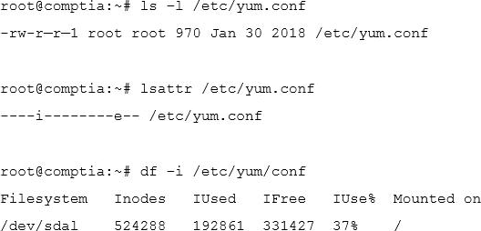

Which of the following commands should Ann execute to write content to /etc/yum.conf?

1. chmod 755 /etc/yum.conf
2. setfacl –m m:rw /etc/yum.conf
3. chattr -i /etc/yum.conf
4. setenforce 0
5. Two specific users need access to a directory owned by root where backups are located.

Which of the following commands would BEST ensure the specified users can access the backup files?

* 1. umask
  2. chcon
  3. chmod
  4. setfacl

3- A company wants to ensure that all **newly created files** can be modified only by their owners and that all new directory content can be changed only by the creator of the directory.

Which of the following commands will help achieve this task?

1. umask 0022
2. umask 0012
3. chmod –R 0644 /

4.A junior systems administrator is upgrading a package that was installed on a Red Hat-based system. The administrator is tasked with the following:

* Update and install the new package.
* Verify the new package version is installed.

Which of the following should be done to BEST accomplish these task? (Choose two.)

1. yum install <package name>
2. yum upgrade
3. rpm –e <package name>
4. rpm –qa
5. apt-get <package name>
6. apt-get upgrade
7. Joe, a user, is unable to log in to the server and contacts the systems administrator to look into the issue.

The administrator examines the /etc/passwd file and discovers the following entry:

**joe:x:505:505::/home/joe:/bin/false**

Which of the following commands should the administrator execute to resolve the problem?

1. usermod -s /bin/bash joe
2. passwd –u joe
3. useradd –s /bin/bash joe
4. chage –E -1 joe
5. Which of the following server roles would assign a host IP address?
   1. DHCP
   2. NTP
   3. DNS
   4. SSH
6. Given the output below:

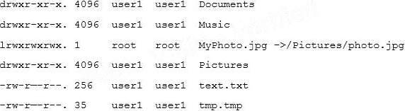

Which of the following commands can be used to remove MyPhoto.jpg from the current directory?

1. unlink ./MyPhoto.jpg
2. del Pictures/photo.jpg
3. rm –rf ./Pictures
4. rm –f MyPhoto.jpg
5. ln –rm ./Pictures/photo.jpg
6. A Linux administrator needs the “tech” account to have the option to run elevated commands as root. Which of the following commands would BEST meet this goal?
7. $ su - tech -c “/bin/bash”
8. # usermod -aG wheel tech
9. # sudo -I tech
10. # groupadd –u tech –g root