1-
A junior Linux administrator is setting up system-wide configuration settings. The goal is to ensure the PATH environment variable includes the following locations for all users who log into a Linux system.
The administrator issues the following commands at the terminal:
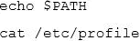
Respectively, the output of these commands is as follows:

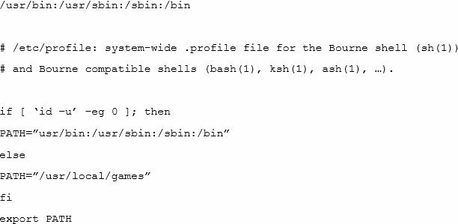
Given this output, which of the following would be the BEST action for the administrator to perform to address this issue?
- Update the /etc/profile.d file using a text editor, navigate to the PATH element add the missing locations, and run the bash_completion.sh script to update the changes.
- Update the /etc/profile file using a text editor, navigate to the PATH element, add the missing locations and run the . /etc/profile command to update the changes.
- Update the /etc/profile.d file using a text editor, navigate to the PATH element, add the missing locations, and reboot to update the changes.
- Update the /etc/profile file using a text editor navigate to the PATH element, add the missing locations, and restart the bash process to update the changes.

2

A network has been crashing intermittently. A Linux administrator would like to write a shell script that will attempt to ping the server and email an alert if the server fails to respond. The script will later be scheduled via cron job.
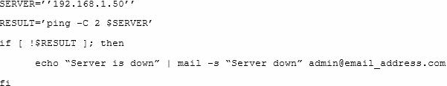Which of the following scripts would BEST accomplish this task? A)
B)
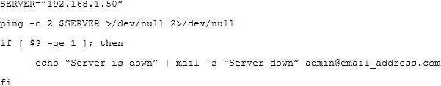
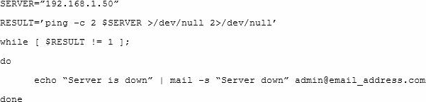C)
D)

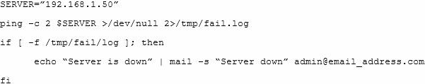
- Option A
- Option B
- Option C
- Option D

Question 3

Which of the following shell scripts will accomplish this task?

A.

#/bin/bash

find /etc -name services | sort > /var/tmp/foundservices

B.

#/bin/bash

locate /etc -sort -name services > /var/tmp/foundservices

C.

#/bin/bash

find -name services -sort </var/tmp/foundservices

D.

#/bin/bash

find /etc -name services -sort > /var/tmp/foundservices

