Phase3:

Pert Chart

1. User registration and Authentication:
   1. Develop user registration functionality (2-3 days): task 1
   2. Implement user authentication system (2-3 days): task 2
   3. Insure secure password storage and transmission (1-2 days): task 3
   4. Design user profile management interface (2-3 days): task 4
2. Guest Management:
   1. Create guest list management feature (3-4 days): task 5
   2. Implement RSVP tracking functionality (2-3 days): task 6
   3. Develop meal preference and dietary restriction management (2-3 days): task 7
   4. Design seating arrangement and floor plan generation (3-4 days): task 8
3. Budget Management:
   1. Develop budget setting and management features (3-4 days): task 9
   2. Implement expense tracking and categorization (2-3 days): task 10
   3. Create alerts for corresponding or deviations (1-2 days): task 11
4. Vendor Management:
   1. Design vendor search and selection feature (3-4 days): task 12
   2. Implement contract and agreement management (2-3 days): task 13
   3. Develop vendor communication system (2-3 days): task 14
5. Task Management:
   1. Create task management functionality (3-4 days): task 15
   2. Implement task assignment deadline setting (2-3 days): task 16
   3. Design reminders and alerts for tasks (2-3 days): task 17
6. Calendar and Timeline Management:
   1. Develop customization timeline creation feature (3-4 days): task 18
   2. Implement synchronization with personal calendars (2-3 days): task 19
   3. Design reminders and notifications for deadlines (2-3 days): task 20
7. Venue and Floorplan Management:
   1. Create Venue search and booking functionality (3-4 days): task 21
   2. Implement guest and seating arrangement management (2-3days): task 22
   3. Design floor plan customization feature (3-4 days): task 23
8. Customization and Personalization:
   1. Develop options for theme , color scheme , and branding customization (3-4 days):task 24
   2. Implement user interface personalization features (2-3 days): task 25

Task Management:

Task 1 must be done before Task 2

1-User Registration

1-User Registration

1-User Registration

1-User Registration

Task 2 must be done before Task 3

Task 3 must be done before Task 4

Task 5 must be done before Task 6 and Task 8

2-Guest Management

Task 6 must be done before Task 7

Task 7 must be done before Task 8

Task 9 must be done before Task 10

3-Budget Management

Task 10 must be done before Task 11

Task 12 must be done before Task 13

4-Vendor Management

Task 13 must be done before Task 14

Task 15 must be done before Task 16 and Task 17

5-Task Management

Task 16 must be done before Task 17

Task 18 must be done before Task 19 and Task 20

6-Calendar Management

Task 19 must be done before Task 20

Task 21 must be done before Task 22 and Task 23

7-Venue Management

Task 22 must be done before Task 23

8-Customization

Task 22 must be done before Task 23

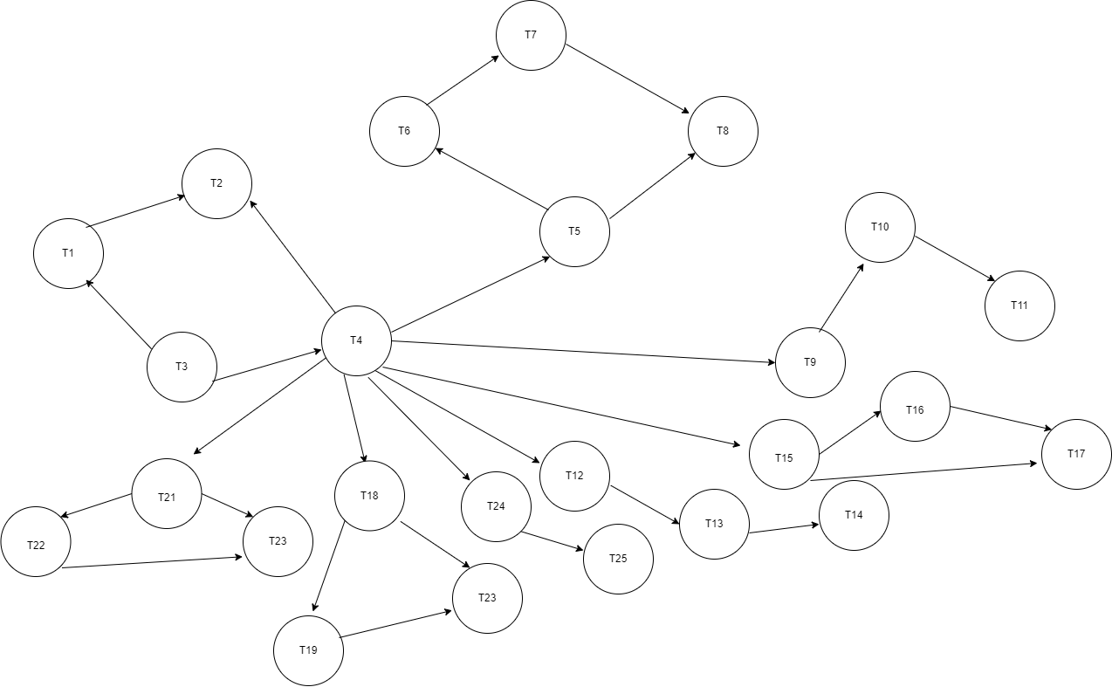

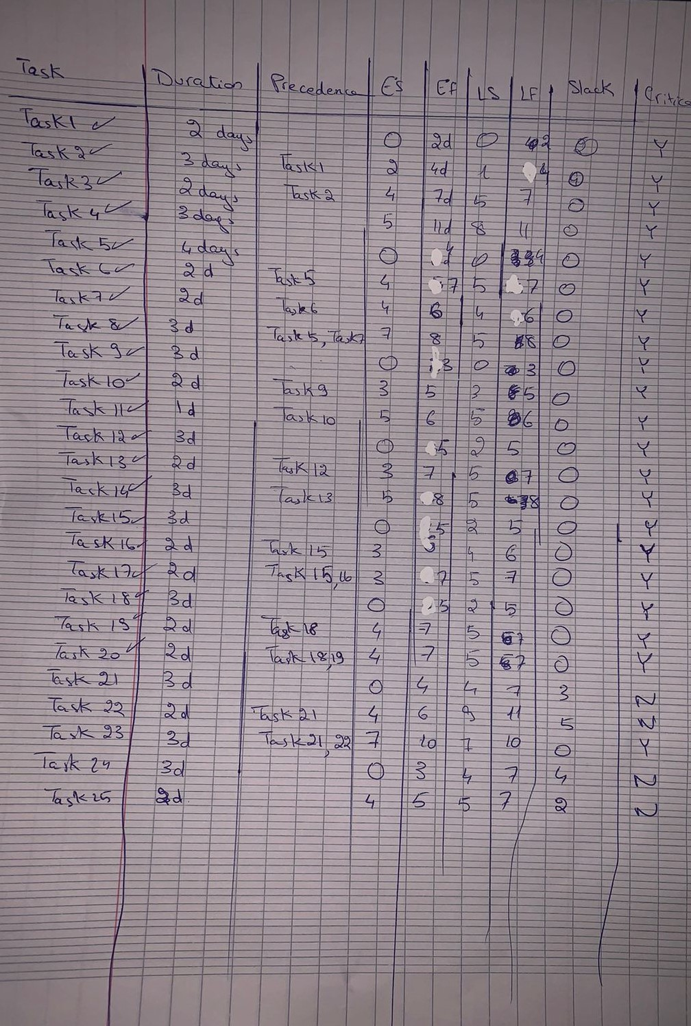

Gantt Chart

