 | Faculty of Arts & Sciences/ Computer Sciences  Department  Final Exam (Spring2024)  CSCI210 – Computer Architecture and Logic Design | Code: EXM-FR 02/1  ED:2.1

Instructor Name:  Section: A | Exam Type: Closed Book  Allowed Tools: Calculator |  | Booklet Needed: NO  Exam Date:24
Exam Time: 2H |  | Grade: ……..…../100
Problem 1: 10 pts
- List the three types of the flipflops (2 pts) SR, JK, D flipflops

- Is the architecture and registers of Marie processor being the same in all other processors (Intel,
ARM …)? (2 pts)
While MARIE, Intel, and ARM processors all adhere to the fundamental principles of the Von Neumann architecture, their implementations differ greatly to meet different design goals and application requirements. MARIE is a simplified model for educational purposes, whereas Intel and ARM processors incorporate advanced features to optimize performance, power efficiency, and versatility in real-world applications .
- How many bits is needed to present 22 opcodes? (2 pts)
Determine the number of bits needed to represent 22 different opcodes, you need to calculate the smallest number of bits n such that 2^n is at least 22. Calculate 2^n for increasing values of n:
2^1 = 2
2^2 = 4
2^3 = 8
2^4 = 16
2^5 =32
2^5 = 32 is the first power of 2 that is equal to or greater than 22.
Therefore, you need 5 bits to represent 22 different opcodes.

- What is the max unsigned number presented in an 2M*32 RAM? (2 pts)
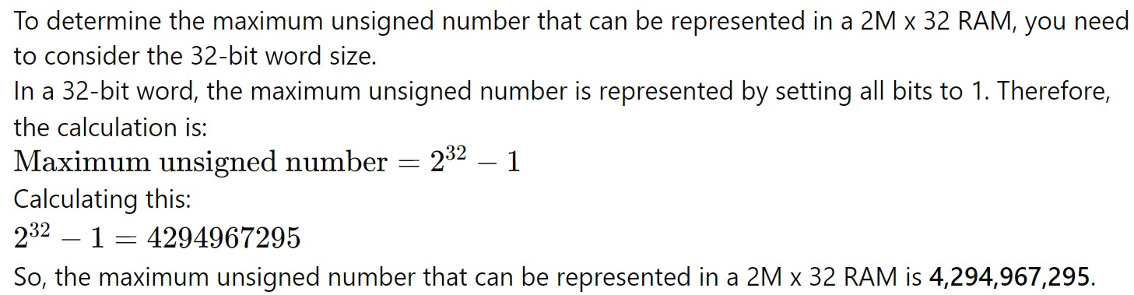

1
1 1 1 … 1

32

bit

- How to create 16 bits register in digital circuit. (2 pts)
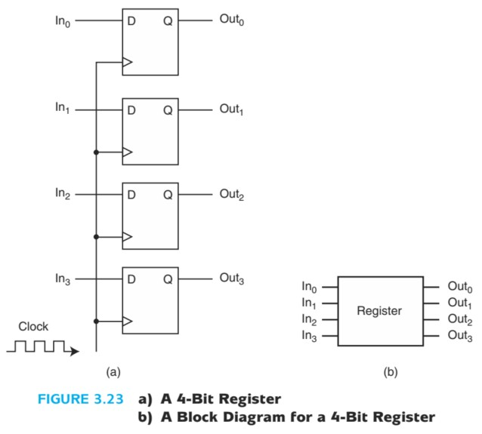
• 16 D flip-flops: Each flip-flop stores a single bit.

Problem 2: 20pts (5 x 4 pts)
Complete the timing diagram of the 2 JK flip-flops, for J2, K2 and R. Refer to the circuit diagram provided below and use the truth table of the JK flip-flop to complete your work.
Noting that: The JK flip-flop is triggered on the falling edge ↓ of the clock.
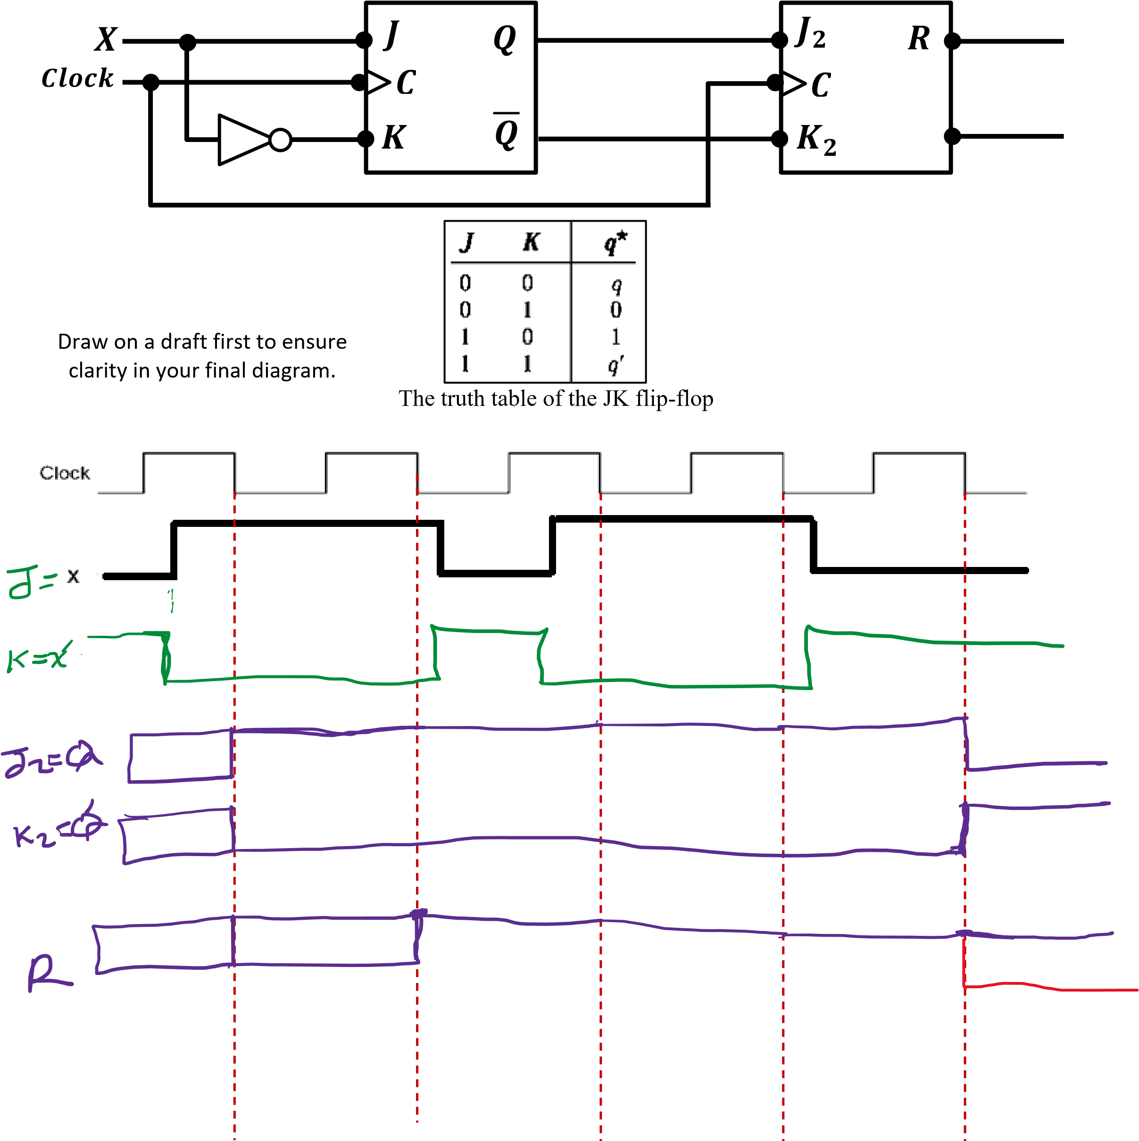
Problem 3: 5 pts
Draw the CPU basic architecture linking the main parts with the ideas from the chapters (logic gates, flipflops, decoders, multiplexers, full adders).
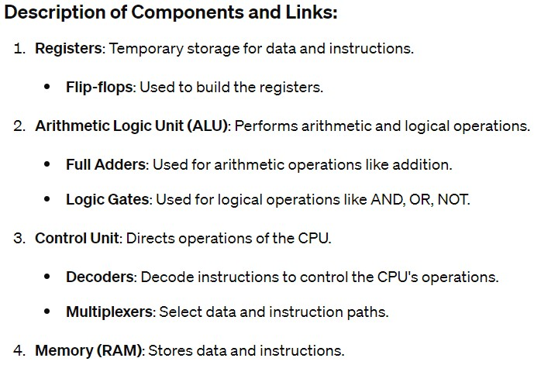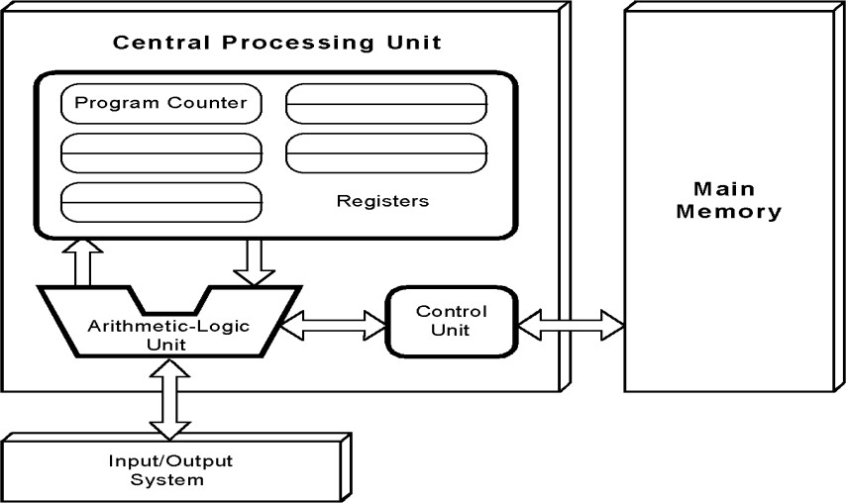

D Flip flops

Problem 4: 5 pts
List the registers of the Marie simulator with a little explanation for each:
MARIE’s seven registers are:
- ACcumulator, AC, a 16-bit register that holds a conditional operator (e.g., "less than") or one operand of a two-operand instruction. This is a general purpose register and holds data that the
CPU needs to process.
- Memory Address Register, MAR, a 12-bit register that holds the memory address of an instruction or the operand of an instruction.
- Memory Buffer Register, MBR, a 16-bit register that holds the data after its retrieval from, or
before its placement in memory.

- Program Counter, PC, a 12-bit register that holds the address of the next program instruction to be executed.
- Instruction Register, IR, which holds an instruction immediately preceding its execution.

- Input REGister, InREG, an 16-bit register that holds data read from an input device.

- Output REGister, OutREG, an 16-bit register, that holds data that is ready for the output device.

Problem 5: 15 pts (3 x 5 pts)
write an assembly code that gets 3 variables from the user, and write the values of three variables in an array.
ORG 100 / Starting address of the program

LOAD Base / Load the base address of the array STORE Ptr / Store it in Ptr

INPUT / Get the first value from the user
STOREI Ptr / Store it in the array at Ptr (initially Array[0])

LOAD Ptr / Load the address in Ptr
ADD One / Add 1 to the address
STORE Ptr / Store the new address back in Ptr

INPUT / Get the second value from the user
STOREI Ptr / Store it in the array at Ptr (now Array[1])

LOAD Ptr / Load the address in Ptr
ADD One / Add 1 to the address
STORE Ptr / Store the new address back in Ptr

INPUT / Get the third value from the user
STOREI Ptr / Store it in the array at Ptr (now Array[2])

HALT / End of the program

Base, HEX 112 / Base address of the array (Array)
Ptr, DEC 0 / Pointer to the array
One, DEC 1 / Constant value 1
Array, DEC 0 / Array start (Array[0]) at address 112
DEC 0 / Array[1]
DEC 0 / Array[2]

Problem 6 (20 points):
Consider the following MARIE assembly code:
Address in Hexa | Org 015
015 | loop, load counter | /ac=0
016 | subt limit | /ac=
017 | skipcond 400
018 | jump else
019 | jump if
01A | else, load sum
01B | addi address
01C | store sum
01D | load address
01E | subt two
01F | store address
020 | load counter
021 | add two
022 | store counter
023 | jump loop
024 | if, load sum
025 | Output
026 | Halt
027 | counter, dec 0
028 | limit, dec 6
029 | two, dec 2
02A | sum, dec 0
02B | address, hex 31
02C | dec 5
02D | dec 6
02E | dec 7
02F | dec 8
030 | dec 9
31 | dec 10

- Explain what the program do. (4 pts)
The program iterates through the array in steps of 2, starting from the end, summing the values until i equals limit (6). It then outputs the sum and halts.
Given the array values [5, 6, 7, 8, 9, 10], the program adds 10, 8, and 6, resulting in a final sum of 24, which it outputs.
The program calculates the sum of values stored at memory addresses in reverse order starting from 31, decrementing by 2 each iteration. It continues this until the counter reaches or exceeds the limit (6). Finally, it outputs the calculated sum.
- What is the output at the of the program in DEC: (4 pts)
24

- Write the RTL micro steps for Addi address (4 pts)

MAR == X

MBR = M[MAR]


ADDI X MAR == MBR
MBR == M[MAR]
AC == AC + MBR
- Fill the 5 missing values in the memory (black cells) (5 pts)
 | +0 | +1 | +2 | +3 | +4 | +5 | +6 | +7 | +8 | +9 | +A | +B | +C | +D | +E | +F
000 | 0000 | 0000 | 0000 | 0000 | 0000 | 0000 | 0000 | 0000 | 0000 | 0000 | 0000 | 0000 | 0000 | 0000 | 0000 | 0000
010 | 0000 | 0000 | 0000 | 0000 | 0000 | 1027 | 4028 | 8400 | 901A | 9024 | 102A | B02B | 202A | 102B | 4029 | 202B
020 | 1027 | 3029 | 2027 | 9015 | 102A | 6000 | 7000 | 0006 | 0006 | 0002 | 0018 | 002B | 0005 | 0006 | 0007 | 0008
030 | 0009 | 000A | 0000 | 0000 | 0000 | 0000 | 0000 | 0000 | 0000 | 0000 | 0000 | 0000 | 0000 | 0000 | 0000 | 0000

- Value at 014 (hex): ___0000_____________________________________________
- Value at 015 (hex): ___1027_______________________________________________
- Value at 0203 (hex): __9015________________________________________________
- Value at 020B (hex):__002B____________________________________________
- Value at 0303(hex): __0000_____________________________________________
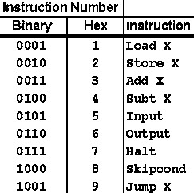

Given: The Binary and Hexadecimal equivalents for the
Opcode are shown in this table

e- What is the address of the first instruction of the code in the memory? Explain your reasoning. (3 pts)
Address: 015 (hexadecimal)
Thus, the address of the first instruction of the code in memory is 015 (hex). This is confirmed by the _{Org 015} directive, which sets the starting point for the program's instructions.

Problem 7 (15 points):
Fill the value loaded into the AC (Accumulator) for the following instruction using multiple addressing modes:


LOAD 500

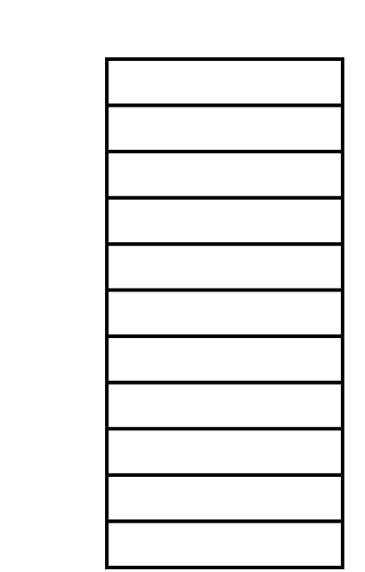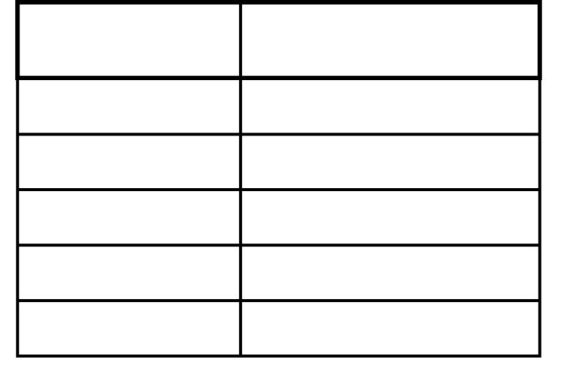

Memory

200

900

…

400

300

…

500

400

…

600

600

…

700

1100

…

900

100

R1

200

Mode

Value Loaded

into AC

Immediate

500

Direct

400

Indirect

300

Indexed

1100

Register Indirect

100

Problem 8: 10 pts
micro-steps: | 𝑆1, 𝑆2, 𝑆3, 𝑆4, 𝑆5
CPU instructions is divided into smaller steps. In this scenario, each instruction is divided into 5 . Each micro-step requires only one clock cycle.
- If three instructions runs without piplining how many clock cycles is required. Justify your answer by the drawing time diagram.
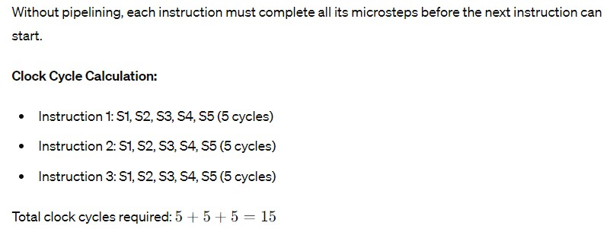

- Now if pipelining is used, how many clock cycles is required? Justify your answer by drawing a time diagram.
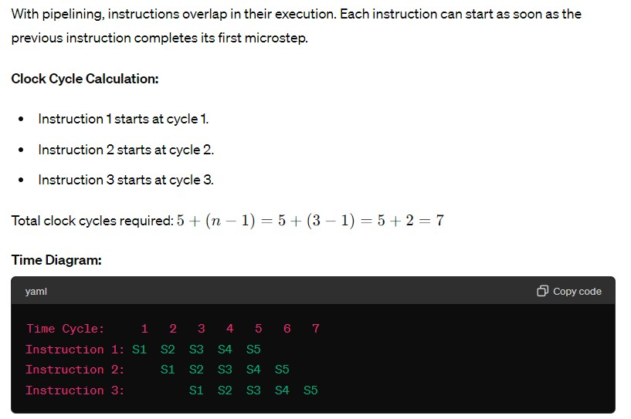

Good Luck !

