Cairo University  
Faculty of Computers and Information



**CS251**

**Software Engineering I**

Project Name

Software Design Specifications

Version 2.0

Team Names and Emails

Month & Year

Contents

Instructions [To be removed] 3

Team 3

Document Purpose and Audience 3

System Models 3

I. Class Diagram(s) 3

II. Class Descriptions 5

III. Sequence diagrams 5

Class - Sequence Usage Table 6

IV. User Interface Design 7

Tools 7

Ownership Report 7

References 7

Authors 7

# Instructions [To be removed]

* **IMPORTANT. Rename this document to CS251-Group-TAName-LeaderID-SDDocument.docx or pdf**

**(e.g. CS251-G5-MohamedSamir-20180352-SDSDocument.docx or pdf)**

* **Remove the following notes and any red notes**
* **This document is the template document for your Software Design.**
* **For further guidelines and information, READ Assignment 3 document, project description and sample SRS.**

# Team

|  |  |  |  |
| --- | --- | --- | --- |
| **ID** | **Name** | **Email** | **Mobile** |
|  | 1st name is team leader |  |  |
|  |  |  |  |
|  |  |  |  |

# Document Purpose and Audience

* **Any document should tell the reader 2 things: (1) What is this document? (2) Who is expected to read it?**
* **Write in simple notes: what this document is.**
* **List the target audience to read this document (e.g. CEO? Project Manager? Customer? Developers, ...?)**

# System Models

## I. Class Diagram(s)

* **You should provide your class diagram. Diagram should show the components and packages in your system as well as all classes, their attributes and operations and their relations.**
* **In case one diagram is so complex, divide it to several ones of reasonable size or draw separate ones, each for one of the components on the system decomposition diagram.**
* **Class diagram is a static diagram and should not represent any dynamic flow of events.**
* **Put stereotypes of the classes to give more information. UML predefines some stereotypes like: <<interface>>, <<type>>, <<implementationClass>>, <<enumeration>>, etc. and you create your own also.**
* **Put Relationships between classes and the types of the relationships.**
* **Put multiplicity.**
* **Put relationship name (e.g. faculty "offer" course).**
* **Put attributes in the classes and their types and visibility.**
* **Put functions, parameters and return types.**
* **Include all domain (entity), boundary and control classes needed to implement the system.**
* **The following is a Shopping Cart Component class diagram example.**

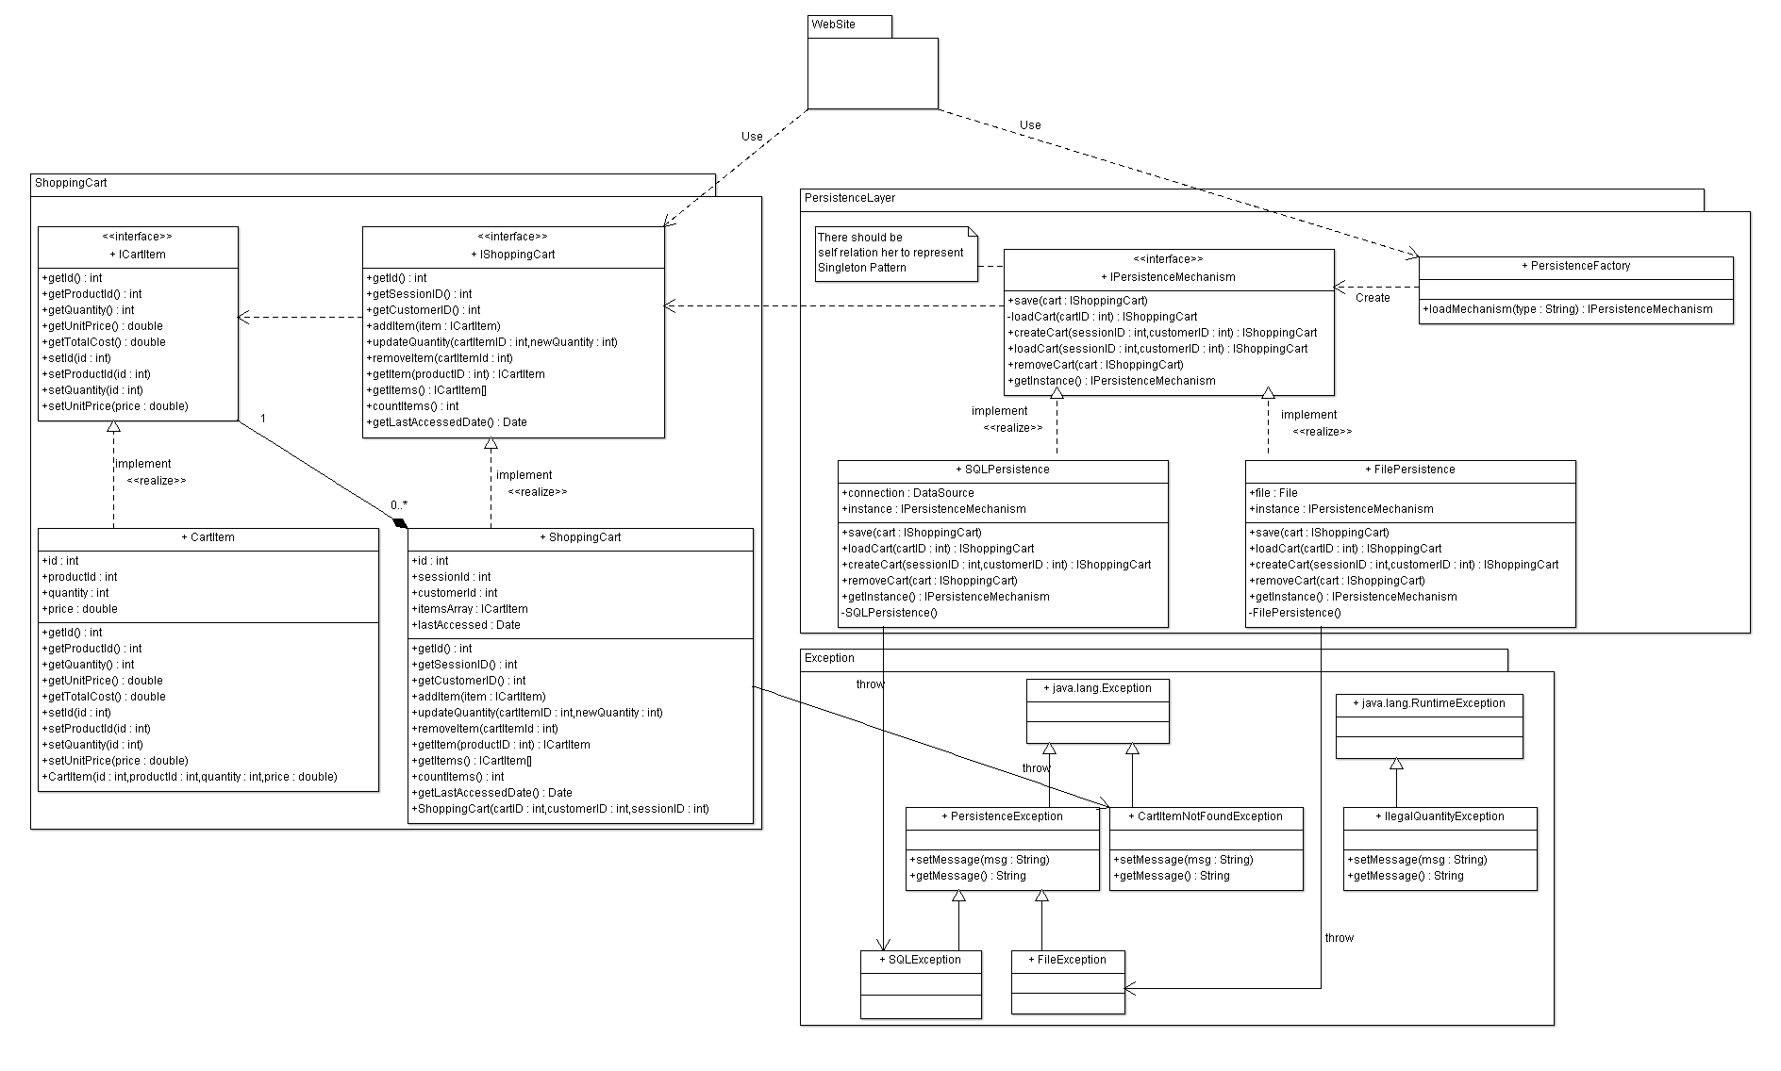

## II. Class Descriptions

* **List down your classes and describe them**

| **Class ID** | **Class Name** | **Description & Responsibility** |
| --- | --- | --- |
| 1. |  |  |

## III. Sequence diagrams

* **Usually each use case is represented by a sequence diagram or more.**
* **Draw a sequence diagram for the most important FOUR use cases.**
* **Overall, all the diagrams should represent all requirements and possible flows for the use case.**
* **Make sure that each object in the sequence diagram has a corresponding class in the class description table above. If not, it will be REJECTED.**
* **Put actual function calls with proper parameters and return types corresponding to class diagrams.**
* **Following are couple of examples for small / medium examples. We expect such diagrams, however there is a missing thing in them. Most of calls don’t have parameters. Please always specify the parameters in the call, matching the class diagram.**

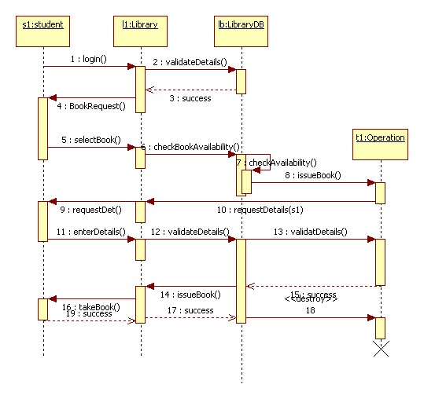

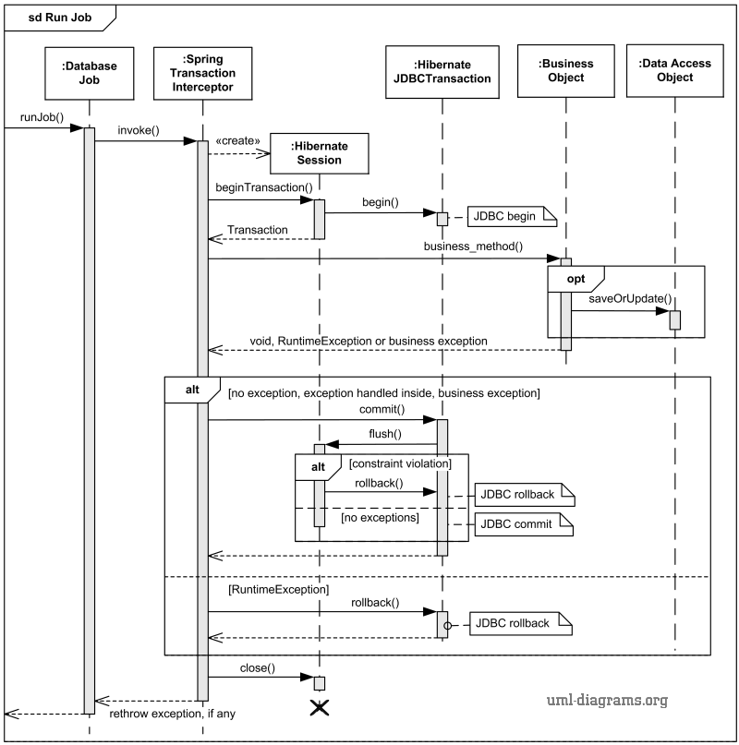

### Class - Sequence Usage Table

* **In this table, we will list the sequence diagrams you drew. For each one, list all the classes used in this sequence. For each class list all the methods you used in this class. Every method or object on a sequence diagram must belong to an existing class in the class diagram and be shown there. If sequence diagrams do not reflect actual classes and methods, they will be REJECTED.**

| **Sequence Diagram** | **Classes Used** | **All Methods Used** |
| --- | --- | --- |
| 1. Book Field | Class Field  Class Player | Methods …..  Methods …. |

## IV. User Interface Design

* **Provide a design of all the important screens of your system as wireframes or mockups. Use a tool to do that. Give each screen a number and name.**
* **Draw a navigation map that show how the screens are related (See example at** <https://stuff.mit.edu/afs/sipb/project/android/docs/training/design-navigation/wireframing.html>)
* **For each screen, describe what it does and what it is for.**

|  |  |  |
| --- | --- | --- |
| **Screen ID** | **Screen Name** | **Screen / Wireframe Description** |
|  |  |  |

# Tools

* **Write a list of all tools used to develop the design (e.g., ArgoUML, Visual-Paradigm, mocqus, etc.)**

# Ownership Report

* **Remove the following notes and any red notes**
* **For every item in this document, write the owners. If someone is owner of something, s/he understands it 100%.**
* **Team leader must verify the table with the team members.**

|  |  |
| --- | --- |
| **Item** | **Owners** |
| **Mohammad Ali Sayed** | **Part of class diagram and sequence diagrams 2 and 3.** |
|  |  |
|  |  |

# References

* <http://www.mhhe.com/engcs/compsci/pressman/graphics/Pressman5sepa/common/cs1/design.pd>
* Mockups (<https://moqups.com/>).
* How to use Moqups <https://www.youtube.com/watch?v=glijkZFo4AY>
* Example wireframes and designs (you can contact the author for questions) <http://malakumar.com/wp-content/uploads/2018/12/MalaKumar_SampleWireframes-1.pdf>

# Authors

* Mostafa Saad and Mohammad El-Ramly (Edited by Mohamed Samir) (V1.0)
* Updated by Mohammad El-Ramly (V2.0)